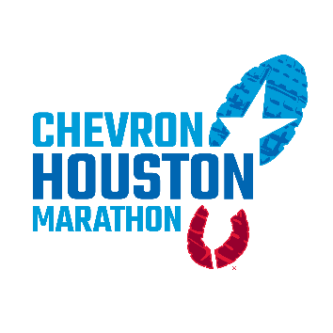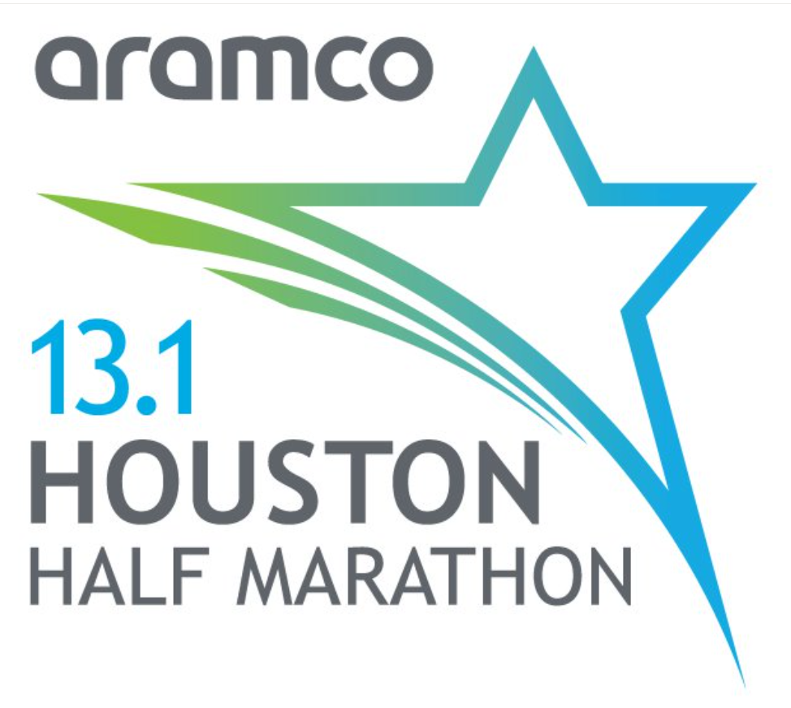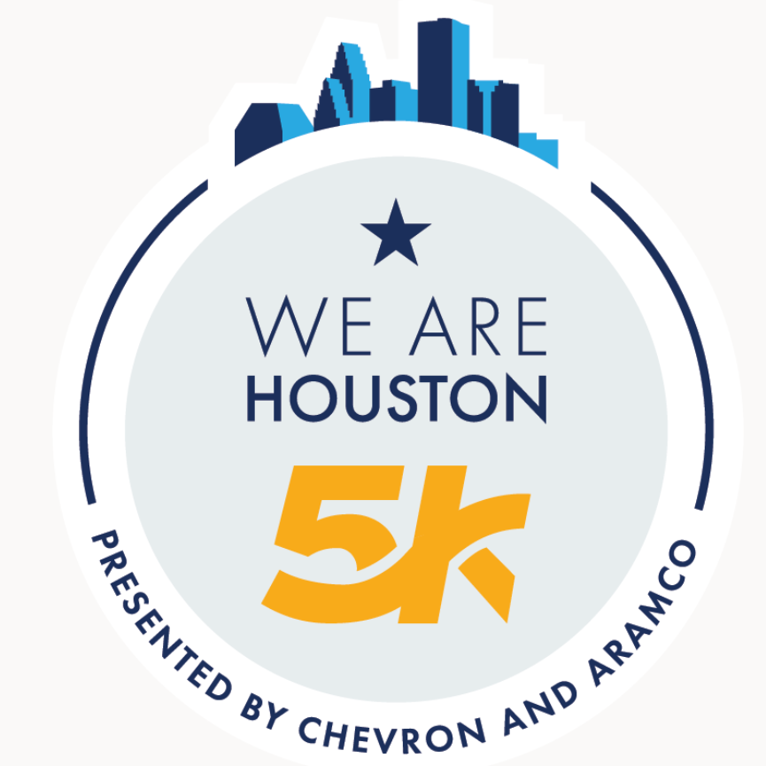

2026 Houston Marathon Weekend Events

The City of Houston welcomes the Chevron Houston Marathon, Aramco Houston Half Marathon and We Are Houston 5K presented by Aramco and Chevron on the weekend of Jan. 10 - 11. In addition to the races, multiple events occur in and around the downtown area that add to the excitement.

Various city departments work together with the Houston Marathon Committee and public safety agencies to minimize traffic concerns and to ensure a safe and fun event.

Street Closures

Several roads in and around the downtown area will close beginning Thursday morning, Jan. 8th. On Saturday, Jan. 10th, downtown will experience additional closures from 7:00 a.m. – 11:00 a.m. for the We Are Houston 5K presented by Aramco and Chevron. On Sunday, Jan. 11th streets along the 26.2-mile marathon and 13.1-mile half marathon routes will begin closing as early as 5:45 a.m. Once participants have completed their pass through each area the streets will reopen. Please reference the maps posted on the following pages for race routes, street closure and reopening times.

Thursday, Jan. 8, through Sunday, Jan. 11
Expect areas around the George R. Brown Convention Center and Discovery Green Park to close for the installation of the Finish Line and related fencing. Closures will include Lamar Street in front of the Hilton Americas and Avenida de las Americas south of Discovery Green Parking Garage.

Finish Line Stakeholder Map

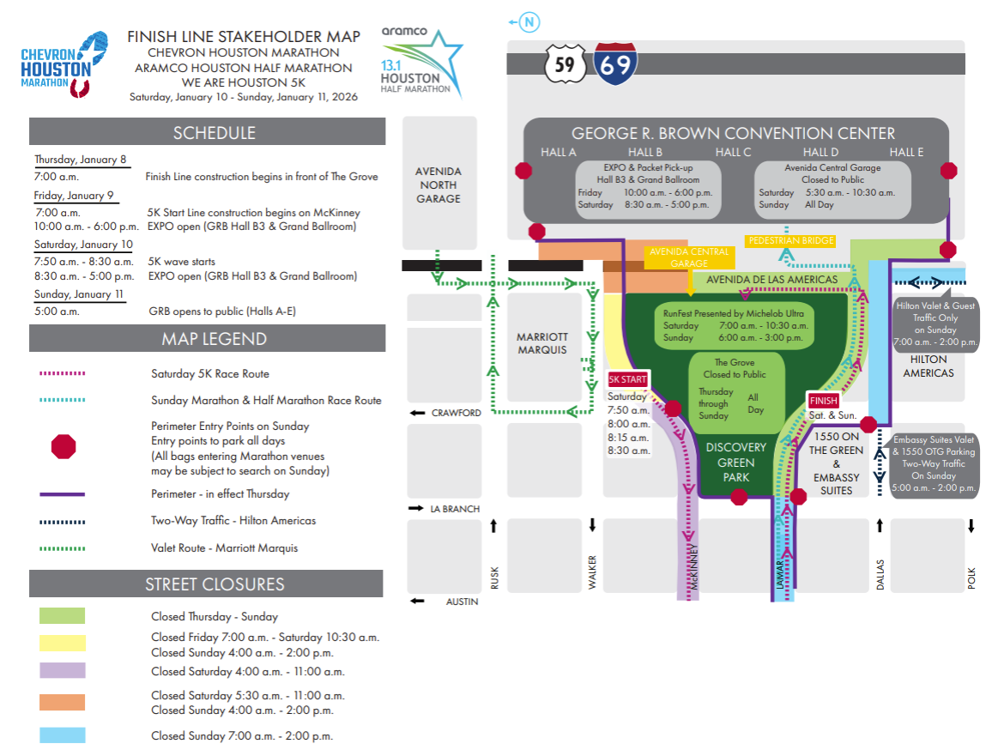

Friday, Jan. 9, through Sunday, Jan. 11
Expect areas in the northeast part of downtown to be intermittently or permanently closed until Sunday afternoon for Start Line installation.

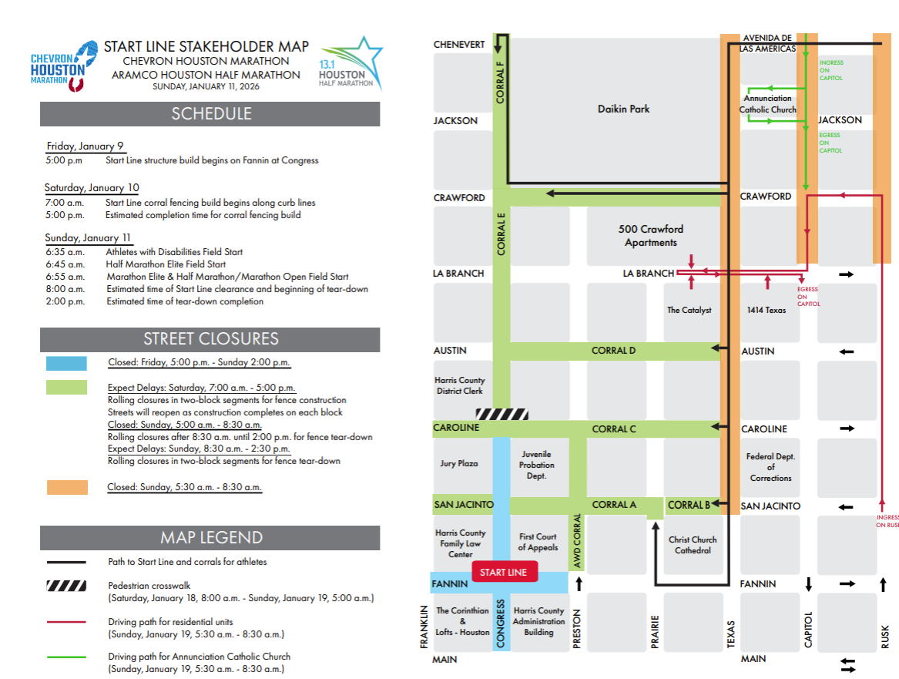

Saturday, Jan. 10, 7 a.m. – 10:00 a.m.
The We Are Houston 5K presented by Aramco and Chevron will take place beginning at 8 a.m. and will result in street closures between downtown and Midtown from 7- 10:00 a.m.

We Are Houston 5K Map

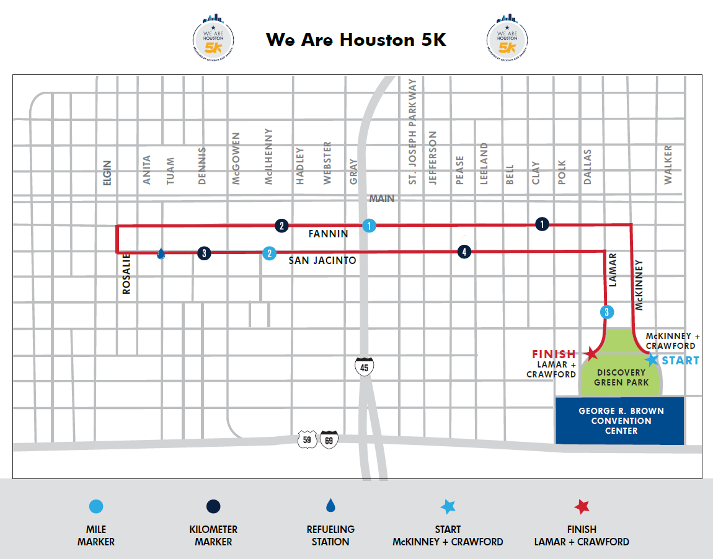

Sunday, Jan. 11, 6 a.m. – 2 p.m.
Streets along the marathon and half marathon course will close and reopen as the race progresses.

Chevron Houston Marathon and Aramco Houston Half Marathon Map

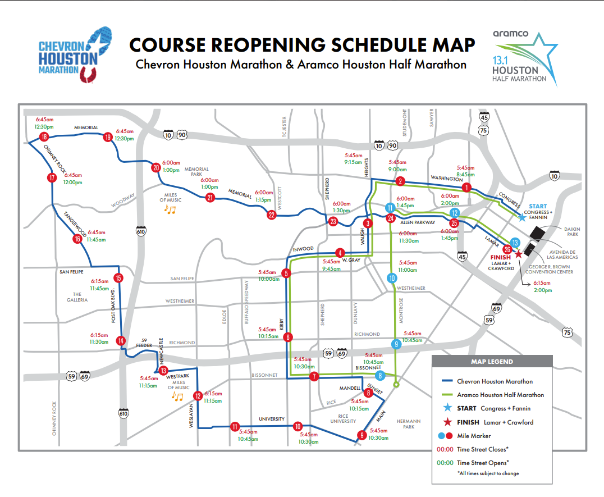

Click here for more information on street closures and alternate driving suggestions.

Race Day Driving Directions

Expect slow traffic in and around areas impacted by the race route on Sunday, Jan. 15th and work to minimize delays by using alternate routes to avoid the course entirely.

Need help getting around on race day?

Click the link for your neighborhood to get detailed information on closures and driving directions.

- Start Line Area Closure Schedule Map
- Discovery Green & Finish Line Area Closure Schedule Map
- Washington Corridor Driving Directions
- Upper Kirby Driving Directions
- Rice & West University Driving Directions
- Galleria Area Driving Directions
- Tanglewood & Memorial Driving Directions
- Memorial Park Driving Directions

Spectator Information

The City of Houston encourages residents to cheer on race participants! There are many places to see along the route. The Houston Marathon Committee has identified the top 10 on our website.

Download the Mobile App for Runner Tracking, Maps & More

Want to track a runner, get results or access course maps? Download the Chevron Houston Marathon mobile app, available now for free in your phone’s app store.

Click here for a link to download the mobile app.

Watch the Race Live on ABC 13 or ESPN3

Can't make it to the race route? Watch the race live on ABC13 from 6:30 a.m. to 10:00 a.m., or catch the recap show Sunday night at 10:35 p.m., also on ABC13.

Want to watch on the go? Live stream at abc13.com or on ESPN3.

Security & Safety

As with any public event, the main goal is to keep everyone safe. With that in mind, please remember to be vigilant about what is going on around you.

See something suspicious? Say something! Contact the nearest law enforcement officer or call the iWatch Houston Hotline at 1-855-iwatch4 (492-8244). If you see something that you believe to be a life-threatening emergency, call 9-1-1.

Also, there are certain security and safety rules in effect for those planning on attending official marathon events. If you plan to attend official events, please make yourself familiar with them by visiting the official race website: chevronhoustonmarathon.com.

Be sure to stay informed of emergencies and large special events in Houston by signing up for AlertHouston online at houstontx.gov/emergency, or by following them on Twitter or Facebook.

Need More Information?

Visit chevronhoustonmarathon.com and bookmark houstontx.gov/emergency for public safety official announcements.

