Nicaragua Mission Trip – Day 3 update, (Jan 5, 2026)
Greetings again from Nicaragua. Wow, what a day.
Home construction started today for 2 local church members, Blanca and Ricardo  This is the cleared lot  Posts were put into the ground and support beams were welded  More to come on this tomorrow | 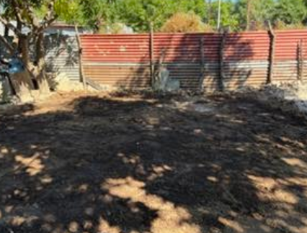
We went door to door talking to people, inquiring about their faith, and inviting them to our afternoon of VBS and adult discipleship teaching. All the people we met were very hospitable, inviting us into their yards or homes, and willing to hear. Many agreed to come to the afternoon program, but some did not show, which is normal (like in the U.S.) We also had some hear the Gospel but rejected it.
Below are pictures of typical houses in Carlos Fonseca. All have barb wire fencing to keep people and livestock in or out. Dirt floors are common in the main houses with usually just one room that serves for sleeping and with a couch. The food is normally prepared outside on an open fire.
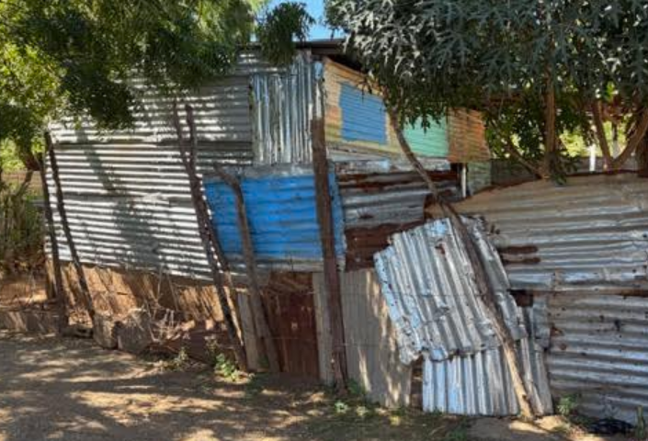 | 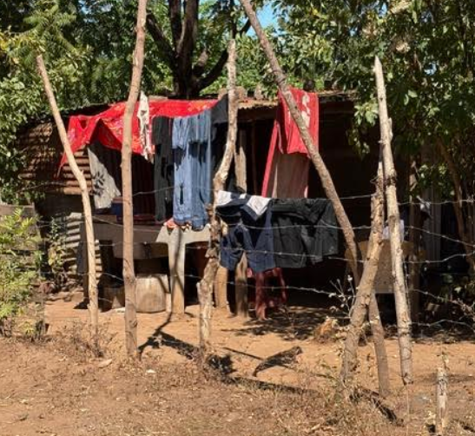

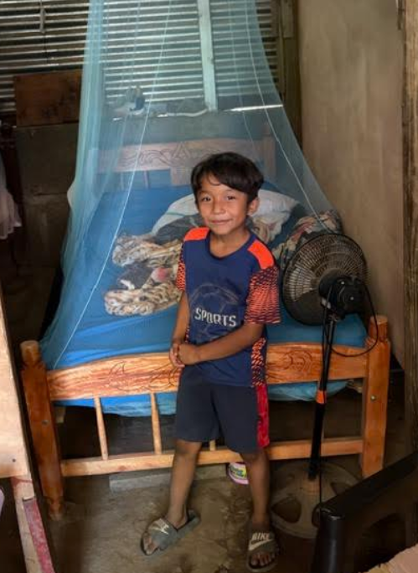 | - This is Oscar  - He is a child sponsored in the community  - He is standing in front of his bed that has netting over it given the bugs and mosquitos  - To the left of his bed is his mom’s bed  - Their house is about 20 ft x 15 ft  - He faithfully attends bible class every Saturday and church  - He is always smiling and is excited to see us each year

Last night, to prepare for VBS, the team made 100 salvation bracelets
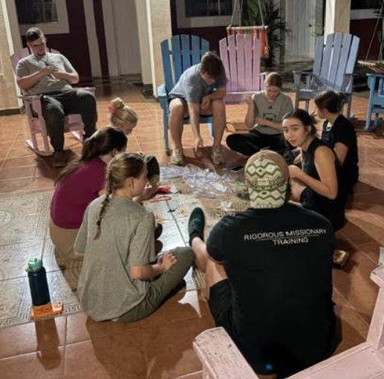
With VBS, the church was packed with ~100 children. The gospel was shared.
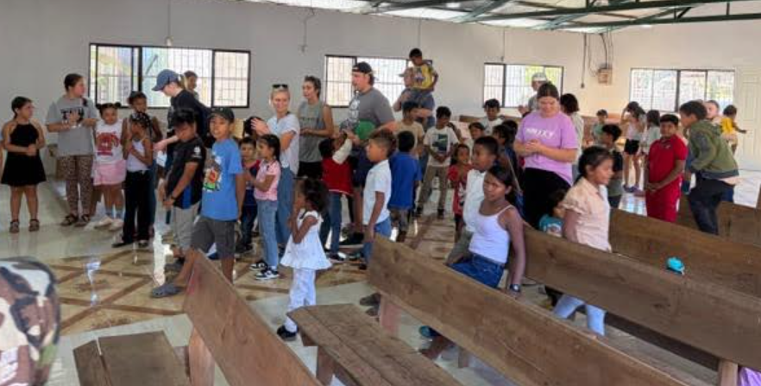
There were also many relationships formed during the training.
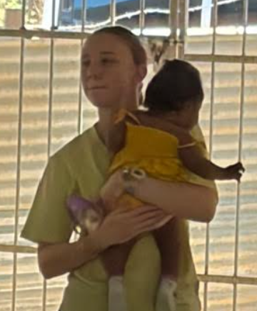 | 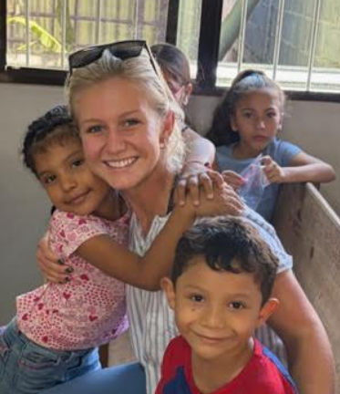 | 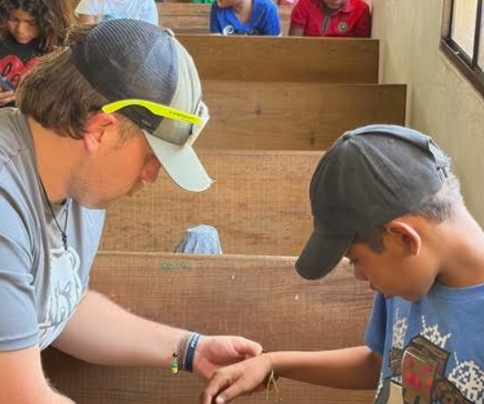
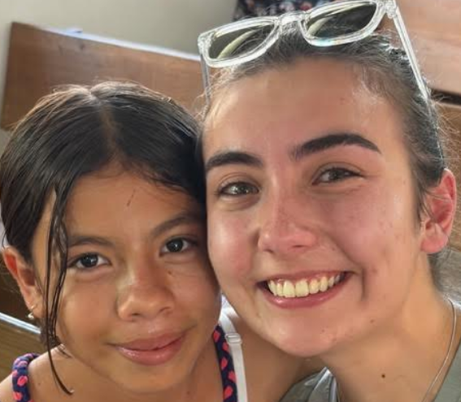 | 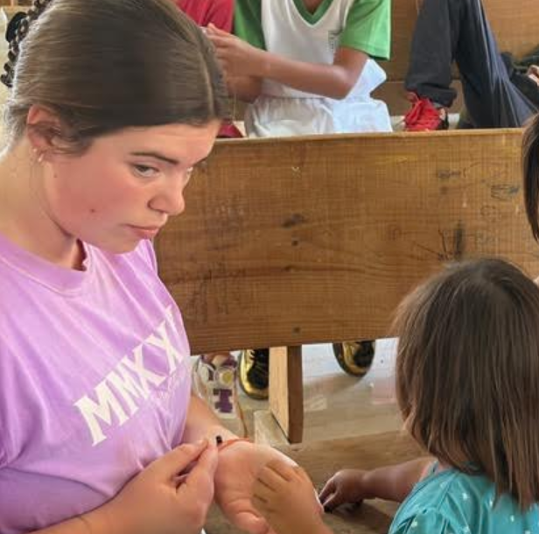 | 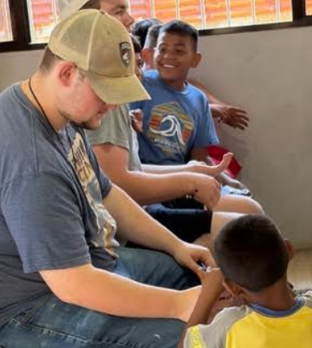

With the discipleship training, we had ~50 adults and I taught on our spiritual armor from Ephesians 6. There were 6 who trusted Christ as their Savior and 3 asked for prayer relative to depression and the need for God’s strength in their walk. Praise God!!
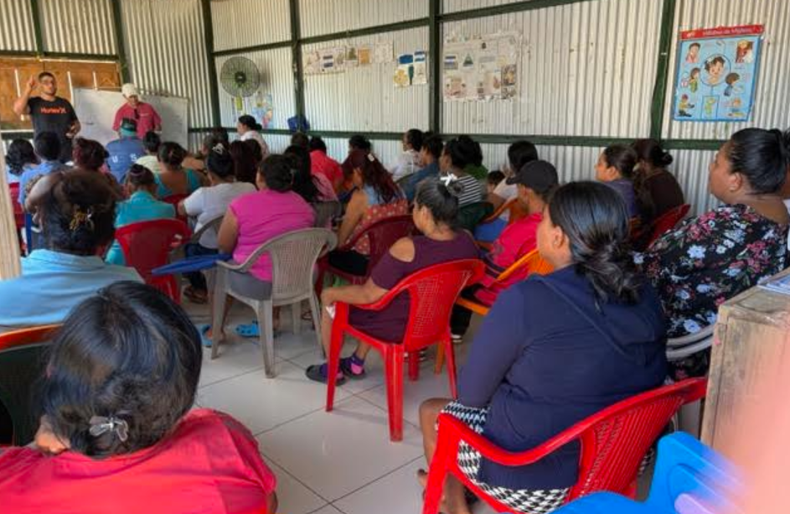
Tomorrow we will continue door to door visits, home construction, followed by VBS and adult discipleship in the afternoon. We are grateful for your prayers. Please pray for the hearts of the people to respond to the truth being shared. Please pray for the team, to stay strong and continue in their excitement while serving and sharing. Please pray against the spiritual oppression in the community in terms of martial issues, alcoholism, depression, and abject poverty. Lastly, pray for the local church, New Covenant Church, that it would grow stronger in sharing their faith and loving their neighbor as this community needs the light of Christ. There is darkness here, but we know there is a greater Light that needs shared. Please continue to pray.
Thank you for your prayers….
Until tomorrow
God Bless
Pastor Chris

