Nicaragua Mission Trip – Day 4 update, (Jan 6, 2026)
Greetings again from Nicaragua.
Today was another amazing day God put together. Home construction is going really well. The frame and roof were completed. Tomorrow the sides, windows, and doors will be put on. Thursday will be a special day when the home is presented to the family.
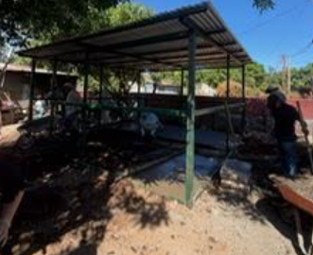 | 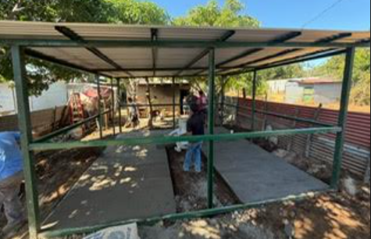

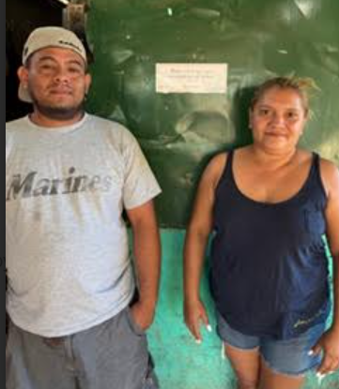 | Door to Door was amazing. We had 3 salvations. Praise God!  Many houses were visited. Many asked for prayers for sickness or marital problems. Some did not have any food. We found out 4 people were sleeping on the floors of their houses. Tomorrow we are delivering 4 beds as well as some food. We also got to hear the testimony of a man named Sebastian, who was in the war in Nicaragua years ago, when he was 13 years old, serving for 13 years, and how God saved Him. At 70 years old, he’s on fire for God.  This couple in this picture had been to different churches but had never heard the Gospel. They both trusted Christ today and are excited about growing in their faith together. Take note of the sign between them.
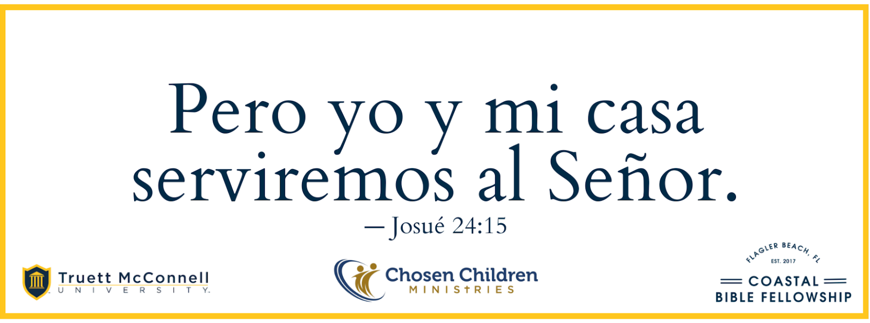 |  |  | For the church members in the community and those who want to walk with God, we placed these signs on their homes. It’s from Joshua 24:15. There is not one house we have come across that has Scripture hanging, until today. Praise God! We plan to put up 100 signs.
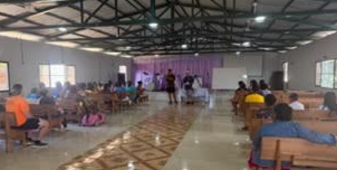 |  | The adult discipleship class this afternoon got so large (90 people), the kids had to do VBS outside. We talked about a “Faith that Works” from James 2. The conviction came when the church was challenged that knowing God’s word is not enough, you must do what it says. And, at a minimum, know your neighbor and their needs.  One person trusted Christ in the teaching, Praise God!

Below are a few pictures to reflect on. It’s common to come across roaming horses in the community with trash all over the place. It’s common to see power lines hanging by makeshift limbs to power houses. And it’s also common for people to open their homes, welcome prayer, and hear about Christ. They gladly welcome you into their homes with dirt floors, with maybe one chair, to hear what is on your heart. None refuse prayer, and many give you a hug when you leave, very grateful that you would take the time to listen to them. That’s something to chew on for all of us in our busy lives.
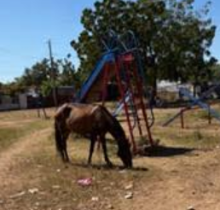 | 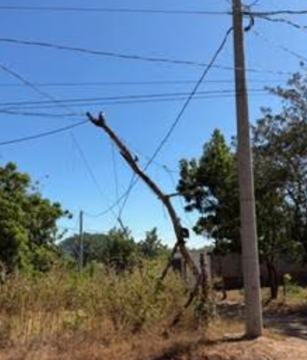 | 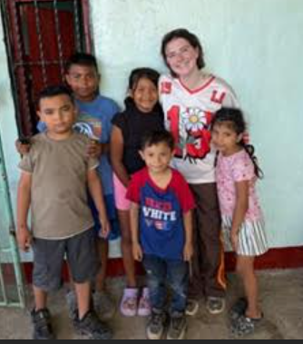

Tomorrow is a big day. We need to finish the house. We have our last day of VBS and Discipleship. We also will be doing door to door for the last time, because on Thursday it all comes together with a house dedication and community feeding with the Gospel being presented.
Please pray that all the logistics come together tomorrow. Please pray for hearts to be receptive to the Gospel and the truth of His Word be applied in their lives. Also pray for the team as we go forth, that we would listen for the Spirit as He directs. But most of all pray that God is honored tomorrow.
We are grateful for your prayers
May God bless you richly tomorrow, but please remember the people of Carlos Fonseca
God Bless
Pastor Chris

