
Holy Trinity Lutheran Church
150 River Road Red Bank, NJ 07701
Church Office: (732) 741-9241 Fax: (732) 741-9577
email: holytrinitychurch4@verizon.net
Website: htlcredbank.org
Pastor: Rev. John Mack, Jr.
Cell: (336)-392-5839
Minister of Music: Peter Isherwood
Parish Administrator: Deanna Vergari
Council President: Cynthia Kazmac



December 25, 2025

Nativity of Our Lord: Christmas Day

Introduction
As on the first day of creation, on this Christmas Day the Word illumines the world, shining forth to bring all things into being. Today we celebrate the incarnate Word, God becoming flesh to live among us in the person of Jesus Christ then and now. Emboldened by the good news of Christ’s birth, along with the shepherds, Mary and Joseph, and all witnesses to the light of Christ, we declare to the world that we have indeed seen and been transformed by the arrival of “the salvation of our God.” O come, let us adore!

Welcome & Announcements (Please remember to silence your cell phone!)

Prelude (We prayerfully prepare our hearts and minds to worship!)

+ GATHERING +

*CHRISTMAS DIALOG (P=Pastor, C=Congregation)
P: In the name of the Father, and of the †Son, and of the Holy Spirit.
C: Amen
P: The Word became flesh and lived among us, and we have seen his glory.
C: Oh, come, let us worship him.
P: The people who walked in darkness have seen a great light.
C: The light shines in the darkness, -- and the darkness did not overcome it.
P: Those who lived in a land of deep darkness--on them light has shined.
C: We have seen Christ's glory, the glory as of a father's only son, full of grace and truth.
P: For a child has been born for us, a son given to us.
C: What has come into being in him was life, and the life was the light of all people.
P: Christ is born; salvation has appeared.
C: Glory to God in the highest! Alleluia!

*Gathering Hymn ELW 283 O Come All Ye Faithful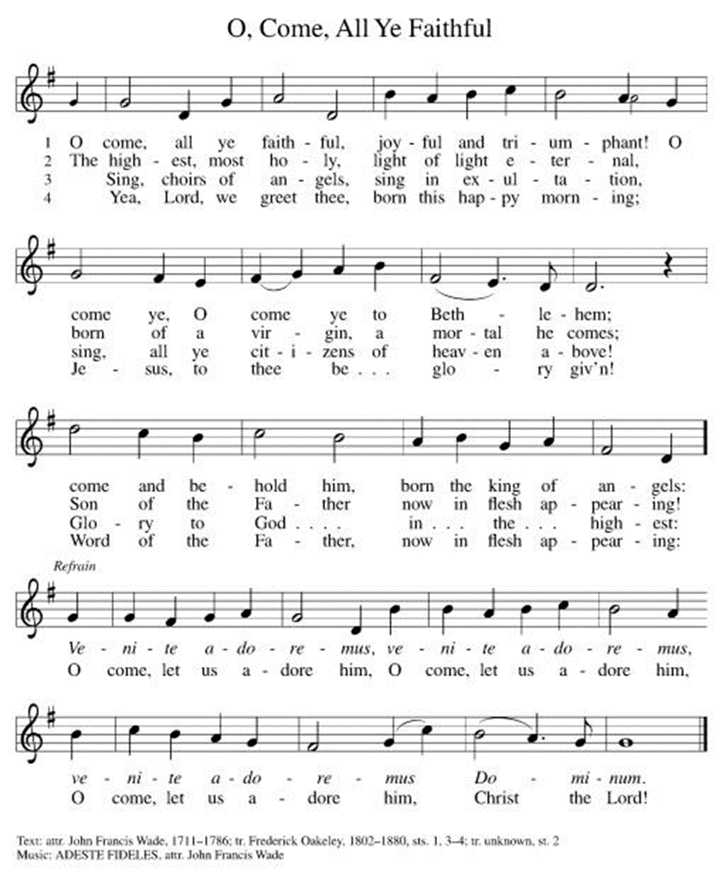

*Pastoral Greeting

P: The Grace of our Lord Jesus Christ, the love of God, and the communion of the Holy Spirit be with you all.

C: And also with you!

Hymn of Praise ELW #289 (v.1)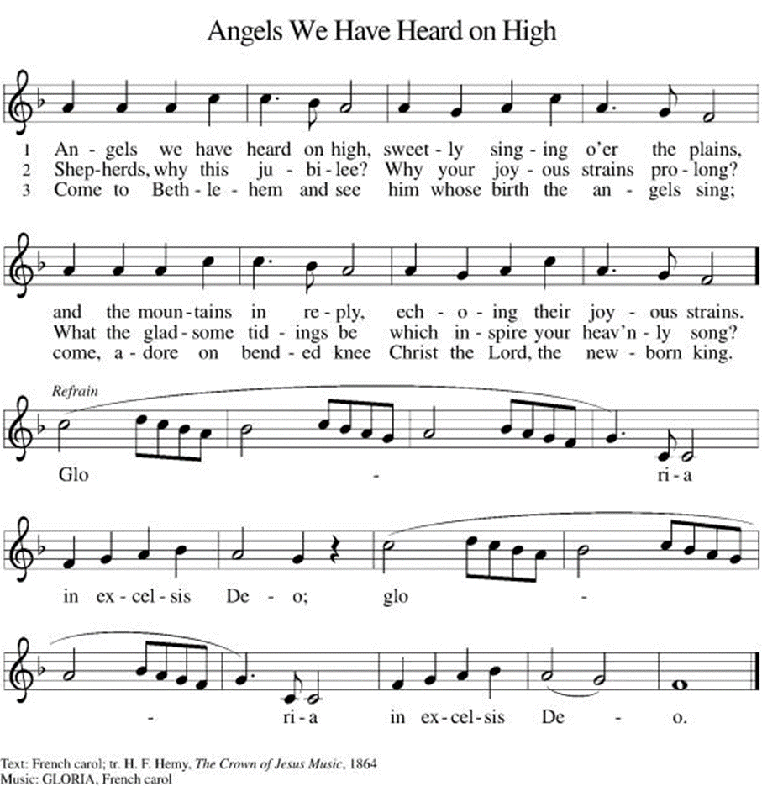

*Prayer of the Day
P: All-powerful and unseen God, the coming of your light into our world has brightened weary hearts with peace. Call us out of darkness, and empower us to proclaim the birth of your Son, Jesus Christ, our Savior and Lord, who lives and reigns with you and the Holy Spirit, one God, now and forever.
C: Amen!

+WORD+

First Reading: Isaiah 52:7-10
Isaiah proclaims news of great joy: “Your God reigns!” Just as God saved the people from oppression in Egypt, God delivers Israel from exile. All the earth will witness the saving acts of God.

⁷ How beautiful upon the mountains
are the feet of the messenger who announces peace,
who brings good news,
who announces salvation,
who says to Zion, “Your God reigns.”
⁸ Listen! Your sentinels lift up their voices;
together they shout for joy,
for in plain sight they see
the return of the Lord to Zion.
⁹ Break forth; shout together for joy,
you ruins of Jerusalem,
for the Lord has comforted his people;
he has redeemed Jerusalem.
¹⁰ The Lord has bared his holy arm
before the eyes of all the nations,
and all the ends of the earth shall see
the salvation of our God.

Psalm: Psalm 98
All the ends of the earth have seen the victory of our God. (Ps. 98:3)

¹ Sing a new song to the Lord, who has done | marvelous things,
whose right hand and holy arm have | won the victory.
² O Lord, you have made | known your victory,
you have revealed your righteousness in the sight | of the nations.
³ You remember your steadfast love and faithfulness to the | house of Israel;
all the ends of the earth have seen the victory | of our God.
⁴ Shout with joy to the Lord, | all you lands;
lift up your voice, re- | joice, and sing.
⁵ Sing to the Lord | with the harp,
with the harp and the | voice of song.
⁶ With trumpets and the sound | of the horn
shout with joy before the | king, the Lord.
⁷ Let the sea roar, and | all that fills it,
the world and those who | dwell therein.
⁸ Let the rivers | clap their hands,
and let the hills ring out with joy before the Lord, who comes to | judge the earth.
⁹ The Lord will judge the | world with righteousness
and the peo- | ples with equity.

Second Reading: Hebrews 1:1-4 [5-12]
This letter opens with a lofty declaration of Jesus’ preeminent status as the Son through whom God created the world and through whom our sins are cleansed. God speaks to us now through the Son, who is exalted even above the angels.

¹ Long ago God spoke to our ancestors in many and various ways by the prophets, ² but in these last days he has spoken to us by a Son, whom he appointed heir of all things, through whom he also created the worlds. ³ He is the reflection of God’s glory and the exact imprint of God’s very being, and he sustains all things by his powerful word. When he had made purification for sins, he sat down at the right hand of the Majesty on high, ⁴ having become as much superior to angels as the name he has inherited is more excellent than theirs.
[
⁵ For to which of the angels did God ever say,
“You are my Son;
today I have begotten you”?
Or again,
“I will be his Father,
and he will be my Son”?
⁶ And again, when he brings the firstborn into the world, he says,
“Let all God’s angels worship him.”
⁷ Of the angels he says,
“He makes his angels winds
and his servants flames of fire.”
⁸ But of the Son he says,
“Your throne, O God, is forever and ever,
and the scepter of righteousness is the scepter of your kingdom.
⁹ You have loved righteousness and hated lawlessness;
therefore God, your God, has anointed you
with the oil of gladness beyond your companions.”
¹⁰ And,
“In the beginning, Lord, you founded the earth,
and the heavens are the work of your hands;
¹¹ they will perish, but you remain;
they will all wear out like clothing;
¹² like a cloak you will roll them up,
and like clothing they will be changed.
But you are the same,
and your years will never end.”
]

Gospel Acclamation(v.1&2)
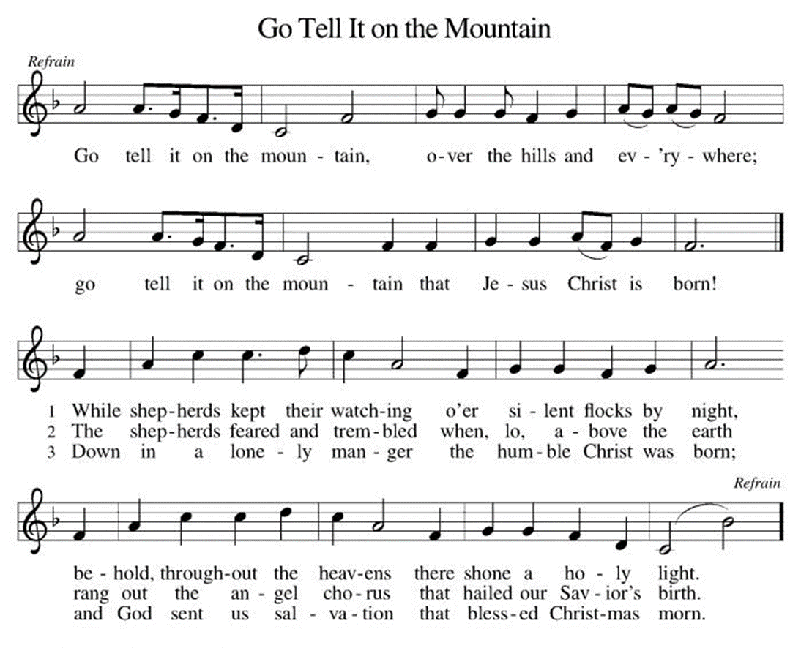
P: The Holy Gospel According to St. John 1st Chapter
C: Glory to You O Lord!

Gospel: John 1:1-14
The prologue to the Gospel of John describes Jesus as the Word of God made flesh, the one who reveals God to be “full of grace and truth.”

¹ In the beginning was the Word, and the Word was with God, and the Word was God. ² He was in the beginning with God. ³ All things came into being through him, and without him not one thing came into being. What has come into being ⁴ in him was life, and the life was the light of all people. ⁵ The light shines in the darkness, and the darkness did not overtake it.
⁶ There was a man sent from God whose name was John. ⁷ He came as a witness to testify to the light, so that all might believe through him. ⁸ He himself was not the light, but he came to testify to the light. ⁹ The true light, which enlightens everyone, was coming into the world.
¹⁰ He was in the world, and the world came into being through him, yet the world did not know him. ¹¹ He came to what was his own, and his own people did not accept him. ¹² But to all who received him, who believed in his name, he gave power to become children of God, ¹³ who were born, not of blood or of the will of the flesh or of the will of man, but of God.
¹⁴ And the Word became flesh and lived among us, and we have seen his glory, the glory as of a father’s only son, full of grace and truth.

P: The Gospel of the Lord
C: Praise to you, O Christ!

Gospel Acclamation (3.)

Sermon

*Hymn of the Day ELW 288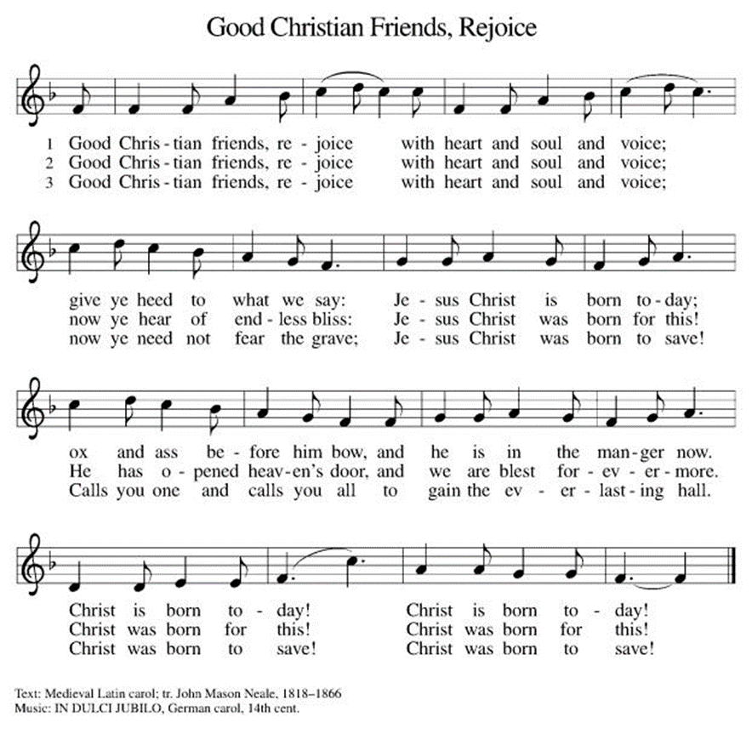

*Prayers of Intercession
Empowered by the news of Christ’s birth, let us pray boldly for the church, creation, and all who are in need.
A brief silence.
The Word becomes flesh and dwells among us, bringing life, love, and joy to a weary world. Gracious God, use our lips and our lives to proclaim the good news of your coming. Hear us, O God.
C:Your mercy is great.
The earth rejoices and the coastlands are glad on the day of your birth. Bring life to barren wastelands, healing where we have caused harm, and bold hearts to respond to creation’s call for justice. Hear us, O God.
C:Your mercy is great.
Righteousness and justice are your foundation, O Holy One. Fill world leaders with your zeal for righteousness and your love for any who are marginalized and oppressed (especially). Hear us, O God.
C:Your mercy is great.
The heavens proclaim your glory and announce that we have been made your own people. Keep watch over all who are spending this holy day alone, alienated, or ill (especially). Hear us, O God.
C:Your mercy is great.
Light dawns for the righteous and joy visits the upright in heart. Fortify us with your grace and fill us with zeal to proclaim the news of your birth to those who long for love. Hear us, O God.
C:Your mercy is great.
Here other intercessions may be offered.
From the nurturing darkness of the womb to the tender night of the tomb, you enfold us in your love. We remember with affection those who have died and now rest in your eternal embrace (especially). Hear us, O God.
C:Your mercy is great.
With the joy of Christ’s birth in our hearts, we commend our prayers to you, O God, trusting in your boundless mercy and eternal love; through Jesus Christ our Savior.
C: Amen.

Greeting of Peace
P: The peace of Christ be with you always!
C: And also with you!

Offering (Thank you for your support for our ministry!)

Offering Hymn ELW 270 Hark! The Herald Angels Sing
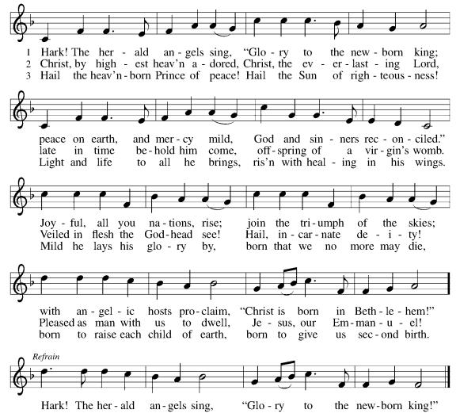

*Doxology ELW 275 Angels, From the Realms of Glory (v.4)
(Please stand and join in singing as we share our gifts!)
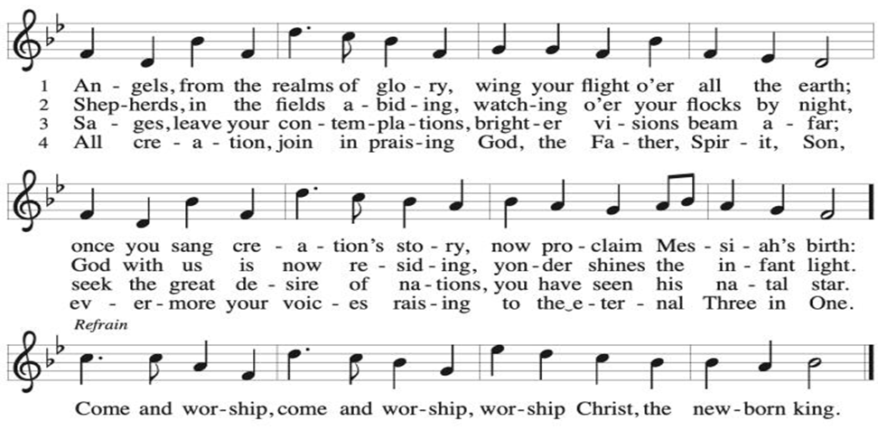

*Offering Prayer
A: God of glory,
C: great are your wonders among us
and many are the blessings you bestow.
Use us and these your gifts for the needs of the world,
that all the ends of the earth may rejoice in your saving grace,
through Christ our Savior..
Amen!
+MEAL+
*Great Thanksgiving
P: The Lord be with you.
C: And also with you.

P: Lift up your hearts.
C: We lift them to the Lord.

P: Let us give thanks to the Lord our God.
C: It is right to give our thanks and praise.

P: It is indeed right, our duty and our joy,
that we should at all times and in all places
give thanks and praise to you, almighty and merciful God,
through our Savior Jesus Christ.
In the wonder and mystery of the Word made flesh
you have opened the eyes of faith
to a new and radiant vision of your glory,
that, beholding the God made visible,
we may be drawn to love the God whom we cannot see.
And so, with all the choirs of angels,
with the church on earth and the hosts of heaven,
we praise your name and join their unending hymn:

*Sanctus
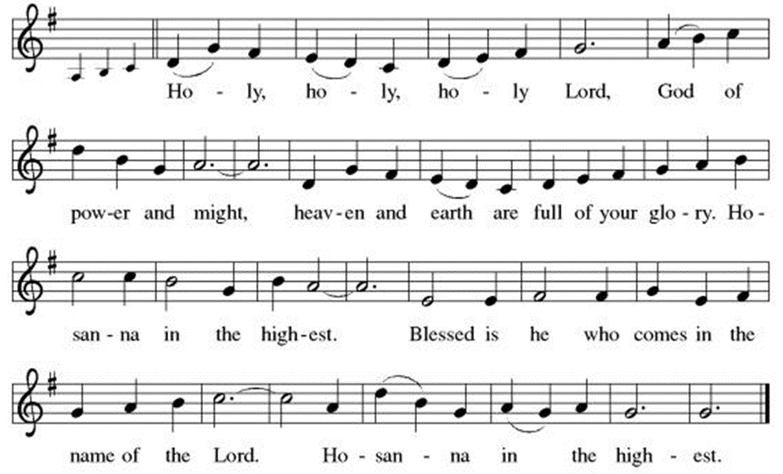

P: In the night in which he was betrayed,
our Lord Jesus took bread, and gave thanks;
broke it, and gave it to his disciples, saying:
Take and eat; this is my body, given for you.
Do this for the remembrance of me.

Again, after supper, he took the cup, gave thanks,
and gave it for all to drink, saying:
This cup is the new covenant in my blood,
shed for you and for all people for the forgiveness of sin.
Do this for the remembrance of me.

Through him, with him, in him, in the unity of the Holy Spirit,
all glory and honor is yours, almighty Father, now and forever.
C: Amen!
*THE LORD’S PRAYER
Our Father, who art in heaven,
hallowed be thy name,
thy kingdom come,
thy will be done,
on earth as it is in heaven.
Give us this day our daily bread;
and forgive us our trespasses,
as we forgive those
who trespass against us;
and lead us not into temptation,
but deliver us from evil.
For thine is the kingdom,
and the power, and the glory,
forever and ever. Amen.
*Lamb of God
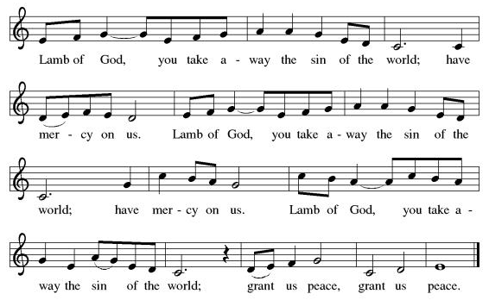

Spiritual Communion Prayer
P: Let us pray for the communion of all present here, those viewing our service virtually, those in our hearts and in our world.
C: Lord Jesus, I believe you are truly present in the Sacrament of Holy Communion. When I cannot receive Communion, I pray that you come into my heart. I know that nothing in Heaven or on earth can separate me from your love. Amen.
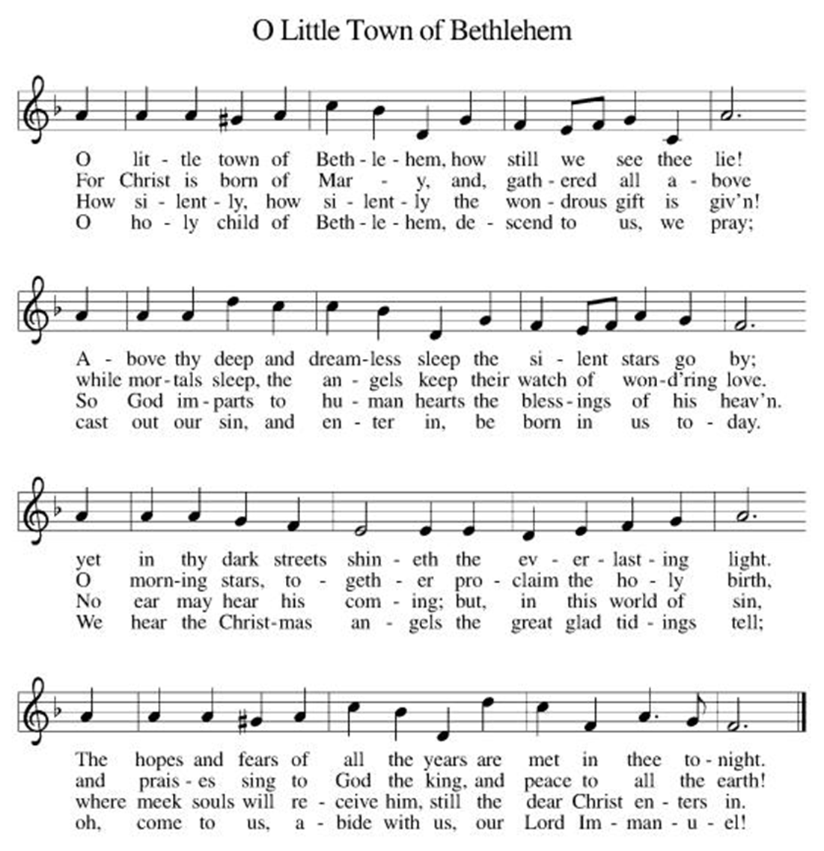
Invitation to Communion
P: God is now in flesh appearing.
Come to the feast of joy! C: Thanks be to God!

(All are invited to the communion rail following the guidance of the ushers. Communion will be shared through the host and individual cups. If you would like communion but are unable to join us at the rail, please alert the usher!)

Communion Hymns (Please join in singing!)
ELW #278 Away in a Manger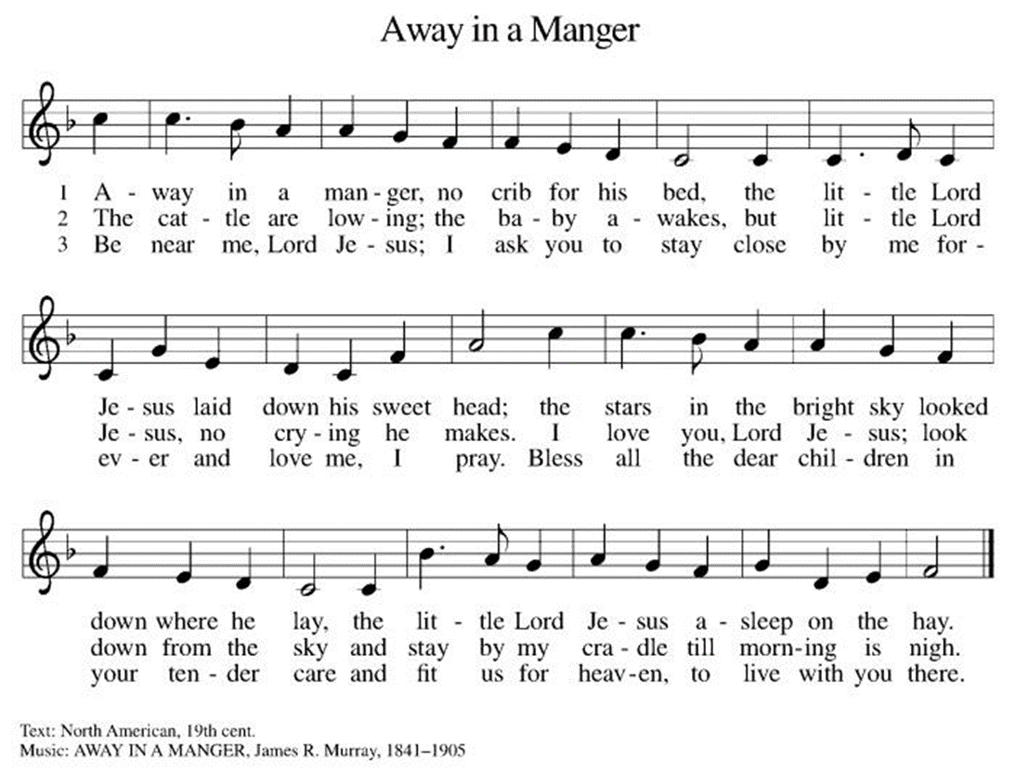

ELW 276 Infant Holy, Infant Lowly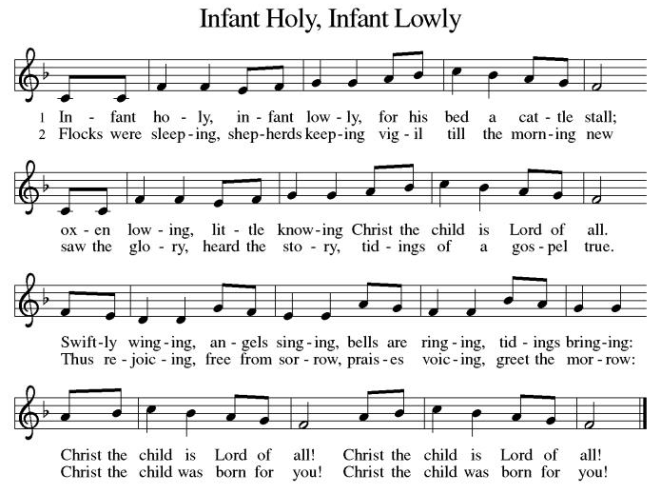

*Prayer after Communion
A: Incarnate God, you are among us at this table.
May we treasure this gift and ponder in our hearts
the mystery of your presence.
Move us to discover the wonders of your love
in the everyday moments of our lives,
through Christ born in us.
C: Amen.
+Sending+

*Blessing
P: The triune God,
glorious Mystery,
holy Incarnate One,
abiding Comforter,
☩ bless you with endless grace, peace, and joy. C: Amen!
*Sending Hymn ELW 267 Joy to the World
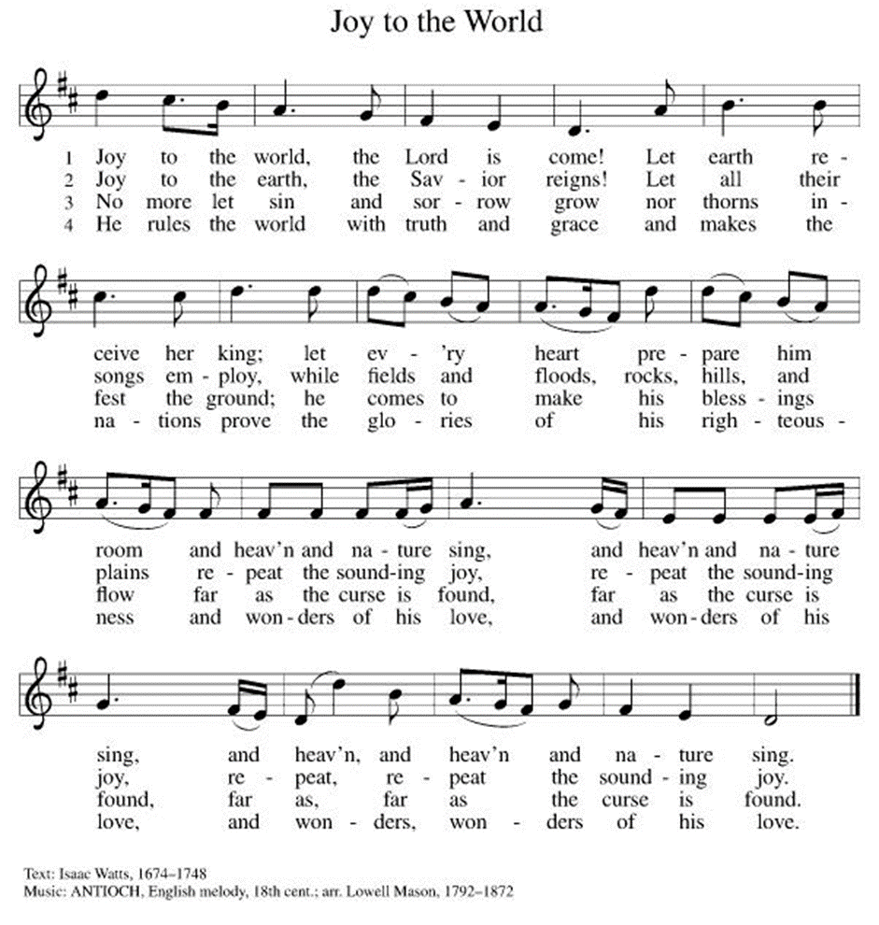

*Dismissal
A:Glory to God in the highest!
C: And peace to God’s people on earth!
A: Go in joy. Embody God’s redeeming grace.
C: Thanks be to God!

Postlude

Copyright © 2020 Augsburg Fortress. All rights reserved. Reprinted by permission under Augsburg Fortress Liturgies Annual License #SB106907. New Revised Standard Version Bible, Copyright © 1989, Division of Christian Education of the National Council of the Churches of Christ in the United States of America. Used by permission. All rights reserved. Revised Common Lectionary, Copyright © 1992 Consultation on Common Texts, admin Augsburg Fortress. Used by permission.

Treasurer’s Report
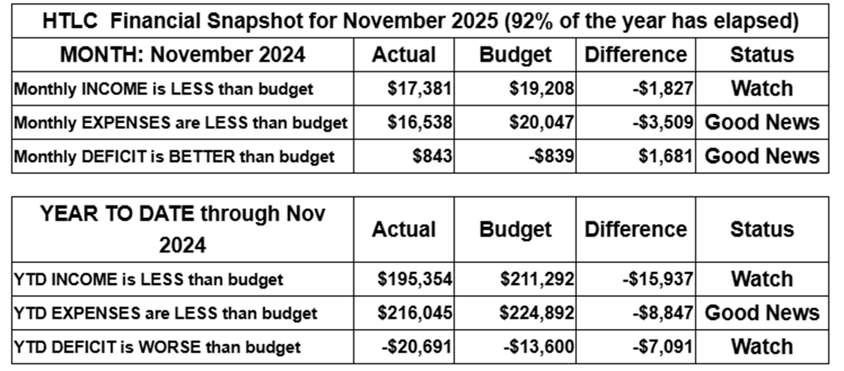
November giving improved over that of October, but still is short for the year to date. Expenses remain under control, but we rely on strong giving in December to maintain stability and support our ministries. Gifts above and beyond regular giving will help us build a growing, healthy church. Thank you for your generosity.
Thank you for supporting our ministry! Chris Foard, Treasurer
Worship Volunteer Schedule
Date | Asst. Min | Usher | Sacristan | Lector | Counter
December 28 | Linda Coleman | Dan Grillon | Helga Britton | Cynthia Kazmac | McKenna/Kazmac
January 4 | Keith Bennett | Gary Joblon | Joanne Giordano | Jeff Ridberg | Foss/Coleman
January 11 | Chris Foard | Kathy Caputo | Sherry Lee | Rosemary Lane | Socha/Foard
January 18 | Elaine Bradford | Dan Grillon | Carol Rosen | Emily Kaster | Bohner/Volk

ANNOUNCEMENTS Thank you! To all who consistently support our church and ministries through your time, talent, and treasure. Please help us grow by inviting your friends and family to worship and events. You are what makes Holy Trinity a wonderful church family!

Stay in touch! Please visit our church website, www.htlcredbank.org for updates and information. You can also find us on Facebook and view services online. The office is open from 9am to 2pm, Monday to Thursday.

100 Anniversary Committee- If you are interested in being a part of the committee to help plan the 100th anniversary celebration of HTLC in 2028, please sign up in the red book. All are welcome! Also, the committee will be looking for photos and documents of HTLC throughout the years. If you have anything to share, please bring them to the church and marked envelopes or email electronic copies to the church office.

Photo Directory- Day one of photos was a success! After worship, we will be taking photos for an updated Holy Trinity photo directory. Casey H. and her boyfriend Bart (professional photographer!) will have a station set up during coffee hour, so please stop by for an updated head shot! Photos will be taken on the following dates: 11/23, 12/7, 12/14, 12/21. Please see Casey H. or Elaine B. with any questions.

Name Tag Sundays: On the first Sunday of each month, names tags and markers will be at each entrance of the sanctuary. Please fill out a tag and wear one for worship and for coffee hour to welcome visitors and help newcomers put names to faces.

Choir The Holy Trinity Choir welcomes our singers back for a preparation rehearsal on Sunday, September 7th at 9am in the church hall. All are welcome to join us in song as often as you are able. Choir meets each Sunday at 9am to practice and prepare our music. Join us and help us grow by spreading the word about the HTLC Choir!

Blood drive Tuesday January 6, 2026, noon to 6 pm
On Tuesday, January 6, 2026 we will be hosting a blood drive here at Holy Trinity from Noon to 6pm. Donors, mark your calendars! If you cannot donate, please recruit from among your friends and family. This day marks Epiphany, ending the Christmas season, so let's give a final gift -- of life!

Quilting- The Quilters need gently used any bed sheets of any size! Please leave any donations in the quilters closet in Fellowship Hall. Thank you!

Weekly Quilting on Wednesdays at 9:30. Bring your lunch and enjoy some fellowship at noon. All are welcome. There will be no quilting on Wednesday September 24 due to the garage sale set up.

Evening Quilting Evening Quilting –
Please share this information . This is an important ministry that helps so many. It’s very easy and you don’t need to know how to sew. We have a great time socializing too! We will meet:
Jan. 21, Feb. 18, March 18 at 6:00 PM. Note: If we have to cancel I will send an email. Please let me know only if you can come. Contacts: Pat Pienkos 732-513-9615 Debbie Yetka 908-461-4084 Looking forward to seeing you all!

Bagels and Bible- In January 2026 we will be starting the video lecture series The Great Courses: Confucius, Buddha, Jesus, and Muhammad. We will meet in the Parish House and watch a 30 minute video that will be followed by a group discussion. In an attempt to find a time that works best for most we are soliciting your preference for one of the following days/times:
Saturday mornings at 8:30am Or Sunday mornings at 9:00am. Please make your preference known by signing up in the Red Book. If you have any questions please email Rosemary Lane, rrlane13@gmail.com

Social Ministry
CPC Thanksgiving Dinner
We celebrated another joyful Thanksgiving dinner with 45 CPC clients and staff the Wednesday before Thanksgiving! Thank you to all the volunteers that helped make this happen and run smoothly including shopping, decorating, setting up, cooking, serving, and clean up! With the help of Thrivent in Action grant money, we were able to provide this dinner which means so much to the gracious CPC clients. HTLC has been hosting this dinner since 1983 and we hope to keep the tradition going!

*Year-round collections will continue for food items for Lunch Break. There is a sign-up sheet in the red book for those who can help drop these items to Lunch Break.
*We will also collect adult men's socks to periodically drop at the Red Bank Warminq Center.
*For those interested in the Heartwarminq Center — the new women's shelter is adjacent to the First Baptist Church of Red Bank at 90 Maple Ave. You can follow up on this mission through their website - https://www.thefeastnj.org- On this site, they also include wish list items that can be purchased through amazon. We will be exploring purchasing some of these through a Thrivent card. If you want to purchase on your own, you can leave items at church, and the Social Ministry will deliver them.

Pastoral Care and Prayer... We are here to care for and pray! Please contact the office to add or adjust prayer requests. If you or someone you know needs pastoral care, please contact the office and Pastor Mack!

THANK YOU for supporting and sustaining our church and ministries! All are welcome here! Please invite your family and friends to worship with us! Find us online at www.htlcredbank.org

Poinsettia Flower donations.
The Busch Family | Johanna, Herman and Barbara Pluschau  Margaret, August, and Herbert Busch
Linda Coleman | Merry Christmas!
Linda and Mark Csernica | In honor of our children and grandchildren
The Doyles | Greg, Carly, Theo and Clara
The Foards | In memory of loved ones.
The Grillon Family | In celebration of the Christmas season.
Bruce and Rosemary Lane | In memory of our parents.
Lisa Lynch | In memory of Robert Coppotelli.
Pat and Jeff Pienkos | In celebration of our granddaughter Matilda born 10/21/2025
Carol Rosen | Glory of God.
Peter and Elaine Theophall | In celebration of Christ’s birth and our family.
Linda Vacca D’Amico | In memory of parents Joyce & Erwin Taper



