This Week at PPBC

Tuesday, January 6th

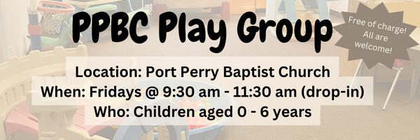


January 17th, 2025

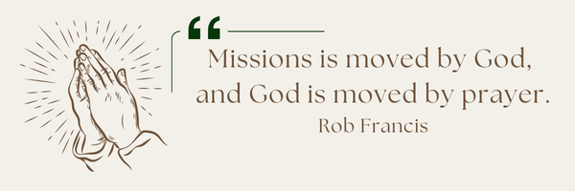
A Prayer Request from the Merajis: Please pray for their ministry. Pray for their newly started discipleship group. Pray God will draw Farsi speakers to the group and His Kingdom will grow.
Christmas Greetings! Thank you so much for blessings us with the generous gift card. We are grateful for the church family. All God's blessings as you celebrate Christ's birth. Merry Christmas! Love Ebi, Carolyn, Kian and Eli

Ada Faber Funeral Service
Please continue to pray for Bert Faber and the family as they prepare a service for Ada (details below).
Visitation will be from 10am-11am at Port Perry Baptist Church on Saturday, January 10th, 2026
A service will be held at 11am on Saturday, January 10th, 2026, at Port Perry Baptist Church, 2210 ON-7A.
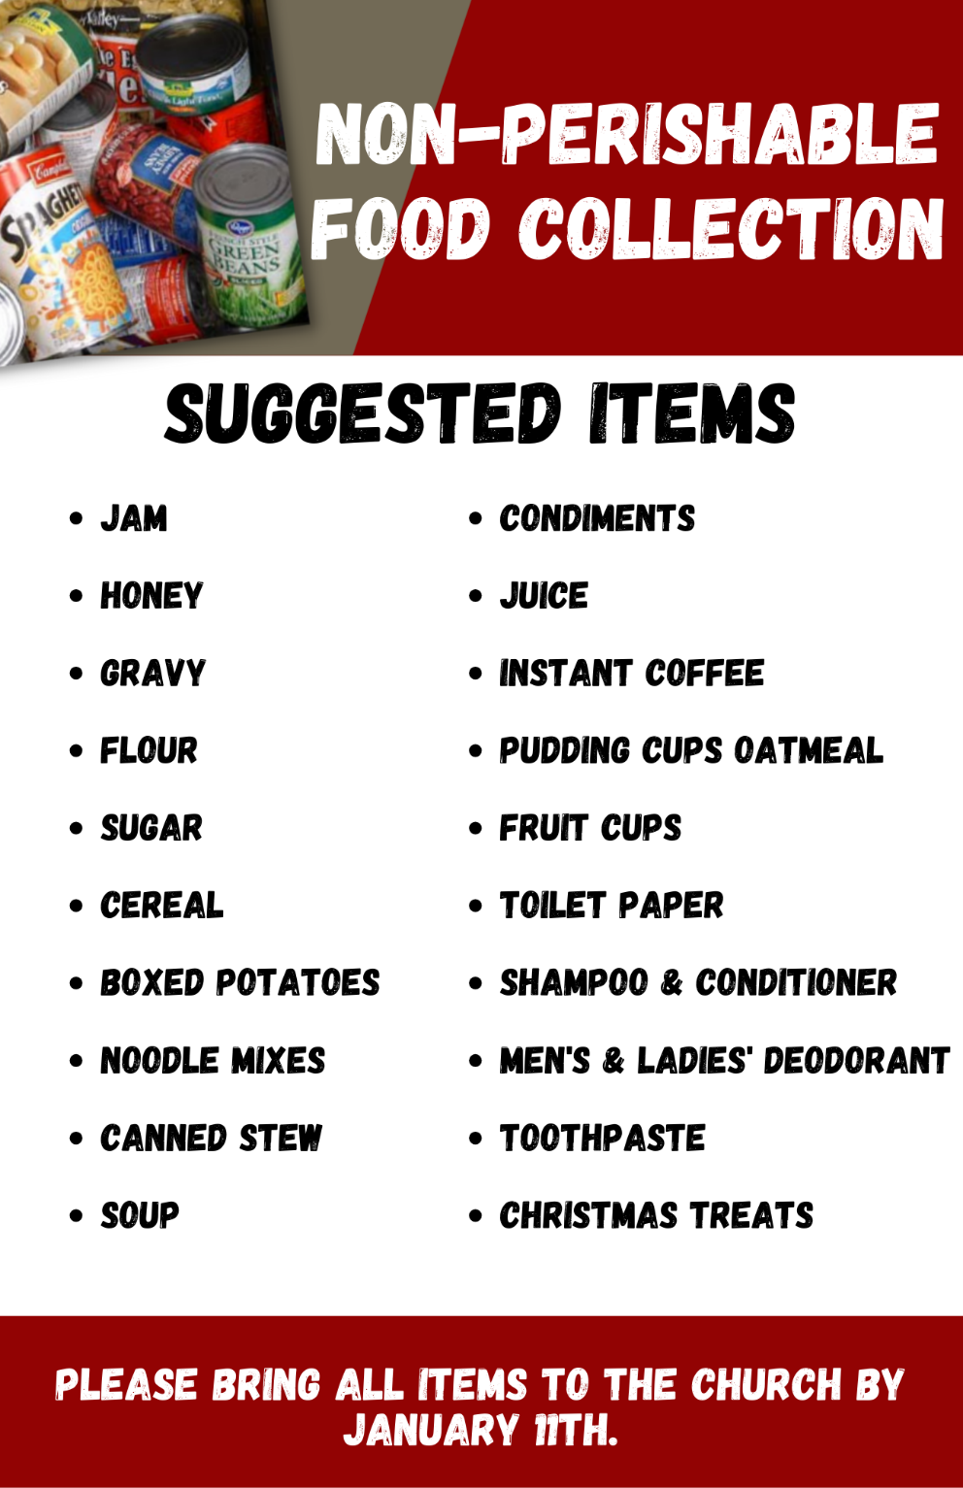

Sunday Ministry Schedules
Nursery
Jan 4: Kathryn denOuden, Alyssa Summers
Jan 11: Jan Gerrow, Hannah Colwell
Infant Nursery
Jan 4: Karen Clemens, Rosalie McLaren
Jan 11: Lisa Dallas, Elise Anderson
Jr. Church; ages 3 to grade 1
Jan 4: Christine McLaren, Kelsey Schoenrock
Jan 11: Justine McKenzie, Mikayla Ferguson
Jr. Church; Grades 2 to 6
Jan 4: Gregg & Karen Anderson, Tiffany Green
Jan 11: Mary Deli, Kim St-Onge
Greeters
Jan 4: Fern & Kim St-Onge
Jan 11: Roy & Elizabeth Werner
Ushers
Jan 4: Gregg Anderson, Graeme Foster
Jan 11: Joe Colwell, Matt Saunders
Sound & Video
Jan 4: Sound: Charlie Deane | Video: Josh Myers
Jan 11: Sound: | Video:



Morning Service
Welcome
Song – How Great is Our God
Song – How Great Thou Art
Scripture
Song – The Old Rugged Cross
Communion
Song – There is One Gospel
Prayer
Message – Pastor Jim
Song – Yet Not I But Through Christ in Me

Praise & Prayer Highlights
PRAY for Joan Mabley and her ongoing health concerns. Joan who is at Lakeridge Health Bowmanville unit #1 room #108 bed #1.
PRAY for John & Joan Mank and their ongoing health concerns.
PRAY for Martin & Tina McCurley as they are both in Port Perry Hospital, rooms #112 and #104 dealing with infections.
PRAY for Bert Faber and the family as the mourn Ada's passing. PRAY that God will give them great comfort in Christ and that the truth of the Gospel will shine through this loss.
PRAY for Sam and Susan Millington. Susan is dealing with ongoing chronic pain. PRAY for her comfort and peace.
PRAY for Andrew and Gladys Alexander. PRAISE that Andrew is now home from Hospital. PRAY for his health and recovery and for Gladys as she cares for her husband.
PRAY for Winnie Miller and her ongoing health concerns.
PRAY for Caleb Bolsonello and his fiancée Stephanie as they prepare for their wedding and marriage January 17th, 2026.
PRAY for New Song Church & Port Perry Baptist as they plan to co-host a Christianity Explored outreach at That Place on Queen in the new year. Please PRAY for God to prepare the hearts of those who will attend from the community to receive the gospel.

Giving
Just as a reminder, there are several ways you can give:
In Person using the offering box located on the back wall of the sanctuary. Donation envelopes are available at the Welcome Centre. Please contact the church office if you would like a box of donation envelopes (office@portperrybaptist.ca)
Through your online banking, you may send electronic transfers to ppbcdonations@gmail.com.
You can also give through Canada Helps. Donation receipts will be provided by Canada Helps, and transaction fees apply.
***********************************************************************
Weekly Newsletter
The PPBC Newsletter is emailed to the church family every Friday. If you would like to be added to the weekly email list, please contact the office by phone: 905-985-8681 or by email: office@portperrybaptist.ca.
*****************************************************************
Church Information:
Location:
2210 Hwy 7A
Port Perry, ON
L9L 1B4
Office Hours:
Monday: 8:30am – 4:00pm
Tuesday: 8:30am – 4:00pm
Wednesday: Closed
Thursday: 8:30am – 4:00pm
Friday: 8:30 am - 3:00 pm
Contact:
Phone: 905.985.8681
Email: office@portperrybaptist.ca
Website: www.portperrybaptist.ca
Staff:
Sr. Pastor – Rev. Jim Clemens
Administrative Assistant – Madeline Werner
Family Ministries Director – Josh Anderson

PPBC Newsletter
Sunday, January 4, 2026


Sunday Starting Point
Sunday, January 4, 2026 - 9:30 am
“Beginning the day with the Word and prayer”
Adults:
Adults will meet in the sanctuary for a time of study and prayer. Psalm 150.
Youth:
Jr High (Grades 7-8) will meet in room 18 with Kate Anderson to study Ecclesiastes.
Children:
Children ages 3 - grade 6 will meet in room 26.
(Please note nursery is unavailable during Starting Point)
Sunday Morning Worship
Sunday, January 4, 2026 - 10:30 am
We are meeting in the sanctuary and will continue to live-stream for those who are unable to attend.
Message: Working Out in the New Year
Scripture: Philippians 2:12-13
Pastor Jim Clemens

