All Saints Anglican Church
6904 Lougheed Highway, Agassiz, B.C. V0M 1A0
Bulletin December 29th, 2025 – January 4th, 2026

Happy New Year!

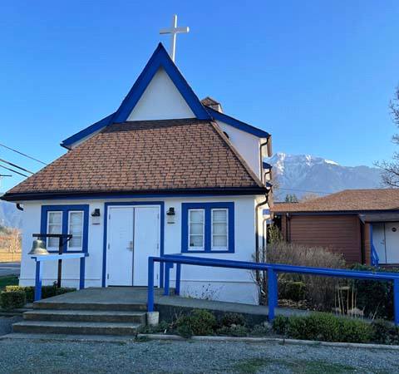

‘The ground we walk does not belong to us; for thousands of years it has been - and remains - the territory of the Stó:lō. We are grateful for their sharing.

Phone: 604-796-3553
Website: www.allsaints-agassiz.ca
https://www.facebook.com/groups/AllSaintsFamily
OUR DOOR IS OPEN AND ALL ARE WELCOME
January 4th, 2026, Second Sunday After Christmas
Priest in Charge: The Reverend Philip Barker
Hosts: Graham Featherstone/Jennifer Pinlac
Intercessor: David Hamilton
Lay Administrator: Dorothy Cresswell
Announcer: Virginia Jennings
Organ/Piano: Francesca Froehlich
Readers: Sheila Barker/Valerie Hamilton
Vicar’s cell phone: Revd. Philip Barker. 778-867-2461

Vicar’s Warden: Ginny Jennings. 604-796-2206
People’s Warden: Lynn Laughlin. 604-799-5131
Parish email: revpb1950@gmail.com
Please contact either warden if you have an issue that needs to be brought to the attention of the Vicar - or contact the Vicar direct (see above for details).

All Saint’s Calendar/Announcements:

- Book Club has chosen the next book, "Amazing Grace, the life of John Newton", by Bruce Hindmarsh and Craig Borlase. It's $24.99 as a paperback on Amazon and is also available on Kindle and as an audio book for free if you have an audio membership.
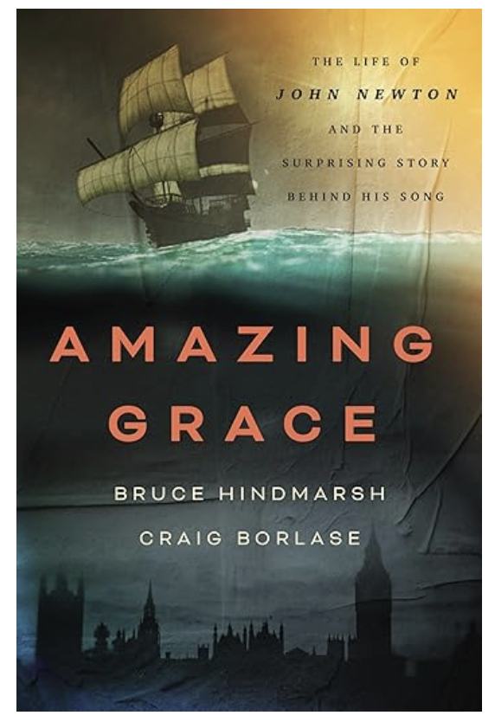

Our first meeting of the New Year will be on
Wednesday, January 14th, at 1700 (5.00pm) on Zoom.

Please let Sheila know at sjbarker0379@gmail.com
if you would like to join the group discussions or have
her order a copy of the book.

- Bible Study with Karol is every Saturday morning 0830-0900 on Zoom.

- Prayer Requests can be given on a piece of paper to either of the Wardens or the Vicar or entered in the Prayer Request Book on the lectern. Alternatively, you can contact Anthea Lewis at antheamlewis@shaw.ca for Pray First Prayer Circle, which is a confidential online prayer circle.

- Music Requests may be given to the Wardens or the Vicar.

- AA meets in the hall every Tuesday and Friday at noon.

- Every Thursday in the hall 1100-1200 we have a social time with coffee, games if you like or just talk.

- At 1000-1100 on Thursdays there is an Interactive Bible Study on the day’s Lectionary readings. All are welcome – discover the treasures in this amazing book!

- 5th Sunday of each month will be a potluck lunch after the service.

Ministerial Meandering
Not waving…

You know that feeling - when your sense of control over a situation just slips your grasp, and you know that unless something miraculous happens in the next thirty seconds or so, you’re toast.
As a surgeon who is prepared to tell the truth about my experience, I can vouch for more than one occasion when I knew that I had lost the moment when I could save my patient on the table.
I remember when I was training in cardio-thoracic surgery, and I was working with a senior colleague to close a congenital hole in the heart; my senior colleague, whilst not a Consultant, was nevertheless highly experienced but had discovered she had made a tear in the left atrium. This is a very difficult area to access as it is behind the heart when one approaches from the front by splitting the sternum (breastbone).
She knew she was in deep guano and called the senior consultant, and when he put his head around the OR door, she simply said, “I’m having a death on the table.” He came in and looked, assessed the failing physiology of the child, the look of hopelessness on the anaesthetist’s face, and said, “Yes,” and walked out.

I had a similar experience of my own later when I was in the same position my female colleague had been in. I had received a victim of a severe car crash who arrived at the ER in ‘kit form’, and already in clinical shock. We took him straight to the OR, placed chest tubes and I opened his abdomen to be faced with the Red Sea. Swimming rapidly to the bottom of the sea, I found his liver and spleen in many different pieces that the Almighty had not planned for. The spleen hit the bucket very fast, but in those early training days we still tried to suture liver lacerations together. The loose bits joined the spleen, but I tried to restore what was left by suture and not packing - which is what we would do now.
The Red Sea had used up all his clotting factors and I knew I was losing him, so I called my boss. It was (of course) 0430 in the morning. I battled on until my senior arrived, and then used the same words; “I’m having a death on the table, Sir.”
My boss - not known for his surgical skill - didn’t venture further into the OR, but said simply, “I’m going to make a pot of tea,” - and left. When my man on the table arrested, which he did fairly soon thereafter, we didn’t bother to try to resuscitate him further - his heart was empty as a stone, and I was paddling in the Red Sea.

I wish I could say that these were the only occasions when I have lost a patient in the OR - or even in the ER - but it wouldn’t be true. I have lost them on the road side, in the desert, in tents in the jungle, and other odd places. Trauma is a severe task-master.

But these gory and sad stories remind me of the time when Jesus’ disciples were in a similar position on the Sea of Galilee and their boat was about to sink in a raging storm. All experienced fishermen, they had nothing left to try - they were going to drown, all of them.
But Jesus was in the back of the boat, apparently asleep. When they called him and shouted at him above the howling wind, “Master, don’t you care if we drown?”, Jesus does not simply leave them to it; he says to the wind, “Peace, be still.” And there was calm.

Remember, He knows when we need him, and never walks away.

Philip+

Truth and Reconciliation
Thank you for the very positive response to the invitation to the current Table Talks series. I had to limit the numbers in the group because it is meant to be a series of small group conversations. Several people were disappointed, so I plan to run the series a second time, probably after Christmas.
Please let me know as soon as possible at sjbarker0379@gmail.com if you would like to join. Feel free to ask those taking part now for their feedback.
A Little Chuckle
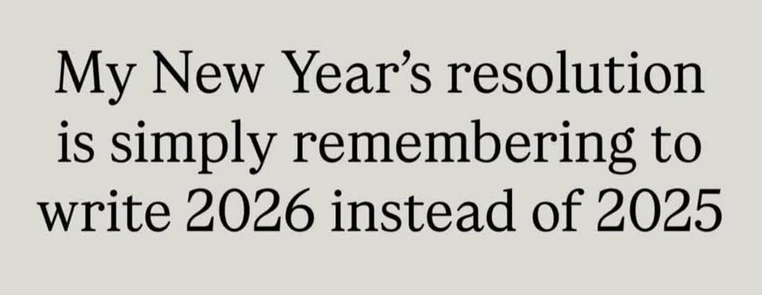

Birthdays this Month  January

Cecil Kirksey – 3rd Judy Gibb – 4th
Gord Elliot – 5th Anne Burden – 16th
Valerie Hamilton – 29th

Diocesan Cycle of Prayer: We Pray for the Clergy and Congregation:

Archdeacon Ruth Monette (Westminster); St. John the Evangelist, North Vancouver - The Revd Patrick Blaney & The Revd Shawn Bullock; Salal & Cedar Watershed Discipleship Ministry – The Revd Laurel Dykstra

Anglican Church of Canada Cycle of Prayer – We Pray for:

Sheilagh McGlynn, Youth Ministries Animator; the Rev. Canon Dr. Scott Sharman,
Animator for Ecumenical and Interfaith Relations

Collect

God of power and life, the glory of all who believe in you, fill the world with your splendour and show the nations the light of your truth; through Jesus Christ your Son our Lord, who is alive and reigns with you and the Holy Spirit, one God, now and for ever.

Isaiah 60: 1-6 Sheila Barker

60 “Arise, shine, for your light has come,
and the glory of the Lord rises upon you.
² See, darkness covers the earth
and thick darkness is over the peoples,
but the Lord rises upon you
and his glory appears over you.
³ Nations will come to your light,
and kings to the brightness of your dawn.

⁴ “Lift up your eyes and look about you:
All assemble and come to you;
your sons come from afar,
and your daughters are carried on the hip.
⁵ Then you will look and be radiant,
your heart will throb and swell with joy;
the wealth on the seas will be brought to you,
to you the riches of the nations will come.
6 Herds of camels will cover your land,
young camels of Midian and Ephah.
And all from Sheba will come,
bearing gold and incense
and proclaiming the praise of the Lord.

Psalm 72:1-14

¹ Endow the king with your justice, O God,
the royal son with your righteousness.
² May he judge your people in righteousness,
your afflicted ones with justice.

³ May the mountains bring prosperity to the people,
the hills the fruit of righteousness.
⁴ May he defend the afflicted among the people
and save the children of the needy;
may he crush the oppressor.
⁵ May he endure as long as the sun,
as long as the moon, through all generations.
⁶ May he be like rain falling on a mown field,
like showers watering the earth.
⁷ In his days may the righteous flourish
and prosperity abound till the moon is no more.

⁸ May he rule from sea to sea
and from the River to the ends of the earth.
⁹ May the desert tribes bow before him
and his enemies lick the dust.
¹⁰ May the kings of Tarshish and of distant shores
bring tribute to him.
May the kings of Sheba and Seba
present him gifts.
¹¹ May all kings bow down to him
and all nations serve him.

¹² For he will deliver the needy who cry out,
the afflicted who have no one to help.
¹³ He will take pity on the weak and the needy
and save the needy from death.
¹⁴ He will rescue them from oppression and violence,
for precious is their blood in his sight.

Ephesians 3:1-12 Valerie Hamilton

3 For this reason I, Paul, the prisoner of Christ Jesus for the sake of you Gentiles—

² Surely you have heard about the administration of God’s grace that was given to me for you, ³ that is, the mystery made known to me by revelation, as I have already written briefly. ⁴ In reading this, then, you will be able to understand my insight into the mystery of Christ, ⁵ which was not made known to people in other generations as it has now been revealed by the Spirit to God’s holy apostles and prophets. ⁶ This mystery is that through the gospel the Gentiles are heirs together with Israel, members together of one body, and sharers together in the promise in Christ Jesus.

⁷ I became a servant of this gospel by the gift of God’s grace given me through the working of his power. ⁸ Although I am less than the least of all the Lord’s people, this grace was given me: to preach to the Gentiles the boundless riches of Christ, ⁹ and to make plain to everyone the administration of this mystery, which for ages past was kept hidden in God, who created all things. ¹⁰ His intent was that now, through the church, the manifold wisdom of God should be made known to the rulers and authorities in the heavenly realms, ¹¹ according to his eternal purpose that he accomplished in Christ Jesus our Lord. ¹² In him and through faith in him we may approach God with freedom and confidence.

Matthew 2:1-12 Vicar Philip Barker
2 After Jesus was born in Bethlehem in Judea, during the time of King Herod, Magi from the east came to Jerusalem ² and asked, “Where is the one who has been born king of the Jews? We saw his star when it rose and have come to worship him.”

³ When King Herod heard this he was disturbed, and all Jerusalem with him. ⁴ When he had called together all the people’s chief priests and teachers of the law, he asked them where the Messiah was to be born. ⁵ “In Bethlehem in Judea,” they replied, “for this is what the prophet has written:

⁶ “‘But you, Bethlehem, in the land of Judah,
are by no means least among the rulers of Judah;
for out of you will come a ruler
who will shepherd my people Israel.’”

⁷ Then Herod called the Magi secretly and found out from them the exact time the star had appeared. ⁸ He sent them to Bethlehem and said, “Go and search carefully for the child. As soon as you find him, report to me, so that I too may go and worship him.”

⁹ After they had heard the king, they went on their way, and the star they had seen when it rose went ahead of them until it stopped over the place where the child was. ¹⁰ When they saw the star, they were overjoyed. ¹¹ On coming to the house, they saw the child with his mother Mary, and they bowed down and worshiped him. Then they opened their treasures and presented him with gifts of gold, frankincense and myrrh. ¹² And having been warned in a dream not to go back to Herod, they returned to their country by another route.
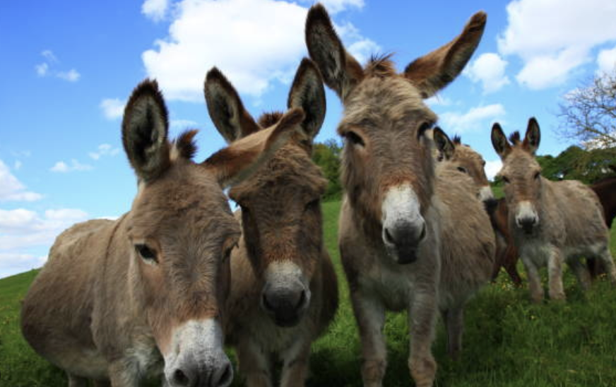
Odds and Ends

UPDATE!!

Donkeys for Kenya
Thank you to everyone who contributed to the Donkeys for Kenya collection. The total was $970, enough to buy 6 donkeys with $10 over! If our donation is doubled for Alongside Hope, we will have contributed 12 donkeys to needy families in East Africa. It is wonderful that this project captured your hearts.

A Prayer for the New Year

May 2026 arrive gently, like a quiet sunrise after a long night. May it find you stronger than you realize and softer where it matters most. May this year heal what last year could not. May it restore what was lost, mend what was broken, and breathe hope into places that grew tired of waiting. May your heart learn to rest without fear, to trust without doubt, and to hope again, even when it feels fragile. May you discover that you were never behind, never forgotten, never too late. In 2026, may joy surprise you in ordinary moments, peace settle where anxiety once lived, and gratitude grow - even in small beginnings. May your prayers be heard, your tears counted, and your quiet strength rewarded. May God walk ahead of you, stand beside you and surround you with grace. May you end this year not just surviving, but becoming, healing, and blooming in ways you never imagined. Step into 2026 with faith. The best chapters are still being written.
Happy New Year!

(Thank you to the Anglican church in North Vancouver for sharing this lovely prayer)

