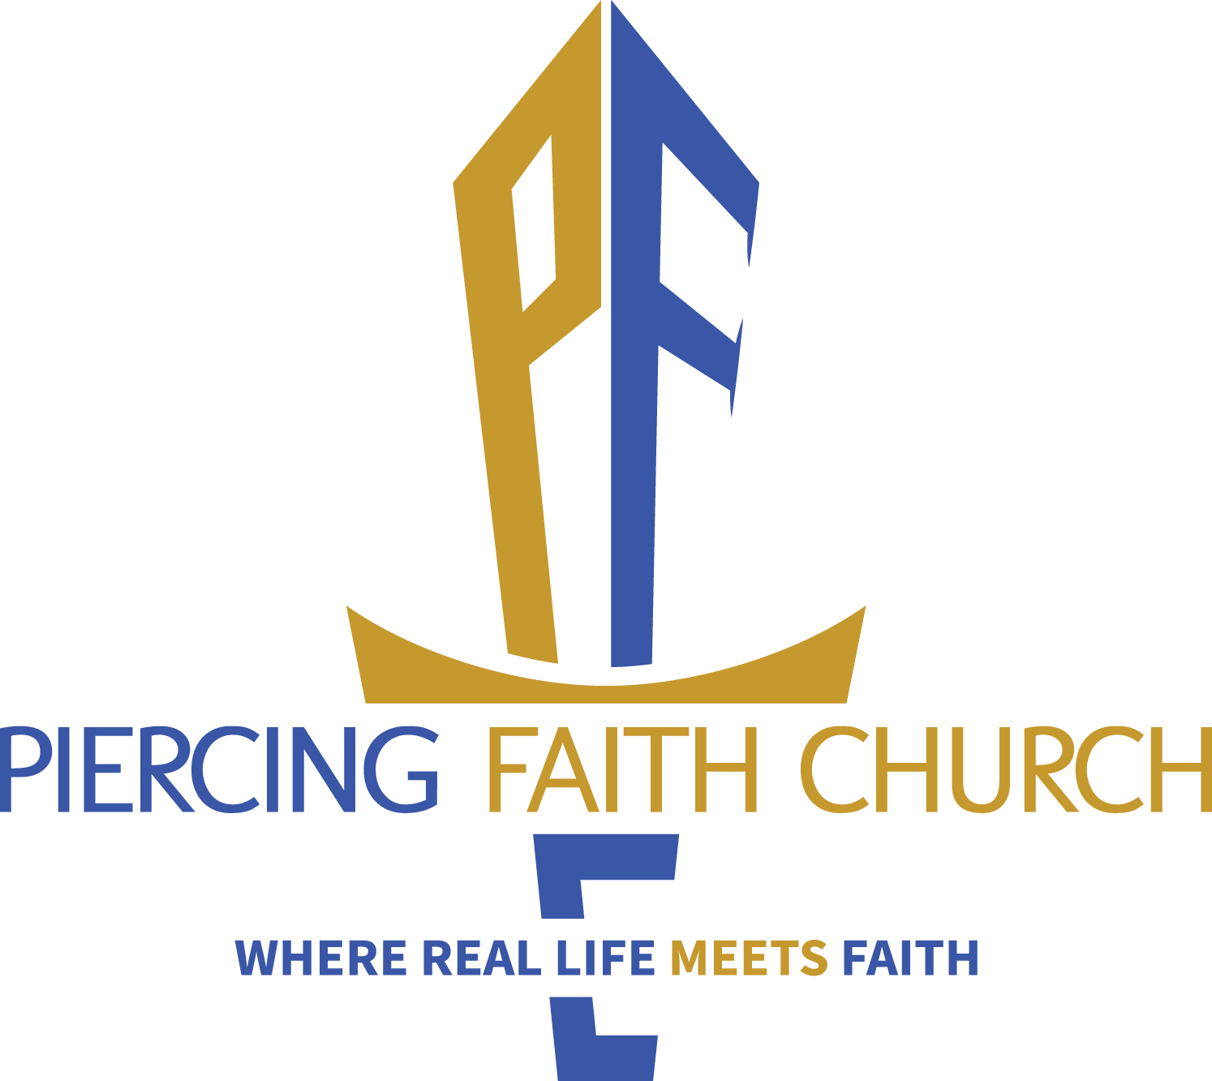NEW YEAR & QUARTERLY CONSECRATIONS 2026
21 DAYS of PRAYER & FASTING
JANUARY SUNDAY SANCUARY PRAYER


Quarter One | Quarter Two | Quarter Three | Quarter Four
Starts: Sunday. Jan. 4- SUNRISE  Ends: Sat.  Jan. 10- SUNSET  Jan. 11 High Praise | Starts: Sunday Apr. 5 –SUNRISE  Ends: SATURDAY  Apr. 11- SUNSET Apr. 12 High Praise PRAYER - 733 | CALL TO PRAYER  8:00-8:50 am  EVERY SUNDAY IN  JULY 8 -8:50 AM  SUNDAY SERVICE AT THE LAND  JULY | Starts: Sunday  October 4- SUNRISE  Ends: Saturday  Oct. 10 – SUNSET  Oct. 11 High Praise

