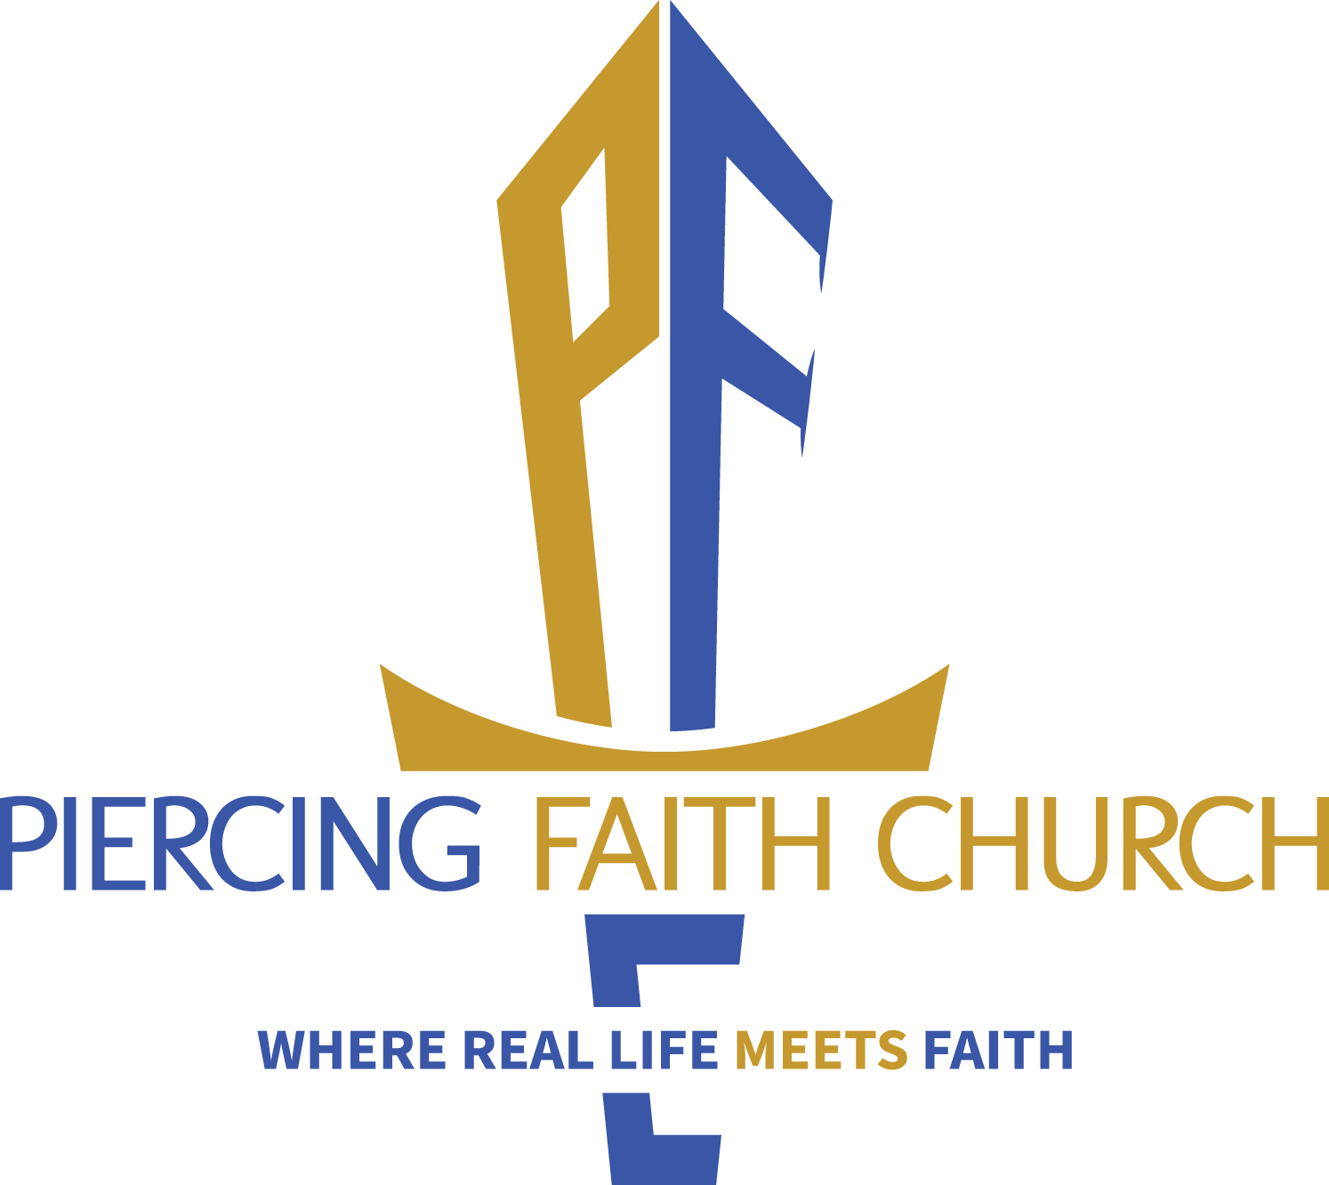
DAY 2 FORGIVENESS
MT. 6:5-15
MARK 11:24-26
DAY 7 MISSION & CAMPUS VISION 1 KINGS 6; PS. 127:1; PROV. 3:5-6; MARK 16:14-18
DAY 4 REFOCUS
DAN. 11:32; ROMANS 8:5-6, CHAPTER 12; COLOSSIANS 3

DAY 6 UNITY
HEB. 10:19-25; 13:1.
1 PETER 4:7-11

JAN. 4 – JAN. 10
SUGGESTED 7 DAY READING PLAN

NEW YEAR CONSECRATION READING SCHEDULE 2026
DAY 5 FAMILY & FRIENDS
MARK 12:28-35; LUKE 10:25-37
DAY 3 RESTORATION & SPOIL
1 SAMUEL CHAPTER 30
GAL. 6:1-5
DAY 1 REPENTANCE
2 CHRON. 7:12-15
1 JOHN 1:5-10
* This is a spiritual journey not a weight loss plan
If on medications: Please consult your doctor and our Lord.
If married: no procreative activity during the seven days (must be mutually agreed upon with your spouse – God is not the author of confusion)

*This fast is totally voluntary and is designed to strengthen the fellowship and the individual. Please feel free to join in at any point as you are able.
We believe that there will be spiritual blessings and physical benefits for those who are able to participate. Thank you in advance for your prayerful consideration! Enjoy the journey!

When eating: No meats, sweets, dairy, sugary cereal, pasta or bread. Please avoid processed sugar (substitutes) and minimize fried foods! Focus on eating vegetables, fruit, bean, oatmeal, baked potatoes or brown rice etc. only. Feel free to exchange recipes.
When drinking: No sugary drinks, milk coffee, tea or alcohol- Water only!

STARTING 2026 WELL
7 DAYS of CONSECRATION BEFORE THE LORD
Sunday Jan. 4 Through - Saturday Jan. 10
FASTING: Sun-up to Sun-down
*Sanctuary will be open every morning for 7am-8am prayer
On the Seventh Day there will be seven prayer times
Saturday January 10th the Sanctuary prayer times:
7 am, 9 am (half hour), 11 am, 1pm, 3pm, 5pm, & 7pm
Sunday January 11TH HIGH PRAISE
“FAITH MOVES IMPOSSIBLE”

