PARISH HOUSE: Items for Month of
November: See list for Holiday Donations

Upcoming Events:
November 26th – No Choir Practice or Bible Study
December 3rd - 6:00pm Charge Christmas Dinner
and Advent Study
- Meat, Mashed Potatoes, Dressing, Rolls provided
- Bring Side Dishes and Dessert
December 14th – 2:00pm Christmas Caroling
December 16th – 6:30pm Advent Study @
West Buckhannon UMC
December 18th – 6:30pm Advent Study @
Mt. Lebanon UMC
December 24th – 7:00pm Christmas Eve Candle Light Service
December 31st – No Choir Practice or Bible Study

NOVEMBER BIRTHDAYS
Jim Minutelli – 3rd, Yvonnda Tenney – 4th, Dolly Coleman – 6th,
Linda DeBarr - 7th, Betty Smith – 13th, Kathy Black – 25th,
Pam Moll – 27th, Delores Wilson – 27th
NOVEMBER ANNIVERSARIES
Charles & Yvonnda Tenney – 7th

Tithes and Offerings: Give your gifts,
tithes, and offerings through PayPal. It is
quick, easy, and safe! Just use the
camera on your phone to scan the QR
Code. All donations will be placed into
our General Account unless otherwise
stated.

TENNERTON
United Methodist Church
November 23, 2025
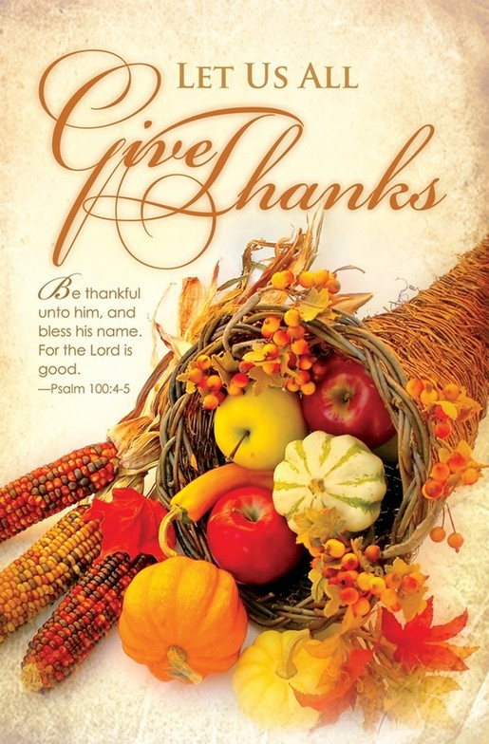
Pastor Jim Minutelli
304-629-9398

Office: 126 Tallmansville Rd.
Buckhannon, WV 26201
Office Phone: 304-472-1064
Sermon by Phone: 304-460-0029
Website: https://tennertonumc.org
Email: umc.tennerton@gmail.com
Facebook: https://www.facebook.com/thetennertonumc
Prayer Concerns: Call Candy George @ 304-613-6424

JOYS & CONCERNS
WELCOME/OPENING PRAYER Pastor
*OPENING HYMN: “This Is the Day” 22/31 UMH 657

CALL TO WORSHIP:
Leader: Make a joyful noise to the LORD,
all the earth.
People: Worship the LORD with gladness;
come into his presence with singing.
Leader: Know that the LORD is God. It is he
that made us, and we are his; we are
his people, and the sheep of his pasture.
People: Enter his gates with thanksgiving, and
his courts with praise. Give thanks
to him, bless his name.
Leader: For the LORD is good; his steadfast love
endures forever, and his faithfulness to
to all generations. Come let us worship
our Lord!

*OFFERING/DOXOLOGY/PRAYER UMH 95
CHOIR: “Now Thank We All Our God” 3/14 UMH 102
CHILDREN MESSAGE Vickie Snyder
ANNOUNCEMENTS (ON BACK PAGE)
READING: Philippians 4: 4 – 9
*HYMN: “We Gather Together” 4/11 UMH 131

SCRIPTURE READING:

SERMON:

*CLOSING HYMN: “Come, Ye Thankful People
Come” 23/27 UMH 694

*BENEDICTION

*Please stand if you are able. Don’t Forget to Feed the Pig

GREETERS & WORSHIP LEADERS
If you would like to be a greeter or lead worship service,
print your name on the clip board on the front pew.

This Week
GREETER(S): Rick Black
WORSHIP LEADER: Lynn Frum

Next Week
GREETER(S): Patsy Burgess
WORSHIP LEADER: Vickie Snyder

Women’s Group will be filling Baskets for Shut-Ins.
Bring items before December 14th

Christmas Store Donations – new toys or items for teens
Put in box in entry

Break Bags instead of layette items for Christmas Dinner
Ramen Noodles, Canned Soup, Canned Pasta, Applesauce Cups,
Individual-Packed Snacks, Instant Oatmeal Packs, Granola, Cereal

