Diocese of Ottawa • Anglican Church of Canada



First Sunday
after Christmas

Dec 28th, 2025
Sung Eucharist ~ 10 a.m.
Book of Alternative Services, p. 185

Welcome to the Church of
St. John the Evangelist

We acknowledge that we gather at St. John’s on the traditional and unceded territory of the Algonquin Nation. May we dwell on this land with respect and peace.

This service is video recorded, streamed, and broadcast. By attending this service, you are agreeing to appear on video in our on-line worship offering through St. John’s website and Facebook pages.
Hymns are from the blue Common Praise hymnbook unless otherwise indicated.
Today’s service can be found on page 185 of the green Book of Alternative Services (BAS) located in the pew-back in front of you.

THE GATHERING OF THE COMMUNITY

Prelude – “In the Bleak Midwinter” (arr. Young)

Announcements

Processional (Opening) Hymn

123 – “Once in Royal David’s City” (vs. 1-3)

Greeting p.185

Children’s Talk

Collect for Purity p.185
The Kyrie Sung as printed here.

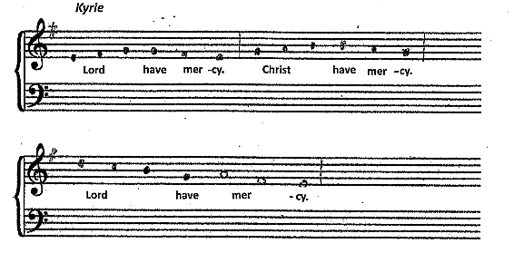

Collect of the Day
Almighty God,
you have shed upon us the new light
of your incarnate Word.
May this light, enkindled in our hearts,
shine forth in our lives;
through Jesus Christ our Lord,
who lives and reigns with you,
in the unity of the Holy Spirit,
one God, now and for ever.
Amen.

THE PROCLAMATION OF THE WORD

First Reading Isaiah 63:7-9
I will recount the gracious deeds of the Lord, the praiseworthy acts of the Lord, because of all that the Lord has done for us, and the great favour to the house of Israel that he has shown them according to his mercy, according to the abundance of his steadfast love. For he said, "Surely they are my people, children who will not deal falsely"; and he became their saviour in all their distress. It was no messenger or angel but his presence that saved them; in his love and in his pity he redeemed them; he lifted them up and carried them all the days of old.

Reader: The Word of the Lord
People: Thanks be to God

Psalm 148:1-6 Tune 85/St. Agnes

Hallelujah! Give praise to God
From heaven and in the heights;
Praise him all angels, sun and moon,
Praise him all shining lights.

Praise him, high heavens and floods above,
Let them all praise his Name;
For he commanded by his word,
He spoke and forth they came.

He gave them being, they stand fast
In his eternal sway;
The Lord has given them a law
Which shall not pass away.

Second Reading Hebrews 2:10-18
It was fitting that God, for whom and through whom all things exist, in bringing many children to glory, should make the pioneer of their salvation perfect through sufferings. For the one who sanctifies and those who are sanctified all have one Father. For this reason Jesus is not ashamed to call them brothers and sisters, saying, "I will proclaim your name to my brothers and sisters, in the midst of the congregation I will praise you." And again, "I will put my trust in him." And again, "Here am I and the children whom God has given me." Since, therefore, the children share flesh and blood, he himself likewise shared the same things, so that through death he might destroy the one who has the power of death, that is, the devil, and free those who all their lives were held in slavery by the fear of death. For it is clear that he did not come to help angels, but the descendants of Abraham. Therefore he had to become like his brothers and sisters in every respect, so that he might be a merciful and faithful high priest in the service of God, to make a sacrifice of atonement for the sins of the people. Because he himself was tested by what he suffered, he is able to help those who are being tested.

Reader: The Word of the Lord
People: Thanks be to God

Gospel Acclamation
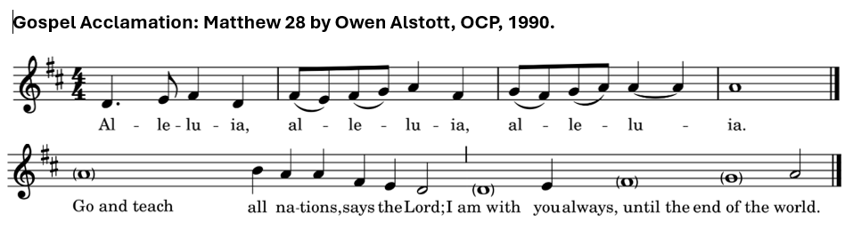

Holy Gospel Matthew 2:13-23

Gospeller: The Lord be with you
All: And also with you

Gospeller: The Holy Gospel of our Lord Jesus Christ according to Matthew
All: Glory to you, Lord Jesus Christ
Now after they had left, an angel of the Lord appeared to Joseph in a dream and said, "Get up, take the child and his mother, and flee to Egypt, and remain there until I tell you; for Herod is about to search for the child, to destroy him." Then Joseph got up, took the child and his mother by night, and went to Egypt, and remained there until the death of Herod. This was to fulfil what had been spoken by the Lord through the prophet, "Out of Egypt I have called my son." When Herod saw that he had been tricked by the wise men, he was infuriated, and he sent and killed all the children in and around Bethlehem who were two years old or under, according to the time that he had learned from the wise men. Then was fulfilled what had been spoken through the prophet Jeremiah: "A voice was heard in Ramah, wailing and loud lamentation, Rachel weeping for her children; she refused to be consoled, because they are no more." When Herod died, an angel of the Lord suddenly appeared in a dream to Joseph in Egypt and said, "Get up, take the child and his mother, and go to the land of Israel, for those who were seeking the child's life are dead." Then Joseph got up, took the child and his mother, and went to the land of Israel. But when he heard that Archelaus was ruling over Judea in place of his father Herod, he was afraid to go there. And after being warned in a dream, he went away to the district of Galilee. There he made his home in a town called Nazareth, so that what had been spoken through the prophets might be fulfilled, "He will be called a Nazorean."

Gospeller: The Gospel of Christ
People: Praise to you, Lord Jesus Christ

Sermon

Nicene Creed p. 188

Prayers of the People

Confession and Absolution p. 191

The Peace p. 192

People may greet one another with the peace of Christ.

Offertory Hymn 122 – “In the Bleak Midwinter”
THE CELEBRATION OF THE EUCHARIST

Prayer over the Gifts
God of light,
in the birth of your Son we see your glory.
May we who share in this mystery
grow daily in your love.
This we ask in the name of Jesus Christ the Lord.
Amen.

Eucharistic Prayer 2 p. 196

Sanctus (sung)

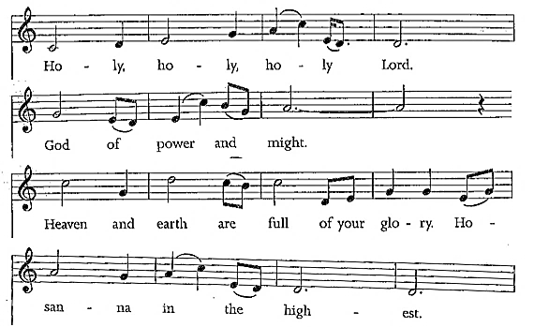
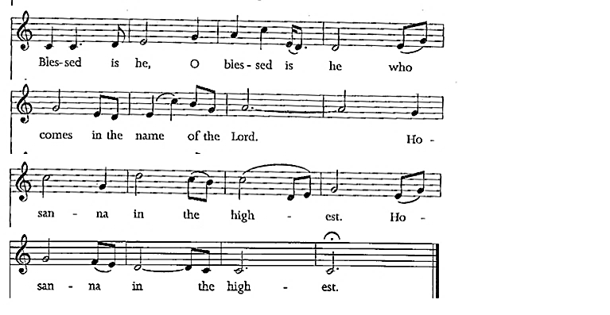

The Lord’s Prayer (sung)
Our Father in heaven, hallowed be your name;
Your kingdom come;
Your will be done
On earth, as in heav’n.
Give us today our daily bread.
Forgive us our sins
as we forgive those who sin against us.
Save us from the time of trial,
and deliver us from evil.
For the kingdom, and the power, and the glory are yours;
Now and forever.
Amen.

Breaking of the Bread 6 p. 213
Celebrant: We break the bread of life,
And that life is the light of the world.
All: God here among us,
Light in the midst of us,
Bring us to light and life.

Agnus Dei (Lamb of God) Sung as printed here.

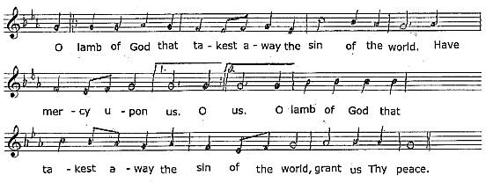

Communion
All who are baptized are welcome to receive the bread and/or the wine of Holy Communion. At the Greeter’s direction, please make your way to receive the elements if you wish to. All are welcome to come forward for a blessing.

Hymns during Communion
“O Holy Night”
“Still, Still Still” (arr. Hobson)
“Sheep May Safely Graze” (Bach)

Prayer after Communion
Source of truth and joy,
may we who have received the gift of divine life
always follow the way of your Son.
This we ask in the name of Jesus Christ the Lord.
Amen.

Doxology p. 214

The Blessing

Recessional Hymn 50 – “Go Tell it On The Mountain”

Dismissal

Postlude “Sheep May Safely Graze” (Bach)

ANNOUNCEMENTS

Parish Office Closure – The office is currently closed and will reopen Friday, January 2nd, 2026, at 9.00am.

2026 Offering Envelopes – The 2026 weekly giving envelopes are now at the back of church, sorted alphabetically. If you do not see your name or I have missed someone, please let me know. As well, there are extra boxes of envelopes if you or someone you know would like a set. – Tammy Mulrooney, Envelope Secretary.

PRAY K7A – Tonight, we will gather here at St. John’s for 7.00 pm. We will be praying for the coming year, and giving thanks for the year that has passed.

2025 Contributions - December 31st is a Wednesday this year. The last day to submit your contributions for 2025, will be Sunday, January 4th, 2026. Any cheque, e-transfers, tithes, etc., must be dated no later than December 31st, 2025. Offerings submitted after January 4th, will be entered as 2026 contributions. Thank you.

Christmas Choir –There will be a get together for the TGIE (thank goodness it’s Epiphany) party. The next practice is scheduled for Saturday, January 3rd, 2026 at 10.00am. For further information or to sign up, please contact Wendy at: wendy.earl75@yahoo.com.

Games Night – Mark your calendars for our next Games Night in 2026 – Friday, January 9th, 2026 at 5.30pm. Come out and join us for an evening of fun. A meal will be served, followed by games and crafts. Donations are always appreciated.

Let us continue to pray for whomever God might call to become the next Bishop of Ottawa, and pray for those who carry those responsibilities in the meantime.

Presiding Celebrant: Rev. Jim Roberts
Preacher: Rev. Dr. Jim Roberts
Communion Assistant:
Reader/Intercessor: Andrew Howard
Greeters: Paul Howard & Donna Howard
Altar Guild: Debbie Lewis & Jessica Coughlan
Organist: Wendy Stokes-Earl
Readings for next Sunday, Jan 4, 2025 ~
IS 60:1-6; PS 72:1-7,10-14; EPH 3:1-12; MT 2:1-12

ST. JOHN THE EVANGELIST ANGLICAN CHURCH
2 George Street South, Smiths Falls, Ontario K7A 1X4
613.283.1261 | stjohns.smithsfalls@gmail.com
www.stjohn-smithsfalls.com

Follow us on Facebook at:
St-John-the-Evangelist-Anglican-Church-Smiths-Falls

Laura Savage – Parish Administrator
Office Hours: Monday – Wednesday 9am – 12 noon
Thursday 1 – 4pm
Friday 9am – 12 noon

Weekly Liturgies
Holy Eucharist – Sundays 8am & 10am* – Wednesdays 10am
*Sunday School offered at 10am from September – June

The Reverend Dr. Thomas Brauer, Presiding Celebrant & Preacher
The Reverend Canon Brian Burrows – Honorary Assistant
The Reverend Canon Jim Roberts – Honorary Assistant

Wendy Stokes-Earl – Organist
Dan Willis – Rector’s Warden 613.884.5095
Lois Arkell – People’s Warden 613.485.9181
Tammy Mulrooney – Deputy Warden 613.485.3128
Pat Lee – Deputy Warden 613.485.3368
Tammy Mulrooney – Envelope Secretary
sjsfenvelopesecretary@gmail.com

