This Week at PPBC


Doors open at 7pm
Balloon drop at 9pm and midnight
Snack style potluck
Games, music, fellowship and food!!
Please sign up at the welcome centre

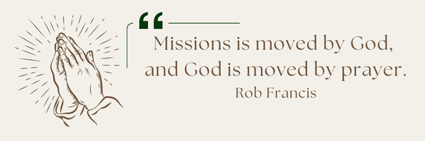
A message from Maria: Pray for the Lord's wisdom and discernment to provide proper biblical guidance to Spanish women who need help in their personal lives. For my own discipline, to organize 2 team's (English & Spanish) for evangelism, to disciple others and spiritual growth in their lives for the new Spanish believers. (90%first generation of believers).

Coming Soon
Tuesday, January 6th


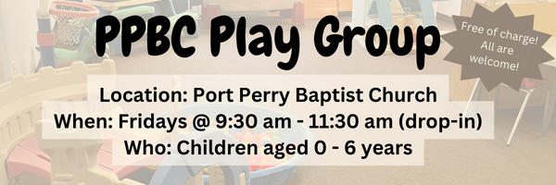

January 10th, 2025

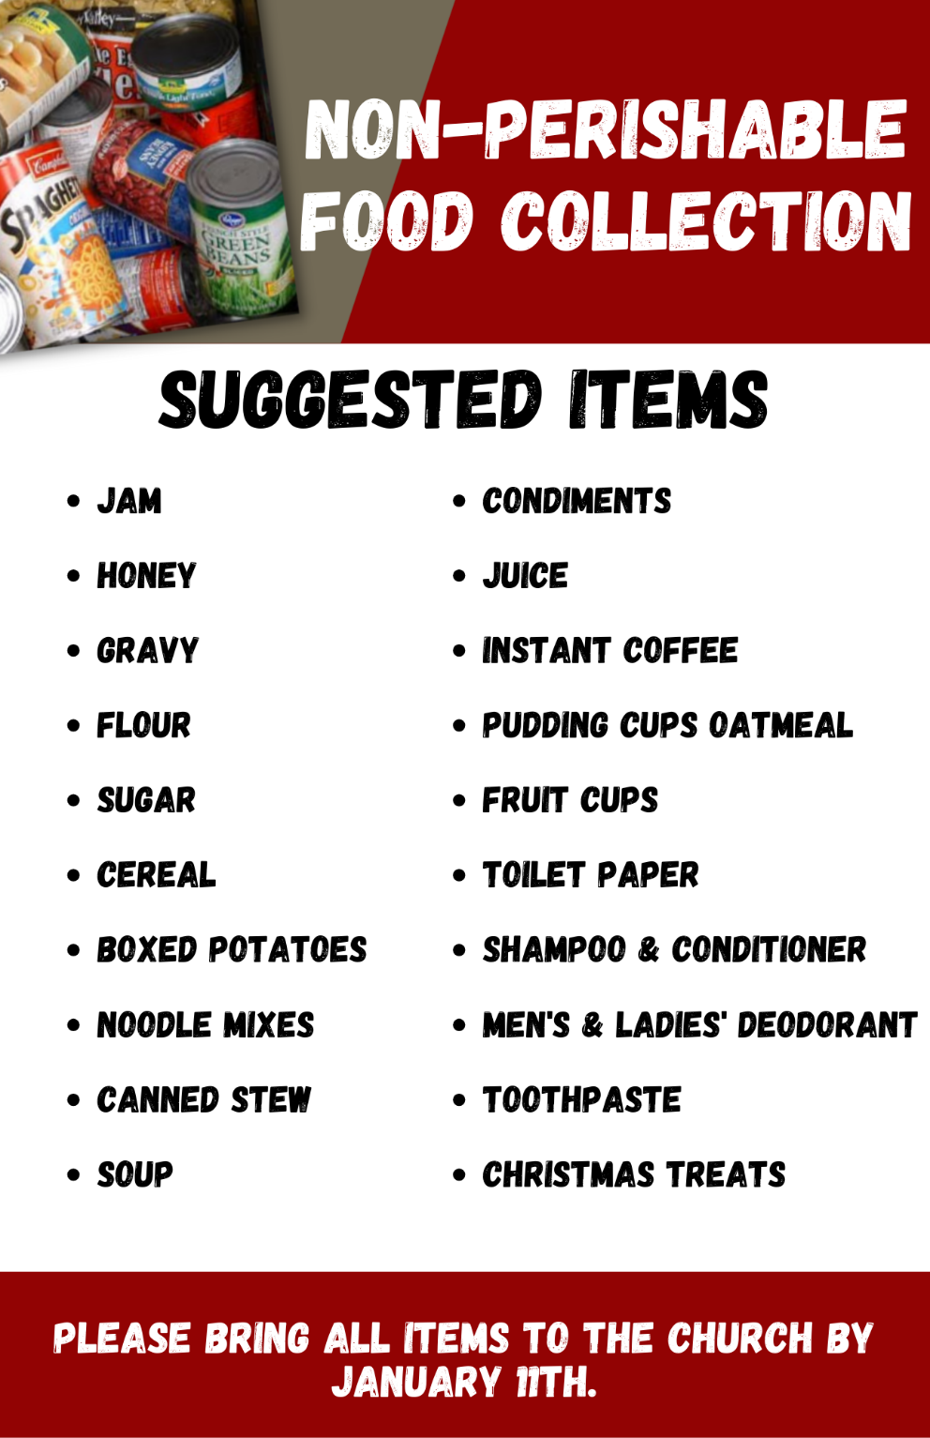

Sunday Ministry Schedules
Below are ministry schedules for Nursery, Jr. Church, Greeters, Ushers, and Sound & Video:
Nursery
Dec 28: Jen Werner, Brantley Colwell
Jan 4: Kathryn denOuden, Alyssa Summers
Infant Nursery
Dec 28: Laura Saunders, Amber Saunders
Jan 4: Karen Clemens, Rosalie McLaren
Jr. Church; ages 3 to grade 1
Dec 28: Deb Brown, Grace Brown
Jan 4: Christine McLaren, Kelsey Schoenrock
Jr. Church; Grades 2 to 6
Dec 28: Kate Anderson, Graeme Anderson
Jan 4: Gregg & Karen Anderson
Greeters
Dec 28: Graeme & Barb Foster
Jan 4: Fern & Kim St-Onge
Ushers
Dec 28: Mark McLaren, Roy Wilson
Jan 4: Gregg Anderson, Graeme Foster
Sound & Video
Dec 28: Sound: Wyatt Werner | Video: Josh Bolsonello
Jan 4: Sound: Charlie Deane | Video: Josh Myers


Morning Service
Song – Glory to His Name
Welcome
Song – He is Worthy
Scripture
Prayer
Song – Come to Jesus (Rest in Him)
Song – I’d Rather Have Jesus
Message – Scott McKenzie
Song – All Hail the Power of Jesus Name

Praise & Prayer Highlights
PRAY for Joan Mabley and her ongoing health concerns. Joan has been moved to Lakeridge Health Bowmanville unit #1 room #108 bed #1.
PRAY for John & Joan Mank and their ongoing health concerns.
PRAY for Martin & Tina McCurley. Tina has some shoulder injuries. PRAY for her healing and recovery.
PRAY for Martin & Tina McCurley's two month old grandson Walker who is in Oshawa Hospital with the flu. PRAY for the family and doctors as they care for him.
PRAY for Bert & Ada Faber. PRAY for Ada who is in Port Perry Hospital room #119 for observation.
PRAY for Andrew and Gladys Alexander. PRAISE that Andrew is now home from Hospital. PRAY for his health and recovery and for Gladys as she cares for her husband.
PRAY for Winnie Miller and her ongoing health concerns.
PRAY for Caleb Bolsonello and his fiancée Stephanie as they prepare for their wedding and marriage January 17th, 2026.
PRAY for New Song Church & Port Perry Baptist as they plan to co-host a Christianity Explored outreach at That Place on Queen in the new year. Please PRAY for God to prepare the hearts of those who will attend from the community to receive the gospel.
Giving
Just as a reminder, there are several ways you can give:
In Person using the offering box located on the back wall of the sanctuary. Donation envelopes are available at the Welcome Centre. Please contact the church office if you would like a box of donation envelopes (office@portperrybaptist.ca)
Through your online banking, you may send electronic transfers to ppbcdonations@gmail.com.
You can also give through Canada Helps. Donation receipts will be provided by Canada Helps, and transaction fees apply.
***********************************************************************
Weekly Newsletter
The PPBC Newsletter is emailed to the church family every Friday. If you would like to be added to the weekly email list, please contact the office by phone: 905-985-8681 or by email: office@portperrybaptist.ca.
*****************************************************************
Church Information:
Location:
2210 Hwy 7A
Port Perry, ON
L9L 1B4
Office Hours:
Monday: 8:30am – 4:00pm
Tuesday: 8:30am – 4:00pm
Wednesday: Closed
Thursday: 8:30am – 4:00pm
Friday: 8:30 am - 3:00 pm
Contact:
Phone: 905.985.8681
Email: office@portperrybaptist.ca
Website: www.portperrybaptist.ca
Staff:
Sr. Pastor – Rev. Jim Clemens
Administrative Assistant – Madeline Werner
Family Ministries Director – Josh Anderson

PPBC Newsletter
Sunday, December 28, 2025


Sunday Starting Point
Sunday, December 28, 2025 - 9:30 am
“Beginning the day with the Word and prayer”
Adults:
Adults will meet in the sanctuary for a time of study and prayer. Psalm 148.
Youth:
Jr High (Grades 7-8) will meet in room 18 with Kate Anderson to study Ecclesiastes.
Children:
Children ages 3 - grade 6 will meet in room 26.
(Please note nursery is unavailable during Starting Point)
Sunday Morning Worship
Sunday, December 28, 2025 - 10:30 am
We are meeting in the sanctuary and will continue to live-stream for those who are unable to attend.
Message:
Scripture: Psalm 110
Scott McKenzie

