All Saints Anglican Church
6904 Lougheed Highway, Agassiz, B.C. V0M 1A0
Bulletin December 15th, 2025 – December 21st, 2025

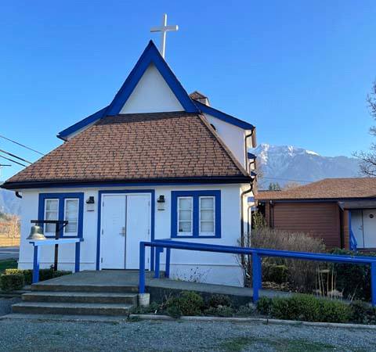

‘The ground we walk does not belong to us; for thousands of years it has been - and remains - the territory of the Stó:lō. We are grateful for their sharing.

Phone: 604-796-3553
Website: www.allsaints-agassiz.ca
https://www.facebook.com/groups/AllSaintsFamily
OUR DOOR IS OPEN AND ALL ARE WELCOME
December 21st, 2025, Fourth Sunday of Advent
Priest in Charge: The Reverend Philip Barker

Hosts: Graham Featherstone/Jennifer Pinlac
Intercessor: Sheila Barker
Lay Administrator: Dorothy Cresswell
Announcer: Virginia Jennings
Organ/Piano: Francesca Froehlich
Readers: Graham Featherstone/Dorothy Cresswell
Vicar’s cell phone: Revd. Philip Barker. 778-867-2461

Vicar’s Warden: Ginny Jennings. 604-796-2206
People’s Warden: Lynn Laughlin. 604-799-5131
Parish email: revpb1950@gmail.com
Please contact either warden if you have an issue that needs to be brought to the attention of the Vicar - or contact the Vicar direct (see above for details).

All Saint’s Calendar/Announcements:

- Book Club has chosen the next book, "The Watchmaker's Daughter" by Larry Loftis. It is the true story of Corrie ten Boom, who helped her family hide Jewish and other refugees during WWII, survived Ravensbruck concentration camp and went on to be an evangelist across the globe. Some of you may have read her autobiography, "No Hiding Place". The book club started the book on November 5thand meets online every Wednesday to discuss the readings.


The book is $24.99 0n Amazon. There is no Kindle option
on Amazon but the Kobo e-book on the indigo.ca website
is $13.99. Please email Sheila at sjbarker0369@gmail.com
if you would like to join the group discussions or
have her order a book for you.

- Bible Study with Karol is every Saturday morning 0830-0900 on Zoom.

- Prayer Requests can be given on a piece of paper to either of the Wardens or the Vicar or entered in the Prayer Request Book on the lectern. Alternatively, you can contact Anthea Lewis at antheamlewis@shaw.ca for Pray First Prayer Circle, which is a confidential online prayer circle.

- Music Requests may be given to the Wardens or the Vicar.

- AA meets in the hall every Tuesday and Friday at noon.

- Every Thursday in the hall 1100-1200 we have a social time with coffee, games if you like or just talk.

- At 1000-1100 on Thursdays there is an Interactive Bible Study on the day’s Lectionary readings. All are welcome – discover the treasures in this amazing book!

- 5th Sunday of each month will be a potluck lunch after the service.

- Sunday December 28th – Community Lunch at All Saint’s – We will need volunteers to help with clean-up. God works in mysterious ways, but he doesn’t do dishes. We also need to know who is coming, see instructions below.
Instructions from Fran
- There is a signup poster in the hall on the bulletin board. Please add your name(s) and how many are coming from your group.

- If you are not at church, text or call Fran at 604-991-7471 to sign up. Also, please indicate what you are able to bring for the lunch.

There is no cost, but donations will be welcomed.

Please invite friends, family, and anyone who would like to come. Guests do not need to bring food but may do so if they like.
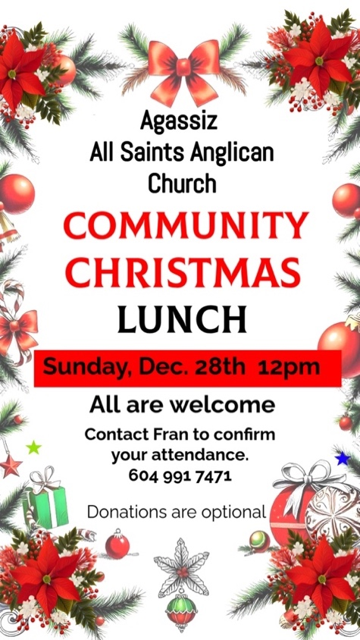


Christmas Services
Wednesday, December 24th, Christmas Eve, at 1600 (4.00pm)
Nine Lessons and Carols

Thursday, December 25th, Christmas Day, at 1000

Ministerial Meandering
Call of the wild

One of my closest friends asked me recently why I feel the need to go off to crazy places to work. I’m still trying to formulate an answer a week later. How did this come about?

During my career as a surgeon I have been to some out-of-the-way places, and always enjoyed my time. But, whilst there, I would rub up against other characters with a similar drive or need to get out of their comfort zone. This is by no means restricted to men alone; I have encountered lots of women who are just as motivated. Why do any of us do it?

I think - in my own case - I need to test myself. I ask myself, “Do I have what it takes to do this work?” In some ways I want to be frightened, I want to be pushed to my limits - to see what they are and where I meet them.
I wish I could claim pure altruism as my motive - but it wouldn’t be true. It comes into the equation - for sure - but that is certainly not the whole story. I think a lot of us who join the military are secretly longing for a combat deployment, where we can test our mettle.

I recently watched Clint Eastwood’s excellent film, ‘American Sniper’ - the true story of Chris Kyle, who served four tours of Iraq as a sniper, and notched up the highest score of enemy kills in American history. He eventually left the Navy Seals to try to make a ‘normal life’ with his wife and children, which he found enormously difficult. Continuing to miss his service life, he took up helping other returned and traumatized vets - only to be killed by one he was trying to help.
The way the movie tells it, he never really left that need for the adrenaline - and his wife never really understood it.

On the civilian side of things I have also read David Nott’s autobiography called, ‘War Surgeon’, detailing his service with many humanitarian organizations and serving in many different war-torn countries. He also admits in his book to the need for the adrenaline motivation. We all have our addictions.

I am sure that Mother Theresa and others may have been motivated entirely by the love of God and their fellow man and woman, but those of us who don’t reach such admirable heights may have to be content with our more basic drives.

If people in need benefit - does it really matter why we go?

Philip+

Truth and Reconciliation
Thank you for the very positive response to the invitation to the current Table Talks series. I had to limit the numbers in the group because it is meant to be a series of small group conversations. Several people were disappointed, so I plan to run the series a second time, probably after Christmas.
Please let me know as soon as possible at sjbarker0379@gmail.com if you would like to join. Feel free to ask those taking part now for their feedback.
A Little Chuckle


Birthdays this Month  December

Fran Froehlich – 19 Carol Taylor – 25

Diocesan Cycle of Prayer: We Pray for the Clergy and Congregation:

Archdeacon Stephen Muir (Capilano); St. Michael, Vancouver – The Revd Wilmer Toyoken; St. Augustine, Marpole - The Revd Katherine Hough

Anglican Church of Canada Cycle of Prayer – We Pray for:

The Rt. Rev. Christopher Harper, National Indigenous Anglican Archbishop, and the staff of Indigenous Ministries; the Anglican Council of Indigenous Peoples; Dawn Maracle, Indigenous Justice Animator

Collect

Heavenly Father, who chose the Virgin Mary, full of grace, to be the mother of our Lord and Saviour, now fill us with your grace, that we in all things may embrace your will and with her rejoice in your salvation; through Jesus Christ our Lord, who lives and reigns with you and the Holy Spirit, one God, now and for ever.

Isaiah 7:10-16 Graham Featherstone

¹⁰ Again the Lord spoke to Ahaz, ¹¹ “Ask the Lord your God for a sign, whether in the deepest depths or in the highest heights.”

¹² But Ahaz said, “I will not ask; I will not put the Lord to the test.”

¹³ Then Isaiah said, “Hear now, you house of David! Is it not enough to try the patience of humans? Will you try the patience of my God also? ¹⁴ Therefore the Lord himself will give you a sign: The virgin will conceive and give birth to a son, and will call him Immanuel. ¹⁵ He will be eating curds and honey when he knows enough to reject the wrong and choose the right, ¹⁶ for before the boy knows enough to reject the wrong and choose the right, the land of the two kings you dread will be laid waste.

Psalm 80:1-7 17-19

¹ Hear us, Shepherd of Israel,
you who lead Joseph like a flock.
You who sit enthroned between the cherubim,
shine forth ² before Ephraim, Benjamin and Manasseh.
Awaken your might;
come and save us.

³ Restore us, O God;
make your face shine on us,
that we may be saved.

⁴ How long, Lord God Almighty,
will your anger smolder
against the prayers of your people?
⁵ You have fed them with the bread of tears;
you have made them drink tears by the bowlful.
⁶ You have made us an object of derision to our neighbors,
and our enemies mock us.

⁷ Restore us, God Almighty;
make your face shine on us,
that we may be saved.

¹⁷ Let your hand rest on the man at your right hand,
the son of man you have raised up for yourself.
¹⁸ Then we will not turn away from you;
revive us, and we will call on your name.

¹⁹ Restore us, Lord God Almighty;
make your face shine on us,
that we may be saved.

Romans 1:1-7 Dorothy Cresswell

1 Paul, a servant of Christ Jesus, called to be an apostle and set apart for the gospel of God— ² the gospel he promised beforehand through his prophets in the Holy Scriptures ³ regarding his Son, who as to his earthly life was a descendant of David, ⁴ and who through the Spirit of holiness was appointed the Son of God in power by his resurrection from the dead: Jesus Christ our Lord. ⁵ Through him we received grace and apostleship to call all the Gentiles to the obedience that comes from faith for his name’s sake. ⁶ And you also are among those Gentiles who are called to belong to Jesus Christ.

⁷ To all in Rome who are loved by God and called to be his holy people:

Grace and peace to you from God our Father and from the Lord Jesus Christ.

Matthew 1:18-25 Vicar Philip Barker
¹⁸ This is how the birth of Jesus the Messiah came about: His mother Mary was pledged to be married to Joseph, but before they came together, she was found to be pregnant through the Holy Spirit. ¹⁹ Because Joseph her husband was faithful to the law, and yet did not want to expose her to public disgrace, he had in mind to divorce her quietly.

²⁰ But after he had considered this, an angel of the Lord appeared to him in a dream and said, “Joseph son of David, do not be afraid to take Mary home as your wife, because what is conceived in her is from the Holy Spirit. ²¹ She will give birth to a son, and you are to give him the name Jesus, because he will save his people from their sins.”

²² All this took place to fulfill what the Lord had said through the prophet: ²³ “The virgin will conceive and give birth to a son, and they will call him Immanuel” (which means “God with us”).

²⁴ When Joseph woke up, he did what the angel of the Lord had commanded him and took Mary home as his wife. ²⁵ But he did not consummate their marriage until she gave birth to a son. And he gave him the name Jesus.

Odds and Ends
$Donations and Tax Receipts$
Only a couple more weeks before we welcome 2026. Please keep this in mind as all donations for the 2025 tax year must be received and deposited prior to end of December.

Prayers for our Christmas Tree
Please help us decorate the All Saint’s Christmas Tree with your prayers. Hang your favourite Christmas prayer to our tree. All prayers will be shared among our All Saint’s Family.

Donkeys for Kenya
As part of our Christmas giving as a parish we are hoping to donate $320 to Alongside Hope (formerly PWRDF Primate’s World Relief and Development Fund) to send 2 donkeys to a rural community in Kenya, East Africa. A gift match could make this 4 donkeys. ‘By carrying heavy loads of water, firewood or building materials, donkeys ease the burden on women, children and the elderly.’ The school ‘bus’ may be a donkey cart and goods may be carried to market to be sold to help the village economy. Around $10 per person would get us to our target. There will be a basket in church for donations or for tax purposes you can add a little extra to your regular giving, but please make it clear how much is to go to the Donkey Fund.
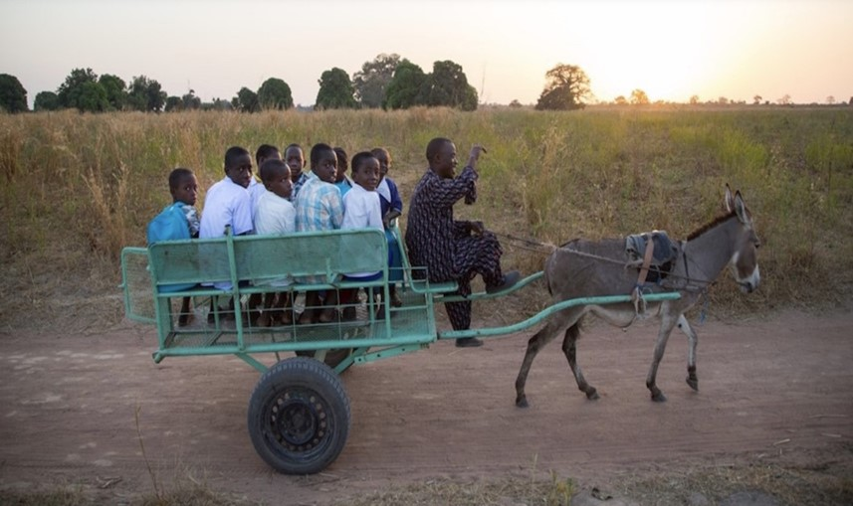
Thank you for your support!

Check the donkey ears chart
in the hall to see how we are
doing.

