

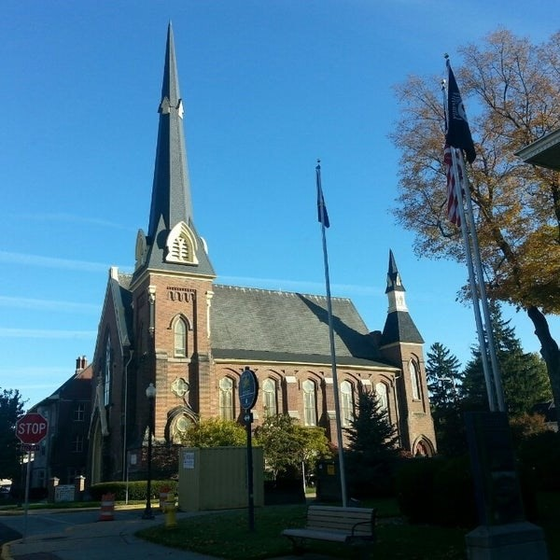
December 10, 2025

A Global Methodist Church
214 S. 5th Street
Goshen, IN 46528
Phone: 574-533-9518
Web Site: goshenfirstgmc.org

Office Hours: Monday-Friday,
8:00 a.m.-12:00 noon
Worship: 9:00 a.m.
Sunday School: 10:30 a.m.
Pastor Jeff & Lisa
Associate Pastor Rich Hull
OUR CHURCH VISION – “Growing in Faith, Gathering in Community, and Giving in Love”.


CHRISTMAS TREE ORNAMENTS
The Christmas ministry ornaments are on the tree and need to be returned to the church by December 14. Gifts will be delivered December 16-20. They are given to needy children in the Goshen area. You may make financial gifts for others to shop. If you are available to help with shopping or delivering or have questions, contact Loraine Troyer, 574-361-3123.


CHRISTMAS CARD EXCHANGE
The Christmas mailbox and cards are just outside the sanctuary. That allows those who use the elevator to easily send cards and to check for cards being received. Please remember to check for your cards. We will be there to assist you. The last day to mail cards will be December 21. Cards coming in on December 21 will be distributed on Christmas Eve and December 28. Please mail cards to those who would not be available to pick up cards during those dates.


CHRISTMAS CANTATA
Our Christmas Cantata with choir and orchestra will be on Sunday, December 14, at 9:00 a.m. Everyone is welcome!

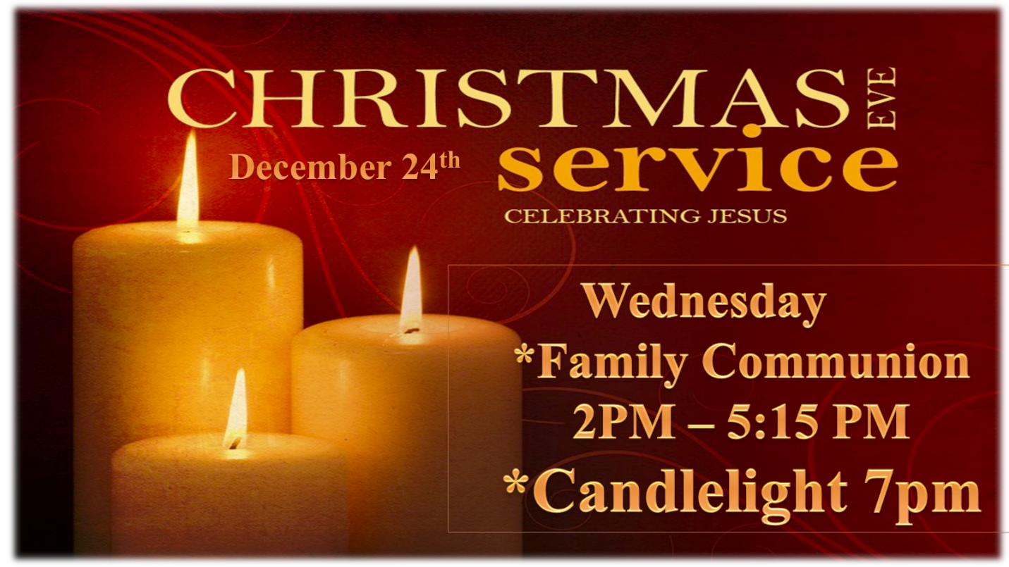

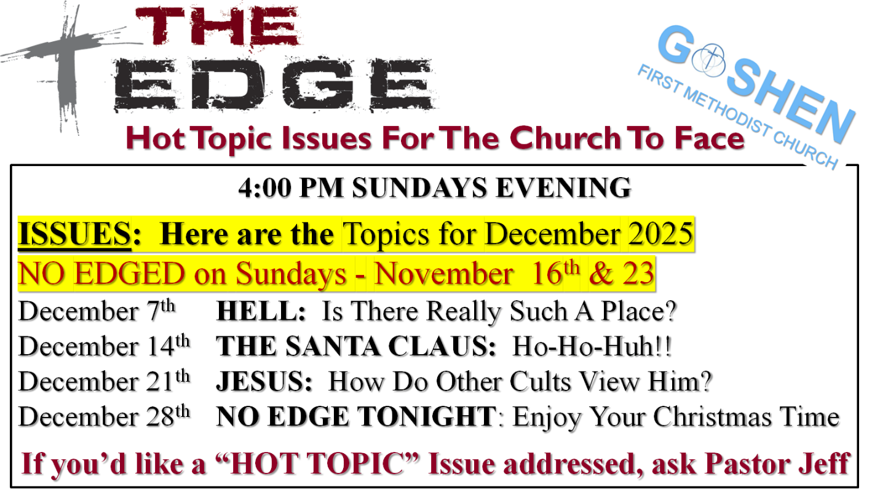

VOLUNTEERS – Thank you for your service! Sunday morning, December 14
Greeters: Neil & Sue Graves VIP: Max Leatherman
Elevator Hosts: Donna Solyom, Janet Taylor
Ushers: Erv Herschberger, Sharon Hull, Ken Smith, Dan Becker, Steve Warner
Scripture Reader: Karen Andrews
Junior Church: Elementary – Pat Huber, Karen Andrews
Junior Church: Jr. High – Jeanne Bigler
Coffee Hour: Kelley Leeper, J.D. & Linda Russell
Bus Driver: Al Eppert


We are in need of a bus driver for Sunday mornings to help pick up some of our members. You would drive on a rotating basis with the other drivers. Please let Harriet at the church office know if you can help.

OUR STAFF
Pastor Jeff Bealmear – pastorjeff@goshenfirstgmc.org
Associate Pastor Rich Hull – rich@goshenfirstgmc.org
Pastor Emeritus Ben Whirledge – benwhirledge@goshenfirstgmc.org
Harriet Martin, Office Administrator – harrietmartin@goshenfirstgmc.org
Scott Carter, Director of Music Ministry – carters@westview.k12.in.us
Rachel Tenorio, Children/Youth Director – rachel@goshenfirstgmc.org
Linda Ponce, Treasurer – lcponce1@gmail.com
DeDe Russell, Caring Ministries Coordinator – russelldede@yahoo.com
Kimberly Lichty-Nyce, Social Media Editor – klichty-nyce@comcast.net
Joel Lane, Pianist – joell12068@gmail.com
John Jinright, Organist – jjinrig@troy.edu
Rodney Troyer, Custodian – troyerstc@gmail.com
Jazlyn Troyer, Sound Tech
Chris & Gretchen Martin, Video Techs – leia2121@hotmail.com

