

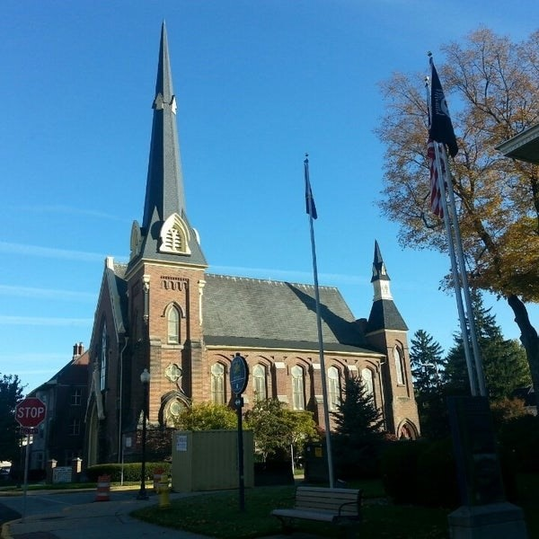
December 3, 2025

A Global Methodist Church
214 S. 5th Street
Goshen, IN 46528
Phone: 574-533-9518
Web Site: goshenfirstgmc.org

Office Hours: Monday-Friday,
8:00 a.m.-12:00 noon
Worship: 9:00 a.m.
Sunday School: 10:30 a.m.
Pastor Jeff & Lisa
Associate Pastor Rich Hull
OUR CHURCH VISION – “Growing in Faith, Gathering in Community, and Giving in Love”.


CHRISTMAS TREE ORNAMENTS
The Christmas ministry ornaments are on the tree and need to be returned to the church by December 14. Gifts will be delivered December 16-20. They are given to needy children in the Goshen area. You may make financial gifts for others to shop. If you are available to help with shopping or delivering or have questions, contact Loraine Troyer, 574-361-3123.


CHRISTMAS CARD EXCHANGE
The Christmas mailbox and cards are just outside the sanctuary. That allows those who use the elevator to easily send cards and to check for cards being received. Please remember to check for your cards. We will be there to assist you. The last day to mail cards will be December 21. Cards coming in on December 21 will be distributed on Christmas Eve and December 28. Please mail cards to those who would not be available to pick up cards during those dates.

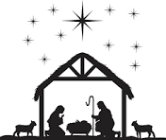
SPECIAL S.S. CLASS
Would you like to learn more about Christ's birth and the prophetic and historical records that show the biblical accounts to be true? Please join Ben and Marie Whirledge in the conference room following Sunday morning worship as they lead a 4 week study, "The Case for Christmas". This is a video series by Lee Strobel as he presents the evidence that shows the true miracle of Christ's birth. Lee was a former atheist and a legal journalist for the Chicago Tribune who came to believe in God after many years of searching. All are welcome to attend!

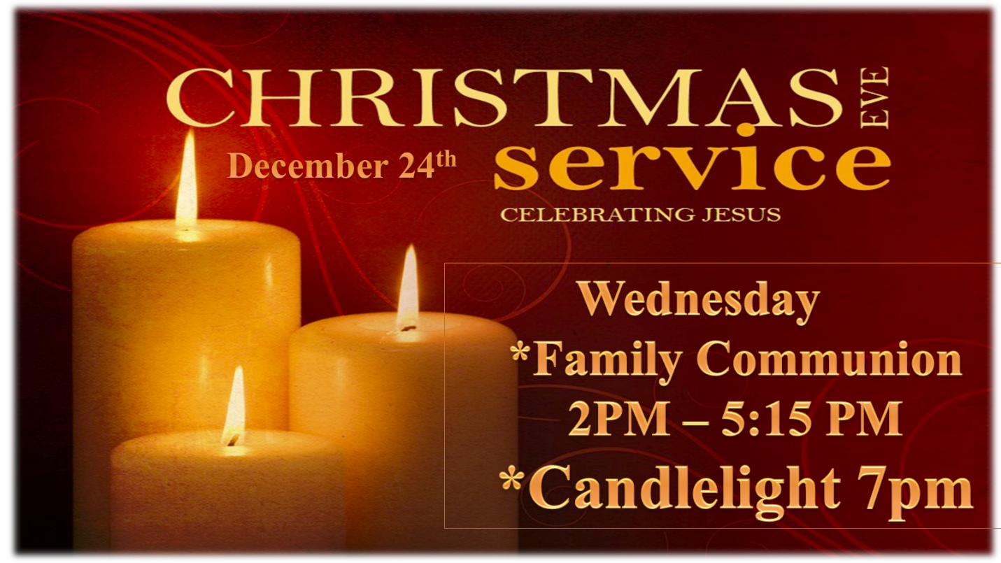

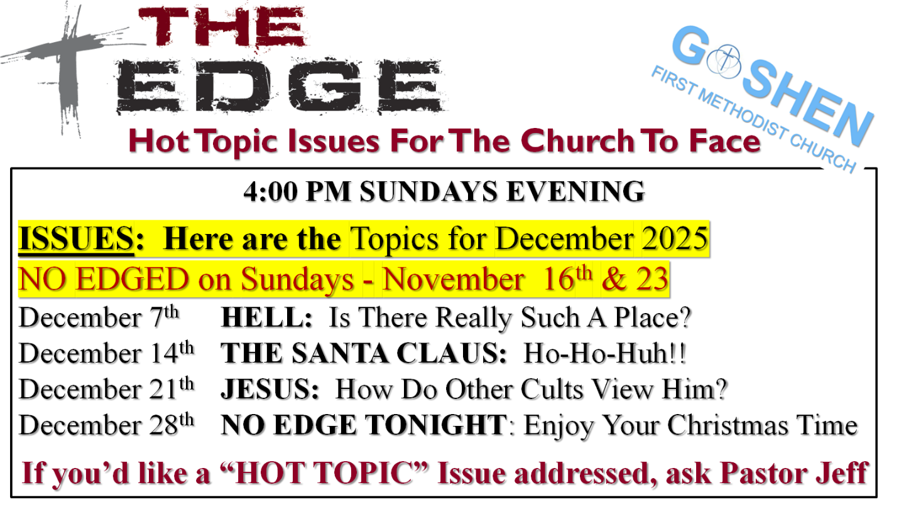

VOLUNTEERS – Thank you for your service! Sunday morning, December 7
Greeters: Kathy Robarge, Carol Rink VIP: Max Leatherman
Elevator Hosts: Dan & Kathy Seltenright
Ushers: Erv Herschberger, Sharon Hull, Ken Smith, Dan Becker, Steve Warner
Scripture Reader: Larry Solyom
Junior Church: Elementary – Rachel Parsons Tenorio, Marcia Parsons
Junior Church: Jr. High – Beth Pettit
Coffee Hour: Steve & Beth Pettit, Sharon Hull
Bug Driver: Gary Miller
Blood Pressure Clinic: Amber Krebs
Communion Servers: Gary & Pat Huber, Dave & Elaine McCann

CHURCH CALENDAR – DECEMBER
MONDAYS
9:30 a.m. – Bible Study – for men and women
12:00-12:45 p.m. – Exercise (PIYO)
6:00 p.m. - Handbells
7:00 p.m. – Boy Scouts/Cub Scouts

TUESDAYS
9:00-9:45 a.m. – Exercise class (Shred 60)
6:00 p.m. – Prayer at church (first and third Tuesdays)
5:30-6:00 p.m. – Exercise class (High Intensity Interval Training)

WEDNESDAYS
10:00 a.m. – Painting class
3:00 p.m. – Church Council (December 10)
5:30 p.m. – Meal
6:00 p.m. – Classes
7:00 p.m. – Choir practice
7:00 p.m. – Christmas Eve Service (December 24)

THURSDAYS
9:00-9:45 a.m. – Exercise class (Shred 60)
12:00-1:00 p.m. – Men’s Brown Bag Lunch (every week)
5:30-6:00 p.m. – Exercise class (High Intensity Interval Training)

SATURDAYS
5:30-10:00 p.m. – Contra Dance (first Saturday night – Dec. 6)
SUNDAYS
9:00 a.m. – Worship
9:00 a.m. – Christmas Cantata (December 14)
10:30 a.m. – Sunday School
4:00 p.m. – “The Edge”

