Parkside Lutheran Church

Rediscovering the Radical Love of Jesus
Gathering All
Serving All
Caring For All

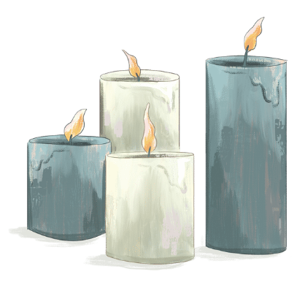

December 21st, 2025
“The Longest Night”
The Rev. Kristen Arends

KEEPING VIGIL FOR HOPE

Gathering Music

Welcome and Passing the Peace
P: Friends, though Christmas is a time of joy and hope, we also recognize that fear and grief are often present too, weighing on us like a heavy fog. Tonight we will light candles together and keep vigil, inviting God to join us no matter what emotions are present too.
The candles in our hands can feel fragile, insignificant, their flames easily extinguished. But in a few minutes, we will turn to our neighbors to spread the light. The light will multiply, wrapping this whole community in warmth. The darkness around us will not be eradicated; if anything, it further illuminates the flicker of the candles. In these vigil spaces, grief and fear dance with gratitude and hope. In these spaces, we find courage and unity. Let us keep vigil. Let us worship God together.

Opening Candle Lighting
P: Even through the longest nights, C: we keep vigil.
P: When days are long and we grow weary, C: we keep vigil.
P: When we’re running out of hope, C: we keep vigil.
P: When peace feels like a pipe dream, C: we keep vigil.
P: When joy seem like a luxury we can’t afford, C: we keep vigil.
P: When the world is more full of hate than love, C: we keep vigil.
P: When we’re desperate for Christ, Emmanuel, God-with-us, C: we keep vigil.
P: Let us keep vigil, for God is surely with us.

Passing the Peace and Passing the Light
P: Let us now pass the peace of Christ to one another as we pass the candlelight, remembering that each of us carries the Christ-light within. May the peace of Christ be with you. C: And also with you.

Opening Hymn: O Little Town of Bethlehem ELW #279
(printed next page)

Scripture Reading: Isaiah 64
L: ¹ O that you would tear open the heavens and come down, so that the mountains would quake at your presence—² as when fire kindles brushwood and the fire causes water to boil—to make your name known to your adversaries, so that the nations might tremble at your presence! ³ When you did awesome deeds that we did not expect, you came down; the mountains quaked at your presence. ⁴ From ages past no one has heard, no ear has perceived, no eye has seen any God besides you, who works for those who wait for him. ⁵ You meet those who gladly do right, those who remember you in your ways.
But you were angry, and we sinned; because you hid yourself we transgressed. ⁶ We have all become like one who is unclean, and all our righteous deeds are like a filthy cloth. We all fade like a leaf, and our iniquities, like the wind, take us away. ⁷ There is no one who calls on your name or attempts to take hold of you, for you have hidden your face from us and have delivered us into the hand of our iniquity.
⁸ Yet, O Lord, you are our Father; we are the clay, and you are our potter; we are all the work of your hand. ⁹ Do not be exceedingly angry, O Lord, and do not remember iniquity forever. Now consider, we are all your people. ¹⁰ Your holy cities have become a wilderness; Zion has become a wilderness, Jerusalem a desolation. ¹¹ Our holy and beautiful house, where our ancestors praised you, has been burned by fire, and all our pleasant places have become ruins. ¹² After all this, will you restrain yourself, O Lord? Will you keep silent and punish us so severely?
L: This is the Word of the Lord. C: Thanks be to God

Silent Reflection
P: I invite you now into a time of quiet reflection. Close your eyes and feel the ground supporting you. Pay attention to what you feel in your body:
What is your breathing like?
Where do you feel tension?
How is your heart?
Notice without judgment the way your body may be carrying fear into this space. Gently ask your body in its wisdom, “What do you fear?” and listen for its response.
Hold silence for a few moments to allow for reflection
I invite you now to slow your breathing. Place a hand on your chest. Relax any areas of tension you’re carrying. Be gentle to your body. Breathe deeply, inviting God—our source, our spirit, our very breath—into your lungs.
Amen.

Poetry Reading: A Step Toward Home
L: I will not tell you to buck up,
to tough it out, to ignore the fear
rattling around in your chest.
I will not tell you that all shall be well
or that morning will come quickly.
I will not ask you to march into danger
without first repeating your name in my prayers.
But if fear stops you in your tracks,
if fear makes it hard to breathe,
hard to move,
hard to think,
then I will remind you
that even one step with shaking knees
is a step toward home.
Scripture Reading: Isaiah 54:10-14
L: ¹⁰ For the mountains may depart and the hills be removed, but my steadfast love shall not depart from you, and my covenant of peace shall not be removed, says the Lord, who has compassion on you. ¹¹ O afflicted one, storm-tossed and not comforted, I am about to set your stones in antimony and lay your foundations with sapphires. ¹² I will make your pinnacles of rubies, your gates of jewels, and all your wall of precious stones. ¹³ All your children shall be taught by the Lord, and great shall be the prosperity of your children. ¹⁴ In righteousness you shall be established; you shall be far from oppression; indeed, you shall not fear; and from terror; indeed, it shall not come near you.
L: This is the Word of the Lord. C: Thanks be to God

Sung Response: Come, Thou Long Expected Jesus ELW #254

Words of Comfort/Affirmation of Faith
P: Time after time, the angels break in with a greeting:
C: “Do not fear.”
P: So when our days are heavy and our sleep grows restless,
C: we believe that God is near.
P. When fear feels greater than hope,
C: we’ll look for signs of new life; we’ll take a step toward God with shaking knees; we’ll stand together; and we won’t let fear stop us.
P: When we’re desperate for Christ, Emmanuel, God-With-Us, we’ll remember:
C: we are the hands and feet of Christ, made in God’s own image, called to be light-bearers in a fearful world.
P: For we know that, no matter how it may seem,
C: God is here, among us, even now. Amen.

Prayers of the People
P: I now invite you to bring your candle to the Communion Table, placing it in a candle holder as you say a prayer for the hopes and fears you carry in your heart. We will hold each of these prayers, trusting that God knows the depths of our longing and enters in with a tenacious hope.

L: God of mercy and compassion, there are those among us who are grieving over what might have been. Death or loss or terrible hurt has changed our experience of Christmas.
We remember that once it was a special day for us, too, but someone or something precious has gone away from us in this life.
We have lost a beloved, a job, a goal, a cause, a dream. We find ourselves adrift and alone.
We are weary from the journey, and we have found no room at the inn.
We come to you seeking rest, and peace, and shelter from the storm. Lord, receive our prayer.
All: And in Your merciful love, answer.

L: God of grace, in the spirit of the season, grant us all that we need to comfort us as we journey through this Christmas season.
We ask that you shelter and sustain all those of us, both here and throughout the world, who wander or want or weep or are heavy laden, that we may be lifted up in courage and journey on in Thy peace. Lord, receive our prayer.
All: And in Your merciful love, answer.

L: God of love, in this Christmas season we embrace and offer up to you all that used to be which is now lost to us, and cannot be again.
With celebration all around us, memories of what was, and fears of what may be, weigh heavy on our hearts.
Please hold us close in your embrace, be near to us this night, until the light returns and morning comes. Lord, receive our prayer.
All: And in Your merciful love, answer.

L: Keep watch, dear Lord, with those who work, or watch, or weep this night, and give thine angels charge over those who sleep. Tend the sick, Lord; give rest to the weary, bless the dying, soothe the suffering, pity the afflicted, shield the joyous; and all for thy love’s sake. C: Amen.

Words of Institution
P: In the night in which he was betrayed, our Lord Jesus took bread, and gave thanks; broke it, and gave it to his disciples, saying: Take and eat; this is my body, given for you. Do this for the remembrance of me. Again, after supper, he took the cup, gave thanks, and gave it for all to drink, saying: This cup is the new covenant in my blood, shed for you and for all people for the forgiveness of sin. Do this for the remembrance of me.

Lord’s Prayer
P: Lord, remember us in your kingdom and teach us to pray.
C: Our Father, who art in heaven, hallowed be thy name, thy kingdom come, thy will be done, on earth as it is in heaven. Give us this day our daily bread; and forgive us our trespasses, as we forgive those who trespass against us; and lead us not into temptation, but deliver us from evil. For thine is the kingdom, and the power, and the glory, forever and ever. Amen.

Communion Distribution

Communion Hymn: In the Bleak Midwinter ELW #294
(printed next page)
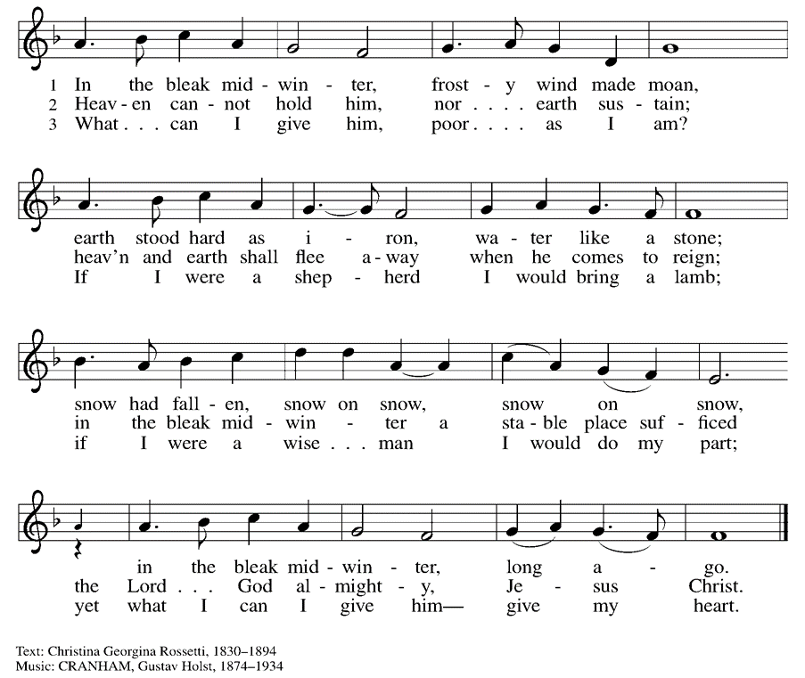

Prayer After Communion
All: Loving God, in a world racked with fear, you gather us together. You set the table. You meet us here. You nourish our bodies as you nourish our spirits. You remind us that this is a joyful feast, and that fear cannot win every time. So with renewed courage, with renewed hope, with renewed conviction, send us out into the world. Help us feed others as you have fed us. With gratitude we pray. Amen.

Closing Hymn: Christ, be Our Light ELW #715
(printed next page)

Benediction*
P: In a fearful world, may you look for God’s spirit. May you reach for each others’ hands. May you choose courage whenever you can. And in all things, may you remember that good news is louder than fear. In the name of the one who calls, the one who sends, and the one who journeys with—go in peace and be not afraid. C: Amen.

*This benediction is by Rev. Sarah Speed from the “What do you fear?” Words for Worship.

Dismissal
P: Go in peace. Christ is with you. C: Thanks be to God.

ELW Music licensed from Sundays & Seasons, Augsburg Fortress CCLI MUSIC License # 11440069 , CCLI
Streaming License#21835523 Do not duplicate any music or Liturgy herein without license and permission

To sponsor Altar flowers or a Soloist in honor of a loved one
or to mark a special occasion. Contact the office for more info.

PARKSIDE STAFF:
• The Rev. Jeremiah Smith: prjeremiahpsmith@gmail.com
• Kris Pope & Suzanne Gracie, Admin. Assistants (Church Office): parksidelutheran@gmail.com
• Mike Hooker, Music Director: mrhooker@me.com

CHURCH OFFICE HOURS: M/T/R 10:00am-3:00pm (716)836-1361

SCHEDULES and Events:
Acolytes: |  | Worship Assistants
12/24 AM – Chris & Katie |  | 12/24 AM – Susan
12/24 PM – David & Grace |  | 12/24 PM - Susan
Readers: |  | Ushers:
12/24 AM - Susan |  | 12/24 AM – Zack R, Joanne N & Charlie R
12/24 PM – Susan |  | 12/24 PM – Dave C, Joanne N & Charlie R

Coming up:
- December 24th – Christmas Eve Family Service 10am & Candle Light Service 10pm
- December 28th – Lessons & Carols 10am
- January 3rd – Holiday Hayride 4pm – 7pm – Contact the Office if you are able to volunteer or donate. See sign-up sheets in the Narthex!
- January 17th – Lego Night in Fellowship Hall 5 – 7pm

Visit our website for more information about these and other Events at Parkside – www.parksidelutheran.org/events

Poinsettias given by:
Pam & Jim Budny:  In honor of our Grandchildren | Susan McNamara:  In memory of Loved Ones
Susan Bundt:  In memory of Richard & Patricia Bundt | Stephanie Rogers  In memory of Patricia A Taylor
Diane Elrod:  In memory of William Elrod | Gail Petschke:  In memory of Thomas Petschke  In memory of Thomas Petschke Jr.
Kaetlyn Simpson:  In memory of Oma & Opa | Kathy & Gary Szakmary:  In memory of Jutta (Oma) & Ernest (Opa) Kosan
Gary & Susan Kenline:  In honor of Our Family & Friends | Jeremiah Smith:  In honor of kids who make joyful noises in worship; In memory of Sherilyn E. Smith; Robert and Beverly Evans
The Griffa & Harden Families:  In honor of June H. Dennis; In Memory of Arthur J. Griffa & Walter J. Harston | The Then Family:  In honor of Loved Ones
Pat Wilson & The Krolewski Family:  In memory of Fran Ball | Katie Simon:  In memory of Herbert, Gloria, & Paul Simon and Gene & Isabelle Schoetz
Jen & Josiah Kachelmeyer:  In memory of Tom Kachelmeyer, Jeff Donato, Eleanor & David Scott, Barb Holmes | Paul & Linda Witmer:  In honor of Loved Ones
Emma Spronk:
In memory of Art Spronk &
Kathleen Van Arragon

2025 Christmas Wish List
Our Values at Parkside are: Proclaiming Grace, Extending Hospitality, Loving Boldly, and Cultivating Community. Without you, and God at work through you, these would remain just words on a page. We invite those who are able, to consider a year end gift towards one of the items from our Christmas List. You need not feel like you must cover the total cost of an item, but are welcome to contribute any amount. We give thanks to God for all the ways you make ministry happen. May God Bless You and we hope to see you for Advent and Christmas Celebrations. -Pastor Jeremiah

For Outreach Ministry:
- Sponsor Buffalo Burrito Project - $200
- Covers Burritos, Coffee, snacks and more for 60 to 100 neighbors who are hungry.
- Sponsor Food Pantry Overhead, including utilities, etc - $100

For The Office:
- Roll of Stamps - $78
- In 2026 we hope to send out a Spring and Fall Newsletter. Covering the stamps helps keep our community informed on upcoming Events and Good News!

For Property:
- Installing Crash Bars- $1000 x 6
- For increased accessibility and safety, we want to convert all doors into crash bars.

For Hospitality:
- Self-Serve coffee bar in Narthex - $25 x 12
- As we seek to build community in a way that does not place more work on volunteers, we would like to add a self-serve coffee bar in the Narthex. This way, folks can feel encouraged to have conversation and build community after worship. Gifts will cover Keurigs, Coffee, and supplies.

For Worship:
- Sponsor a Soloist - $150
- A soloist assists in congregational singing and an aid to our worship. If you sponsor a soloist, you can talk with music Director Michael Hooker and make recommendations for special music!
- Christmas Trees - $600 x 1
(Thank you to a Generous Donor who sponsored one already!)
- After a 100 years of using real trees, we have decided to invest in pre-lit trees. These are less of a fire hazard, easier on volunteers, and better stewardship of resources.
- Sponsor Flowers for the Easter Cross - $175
For Education:
- Sponsor Child Care for a Sunday - $50
- We are so blessed to have wonderful staff who offer safe, welcoming, loving care. We are currently looking to hire a second staff person. Your gift helps with this most important investment, our youngest members.

- Curriculum - $200
- From worksheets and engaging videos, to silly games, our digital curriculum offered through the ELCA’s publishing arm, spark house digital, is a wonderful asset to Confirmation and Sunday School.

