Holy Trinity Evangelical Lutheran Church

December 21, 2025 10:30am

Pastor Tina Crog

*Prelude

*Welcome and Announcements

*Gathering Hymn "The Angel Gabriel from Heaven Came" ELW #265
Public Domain
1. The angel Gabriel from heaven came, with wings as drifted snow, with eyes as flame. “All hail to thee, O lowly maiden Mary, most highly favored lady.” Glo-ri-a!

2. “For know a blessed mother thou shalt be, all generations laud and honor thee; thy son shall be Emmanuel, by seers foretold, most highly favored lady.” Glo-ri-a!

3. Then gently Mary meekly bowed her head; “To me be as it pleaseth God,” she said. “my soul shall laud and magnify God’s holy name.” Most highly favored lady, Glo-ri-a!

4. Of her, Emmanuel, the Christ, was born in Bethlehem all on a Christmas morn, and Christian folk throughout the world will ever say: “Most highly favored lady.” Glo-ri-a

* Confession and Forgiveness Pastor Tina
Blessed be the holy Trinity, ☩ one God, whose home is heaven and earth, whose salvation is sure. Amen.

God is here, and God sees through every defense that fools the world. Since we cannot hide from God, there is nothing left to do but to be honest with each other and humble before God. So, in humility, we confess our sins.

God with us, we have acted helpless, even when you called us to action. We have resisted your truth, even when our lies were exhausting. We have behaved as though we were alone, even when you were beside us. We can never undo the sins of this world, but we trust in your perfect plan for salvation. Forgive our sins. Set us free to chart a new path. Help us learn from the echoes of our past. In the name of Emmanuel, Jesus Christ, we pray. Amen.

Hear the good news: God the Faithful One loves you, ☩ in Christ Jesus your sins are forgiven, and by the power of the Holy Spirit you are set free. Amen.

* Kyrie (to the Tune of “Come Thou Long Expected Jesus,” ELW 254)
Public Domain
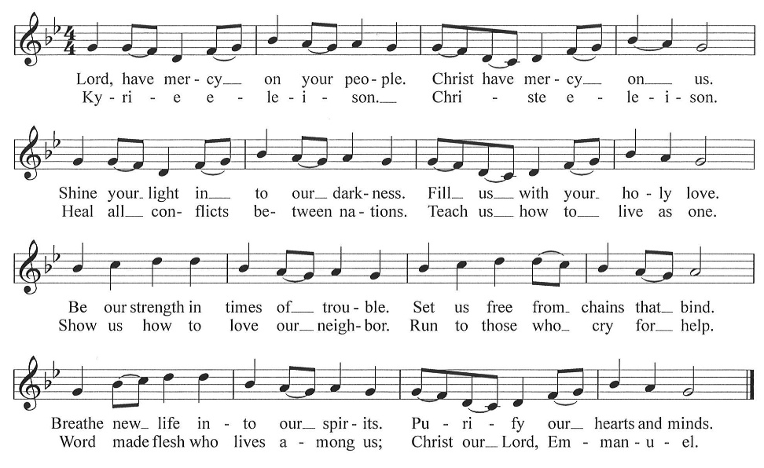

* Greeting

* Prayer of the Day Worship Assistant
Mighty God of mercy, you turn the world upside down through the trust of your servants. As Mary pondered in her heart at your surprising grace, fill us with faith to see your turning points in our lives and courage to say yes to your invitation; through Jesus Christ, the Word made flesh, who lives and reigns with you and the Holy Spirit, one God, now and forever. Amen.

*The Peace Worship Assistant
The peace of Christ be with you, always.
And also with you.
Stay in your seat and wave to one another the peace of Christ.

Lighting of the Advent Wreath Jared and Kali Goldinger The Goldinger’s:
There is a moment when we no longer need a light in the darkness. Perhaps dawn has come to fill every corner of the room with sunlight. Or, we have grown so familiar with our surroundings that we can find our way without sight. Or, the person we have longed to know now rests by our side, peacefully breathing. God’s goodness has always grown quietly in our midst, like the infant who has grown just out of sight, just beyond our touch.
This final candle represents the moment we see and hold God’s promise for ourselves.

Four candles are lit.

Pastor Tina:
Let us pray. Emmanuel, God with us, you are nearer to us every day. We await your promise. In the name of Jesus we pray. Amen.

*Song “Light One Candle to Watch for Messiah” ELW 240
One License A-700000
1.Light one candle to watch for Messiah: let the light banish darkness.
He shall bring salvation to Israel, God fulfills the promise.

2.Light two candles to watch for Messiah: let the light banish darkness.
He shall feed the flock like a shepherd, gently lead them homeward.
3.Light three candles to watch for Messiah: let the light banish darkness. Lift your heads and lift high the gateway for the King of glory.

4.Light four candles to watch for Messiah: let the light banish darkness. He is coming, tell the glad tidings. Let your lights be shining!

*Children’s Message Pastor Tina

*First Lesson: Reader
Read the explanation: An Israelite and Aramean military coalition presented a serious threat to King Ahaz of Judah. In response, Ahaz decided to secure his throne and kingdom by seeking Assyrian help. Isaiah reminds Ahaz that human attempts to establish security will fail. The prophet gives the sign that is the only source of true safety: Immanuel, God is with us!

^{Reading from Isaiah 7:10-16}
¹⁰ The Lord spoke to Ahaz, saying, ¹¹ “Ask a sign of the Lord your God; let it be deep as Sheol or high as heaven.” ¹² But Ahaz said, “I will not ask, and I will not put the Lord to the test.” ¹³ Then Isaiah said, “Hear then, O house of David! Is it too little for you to weary mortals that you weary my God also? ¹⁴ Therefore the Lord himself will give you a sign. Look, the young woman is with child and shall bear a son and shall name him Immanuel. ¹⁵ He shall eat curds and honey by the time he knows how to refuse the evil and choose the good. ¹⁶ For before the child knows how to refuse the evil and choose the good, the land before whose two kings you are in dread will be deserted.”

The Word of the Lord. Thanks be to God.

*Second Lesson: Reader
Read explanation: Most of the Christians in Rome do not know Paul. In this letter’s opening he introduces himself as an apostle divinely appointed to spread God’s gospel. The gospel’s content is the promised coming of Christ, and Paul’s mission is to bring about the obedience of faith among all nations, including his Roman audience.
Reading from Romans 1:1-7 Reader
¹ Paul, a servant of Christ Jesus, called to be an apostle, set apart for the gospel of God, ² which he promised beforehand through his prophets in the holy scriptures, ³ the gospel concerning his Son, who was descended from David according to the flesh ⁴ and was declared to be Son of God with power according to the spirit of holiness by resurrection from the dead, Jesus Christ our Lord, ⁵ through whom we have received grace and apostleship to bring about the obedience of faith among all the gentiles for the sake of his name, ⁶ including you who are called to belong to Jesus Christ,
⁷ To all God’s beloved in Rome, who are called to be saints:
Grace to you and peace from God our Father and the Lord Jesus Christ.

The Word of the Lord. Thanks be to God.

*Gospel Acclamation “Emmanuel, Emmanuel” W&P page 36
CCLI #11222261
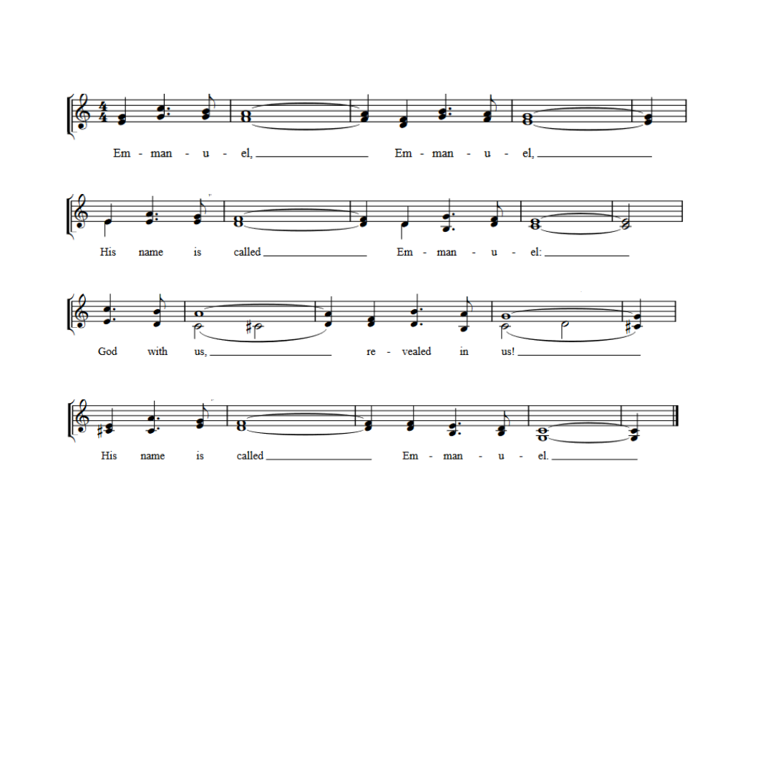
* Gospel: Matthew 1:18-25 Pastor Tina
Matthew’s story of Jesus’ birth focuses on the role of Joseph, who adopts the divinely-begotten child into the family of David and obediently gives him the name Jesus, which means “God saves.”

The Holy Gospel according to Matthew, the 1st chapter. Glory to you, O Lord.

¹⁸ Now the birth of Jesus the Messiah took place in this way. When his mother Mary had been engaged to Joseph, but before they lived together, she was found to be pregnant from the Holy Spirit. ¹⁹ Her husband Joseph, being a righteous man and unwilling to expose her to public disgrace, planned to divorce her quietly. ²⁰ But just when he had resolved to do this, an angel of the Lord appeared to him in a dream and said, “Joseph, son of David, do not be afraid to take Mary as your wife, for the child conceived in her is from the Holy Spirit. ²¹ She will bear a son, and you are to name him Jesus, for he will save his people from their sins.” ²² All this took place to fulfill what had been spoken by the Lord through the prophet:
²³ “Look, the virgin shall become pregnant and give birth to a son,
and they shall name him Emmanuel,”
which means, “God is with us.” ²⁴ When Joseph awoke from sleep, he did as the angel of the Lord commanded him; he took her as his wife ²⁵ but had no marital relations with her until she had given birth to a son, and he named him Jesus.

The Gospel of the Lord. Praise to you, O Christ.

*Sermon Pastor Tina

*Hymn of the Day “What Child Is This?” ELW 296
Public Domain
1.What child is this, who, laid to rest, on Mary’s lap is sleeping?
Whom angels greet with anthems sweet while shepherds watch are
keeping? This, this is Christ the king, whom shepherds guard and
angels sing; haste, haste to bring him laud, the babe, the son of
Mary.

2.Why lies he in such mean estate where ox and ass are feeding?
Good Christian, fear; for sinners here the silent Word in pleading.
Nails, spear shall pierce him through, the cross be borne for me, for
you; hail, hail the Word made flesh, the babe, the son of Mary.

3.So bring him incense, gold, and myrrh; come, peasant, king, to own
him. The King of kings salvation brings, let loving hearts enthrone
him. Raise, raise the song on high, the virgin sings her lullaby; joy,
joy, for Christ is born, the babe, the son of Mary.

* Prayers of the People Pastor Tina
Please be seated
any prayer requests or joys to share
In our waiting and watching, we come to you in prayer, O God, trusting your promise to renew the church, the nations, and the whole creation.
In the anticipation of these days, prepare our hearts for your arrival. Stir our spirits through the gifts of artists, musicians, poets, and preachers, as together we proclaim your advent among us. God of grace, hear our prayer.
The earth breaks forth in singing as it heralds the Messiah’s coming. Fill our hearts with wonder as we join heaven and nature in announcing this holy birth. God of grace, hear our prayer.
You send your saving grace and peace to the nations. Lead us in work for justice and care for the common good. May we meet the Christ-child we seek in the faces of our neighbors. God of grace, hear our prayer.
When tears of grief, exhaustion, or loneliness come, or physical or emotional hurt overwhelms us, come to our aid. Uphold all who are anxious, who know the challenges of depression, or who are ill (especially). God of grace, hear our prayer.
Surround expectant parents and those suffering from infant loss with communities of support. Bless young children and new parents. Guide us in ways that provide safety for all children and those who care for them. God of grace, hear our prayer.
We give thanks for all who have treasured the gospel and lived in faithful service. Strengthen our earthly journeys until, at the last, your face shines upon us and we are held in your in love. God of grace, hear our prayer.
Draw near to us, O God, as we commend all for whom we pray, trusting in your mercy through Jesus Christ, Emmanuel. Amen.

*Offering Worship Assistant

The monthly mission in december is for “The Collaboration.” Let us give to God what He has first given us.

*Offering Music by Jared

*Offertory Hymn “Our Gifts We Now Bring” vs. 1
to the tune AWAY IN THE MANGER, ELW 277
Public Domain
to be sung while the offering is returned to the altar
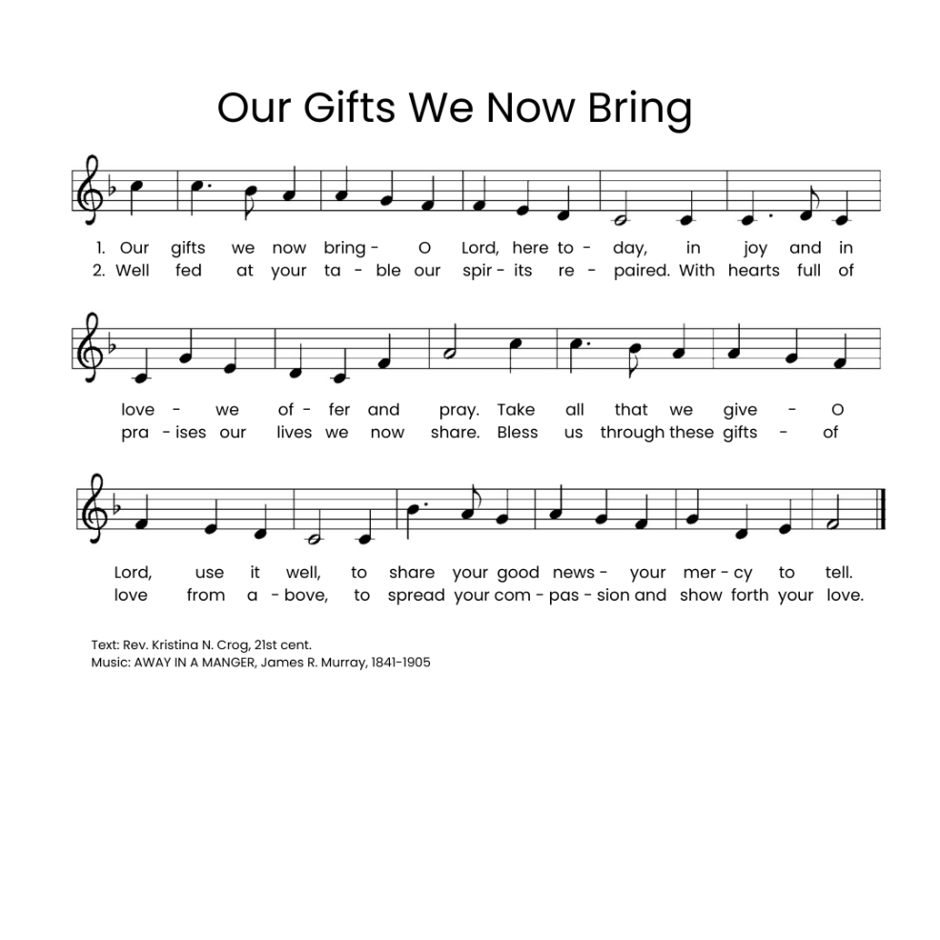

*Offering Prayer Worship Assistant and Congregation
God with us, we cherished what we thought belonged only to us: our money, our time, our families, and our freedom. Yet in a moment, we recognize that every truly good thing was a treasure we had taken from your open hand. We thought such treasures were ours to earn and to own. You grow what we give away. We give you these gifts as a sign of your love and faithfulness. Amen.

* Communion Liturgy Sung to the tune: O Come, O Come, Emmanuel [ELW 257] One License A-700000
Pastor Tina sings a solo and the congregation sings the bold print

The Lord be with you as we gather here.
Lift up your hearts unto the Lord your God.
For it is right to give God our praise.
Let us prepare our hearts for coming days:
Rejoice, Rejoice! Emmanuel
Shall come to you, O Israel.

You created all things and called them good,
made us like you, but we cast off your love.
You set us free and claimed us as yours,
through sage and prophet spoke to us your word.
Rejoice, Rejoice! Emmanuel
Shall come to you, O Israel.

Holy are you and blessed is your Son,
Jesus, the Light, your presence here with us.
You sent him in the fullness of time,
he came to preach good news to all.
Rejoice, Rejoice! Emmanuel
Shall come to you, O Israel.

And on the night that Jesus was betrayed,
Christ took the bread, and unto you gave thanks.
He broke the bread and shared it with friends.
“Take, eat, my body given for you.”
Rejoice, Rejoice! Emmanuel
Shall come to you, O Israel.
After the meal he lifted up the cup,
“My blood, my life, I pour it out for you.
This covenant I make anew.
Set free from sin! Remember me!"
Rejoice, Rejoice! Emmanuel
Shall come to you, O Israel.

Spirit of God descend upon us now,
And make these gifts become for us
the body and the blood of Christ
a holy, living sacrifice.
Rejoice, Rejoice! Emmanuel
Shall come to you, O Israel.

*Lord’s Prayer elw page 208
Our Father, who art in heaven, hallowed be thy name, thy kingdom come, thy will be done, on earth as it is in heaven. Give us this day
our daily bread; and forgive us our trespasses, as we forgive those
who trespass against us; and lead us not into temptation, but deliver
us from evil. for thine is the kingdom, and the power, and the glory,
forever and ever. amen.

*Lamb of God Sung to the tune: O Come, O Come, Emmanuel [ELW 257]
One License A-700000
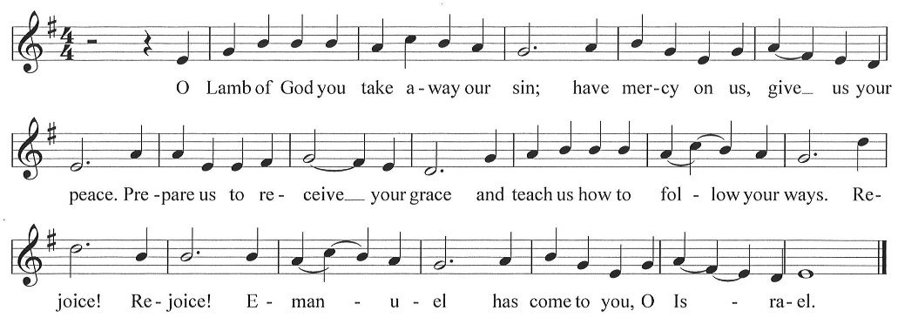

*Post Communion Blessing

*Post Communion Canticle “Our Gifts We Now Bring” vs. 2
To the tund of “Away in the Manger”
Return to page 9 Public Domain

*Prayer After Communion Pastor Tina and Congregation
Jesus, the world looks different from your table. Here, there are no strangers, and grace is never a surprise. Life always thrives in the desert, and a promise never shades with doubt. Soon as we rise from this table, our memories of this goodness fade. Bring us back every day to your promises: astonish us again. Amen.

*Blessing

*Closing Song "Canticle of the Turning" ELW 723
One License A-700000
1.My soul cries out with a joyful shout that the God of my heart is great, and my spirit sings of the wondrous things that you bring to the one who wait. You fixed your sight on your servant’s plight, and my
weakness you did not spurn, so from east to west shall my name be blest. Could the world be about to turn?

2.Though I am small, my God, my all, you work great things in me, and
your mercy will last from the depths of the past to the end of the age
to be. Your very name puts the proud to shame, and to those who
would for you yearn, you will show your might, put the strong to
flight, for the world is about to turn.

3.From the halls of pow’r to the fortress tow’r, not a stone will be
left on stone. Let the king beware for your justice tears ev’ry
tyrant from his throne. The hungry poor shall weep no more, for the
food they can never earn; there are tables spread, ev’ry mouth be
fed, for the world is about to turn.

4.Though the nations rage from age to age, we remember who holds
us fast: God’s mercy must deliver us from the conqueror’s crushing
grasp. This saving word that our forebears heard is the promise
which holds us bound, till the spear and rod can be crushed by God,
who is turning the world around.

*Dismissal
Keep watch! Christ is coming soon!
Thanks be to God!

*Postlude

Prayer of the Day, Advent Wreath Lighting, and Offering Prayer by Barn Geese Worship, 2025
“Kyrie” (based on the tune Come, Thou Long-Expected Jesus) by David Eck, Copyright ©2011
"Emmanuel" by Bob McGee, © 1976 C. A. Music (div. of C. A. Records, Inc.)/ASCAP
“A Sung Communion Liturgy for the Season of Advent” (based on tune: VENI EMMANUEL) by Rev. Beth Quick, 2013, http://bethquick.blogspot.com/2013/11/a-sung-communion-liturgy-for-season-of.html
“Lamb of God” “based on the tune VENI EMMANUEL) by David Eck, Copyright ©2011
"Our Gifts We Now Bring" (based on the tune AWAY IN THE MANGER by James R. Murray) by Rev. Kristina N. Crog, 2024

