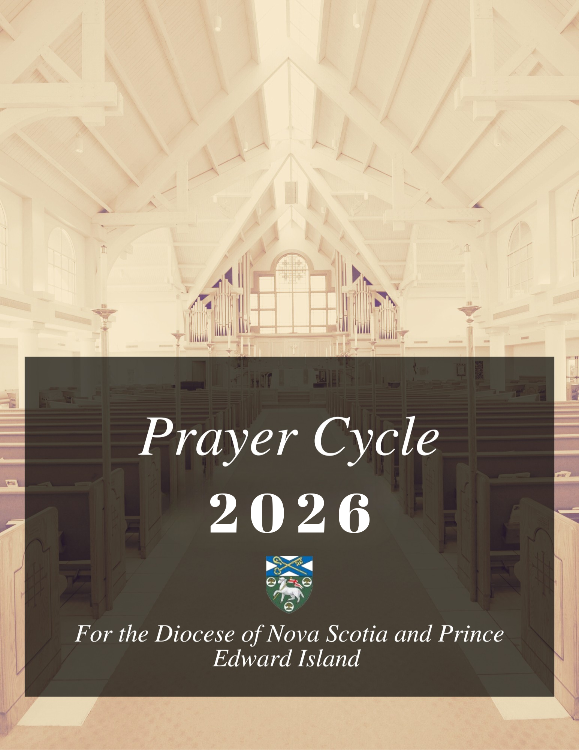

PRAYING BY REGIONS
Regions of the Diocese of Nova Scotia and Prince Edward Island:
- Prince Edward Island
    - January-February
- Cape Breton
    - March
- Northumbria
    - March-April
- Eastern Shore
    - April-May
- Dartmouth
    - May-June
- Chebucto
    - June-July
- Rivers to Trails
    - July-August
- The Valley
    - August- October
- South Shore
    - October-November
- Chignecto
    - November-December

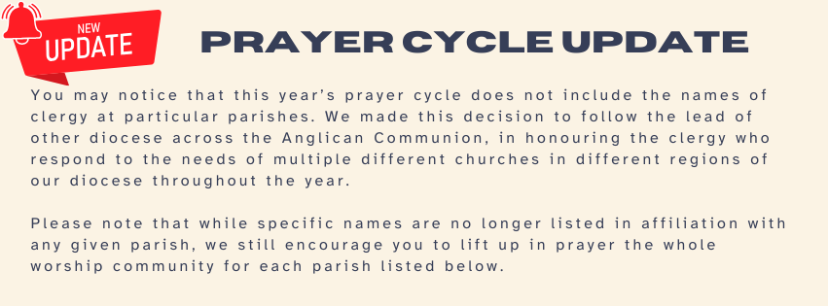
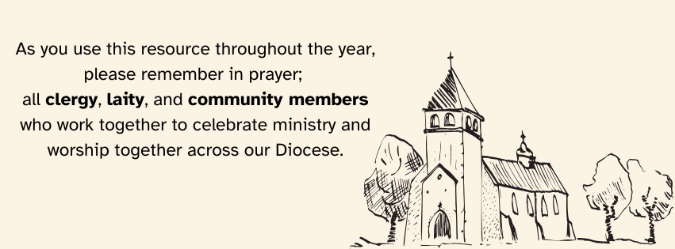

HOW TO READ THE PRAYER CYCLE
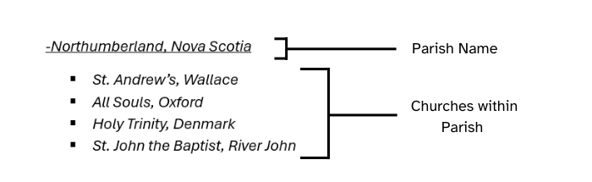

REGION #1 PRINCE EDWARD ISLAND
January 4
-New London, Prince Edward Island
- St. Mark’s, Kensington
- St. Stephen’s, Burlington
- St. Thomas’, Spring Brook
- St. Elizabeth’s, Springfield
January 11
-St. Paul’s, Charlottetown, Prince Edward Island
January 18
-St. Mary And St. John Summerside, Prince Edward Island.
  - St. Mary’s, Summerside
  - St. John’s, Eleanor’s
January 25
-Alberton O'leary, Prince Edward Island
  - Christ Church- Kildare
  - Holy Trinity- Alma
  - St. Luke- O'Leary
  - St. Peter - Alberton
February 1
-Christ Church, Cherry Valley, Prince Edward Island
February 8
-Crapaud, Prince Edward Island.
- St. John the Evangelist, Crapaud
February 15
-Milton/Rustico, Prince Edward Island

February 22
-Port Hill, Prince Edward Island
- St. John’s, Ellerslie
- St. Peter’s, Foxley River
-St. Peter’s Cathedral, Charlottetown, Prince Edward Island
-St. George’s, Montague, Prince Edward Island

REGION #2 THE REGION OF CAPE BRETON
March 1
-St. Alban’s, Sydney, Nova Scotia
-The Collieries Parish in the County of Cape Breton
- All Saints - New Waterford
- Good Shepherd – Dominion
- St. Mary's - Glace Bay
- St. Paul - Port Morien
March 8
-Sydney Mines/ Baddeck
- Trinity Church- Sydney Mines, NS
-Neil’s Harbour with Ingonish, Cape Breton
- St. Andrew - Neil's Harbour
- St. John – Ingonish
March 15
-North Sydney, Cape Breton
- St. John The Baptist, North Sydney, Nova Scotia
-Parish of the Resurrection, Cape Breton, NS
- Church of Christ the King- Sydney
- St. Bartholomew – Louisbourg
- St. George - Sydney
REGION #3 NORTHUMBRIA
March 22
-Three Harbours, Nova Scotia
  - St. Paul’s, Antigonish
  - St. Mary’s, Bayfield
  - Holy Trinity, Country Harbour
March 29
-Canso, Nova Scotia
  - All Saints by the Sea, Canso
  - Holy Trinity, Whitehead
  - Christ Church, Queensport
  - Good Shepherd, Tor Bay
  - St. James’, Halfway Cove
  - Christ Church, Guysborough
April 5
-Anglican Churches of Pictou County, Nova Scotia
  - St. James’, Pictou
  - Christ Church, Stellarton
  - St. Bee’s, Westville
-Liscomb with Port Bickerton, Nova Scotia
- St. Luke’s, Liscomb
- St. James’, Sherbrooke
- St. Paul’s, Port Bickerton
- St. Thomas’, Indian Harbour Lake
April 12
-St. George’s, New Glasgow, Nova Scotia
-Strait-Chedabucto, Nova Scotia
  - St. James’, Melford
  - St. Andrew’s, Mulgrave
  - Holy Trinity, Port Hawkesbury
REGION #4 EASTERN SHORE
April 19
-Ecum Secum, Nova Scotia
- St. Barnabas’, Ecum Secum
- St. Paul’s, Ecum Secum West

-Parish of Musquodoboit/ Ship Harbour
- St. Thomas, Musquodoboit Harbour
- St. James, Head of Jeddore
- St. Stephen’s, Ship Harbour
- St. Matthew’s, Owl’s Head
- St. John’s, Oyster Pond
- St. James’, Upper Lakeville
April 26
-Port Dufferin, Nova Scotia
- St. James’, Port Dufferin
- St. Augustine’s, Beaver Harbour
- St. Mary’s, Harrigan Cove
- St. Margaret’s, Sober Island
- St. Andrew’s, Watt Section
-Seaforth, Nova Scotia
- All Apostles by the Sea, Seaforth
May 3
-Tangier, Nova Scotia
- Holy Trinity, Tangier
- St. James’, Spry Bay
- St. Andrew’s, Spry Harbour
- St. Thomas’, Mooseland
- St. Paul’s, Mushaboom
- St. Peter’s, Murphy Cove

REGION #5 DARTMOUTH
May 10
-Christ Church, Dartmouth, Nova Scotia
-St. Andrew’s, Cole Harbour, Nova Scotia
May 17
-Holy Trinity Emmanuel, Dartmouth, Nova Scotia
-Eastern Passage, Nova Scotia
- St. Peter’s, Eastern Passage
- Christ Church, Cow Bay
May 24
-Holy Spirit, Dartmouth, Nova Scotia
-St. Alban’s, Woodside, Nova Scotia
-St. Andrew’s, Locks Road, Nova Scotia

May 31
-St. Luke’s, Dartmouth, Nova Scotia
-St. John’s, Westphal, Nova Scotia
Region #6 Chebucto
June 7
-The Cathedral Church of All Saints, Halifax, Nova Scotia
-St. James’, Armdale, Nova Scotia

June 14
-St. George’s, Halifax, Nova Scotia
-St. Margaret of Scotland, Halifax, Nova Scotia

June 21
-St. Mark’s, Halifax, Nova Scotia
-Church of the Apostles, Halifax, Nova Scotia
-St. Peter’s Birch Cove, Nova Scotia

June 28
-Parish of Emmanuel, Spryfield, Nova Scotia
-Parish of the Falklands
- St. James, Herring Cove, Nova Scotia
- St. Philip, Purcell’s Cove, Nova Scotia
July 5
-St. Paul’s, Halifax, Nova Scotia
-Trinity Church, Halifax, Nova Scotia

REGION #7 RIVERS TO TRAILS
July 12
-Church of the Good Shepherd, Beaver Bank, Nova Scotia
-Church of the Holy Spirit, Mt. Uniacke, Nova Scotia
-All Saints, Bedford, Nova Scotia
July 19
-St. John’s, Bedford
-Fall River, Nova Scotia
- St. Thomas’, Fall River
- St. Margaret’s, Oakfield

July 26
-French Village, Nova Scotia
- St. Paul’s, French Village
- St. James’, Boutilier’s Point
- St. Margaret’s, Tantallon
- St. George’s, Head of the Bay
-Hackett’s Cove, Nova Scotia
- St. Peter’s, Hackett’s Cove
- St. John’s, Peggy’s Cove
- St. Andrew’s, Indian Harbour
August 2
-St. Nicholas, Westwood Hills, Nova Scotia
-Hatchet Lake and Terence Bay, Nova Scotia
- St. Timothy’s, Hatchet Lake
- St. Paul’s, Terence Bay
August 9
-St. Luke’s, Hubbards, Nova Scotia
- St. Luke, Hubbards
- St. Mark, Mill Cove
-St. John the Evangelist, Sackville, Nova Scotia
August 16
-St. Francis by the Lakes, Lower Sackville, Nova Scotia
-St. Andrew, Timberlea, Nova Scotia

REGION #8 THE VALLEY
August 23
- Annapolis, Nova Scotia
  - St. Luke’s Annapolis Royal
  - All Saints- Gibson’s Lake
  - Christ Church, Karsdale
  - St. John, Moschelle
  - St. Mark, Perotte
-Christ Church, Windsor, Nova Scotia
August 30
The Staff and Students at the Atlantic School of Theology, Halifax, Nova Scotia.
The Rev’d. Dr. Heather McCance, President
The Rev’d Canon Dr. Jody Clarke and Beth
The Rev’d Dr. Paul Friesen and Janet
The Rev’d Paul Jennings, Director of Anglican Formation and Elizabeth Bachem
The Rev’d Laurie Omstead, Interim Director of Re-Imagining Formation, Anglican Accompaniment at AST

The Staff and Students at the University of King’s College, Halifax, Nova Scotia.
Mr. William Lahey, President, and Kathryn
The Rev. Dr. Ranall Ingalls, Chaplain

The Staff and Students at Kings-Edgehill School, Windsor, Nova Scotia.
Mr. Joseph Seagram, Headmaster, and Belinda

The programmes of Discernment, Training and Formation for Ordained Ministry
Rev’d Carl Fraser, Vocations Coordinator for the Anglican Diocese of Nova Scotia and Prince Edward Island.
September 6
-Aylesford with Berwick, Nova Scotia
  - Christ Church, Berwick
  - St. Mary’s, Auburn
  - Christ Church, Morden
-Brooklyn, Nova Scotia
  - St. James’, Brooklyn
  - St. John the Baptist, Poplar Grove
September 13
-Bridgetown, Nova Scotia
- St. James’, Bridgetown
- St. Mary’s, Bellisle
- St. Peter, Dalhousie
-Clements, Nova Scotia
- St. Edward’s, Clementsport
- St. John’s, Bear River
- Old St. Edwards, Old Post Road
- St. Anne’s Birch Chapel, Smith’s Cove

September 20
-St. John’s, Wolfville (Horton), Nova Scotia
-Cornwallis, Nova Scotia
  - St. John’s, Port Williams
  - St. Thomas’, Kingsport
-Digby, Nova Scotia
- Trinity, Digby
- Church of the Nativity, Sandy Cove
September 27
-Weymouth, Nova Scotia
- St. Peter and St. Thomas, Weymouth North
- St. Matthew’s, Weymouth Falls
-St. James’, Kentville, Nova Scotia

October 4
-New Ross, Nova Scotia
- St. Cyprian’s, Dalhousie
- St. Augustine’s, The Forties
- Christ Church, New Ross
-Rawdon, Nova Scotia
  - St. Paul’s, Centre Rawdon
  - St. Stephen’s, Stanley
October 11
-Wilmot, Nova Scotia
- Holy Trinity Church, Middleton
- All Saints' Church, Kingston
-Avon Valley, Nova Scotia
  - St. George’s, Falmouth
  - St. Michael’s, Windsor Forks
  - All Saints, Leminster
  - St. Thomas’, Three Mile Plains
  - St. Andrew’s, Hantsport
REGION #9 SOUTH SHORE
October 18
-Bridgewater and the Conqueralls, Nova Scotia
- Holy Trinity, Bridgewater
- St. James’, Conquerall Mills
-Blandford, Nova Scotia
- St. Barnabas, Blandford
- All Saints, Bayswater
- St. Cuthbert’s, North West Cove
-Yarmouth and Tusket, Nova Scotia
- Holy Trinity, Yarmouth

October 25
-Mahone Bay, Nova Scotia
- St. James’, Mahone Bay
- Christ Church, Maitland
-New Germany, Nova Scotia
- St. John in the Wilderness, New Germany
- St. Andrew’s, West Northfield
November 1
- New Dublin
  - St. John, West Dublin
  - St. Paul, Cherry Hill
  - St. James, LaHave
  - St. Peter, West LaHave
-Blue Rocks, Nova Scotia
- St. Barnabas, Blue Rocks
-Lockeport/Barrington
- Holy Cross - Lockeport
- Holy Trinity – Jordan Falls
November 8
PRAY FOR VETERANS OF THE CANADIAN ARMED FORCES AND THE MINISTRY OF ARMED FORCES CHAPLAINS.
We remember this day the Anglican Priests who serve their country for our Diocese:
Capt. the Rev’d Leonard Bednar
LCol. (Retired) the Rev’d Andrew Cooke and Valerie
Capt. the Rev’d Jim McCorriston
LCol. the Rev’d Canon Todd Meaker and Theresa
Lt.(N) the Rev’d Robert Parker, and The Right Rev’d Rachael Parker.
LCol. (Retired) the Rev’d Canon Dr. Gary Thorne and Sandra
Capt. The Rev'd Maya Bevan
Capt. the Rev’d Kent and Rev'd Dawn-Lea Greer
LCol. the Rev'd Canon Beverley Kean and LCol. Canon Dennis Newhook
Chaplain, Padre A.J. Cottreu
Chaplain, Padre, Meghan Nicholls
LCdr. (Retired) the Rev. Canon Charles Black

November 15
-St. John’s, Lunenburg, Nova Scotia
-St. Martin’s Western Shore, Nova Scotia
- Grace Anglican, Chester Basin
-South Queens, Nova Scotia
- St. John’s, Eagle Head
- Holy Redeemer, Port Medway
- St. Andrew’s, Brooklyn
- Trinity, Liverpool
- St. James’, Hunt’s Point
November 22
-Christ Church Shelburne, Nova Scotia
-Petite Riviere, Nova Scotia
  - St. Mark, Broad Cove
  - St. Michael & All Angels, Petite Riviere
  - St. Alban, Vogler’s Cove,
  - St. Mary, Crousetown
-Chester, Nova Scotia
  - St. Stephen, Chester
  - St. George, East River
  - All Saints’, Canaan
REGION #10 CHIGNECTO
November 29
-Springhill, Nova Scotia
-Parrsboro Shore, Nova Scotia
  - St. George’s, Parrsboro
  - St. Mark’s, Moose River
  - Christ Church, West Bay
  - Holy Trinity, Fox River
December 6
-Amherst, Nova Scotia
  - Christ Church, Amherst
  - Church of the Good Shepherd, Tignish
-Lantz, Nova Scotia
  - Christ Church, Lantz
  - St. George’s, Dutch Settlement
December 13
-Maitland, Nova Scotia
  - Holy Trinity, Maitland
  - St. Peter’s, Upper Kennetcook
  - St. Paul’s, Northfield
-Stewiacke and Shubenacadie, Nova Scotia
- St. James’, Shubenacadie
December 20
-St. John’s, Truro, Nova Scotia
-Northumberland, Nova Scotia
  - St. Andrew’s, Wallace
  - All Souls, Oxford
  - Holy Trinity, Denmark
  - St. John the Baptist, River John

December 27
As we come to the first Sunday of the New Year, we say special prayers for our Bishops and their families of our Diocese:
For Bishop Sandra and Jim
For Retired Archbishop Ron, and Marianne
For Retired Archbishop Arthur, and Elizabeth
For Retired Bishop Sue, and Bruce

