Welcome to Hazelgreen Baptist Church. We are glad you’ve chosen to worship with us today. If you are visiting for the first time, please fill out the welcome card provided by our ushers.
We are an Independent Baptist Church that teach and preaches the Word of God.

Pastor John Reed
Assistant Pastor Kevin Ross
Email: hazelgreenbaptistchurch@gmail.com
Phone: 708-389-5941 (Leave a message)
HBC website: https://www.hazelgreenbaptist.com 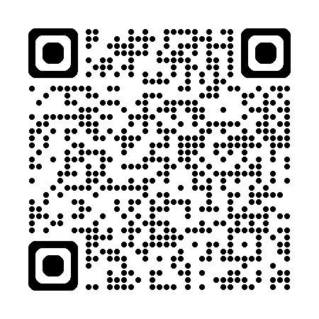
5022 W. 115TH ST.
ALSIP, Illinois
60803 United States

Weekly Services & Meetings

sunday school: 10:00 am – 10:45 am
sunday service: 11:00 am
wednesday night bible study: 6:30 pm – 7:30 pm
Verse of the Week

Order of Service 12/14/25
Welcome & Announcements
Congregation #1:
Special Music: Naomi Ross
Doxology – pg. 815
Offertory: Phoebe Ross
Congregation #2:
Sermon: Pastor John R. Reed
Closing:

Announcements/Dates to Remember

12/14/25: Harvester Place 2:00 pm - Nursing Home Ministry – Join us to sing carols with the residents.
12/14/25: Cocoa & Carols by Candlelight 6:00 pm – Bring a snack or your favorite holiday cookie to share.
12/21/25: Christmas Service 11:00 am – Invite your family, friends, or neighbors.
12/28/25: Ladies' Year-End Fellowship 12:30 pm - Come join us for a fun time of fellowship! Sign up sheet in the foyer.

Pastor’s Corner

