This Week at PPBC

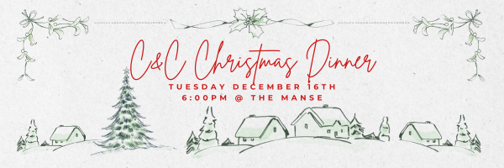

Wednesdays @ 6:30pm




Friday, December 19, 2025

Coming Soon

January 10th, 2025

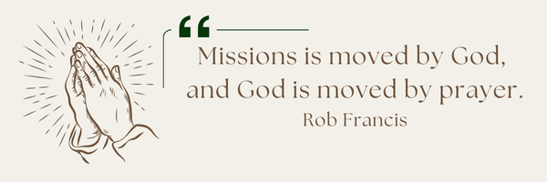
A Prayer Request from AOJ: Guatemala – Parramos
Pray for Field Director Mario as he oversees more than 800 children at our campus. Pray for our teachers as they prepare students for their final exams in November, and for families who long to see their children succeed. Many of our students (Kindergarten through Grade 12) face heavy challenges — the absence of parents, parents struggling with addiction, or being the only Christian in their household. Please pray that these young people will be strong in their faith, and that their lives will shine brightly as lights in dark places.

Please Sign up in the foyer and bring a tray of your favourite dessert to share!

Sunday Ministry Schedules
Below are ministry schedules for Nursery, Jr. Church, Greeters, Ushers, and Sound & Video:
Nursery
Dec 14: Jan Gerrow, Hannah Colwell
Dec 21: Brenda Clemens, Audrianna Angrove
Infant Nursery
Dec 14: Lisa Dallas, Karen Clemens
Dec 21: Stephanie Anderson, Karis Henkelman
Jr. Church; ages 3 to grade 1
Dec 14: Justine McKenzie, Kelsey Schoenrock
Dec 21: Ellianne McLaren, Hailey Ferguson
Jr. Church; Grades 2 to 6
Dec 14: Mary Deli, Jen Owens
Dec 21: Miriam Bolsonello,
Greeters
Dec 14: Tracy & Karen Ballanger
Dec 21: Fern & Kim St-Onge
Ushers
Dec 14: Joe Colwell, Matt Saunders
Dec 21: Nick Woytowich, Gregg Anderson
Sound & Video
Dec 14: Sound: Jordan Anderson | Video: Josh Myers
Dec 21: Sound: Jordan Anderson | Video: William Conley
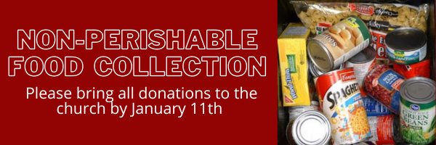

Morning Service
Welcome
Song – Angels from the Realms of Glory
Advent Reading
Song – O Little Town of Bethlehem
Prayer
Song – Come Behold the Wondrous Mystery
Message – Pastor Jim Clemens
Song – All of Our Tomorrows


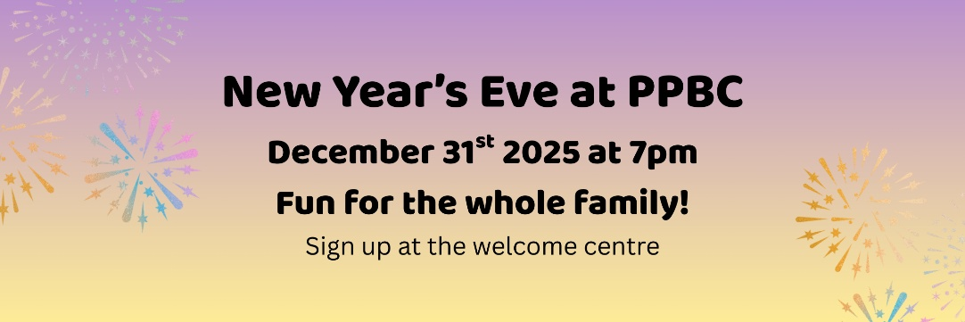

Praise & Prayer Highlights
PRAY for Barbara Fry and the Werner family as they mourn the loss of Ron. PRAY for Barbara, Roy, Elizabeth and the family as they make preparations for a service. PRAY that God will give them great comfort in Christ and that the truth of the Gospel will shine through this loss.
PRAY for Pastor Jim & Brenda. PRAY Pastor Jim as he battles a rather stubborn respiratory illness. He is on new medications and is improving. Please PRAY for renewed health and an increase of patience as he trusts the Lord's timing in his recovery.
PRAY for Joan Mabley who is in Port Perry Hospital room 114. PRAY for her and the doctors and nurses who are caring for her.
PRAY for Alice White and her ongoing recovery.
PRAY for Betty & Ray Collins and their ongoing health concerns.
PRAY for Bert & Ada Faber and their ongoing health concerns.
PRAY for Winnie Miller and her ongoing health concerns.
PRAY for Darryl & Cindy Piwek as Darryl prepares for Baptism this Sunday.

Giving
Just as a reminder, there are several ways you can give:
In Person using the offering box located on the back wall of the sanctuary. Donation envelopes are available at the Welcome Centre. Please contact the church office if you would like a box of donation envelopes (office@portperrybaptist.ca)
Through your online banking, you may send electronic transfers to ppbcdonations@gmail.com.
You can also give through Canada Helps. Donation receipts will be provided by Canada Helps, and transaction fees apply.
***********************************************************************
Weekly Newsletter
The PPBC Newsletter is emailed to the church family every Friday. If you would like to be added to the weekly email list, please contact the office by phone: 905-985-8681 or by email: office@portperrybaptist.ca.
*****************************************************************
Church Information:
Location:
2210 Hwy 7A
Port Perry, ON
L9L 1B4
Office Hours:
Monday: 8:30am – 4:00pm
Tuesday: 8:30am – 4:00pm
Wednesday: Closed
Thursday: 8:30am – 4:00pm
Friday: 8:30 am - 3:00 pm
Contact:
Phone: 905.985.8681
Email: office@portperrybaptist.ca
Website: www.portperrybaptist.ca
Staff:
Sr. Pastor – Rev. Jim Clemens
Administrative Assistant – Madeline Werner
Family Ministries Director – Josh Anderson

PPBC Newsletter
Sunday, December 14, 2025


Sunday Starting Point
Sunday, December 14, 2025 - 9:30 am
“Beginning the day with the Word and prayer”
Adults:
Adults will meet in the sanctuary for a time of study and prayer. Psalm 147.
Youth:
Jr High (Grades 7-8) will meet in room 18 with Kate Anderson to study Advent.
Children:
Children ages 3 - grade 6 will meet in room 26.
(Please note nursery is unavailable during Starting Point)
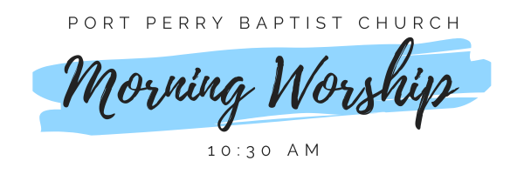Sunday Morning Worship
Sunday, December 14, 2025 - 10:30 am
We are meeting in the sanctuary and will continue to live-stream for those who are unable to attend.
Message: The King Speaks to His Churches Part 2
Scripture: Revelation 2-3
Pastor Jim Clemens

