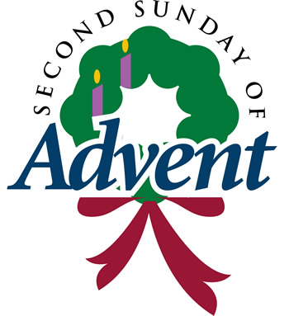

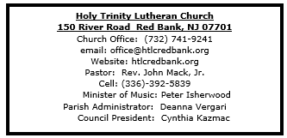
- Greetings and welcome! Angels and Archangels are rejoicing before the throne of God that you have found your way here this day!
- As we gather in this sanctuary and joyfully greet one another, may we also be sensitive to those preparing for worship through silent meditation or by listening to the choir.
- All are invited to share in the Lord's Supper receiving Christ's presence through the ministration of bread and wine. As you come forward, you may receive wine from the pouring chalice (take a small glass from the tray as you approach the communion rail) or common cup. Grape juice is distributed at the communion rail if you prefer it instead. Gluten free communion is available upon request.
- Should you need communion brought to your seat, let the usher know.
- Children are encouraged to participate in the lively movement of worship as they are able.If instead, or at any point in the service your child desires to go to the nursery, it is located across the hall through the double doors of the church in the East transept (the shorter wing of the church). The nursery is for children through age 4.
- Bathrooms are located on the ground floor of the East transept (the shorter wing of the church).
- If this is your first time to worship at Holy Trinity Lutheran Church, please sign our guest book, including your name, address and phone number. Guest books are located at both entrances.
- After worship, please come downstairs for coffee (or tea) and informal fellowship.



December 7, 2025

Second Sunday of Advent

Introduction
At the heart of our Advent preparation stands John the Baptist, who calls us to repent and make a new beginning. As the darkness increases we turn toward the approaching light of Christ. For Christians he is the root of Jesse, the righteous judge who welcomes all, especially the poor and meek of the earth. We wait with hope for that day when the wolf will dwell with the lamb, and there will be no more hurt or destruction. From the Lord’s table we are sent in the spirit of John the Baptist to proclaim that in Christ the kingdom of God has come near.

Welcome & Announcements (Please silence your cell phone!)

Prelude (We prayerfully prepare our hearts and minds to worship!)

+ GATHERING +

Confession and Forgiveness
All may make the sign of the cross, the sign that is marked at baptism, as the presiding minister begins.
P: Blessed be the holy Trinity, ☩ one God,
whose home is heaven and earth,
whose salvation is sure.
C: Amen.
P: Let us confess our sin in the presence of God
and of one another.
Silence is kept for reflection.
Long-expected God,
C: we confess that we look to ourselves
for the peace and security only you can provide.
We reach for swords and spears,
reluctant to release our grip on the ways of war.
We become impatient while waiting
and weary of keeping awake.
Free us from self-reliance,
and teach us to live in harmony with our neighbors.
Increase our trust in God’s timing,
and awaken us to your advent among us,
that we may abound in the hope you have promised.
Amen.
P: God judges us not as we deserve,
but according to God’s own righteousness.
☩ You are freed and forgiven,
saved by grace,
and ready to welcome the Savior.
C: Amen.

*Gathering Hymn ELW 257 O Come, O Come, Emmanuel (v.3& 4)
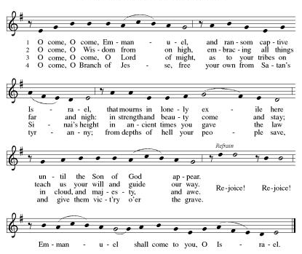

*Pastoral Greeting

P: The Grace and Peace of our Lord Jesus Christ, the love of God, and the communion of the Holy Spirit be with you all! C: And also with you!

Kyrie
Refer the to the blue insert

Emily Kaster and Family

Lighting the Advent Wreath: Week 2
Blessed are you, O Lord our God, ruler of the universe. John the Baptist calls all people to prepare the Lord’s way for the kingdom of heaven is near. Bless us as we light the candles on this wreath. Baptize us with the fire of your Spirit, that we may be a light shining in the darkness
welcoming others as Christ has welcomed us, for he is our light and our salvation.
Blessed be God forever.
C: Amen

ELW 240 v. 2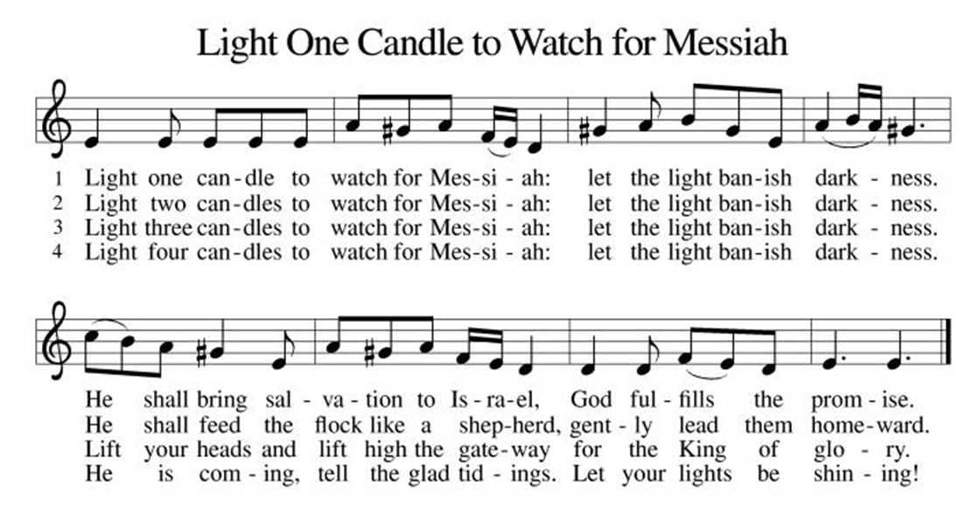

*Prayer of the Day
P: Stir up our hearts, Lord God, to prepare the way of your only Son. By his coming nurture our growth as people of repentance and peace; through Jesus Christ, our Savior and Lord, who lives and reigns with you and the Holy Spirit, one God, now and forever.C: Amen!
+WORD+

First Reading: Isaiah 11:1-10
Isaiah describes the coming of a future, ideal ruler who will renew David’s royal line (the stump of Jesse). Gifted by the spirit of God, this ruler will reign with perfect justice. Enmity and danger will be restored to harmony and peaceful coexistence.
¹ A shoot shall come out from the stump of Jesse,
and a branch shall grow out of his roots.
² The spirit of the Lord shall rest on him,
the spirit of wisdom and understanding,
the spirit of counsel and might,
the spirit of knowledge and the fear of the Lord.
³ His delight shall be in the fear of the Lord.
He shall not judge by what his eyes see
or decide by what his ears hear,
⁴ but with righteousness he shall judge for the poor
and decide with equity for the oppressed of the earth;
he shall strike the earth with the rod of his mouth,
and with the breath of his lips he shall kill the wicked.
⁵ Righteousness shall be the belt around his waist
and faithfulness the belt around his loins.
⁶ The wolf shall live with the lamb;
the leopard shall lie down with the kid;
the calf and the lion will feed together,
and a little child shall lead them.
⁷ The cow and the bear shall graze;
their young shall lie down together;
and the lion shall eat straw like the ox.
⁸ The nursing child shall play over the hole of the asp,
and the weaned child shall put its hand on the adder’s den.
⁹ They will not hurt or destroy
on all my holy mountain,
for the earth will be full of the knowledge of the Lord
as the waters cover the sea.
¹⁰ On that day the root of Jesse shall stand as a signal to the peoples; the nations shall inquire of him, and his dwelling shall be glorious.

Psalm: Psalm 72:1-7, 18-19
May the righteous flourish; let there be an abundance of peace. (Ps. 72:7)

¹ Give the king your jus- | tice, O God,
and your righteousness to | the king’s son;
² that he may rule your | people righteously
and the | poor with justice;
³ that the mountains may bring prosperity | to the people,
and the | hills, in righteousness.
⁴ Let him defend the needy a- | mong the people,
rescue the poor, and crush | the oppressor.
⁵ May he live as long as the sun and | moon endure,
from one generation | to another.
⁶ Let him come down like rain upon | the mown field,
like showers that wa- | ter the earth.
⁷ In his time may the | righteous flourish;
and let there be an abundance of peace till the moon shall | be no more.
¹⁸ Blessed are you, Lord God, the | God of Israel;
you alone do | wondrous deeds!
¹⁹ And blessed be your glorious | name forever,
and may all the earth be filled with your glory. A- | men. Amen.

Second Reading: Romans 15:4-13
God’s promise to include Gentiles within the circle of God’s blessed people has been fulfilled in Jesus Christ. Christians live out their unity by welcoming and encouraging each other just as Christ has welcomed them into God’s family.

⁴ Whatever was written in former days was written for our instruction, so that by steadfastness and by the encouragement of the scriptures we might have hope. ⁵ May the God of steadfastness and encouragement grant you to live in harmony with one another, in accordance with Christ Jesus, ⁶ so that together you may with one voice glorify the God and Father of our Lord Jesus Christ.
⁷ Welcome one another, therefore, just as Christ has welcomed you, for the glory of God. ⁸ For I tell you that Christ has become a servant of the circumcised on behalf of the truth of God in order that he might confirm the promises given to the ancestors ⁹ and that the gentiles might glorify God for his mercy. As it is written,
“Therefore I will confess you among the gentiles
and sing praises to your name”;
¹⁰ and again he says,
“Rejoice, O gentiles, with his people”;
¹¹ and again,
“Praise the Lord, all you gentiles,
and let all the peoples praise him”;
¹² and again Isaiah says,
“The root of Jesse shall come,
the one who rises to rule the gentiles;
in him the gentiles shall hope.”
¹³ May the God of hope fill you with all joy and peace in believing, so that you may abound in hope by the power of the Holy Spirit.

*Gospel Acclamation
Refer to the blue insert

P: The Holy Gospel According to the St. Matthew the 3rd Chapter
C: Glory to You, O Lord!

Gospel: Matthew 3:1-12
Just before Jesus begins his public ministry, John the Baptist appears, calling people to mend their ways and speaking of a powerful one who is to come.

¹ In those days John the Baptist appeared in the wilderness of Judea, proclaiming, ² “Repent, for the kingdom of heaven has come near.” ³ This is the one of whom the prophet Isaiah spoke when he said,
“The voice of one crying out in the wilderness:
‘Prepare the way of the Lord;
make his paths straight.’ ”
⁴ Now John wore clothing of camel’s hair with a leather belt around his waist, and his food was locusts and wild honey. ⁵ Then Jerusalem and all Judea and all the region around the Jordan were going out to him, ⁶ and they were baptized by him in the River Jordan, confessing their sins.
⁷ But when he saw many of the Pharisees and Sadducees coming for his baptism, he said to them, “You brood of vipers! Who warned you to flee from the coming wrath? ⁸ Therefore, bear fruit worthy of repentance, ⁹ and do not presume to say to yourselves, ‘We have Abraham as our ancestor,’ for I tell you, God is able from these stones to raise up children to Abraham. ¹⁰ Even now the ax is lying at the root of the trees; therefore every tree that does not bear good fruit will be cut down and thrown into the fire.
¹¹ “I baptize you with water for repentance, but the one who is coming after me is more powerful than I, and I am not worthy to carry his sandals. He will baptize you with the Holy Spirit and fire. ¹² His winnowing fork is in his hand, and he will clear his threshing floor and will gather his wheat into the granary, but the chaff he will burn with unquenchable fire.”

P: The Gospel of the Lord
C: Praise to you, O Christ!
Sermon

*Hymn of the Day ELW 249 On Jordan’s Bank the Baptist’s Cry
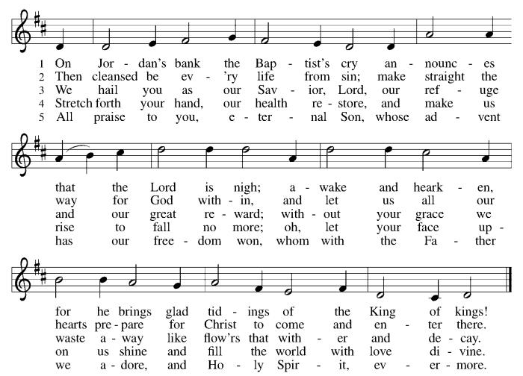

* Nicene Creed
We believe in one God,
the Father, the Almighty,
maker of heaven and earth,
of all that is, seen and unseen.
We believe in one Lord, Jesus Christ,
the only Son of God,
eternally begotten of the Father,
God from God, Light from Light,
true God from true God,
begotten, not made,
of one Being with the Father;
through him all things were made.
For us and for our salvation
he came down from heaven,
was incarnate of the Holy Spirit and the Virgin Mary
and became truly human.
For our sake he was crucified under Pontius Pilate;
he suffered death and was buried.
On the third day he rose again
in accordance with the Scriptures;
he ascended into heaven
and is seated at the right hand of the Father.
He will come again in glory to judge the living and the dead,
and his kingdom will have no end.
We believe in the Holy Spirit, the Lord, the giver of life,
who proceeds from the Father and the Son,
who with the Father and the Son is worshiped and glorified,
who has spoken through the prophets.
We believe in one holy catholic and apostolic church.
We acknowledge one baptism for the forgiveness of sins.
We look for the resurrection of the dead,
and the life of the world to come. Amen.

*Prayers of Intercession
In our waiting and watching, we come to you in prayer, O God, trusting your promise to renew the church, the nations, and the whole creation.
A brief silence.
With wisdom and understanding, inspire the faithful around the world. Unite hearts and minds in work to address poverty, access to housing, and equity among peoples. God of grace,
C:hear our prayer.
With counsel and might, move us to care for creation. As we dream of the day when all creatures will flourish alongside one another, guide us in ways humanity and all creation will mutually thrive. God of grace,
C:hear our prayer.
With righteousness and faithfulness, encourage nations to live in harmony with one another. We pray for international student and teacher exchanges, for our partner churches, and for the shared mission of Lutheran World Relief and Lutheran Disaster Response. God of grace,
C:hear our prayer.
With steadfastness and encouragement, strengthen those who have lost hope in the face of grief, depression, or disease (especially). Renew the spirits of those recovering from surgery and medical procedures. God of grace,
C:hear our prayer.
With welcome and hospitality, embolden us in our shared ministry to overcome all that divides. In acts of repentance, reconciliation, and reparation, may we serve in the way of Christ. God of grace,
C:hear our prayer.
Here other intercessions may be offered.
With joy and peace, we remember our ancestors in the faith (especially Ambrose, Bishop of Milan, whom we commemorate today). Fill us with the hope of the Holy Spirit now and into the ages of ages. God of grace,
C:hear our prayer.
Draw near to us, O God, as we commend all for whom we pray, trusting in your mercy through Jesus Christ, Emmanuel.
C: Amen.

Greeting of Peace
P: The peace of Christ be with you and those you love!
C: And also with you! (The peace is shared with all!)

Offering (Thank you for your support for our ministry!)

*Doxology ELW 246 Hark! A Thrilling Voice Is Sounding! (v.5)
(Please stand and join in singing as we share our gifts!)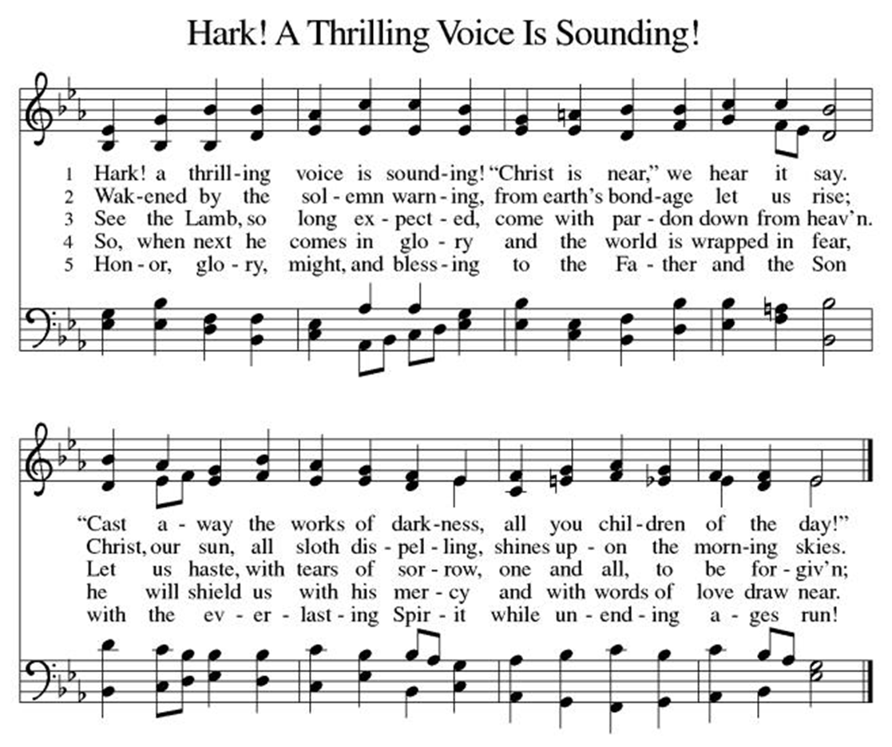*Offering Prayer
A: Nourishing God,
C: you are water in the wilderness and streams in the desert.
Through this meal, satisfy our parched places,
that we may rejoice and be for the world
signs of your kingdom come.
Amen.

+MEAL+
(All are welcome at the table of our Lord!)
*Great Thanksgiving
P: The Lord be with you.
C: And also with you.

P: Lift up your hearts.
C: We lift them to the Lord.

P: Let us give thanks to the Lord our God.
C: It is right to give our thanks and praise.

P: It is indeed right, our duty and our joy, that we should at all times and in all places give thanks and praise to you, almighty and merciful God, through our Savior Jesus Christ.
You comforted your people with the promise of the Redeemer, through whom you will also make all things new in the day when he comes to judge the world in righteousness. And so, with all the choirs of angels, with the church on earth and the hosts of heaven,
we praise your name and join their unending hymn:

*Sanctus
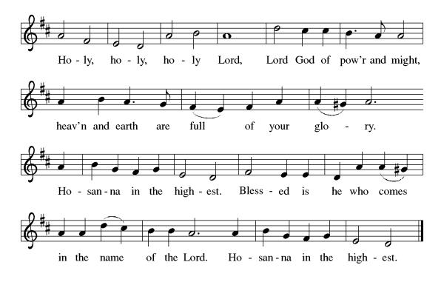

*Eucharistic Prayer
P: Holy One,
the beginning and the end, the giver of life:
Blessed are you for the birth of creation.
Blessed are you in the darkness and in the light.
Blessed are you for your promise to your people.
Blessed are you in the prophets’ hopes and dreams.
Blessed are you for Mary’s openness to your will.
Blessed are you for your Son Jesus,
the Word made flesh.

In the night in which he was betrayed,
our Lord Jesus took bread, and gave thanks;
broke it, and gave it to his disciples, saying:
Take and eat; this is my body, given for you.
Do this for the remembrance of me.

Again, after supper, he took the cup, gave thanks,
and gave it for all to drink, saying:
This cup is the new covenant in my blood,
shed for you and for all people for the forgiveness of sin.
Do this for the remembrance of me.

Let us proclaim the mystery of faith:
C: Christ has died. Christ is risen. Christ will come again.

P: With this bread and cup
we remember your Word dwelling among us,
full of grace and truth.
We remember our new birth in his death and resurrection.
We look with hope for his coming.
C: Come, Lord Jesus.

P: Holy God, we long for your Spirit.
Come among us.
Bless this meal.
May your Word take flesh in us.
Awaken your people.
Fill us with your light.
Bring the gift of peace on earth.
C: Come, Holy Spirit.
P:All praise and glory are yours,
Holy One of Israel,
Word of God incarnate,
Power of the Most High,
one God, now and forever.
C: Amen.

*THE LORD’S PRAYER
Our Father, who art in heaven,
hallowed be thy name,
thy kingdom come,
thy will be done,
on earth as it is in heaven.
Give us this day our daily bread;
and forgive us our trespasses,
as we forgive those
who trespass against us;
and lead us not into temptation,
but deliver us from evil.
For thine is the kingdom,
and the power, and the glory, forever and ever. Amen.

*Lamb of God
Refer to the blue insert

Spiritual Communion Prayer
P: Let us pray for the communion of all present here, those viewing our service virtually, those in our hearts and in our world.
C: Lord Jesus, I believe you are truly present in the Sacrament of Holy Communion. When I cannot receive Communion, I pray that you come into my heart. I know that nothing in Heaven or on earth can separate me from your love. Amen.

Invitation to Communion
P: Here is life. God is with us.
Come, receive what God has promised.

C: Thanks be to God.

(All are invited to the communion rail following the guidance of the ushers. Communion will be shared through the host and individual cups. If you would like communion but are unable to join us at the rail, please alert the usher!)

Communion Hymns (Please join in singing!)
ELW 264 Prepare the Royal Highway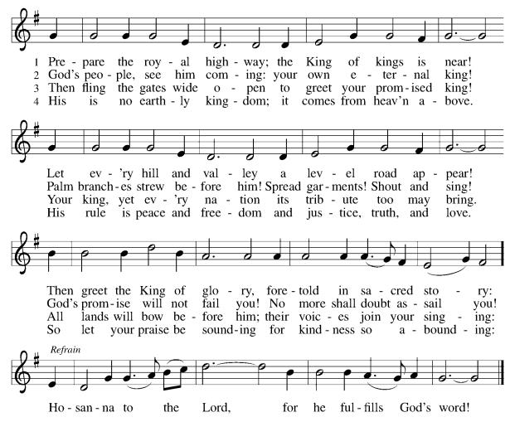
ELW 250 Blessed Be the God of Isreal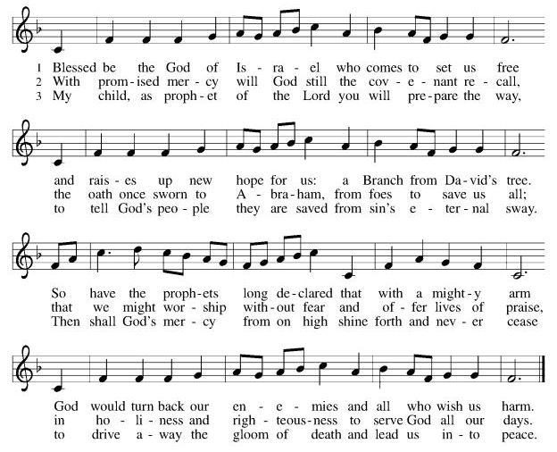

P: The body and blood of our Lord Jesus Christ strengthen you and keep you in his grace. C: Amen!

*Prayer after Communion
A: God our host,
at this table you have fed us with joy and gladness.
Send us forth, eager to share the feast,
welcome the stranger,
and bear good fruit in the name of Jesus.
C: Amen!

+Sending+

*Blessing
P: May God who comes among us,
Father, ☩ Son, and Holy Spirit,
grant you patience in waiting, peace in the darkness,
and good news to share today and always.
C: Amen!

*Sending Hymn ELW 248 People, Look East (v. 3 & 4)
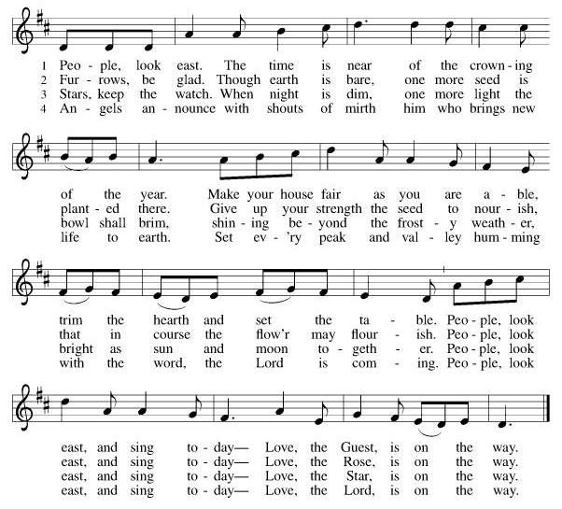

*Dismissal
A: Go in peace. Keep awake.
C: Thanks Be to God.

Postlude

Copyright © 2020 Augsburg Fortress. All rights reserved. Reprinted by permission under Augsburg Fortress Liturgies Annual License #SB106907. New Revised Standard Version Bible, Copyright © 1989, Division of Christian Education of the National Council of the Churches of Christ in the United States of America. Used by permission. All rights reserved. Revised Common Lectionary, Copyright © 1992 Consultation on Common Texts, admin Augsburg Fortress. Used by permission.

Treasurer’s Report
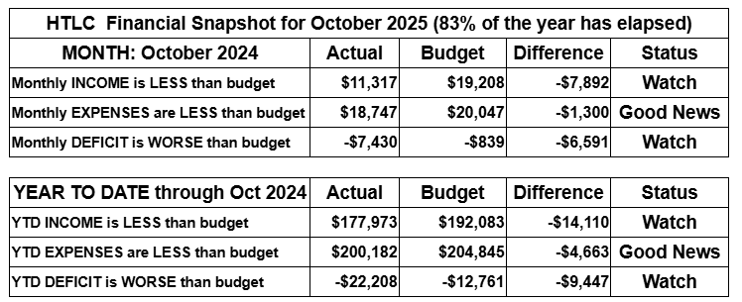
October giving fell far short of expectations, creating real pressure on our cash flow. Expenses remain under control, but we rely on strong giving in the final months of the year to maintain stability and support our ministries. Gifts above and beyond regular giving will help us build a growing, healthy church. Thank you for your generosity.
Thank you for supporting our ministry! Chris Foard, Treasurer

Worship Volunteer Schedule
Date | Asst. Min | Usher | Sacristan | Lector | Counter
December 7 | Chris Foard | Keith Bennett | Carol Rosen | Emily Kaster | Foss/Foard
December 14 | Elaine Bradford | Kathy Caputo | Nancy Poole | Jeff Ridberg | Bohner/Volk
December 21 | Charlie Rugg | Gripps | Helga Britton | Bill Spreen | Bradford/Socha
December 28 | Linda Coleman | Dan Grillon | Helga Britton | Cynthia Kazmac | McKenna/Kazmac
January 4 | Keith Bennett | Keith Bennett | Joanne Giordano | Molly Foard | Foss/Coleman

Altar Flowers
December 7th Gripp family in memory of loved ones during the holidays.
December 14th Frances Padron, memor of husband, son and mother. Felix Padron, Reynaldo, Angelica Alvarez.
Coffee Hour
November 30th Pat & Jeff Pienkos
December 7th Poole
Debember 21st Christmas brunch

Please consider siging up of a coffee hour. Recruit some friends to help. Thank you!

ANNOUNCEMENTS Thank you! To all who consistently support our church and ministries through your time, talent, and treasure. Please help us grow by inviting your friends and family to worship and events. You are what makes Holy Trinity a wonderful church family!

Stay in touch! Please visit our church website, www.htlcredbank.org for updates and information. You can also find us on Facebook and view services online. The office is open from 9am to 2pm, Monday to Thursday.

100 Anniversary Committee- If you are interested in being a part of the committee to help plan the 100th anniversary celebration of HTLC in 2028, please sign up in the red book. All are welcome! Also, the committee will be looking for photos and documents of HTLC throughout the years. If you have anything to share, please bring them to the church and marked envelopes or email electronic copies to the church office.

Photo Directory- Day one of photos was a success! After worship, we will be taking photos for an updated Holy Trinity photo directory. Casey H. and her boyfriend Bart (professional photographer!) will have a station set up during coffee hour, so please stop by for an updated head shot! Photos will be taken on the following dates: 11/23, 12/7, 12/14, 12/21. Please see Casey H. or Elaine B. with any questions.

Name Tag Sundays: On the first Sunday of each month, names tags and markers will be at each entrance of the sanctuary. Please fill out a tag and wear one for worship and for coffee hour to welcome visitors and help newcomers put names to faces.

Choir The Holy Trinity Choir welcomes our singers back for a preparation rehearsal on Sunday, September 7th at 9am in the church hall. All are welcome to join us in song as often as you are able. Choir meets each Sunday at 9am to practice and prepare our music. Join us and help us grow by spreading the word about the HTLC Choir!

Blood drive Tuesday January 6, 2026, noon to 6 pm
On Tuesday, January 6, 2026 we will be hosting a blood drive here at Holy Trinity from Noon to 6pm. Donors, mark your calendars! If you cannot donate, please recruit from among your friends and family. This day marks Epiphany, ending the Christmas season, so let's give a final gift -- of life!

Dorcas Circle-Date / Time: 12/12/2025 12:00 PM Potluck Luncheon and White Elephant Gift Exchange (under $10.0)

Angel Tree Gifts- All unwrapped gifts with the Angel gift tag attached must be returned to church by 12/7/2025. Gifts can be dropped off at the church office during the office hour (Monday to Thursday 9:00 AM to 2:00 PM) or in the church basement after Sunday worship. WELCA members will deliver all the gifts to the Red Bank Salvation Army.

Quilting- The Quilters need gently used any bed sheets of any size! Please leave any donations in the quilters closet in Fellowship Hall. Thank you!

Weekly Quilting on Wednesdays at 9:30. Bring your lunch and enjoy some fellowship at noon. All are welcome. There will be no quilting on Wednesday September 24 due to the garage sale set up.

Evening Quilting Evening Quilting –
Please share this information . This is an important ministry that helps so many. It’s very easy and you don’t need to know how to sew. We have a great time socializing too! We will meet:
Oct. 15, Nov 19, Dec 17 At 6:00 PM. Note: If we have to cancel I will send an email. Please let me know only if you can come. Contacts: Pat Pienkos 732-513-9615 Debbie Yetka 908-461-4084 Looking forward to seeing you all!

Bagels and Bible- Bagels and Bible will be meeting on the second and fourth Saturdays of the month at 8:30. The group will meet in the Parish House.

Social Ministry
*Year-round collections will continue for food items for Lunch Break. There is a sign-up sheet in the red book for those who can help drop these items to Lunch Break.
*We will also collect adult men's socks to periodically drop at the Red Bank Warminq Center.
*For those interested in the Heartwarminq Center — the new women's shelter is adjacent to the First Baptist Church of Red Bank at 90 Maple Ave. You can follow up on this mission through their website - https://www.thefeastnj.org- On this site, they also include wish list items that can be purchased through amazon. We will be exploring purchasing some of these through a Thrivent card. If you want to purchase on your own, you can leave items at church, and the Social Ministry will deliver them.

Pastoral Care and Prayer... We are here to care for and pray! Please contact the office to add or adjust prayer requests. If you or someone you know needs pastoral care, please contact the office and Pastor Mack!

THANK YOU for supporting and sustaining our church and ministries! All are welcome here! Please invite your family and friends to worship with us! Find us online at www.htlcredbank.org

