Parkside Lutheran Church
Rediscovering the Radical Love of Jesus
Gathering All
Serving All
Caring For All



December 14th, 2025
Third Sunday of Advent
Holy Communion 10:00am
Bishop Lee Miller II

Parkside Lutheran Values

Proclaiming Grace - Jesus shared and lived out a message of grace, love, and new life. We believe these promises come from God freely, as a gift for all. We are loved and the Spirit inspires us to share this good news in accessible, relevant, and new ways. Luke 4:17-19, John 1:16-17, John 3:16-17, Ephesians 2:8-9

Practicing Hospitality – Jesus welcomed the little children, broke bread with outcasts, and proclaimed the Good News to all. Whether you are strong in faith, wrestling with doubt, or somewhere in between, we affirm that you are welcome here. Jesus is for everyone. Leviticus 19:34, Matthew 9:10, Matthew 19:14, Hebrews 13:2

Loving Boldly - Jesus challenged traditions to demonstrate God’s justice and love of neighbor. His compassionate and sacrificial love inspires us to take risks. Striving to follow his command to love neighbor, our ministries serve, transform, and advocate for folks near and far. Micah 6:8, Mark 11:15-17, Luke 10:25-28, John 15:12-13

Cultivating Community - Jesus built communities that transformed lives. We are the body of Christ and we are called to continue this ministry of transformation. Guided by the Holy Spirit, we build connections within and outside of these walls, and with all of God’s creation. Ecclesiastes 4:9-12, Matthew 28:16-20, 1 Corinthians 12:12-14, Galatians 3:26-29

Welcome Visitors!
Please use QR code
to let us know you were here today or to sign up for our weekly enewsletter
or, sign up for weekly enewsletter via website parksidelutheran.org.
Find us on Facebook & Instagram WIFI: Balcony password: FreeGrace

For your safety in the event of an emergency: In addition to the three exits in the back of the sanctuary, there are exits on either side of the altar (on left side: floor level near piano and up steps past altar. On right side: up steps to the altar, past band area)

Contact us: (716) 836-1361
2 Wallace Ave. Buffalo, NY 14214
parksidelutheran.org | parksidelutheran@gmail.com

GATHER
The Holy Spirit calls us together as the people of God.

Even in Our Fear, We are Called Forward

Prelude Michael Hooker, Music Director

Call to Worship
WA: Jeremiah said, “I am only a boy.”
C: Moses said, “Who am I to do this work?”
WA: Mary said, “How can this be?”
C: We often say, “But God, I am afraid.”
WA: Even when we are afraid, God invites us closer.
C: So may we trust the Inviter.
WA: May we heed God’s invitation.
C: May we summon our courage and sing God’s praise.
WA: Let us worship our courageous, inviting, calling God. C: Amen!

Gathering Hymn: O Come, O Come, Emmanuel verses 1, 5 & 6 ELW 257
- O come, O come, Emmanuel,
and ransom captive Israel,
that mourns in lowly exile here
until the Son of God appear. Refrain

5. O come, O Key of David, come,
and open wide our heav’nly home;
make safe the way that leads on high,
and close the path to misery. Refrain

6. O come, O Dayspring, come and cheer;
O Sun of justice, now draw near.
Disperse the gloomy clouds of night,
and death’s dark shadow put to flight. Refrain

Refrain – Rejoice! Rejoice! Emmanuel shall come to you, O Israel.

Welcome and Announcements

+Confession and Forgiveness
P: Friends, often in life, when we make mistakes, we want to keep those mistakes to ourselves. We don’t want to advertise our blunders. We don’t want to highlight our failings. We can be tempted to brush those things under the rug and move on.
But when it comes to God, there is nothing we need to brush under the rug. God welcomes and loves our full, honest, messy selves—blunders and all.
So let us go before God in prayer, trusting that there is nothing we need to hide from our Creator. (a brief silence)
P: Courageous God,
C: you invite us to live into our call. You invite us to act, to serve, and to trust. Instead of responding with a resounding “yes,” we often hide our face. We dig our heels in. We look for someone else to volunteer. Spark courage in us. Remind us that every person is capable of making a difference. Remind us that even when we’re scared, we are not alone. You invite us forward. With baby steps we hope, we pray. Amen. P: Family of faith, no matter where your path has led you in the past, today is a new day. So join me in declaring this good news:
C: We are known. We are forgiven! We are sent to serve. May we step forward in faith, always moving closer to God’s call. Amen.

Greeting
WA: The grace of our Lord, Jesus Christ, the love of God, and the communion of the Holy Spirit be with you all. C: And also with you.

Prayer of the Day
WA: Let us pray together.
C: Holy One, the story of this season is not a new one. We’ve heard this tale before. We’ve seen the nativities, watched the plays, sung the songs, witnessed the children act it out. The story of this season is not a new one, and yet we long to hear it as if it is. So spark our spirits awake. Call forth awareness, attention, and reverence in us. Allow us to hear this ancient tale with brand new ears. With hope we pray. Amen.

+Lighting of the Advent Wreath
P: In a world full of fear, where do you see glimmers of joy?
C: We see glimmers of joy in birthday candles and homemade cards. We see joy in the laughter of children and the delight of grandparents. We see joy in meals around the table and in the singing of Christmas songs.
P: You are right. Even in a fearful world, joy is all around us. Today we light the candle of joy as a reminder of this good news. May this flicker of light help us remember that even in a fearful world, joy is here. Joy is real. We only have to look for it.
C: Thanks be to God for that good news! Amen.

Song: Advent Wreath Hymn (tune: Away in a Manger)
A candle is burning, a candle of Joy;
A candle to welcome brave Mary’s new boy.
Our hearts fill with wonder and eyes light and glow
As Joy brightens winter like sunshine on snow.

Children’s Sermon: Jesus said, “Let the little children come to me!”
We welcome children in worship.

WORD
God speaks to us in scripture readings, preaching and song.

“The First Step”
L: Watch any parent. It starts with the first step.
They kneel down. They smile with anticipation.
They reach for their baby, calling and cooing them forward.
And then before they know it, they’re running behind a bike. They’re yelling.
“Keep pedaling! You got it! I’m right there!” And they’re jumping up and down.
because that little red helmet passed the mailbox.
And then, just like that, they’re driving circles in the church parking lot.
They’re giving instructions about easing on and off the pedal.
They’re having conversations about curfew and heartbreak.
And then, before they know it, they’re standing in a hospital room.
Their heart is bursting. And they say, “Put her head right here.
Rock her gently. Do you remember the nursery rhymes?
You were born for this.”
The first step is always the hardest,
but you, beloved, were born for this.

Reading: Jeremiah 1:4-10
L: ⁴ Now the word of the Lord came to me saying,
⁵ “Before I formed you in the womb I knew you, and before you were born I consecrated you; I appointed you a prophet to the nations.”
⁶ Then I said, “Ah, Lord God! Truly I do not know how to speak, for I am only a boy.” ⁷ But the Lord said to me,
“Do not say, ‘I am only a boy,’ for you shall go to all to whom I send you, and
you shall speak whatever I command you. ⁸ Do not be afraid of them, for I am with you to deliver you, says the Lord.”
⁹ Then the Lord put out his hand and touched my mouth, and the Lord said to me,
“Now I have put my words in your mouth. ¹⁰ See, today I appoint you over nations and over kingdoms, to pluck up and to pull down, to destroy and to overthrow, to build and to plant.”
L: Word of God, word of life. C: Thanks be to God.

Please stand as you are able

+Gospel Acclamation ELW setting 4 (p. 151)

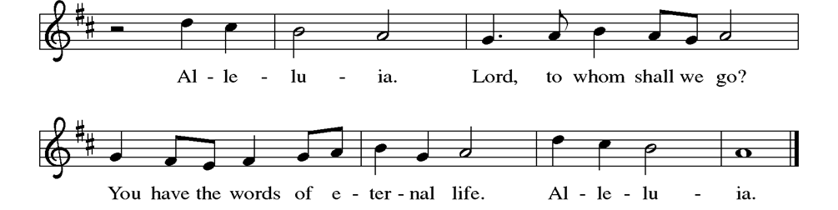

Gospel Reading: Luke 1:26-38
P: The Holy Gospel according to Luke. C: Glory to you, O Lord. P: ²⁶ In the sixth month the angel Gabriel was sent by God to a town in Galilee called Nazareth, ²⁷ to a virgin engaged to a man whose name was Joseph, of the house of David. The virgin’s name was Mary. ²⁸ And he came to her and said, “Greetings, favored one! The Lord is with you.” ²⁹ But she was much perplexed by his words and pondered what sort of greeting this might be. ³⁰ The angel said to her, “Do not be afraid, Mary, for you have found favor with God. ³¹ And now, you will conceive in your womb and bear a son, and you will name him Jesus. ³² He will be great and will be called the Son of the Most High, and the Lord God will give to him the throne of his ancestor David. ³³ He will reign over the house of Jacob forever, and of his kingdom there will be no end.” ³⁴ Mary said to the angel, “How can this be, since I am a virgin?” ³⁵ The angel said to her, “The Holy Spirit will come upon you, and the power of the Most High will overshadow you; therefore the child to be born will be holy; he will be called Son of God. ³⁶ And now, your relative Elizabeth in her old age has also conceived a son, and this is the sixth month for her who was said to be barren. ³⁷ For nothing will be impossible with God.” ³⁸ Then Mary said, “Here am I, the servant of the Lord; let it be with me according to your word.” Then the angel departed from her.
P: The Gospel of the Lord. C: Praise to you, O Christ.

Sermon Bishop Lee Miller II

Please stand as you are able.

Hymn of the Day: The Angel Gabriel from Heaven Came ELW # 265

Affirmation of Faith
WA: Let us join together in the Affirmation of Faith.
C: We have seen the valley. We have seen a sky without stars. We have seen the longest night, and still we believe.
We believe in a with-us God. We believe in the hope of tomorrow. We believe that good news is louder than fear. We believe this good news is for all people.
So even when our knees shake, even when our voice trembles, even when fear is all around us, we will hold onto that good news.
We will reach for each other. We will look for God in our midst. We will sing songs of joy. We will proclaim: Unto us, love is born.
We have seen the longest night, and we have seen unimaginable love. So still, we believe. Amen.

Prayers of the People
WA: In our waiting and watching, we come to you in prayer, O God, trusting your promise to renew the church, the nations, and the whole creation. (a brief silence)

WA: Calling God, if you tapped on my shoulder today, would my knees shake? Would my mind race? Would my voice waver? Or, knowing the stories of all the faithful folks you’ve called before, would I be ready? Would I be brave enough to follow? Would I hear your call for what it is? Would I reply, “Let it be with me according to your will”? It’s hard to know. But what I do trust is that you are a God who calls. Help me to hear your call. God of grace, C: hear our prayer.
WA: You called Mary and Moses, Jeremiah and Peter. You have called ordinary people throughout all of time. You have called artists and activists, poets and prophets, teachers and healers—young and old alike. So as we move through this world, open our ears to hear your voice. God of grace, C: hear our prayer.

WA: As we move through this world, make us mindful of those who are suffering and in any need. When bodies grow weak and hearts grow fearful, speak your blessing. We pray especially for those we name aloud or in the silence of our hearts…. Help us trust that you are always with us and remind us of the promise spoken to our ancestors in faith. God of grace, C: hear our prayer.

WA: As we move through this world, open our hearts to the invitations, the inspiration, and the nudges you place in our lives. As we move through this world, God, allow us to hear whatever call you have in store for us in this season. God of grace, C: hear our prayer.

WA: For no matter how big or how small, we trust that you are a calling, inviting, nudging, inspiring God who sees us in the best light. With hope we lean forward and we listen for your word. God of grace, C: hear our prayer.

WA: Draw near to us, O God, as we commend all for whom we pray, trusting in your mercy through Jesus Christ, Emmanuel. C: Amen.

Peace
P: The peace of Christ be with you always. C: And also with you.

Meal
God feeds us with the presence of Jesus Christ

Offering Congregation may be seated
We are grateful to those who help sustain our mission. To donate online, please use QR code:


Offering Music: “Mary, Did You Know” Mark Lowry & Buddy Greene
Faith Journey

Offering Prayer
WA: Let us pray together:
C: Nourishing God, you are water in the wilderness and streams in the desert. Through this meal, satisfy our parched places, that we may rejoice and be for the world signs of your kingdom come. Amen.

Please stand as you are able
+ Offertory Song “We are an Offering” ELW 692
We lift our voices, we lift our hands, we lift our lives up to you;
We are an offering. Lord, use our voices, Lord, use our hands,
Lord, use our lives, they are yours; We are an offering.
All that we have, all that we are, all that we hope to be-
we give to you, we give to you.
We lift our voices, we lift our hands, we lift our lives up to you;
We are an offering. We are an offering.
GREAT THANKSGIVING
P: The Lord be with you. C: And also with you.
P: Lift up your hearts. C: We lift them to the Lord.
P: Let us give thanks to the Lord our God.
C: It is right to give our thanks and praise.

PREFACE:
P: It is indeed right, our duty and our joy, that we should at all times and in all places give thanks and praise to you, almighty and merciful God, through our Savior Jesus Christ. You comforted your people with the promise of a Redeemer, through whom you will also make all things new in the day when he comes to judge the world in righteousness. And so, with all the choirs of angels, with the church on earth and the host of heaven, we praise your name and join their unending hymn:

Holy Holy Holy ELw setting 4 (p. 153)
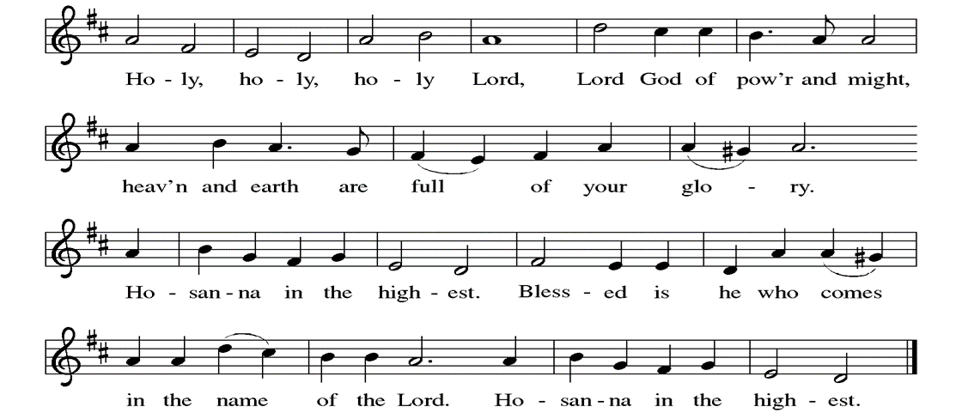

Great Prayer of Thanksgiving
P: With-us God, we live in a fearful world. If we’re honest, we come to this table today with the taste of fear on our tongues. We come to this table carrying our anxiety. We come to this table asking for guidance. We come to this table with all of life’s “what-ifs.”
But you do not disregard our fear. You do not brush it under the rug or call us foolish. You do not ignore the realities in front of us. You do not dish out hurtful platitudes, telling us to “toughen up” or “power through.”
Instead, you meet us here. You listen to our fears. You remind us that we are not alone. You surround us with people who love us. You show us where we are strong. You walk beside us. And you give us a new song to sing.
In the night in which he was betrayed, our Lord Jesus took bread, and gave thanks; broke it, and gave it to his disciples, saying: Take and eat; this is my body, given for you. Do this for the remembrance of me. Again, after supper, he took the cup, gave thanks, and gave it for all to drink, saying: This cup is the new covenant in my blood, shed for you and for all people for the forgiveness of sin. Do this for the remembrance of me.
Today we pray, gracious God: replace the fear on our tongues with words of hope and songs of joy. As we come to this table, remind us that even in a fearful world, you are on the move. Remind us that even in a fearful world, you are here, inviting us to this table, nourishing our spirits, reminding us that we belong, calling us by name.
Instill that good news in us, for this is a joyful feast. Fear is not the loudest voice today. What a gift that is.
Now with hope for a better tomorrow, we pray in your Son’s name. C: Amen

Lord’s Prayer
P: Lord, remember us in your kingdom and teach us to pray.
C: Our Father, who art in heaven, hallowed be thy name, thy kingdom come, thy will be done, on earth as it is in heaven. Give us this day our daily bread; and forgive us our trespasses, as we forgive those who trespass against us; and lead us not into temptation, but deliver us from evil. For thine is the kingdom, and the power, and the glory, forever and ever. Amen.

Invitation to the Table
P: Friends, did you ever have a moment growing up when you walked into the school cafeteria, panned the faces in the crowd, and wondered if you were going to have a place to sit?
Did you ever have a moment, maybe as a new student or at the start of a new school year, when fear nibbled at the back of your mind because you weren’t sure where you belonged?
I image, at some point or another, most of us have experienced that kind of fear. But here at this table, you never have to wonder.
Here at this table, there is enough room, enough food, enough love for everyone. Here at this table, Jesus is standing up on his chair, waving his hands over his head, saying to each of you, “I saved you a seat!” Here at this table, you are wanted and welcomed. You are safe and loved. Here at this table, you belong.
So my friends, there is no need for fear here, for this is a joyful feast. And you are invited. Come. All are welcome.

At Parkside Lutheran Church we have an open table. We believe the invitation to receive comes from Jesus himself and all are welcome at Christ’s table. More than just Bread and Wine these are tangible signs of God’s love for you! If you do not wish to receive communion but would like a blessing, come forward and cross your arms over your chest. The Pastor will give you a blessing before you return to your seat via the side aisle. You’ll receive a communion wafer* in your hands. You may dip it in the cup of wine or juice. When giving the bread and cup, the communion ministers say:
“The body of Christ, given for you. The blood of Christ, shed for you.”
and each person may respond : Amen
*Please let Pastor know if you need a gluten-free bread.

The Communion Distribution

Communion Song ELW setting 4 (p. 154)

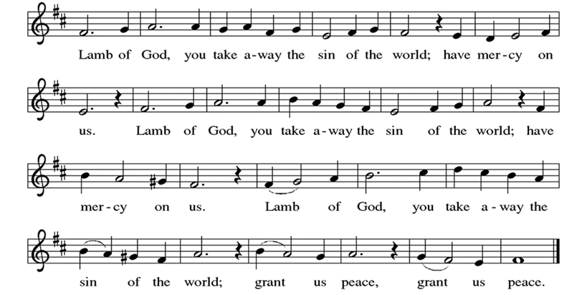

Communion Song: What Feast of Love ELW #487
(printed next page)
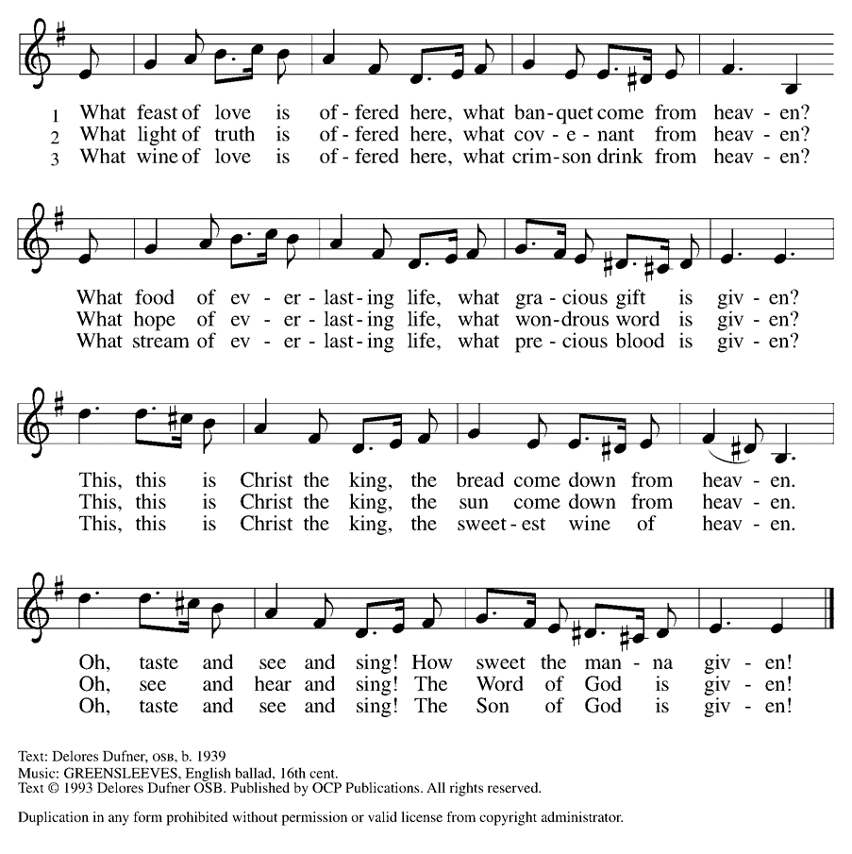
Communion Song: Wait for the Lord ELW #262
Post Communion Blessing
P: The Body and Blood of our Lord and Savior, Jesus Christ, strengthen you and keep you in God's grace. C: Amen.
Prayer After Communion
WA: Let us pray together.
C: Loving God, in a world racked with fear, you gather us together. You set the table. You meet us here. You nourish our bodies as you nourish our spirits. You remind us that this is a joyful feast, and that fear cannot win every time. So with renewed courage, with renewed hope, with renewed conviction, send us out into the world. Help us to feed others as you have fed us. With gratitude we pray. Amen.

Sending - God blesses us and sends us in mission to the world.

Blessing
P: May God who comes among us, Father, ☩ Son, and Holy Spirit, grant you patience in waiting, peace in the darkness, and good news to share today and always. C: Amen.

Sending Hymn: Joy to the World ELW #267
(printed next page)

Dismissal
WA: Parkside Lutheran Church is rediscovering the radical love of Jesus.
C: Gathering All. Serving All. Caring for All.
WA: Go in peace. Keep awake.
C: Thanks be to God.

Postlude: “Messiah” Larry Olson

ELW Music licensed from Sundays & Seasons, Augsburg Fortress CCLI MUSIC License # 11440069 , CCLI
Streaming License#21835523 Do not duplicate any music or Liturgy herein without license and permission

To sponsor Altar flowers or a Soloist in honor of a loved one
or to mark a special occasion. Contact the office for more info.

PARKSIDE STAFF:
• The Rev. Jeremiah Smith: prjeremiahpsmith@gmail.com
• Kris Pope & Suzanne Gracie, Admin. Assistants (Church Office): parksidelutheran@gmail.com
• Mike Hooker, Music Director: mrhooker@me.com

CHURCH OFFICE HOURS: M/T/R 10:00am-3:00pm (716)836-1361

SCHEDULES and Events:
Acolytes: |  | Worship Assistants
12/14 – Annalie & Lorenzo |  | 12/14 - Susan
12/21 – Franklin |  | 12/21 - John
Readers: |  | Ushers:
12/14 – John F |  | 12/14 – Dave C & Zack
12/21 – Kathie |  | 12/21 – David H & Sue S

Coming up:
- December 17th – Brewing Theology at Steel Leaf Brewing 7pm
- December 19th – Middle School Game Night 7pm – Stowell Lounge
- December 21st - Christmas Pageant 10am & Longest Night Service 5pm
- December 24th – Christmas Eve Family Service 10am & Candle Light Service 10pm
- December 28th – Lessons & Carols 10am
- January 3rd – Holiday Hayride 4pm – 7pm – Contact the Office if you are able to volunteer or donate. See sign-up sheets in the Narthex!
- January 17th – Lego Night in Fellowship Hall 5 – 7pm

Visit our website for more information about these and other Events at Parkside – www.parksidelutheran.org/events

2025 Christmas Wish List
Our Values at Parkside are: Proclaiming Grace, Extending Hospitality, Loving Boldly, and Cultivating Community. Without you, and God at work through you, these would remain just words on a page. We invite those who are able, to consider a year end gift towards one of the items from our Christmas List. You need not feel like you must cover the total cost of an item, but are welcome to contribute any amount. We give thanks to God for all the ways you make ministry happen. May God Bless You and we hope to see you for Advent and Christmas Celebrations. -Pastor Jeremiah
For Outreach Ministry:
- Sponsor Buffalo Burrito Project - $200
- Covers Burritos, Coffee, snacks and more for 60 to 100 neighbors who are hungry.
- Sponsor Food Pantry Overhead, including utilities, etc - $100

For The Office:
- Roll of Stamps - $78
- In 2026 we hope to send out a Spring and Fall Newsletter. Covering the stamps
helps keep our community informed on upcoming Events and Good News!

For Property:
- Installing Crash Bars- $1000 x 6
- For increased accessibility and safety, we want to convert all doors into crash bars.

For Hospitality:
- Self-Serve coffee bar in Narthex - $25 x 12
- As we seek to build community in a way that does not place more work on volunteers, we would like to add a self-serve coffee bar in the Narthex. This way, folks can feel encouraged to have conversation and build community after worship. Gifts will cover Keurigs, Coffee, and supplies.
For Worship:
- Sponsor a Soloist - $150
- A soloist assists in congregational singing and an aid to our worship. If you
sponsor a soloist, you can talk with music Director Michael Hooker and make recommendations for special music!
- Christmas Trees - $600 x 2
- After a 100 years of using real trees, we have decided to invest in pre-lit trees. These are less of a fire hazard, easier on volunteers, and better stewardship of resources.
- Sponsor Flowers for the Easter Cross - $175

For Education:
- Sponsor Child Care for a Sunday - $50
- We are so blessed to have wonderful staff who offer safe, welcoming, loving care. We are currently looking to hire a second staff person. Your gift helps with this most important investment, our youngest members.

- Curriculum - $200
- From worksheets and engaging videos, to silly games, our digital curriculum offered through the ELCA’s publishing arm, spark house digital, is a wonderful asset to Confirmation and Sunday School.

Holiday Services & Events:
Christmas Pageant - December 21st at 10am
Longest Night Service – December 21st at 5pm
Christmas Eve – December 24th - Family Service at 10am &
Candle Light Service at 10pm
Lessons & Carols – December 28th at 10am
Holiday Hayride – January 3rd at 4pm

