Announcements

Monday, December 8
Advent Study group Board room 10:00a.m.
Ginger Bread Houses Library 10:00a.m.
Beaver Valley Concert Band Banquet hall 5:30p.m.

Tuesday, December 9
Outreach meeting Banquet hall 3:00p.m.
Bell practice Banquet hall 7:00p.m.

Wednesday, December 10
Prayer Shawl ministry Board room 1:30p.m.
Bay Wind Flutes Banquet Hall 5:00p.m.
Choir rehearsal Banquet hall 7:00p.m.

Thursday, December 11
Probus Banquet hall 10:00a.m.
Board meeting Board room 7:00p.m.
Thursday night group Banquet hall 8:00p.m.

Friday, December 12
Montessori School Banquet hall 11:00a.m.
Christmas concert

Saturday, December 13
Collingwood Garden Club Banquet hall 9:00a.m.

International Human Rights Day
Is December 10. Please consider, now or anytime, going online to http://amnesty.ca/what-you-can do/
and clicking on one, or both , of the links under “Have a minute?”. Write an urgent letter” will take you to urgent cases where amnesty hope letter will change things. You can send a short, respectfully worded email to the authorities in each case, urging them to act. If you don’t have time to send an email, consider signing a petition: clicking the ”Sign a petition” button will bring up a range of cases Amnesty Canada is addressing. You words can change lives!

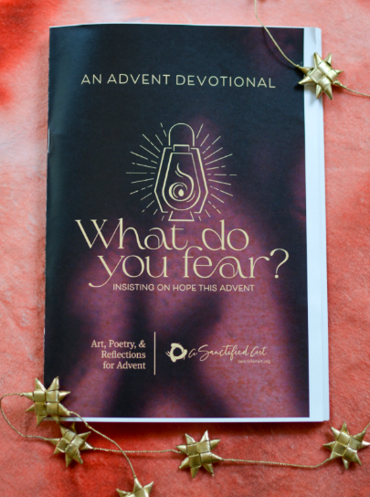
Get your Advent devotional today. Copies are available at the both sanctuary entrances. It includes lovely artwork and daily reflections to guide us through our preparations for Christmas. It starts November 30 which is the First Sunday of Advent and is produced by Sanctified Arts (sanctified art.org).

Christmas Hamper Giveaway
192 First Street at 9 a.m. on Dec. 23
Delivery Requests 705 445-1300
Christmas Day Turkey Dinner
Collingwood Legion 12:30 p.m.
Reservations: Call 211

Participatory Christmas Pagant
Sunday, December 14 @ 10:30a.m.
There is a roll for everyone as we retell the Christmas story in drama and song. Wear a costume of your choice )Shepherd, sheep, animal, wise one, angel, innkeeper or even a dragon) or get one when you arrive.
No rehearsal. Just come and get in on the fun!!

Blue Christmas Service
Thursday, December 18 @7:00p.m.
Let us help you find a little light the Christmas.
The beauty of the Christmas season sometimes reminds us of losses we have suffered. If you are feeling sad or worried or heart-broken this Christmas, our Blue Christmas service offers a time to gather with others experiencing similar things, to sit with our grief and to offer them up to God. If you are looking for a quiet space where it is okay ‘not to be merry’ this Christmas, please join us. A short reflection service will be followed by refreshments.

A presentation of “CHRISTMAS GEMS”
Trinity United Church Choir
Together with Community singers and Instrumentalists
Sunday December 21 @ 10:30a.m.

Christmas Eve Service
Wednesday, December 24 @ 7:00p.m.
The good news of Christmas is for everyone, Join us to explore the meaning of Christmas in story, song and candle-lit prayer. If you are looking for an inclusive, progressive Christian community to celebrate Christmas with, a warm welcome awaits you.

