All Saints Anglican Church
6904 Lougheed Highway, Agassiz, B.C. V0M 1A0
Bulletin December 1st, 2025 – December 7th, 2025

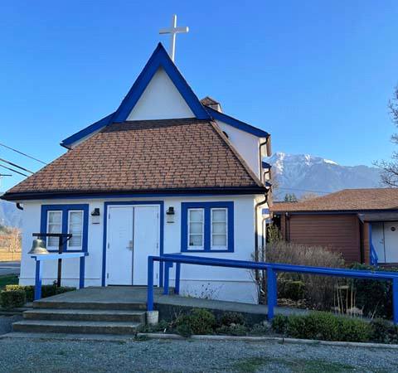

‘The ground we walk does not belong to us; for thousands of years it has been - and remains - the territory of the Stó:lō. We are grateful for their sharing.

Phone: 604-796-3553
Website: www.allsaints-agassiz.ca
https://www.facebook.com/groups/AllSaintsFamily
OUR DOOR IS OPEN AND ALL ARE WELCOME
December 7th, 2025, Second Sunday of Advent
Priest in Charge: The Reverend Philip Barker

Hosts: Graham Featherstone/Jennifer Pinlac
Intercessor: Douglas MacAdams
Lay Administrator: Dorothy Cresswell
Announcer: Virginia Jennings
Organ/Piano: Francesca Froehlich
Readers: David Hamilton/Valerie Hamilton
Vicar’s cell phone: Revd. Philip Barker. 778-867-2461

Vicar’s Warden: Ginny Jennings. 604-796-2206
People’s Warden: Lynn Laughlin. 604-799-5131
Parish email: revpb1950@gmail.com
Please contact either warden if you have an issue that needs to be brought to the attention of the Vicar - or contact the Vicar direct (see above for details).

All Saint’s Calendar/Announcements:

- Book Club has chosen the next book, "The Watchmaker's Daughter" by Larry Loftis. It is the true story of Corrie ten Boom, who helped her family hide Jewish and other refugees during WWII, survived Ravensbruck concentration camp and went on to be an evangelist across the globe. Some of you may have read her autobiography, "No Hiding Place". The book club started the book on November 5thand meets online every Wednesday to discuss the readings.


The book is $24.99 0n Amazon. There is no Kindle option
on Amazon but the Kobo e-book on the indigo.ca website
is $13.99. Please email Sheila at sjbarker0369@gmail.com
if you would like to join the group discussions or
have her order a book for you.

- Bible Study with Karol is every Saturday morning 0830-0900 on Zoom.

- Prayer Requests can be given on a piece of paper to either of the Wardens or the Vicar or entered in the Prayer Request Book on the lectern. Alternatively, you can contact Anthea Lewis at antheamlewis@shaw.ca for Pray First Prayer Circle, which is a confidential online prayer circle.

- Music Requests may be given to the Wardens or the Vicar.

- AA meets in the hall every Tuesday and Friday at noon.

- Every Thursday in the hall 1100-1200 we have a social time with coffee, games if you like or just talk.

- At 1000-1100 on Thursdays there is an Interactive Bible Study on the day’s Lectionary readings. All are welcome – discover the treasures in this amazing book!

- 5th Sunday of each month will be a potluck lunch after the service.

- Sunday December 28th – Community Lunch at All Saint’s – Please contact Fran if you have questions and to confirm your attendance. We will need volunteers to help with clean-up. God works in mysterious ways, but he doesn’t do dishes.

Christmas Services
Wednesday, December 24th, Christmas Eve, at 1600 (4.00pm)
Nine Lessons and Carols

Thursday, December 25th, Christmas Day, at 1000

Ministerial Meandering
Sabbath moments

The nurse’s name was Amber, and she used to tell me that ‘Soup was only for sick people’. She stood quietly in the Trauma bay, looking down at the little child now still amid the detritus of the failed resuscitation all around her. Abandoned by all - except for Amber. It was a moment etched into my memory at the time, and I can see every detail of it still.

Another day, a young lady whose name I never knew, but whose brain had ceased to function - thanks to her boyfriend’s drunken driving - was lying in the OR with different teams of surgeons poised to take their turn at the pickings.
In carefully respected order, lest her heart be taken before her liver or kidneys, every useful organ was removed from this tragic girl, starting with her eyes and ending when, finally, her heart and lungs were removed - and there was no more need for the ventilator. Silence filled her empty spaces. I felt I had witnessed a sort of rape; I called her ‘Briar-Rose’.

Two young parents sat either side of a crib, the mother holding tightly to another hand - one of the Staff Nurses on the Neonatal Intensive Care Unit. Dad, on the other side, was immobile, looking down at his boy - the tiny scrap I had fought for three days to keep alive after his congenital heart defect had been repaired. Sometimes you don’t win, even if the operation was technically perfect. Maybe the lungs were just too immature…maybe this…maybe that.
I stood at the end of the crib quietly, until Dad got up and leant over his son and said, ‘You didn’t have much of a life, did you son? I was so looking forward to taking you fishing, playing soccer with you…’. then he broke down, sobbing. I had to leave before I joined him.

All these are unforgettable ‘sabbath moments’ in my life. You might wonder why I have only mentioned sad and difficult ones - to which I would say that beauty isn’t always or only found in things that bring us joy. I have seen Michelangelo’s ‘Pieta’ in Florence - presumably a copy, as the original is apparently in St Peter’s Basilica in the Vatican. Nevertheless, it remains a sublime work of art. It does not bring us joy - but perhaps invokes a sense of awe, along with intense sorrow.

However, a couple of days ago, Sheila and I were walking Gracie and chanced to look at the sky. Radiating paths of pink/orange cloud came from a point in the west, separating above our heads, and then converging again to an apparent point in the east. I suppose we were under parallel lines of peach clouds.
And years ago, when we were still courting, coming out from an intense Anatomy course in central London, we were stopped by an orange moon hanging over Big Ben and the Houses of Parliament at the end of Westminster Bridge. These both brought us a quiet and unspoken joy.

Some people’s sabbath moments might be more in line with Mary Poppins’ ‘Favourite Things’, but for me, I need something that makes me stop in my tracks and ponder.

And I actually saw a shooting star streak the sky west of the moon three nights ago.

Philip+

Truth and Reconciliation
Thank you for the very positive response to the invitation to the current Table Talks series. I had to limit the numbers in the group because it is meant to be a series of small group conversations. Several people were disappointed, so I plan to run the series a second time, probably after Christmas.
Please let me know as soon as possible at sjbarker0379@gmail.com if you would like to join. Feel free to ask those taking part now for their feedback.
A Little Chuckle
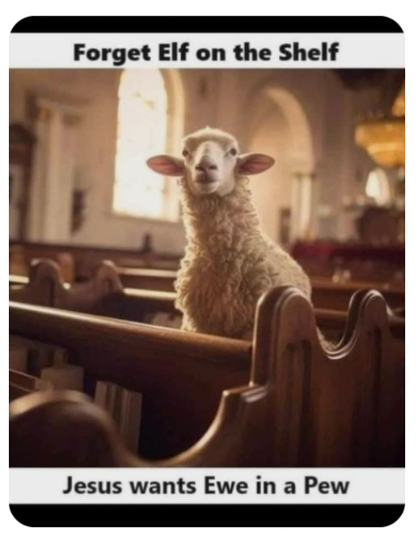

Birthdays this Month  December

Fran Floehlich – 19 Carol Taylor – 25

Diocesan Cycle of Prayer: We Pray for the Clergy and Congregation:

Archdeacon Adam Yates (Granville); Christ Church, Hope; St. Laurence, Coquitlam - The Revd Philip Cochrane, The Revd Patricia Ratcliffe

Anglican Church of Canada Cycle of Prayer – We Pray for:

The Primate Archbishop Shane Parker and the staff of the Primate’s Office of the Anglican Church of Canada

Collect

Almighty God, who sent your servant John the Baptist to prepare your people to welcome the Messiah, inspire us, the ministers and stewards of your truth, to turn our disobedient hearts to you, that when the Christ shall come again to be our judge, we may stand with confidence before his glory; who is alive and reigns with you and the Holy Spirit, one God, now and for ever.

Isaiah 11:1-10 David Hamilton

11 A shoot will come up from the stump of Jesse;
from his roots a Branch will bear fruit.
² The Spirit of the Lord will rest on him—
the Spirit of wisdom and of understanding,
the Spirit of counsel and of might,
the Spirit of the knowledge and fear of the Lord —
³ and he will delight in the fear of the Lord.
He will not judge by what he sees with his eyes,
or decide by what he hears with his ears;
⁴ but with righteousness he will judge the needy,
with justice he will give decisions for the poor of the earth.
He will strike the earth with the rod of his mouth;
with the breath of his lips he will slay the wicked.
⁵ Righteousness will be his belt
and faithfulness the sash around his waist.

⁶ The wolf will live with the lamb,
the leopard will lie down with the goat,
the calf and the lion and the yearling together;
and a little child will lead them.
⁷ The cow will feed with the bear,
their young will lie down together,
and the lion will eat straw like the ox.
⁸ The infant will play near the cobra’s den,
and the young child will put its hand into the viper’s nest.
⁹ They will neither harm nor destroy
on all my holy mountain,
for the earth will be filled with the knowledge of the Lord
as the waters cover the sea.

¹⁰ In that day the Root of Jesse will stand as a banner for the peoples; the nations will rally to him, and his resting place will be glorious.

Psalm 72:1-7, 18-19

¹ Endow the king with your justice, O God,
the royal son with your righteousness.
² May he judge your people in righteousness,
your afflicted ones with justice.
³ May the mountains bring prosperity to the people,
the hills the fruit of righteousness.
⁴ May he defend the afflicted among the people
and save the children of the needy;
may he crush the oppressor.
⁵ May he endure as long as the sun,
as long as the moon, through all generations.
⁶ May he be like rain falling on a mown field,
like showers watering the earth.
⁷ In his days may the righteous flourish
and prosperity abound till the moon is no more.

18 Praise be to the Lord God, the God of Israel,
who alone does marvelous deeds.
19 Praise be to his glorious name forever;
may the whole earth be filled with his glory.
Amen and Amen.

Romans 15:4-13 Valerie Hamilton

⁴ For everything that was written in the past was written to teach us, so that through the endurance taught in the Scriptures and the encouragement they provide we might have hope.

⁵ May the God who gives endurance and encouragement give you the same attitude of mind toward each other that Christ Jesus had, ⁶ so that with one mind and one voice you may glorify the God and Father of our Lord Jesus Christ.

⁷ Accept one another, then, just as Christ accepted you, in order to bring praise to God. ⁸ For I tell you that Christ has become a servant of the Jews on behalf of God’s truth, so that the promises made to the patriarchs might be confirmed ⁹ and, moreover, that the Gentiles might glorify God for his mercy. As it is written:

“Therefore I will praise you among the Gentiles;
I will sing the praises of your name.”

¹⁰ Again, it says,
“Rejoice, you Gentiles, with his people.”

¹¹ And again,
“Praise the Lord, all you Gentiles;
let all the peoples extol him.”

¹² And again, Isaiah says,
“The Root of Jesse will spring up,
one who will arise to rule over the nations;
in him the Gentiles will hope.”

¹³ May the God of hope fill you with all joy and peace as you trust in him, so that you may overflow with hope by the power of the Holy Spirit.

Matthew 3:1-12 Vicar Philip Barker
3 In those days John the Baptist came, preaching in the wilderness of Judea ² and saying, “Repent, for the kingdom of heaven has come near.” ³ This is he who was spoken of through the prophet Isaiah:

“A voice of one calling in the wilderness,
‘Prepare the way for the Lord,
make straight paths for him.’”

⁴ John’s clothes were made of camel’s hair, and he had a leather belt around his waist. His food was locusts and wild honey. ⁵ People went out to him from Jerusalem and all Judea and the whole region of the Jordan. ⁶ Confessing their sins, they were baptized by him in the Jordan River.

⁷ But when he saw many of the Pharisees and Sadducees coming to where he was baptizing, he said to them: “You brood of vipers! Who warned you to flee from the coming wrath? ⁸ Produce fruit in keeping with repentance. ⁹ And do not think you can say to yourselves, ‘We have Abraham as our father.’ I tell you that out of these stones God can raise up children for Abraham. ¹⁰ The ax is already at the root of the trees, and every tree that does not produce good fruit will be cut down and thrown into the fire.

¹¹ “I baptize you with water for repentance. But after me comes one who is more powerful than I, whose sandals I am not worthy to carry. He will baptize you with the Holy Spirit and fire. ¹² His winnowing fork is in his hand, and he will clear his threshing floor, gathering his wheat into the barn and burning up the chaff with unquenchable fire.”

Odds and Ends
$Donations and Tax Receipts$
Only a few more weeks before we welcome 2026. Please keep this in mind as all donations for the 2025 tax year must be received and deposited prior to end of December.


White Wrapped Gifts
We are collecting gifts for donation to local families in need. We are asking people to wrap the gift(s) in white paper and include a tag indicating the age of the recipient. We will collect them under the Christmas Tree.

Donkeys for Kenya
As part of our Christmas giving as a parish we are hoping to donate $320 to Alongside Hope (formerly PWRDF Primate’s World Relief and Development Fund) to send 2 donkeys to a rural community in Kenya, East Africa. A gift match could make this 4 donkeys. ‘By carrying heavy loads of water, firewood or building materials, donkeys ease the burden on women, children and the elderly.’ The school ‘bus’ may be a donkey cart and goods may be carried to market to be sold to help the village economy. Around $10 per person would get us to our target. There will be a basket in church for donations or for tax purposes you can add a little extra to your regular giving, but please make it clear how much is to go to the Donkey Fund.

Thank you for your support! Check the donkey ears chart in the hall to see how we are doing.

