This Week at PPBC

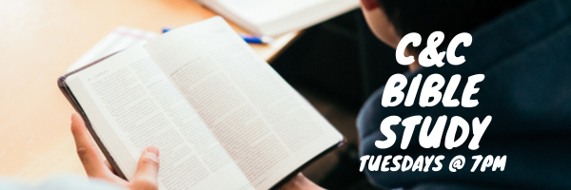

Wednesdays @ 6:30pm



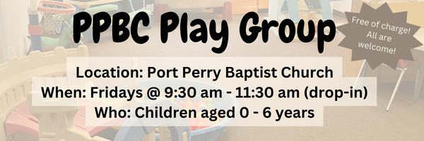Friday, December 12, 2025

Friday, December 12, 2025

December 13th, 2025
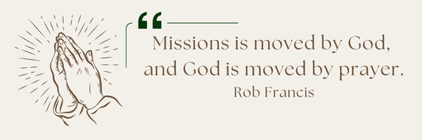
A Prayer Request from the Jones: We are grateful for our church family, for your support and care throughout our mission service with EI. Please pray for Paul as he continues with the responsibilities of the International Office for EI. Pray that God is glorified and that the message of Jesus’ love and salvation is front and center of all that EI does.

Please Sign up in the foyer and bring a tray of your favourite dessert to share!

Sunday Ministry Schedules
Below are ministry schedules for Nursery, Jr. Church, Greeters, Ushers, and Sound & Video:
Nursery
Dec 7: Kathryn denOuden, Brantley Colwell
Dec 14: Jan Gerrow, Hannah Colwell
Infant Nursery
Dec 7: Laura Saunders, Elise Anderson
Dec 14: Lisa Dallas, Karen Clemens
Jr. Church; ages 3 to grade 1
Dec 7: Christine McLaren
Dec 14: Justine McKenzie, Kelsey Schoenrock
Jr. Church; Grades 2 to 6
Dec 7: Gregg & Karen Anderson, Graeme Anderson
Dec 14: Mary Deli, Jen Owens
Greeters
Dec 7: Roy & Elizabeth Werner
Dec 14: Tracy & Karen Ballanger
Ushers
Dec 7: Gregg Anderson, Graeme Foster
Dec 14: Joe Colwell, Matt Saunders
Sound & Video
Dec 7: Sound: Charlie Deane | Video: William Conley
Dec 14: Sound: Wyatt Werner | Video: Josh Myers
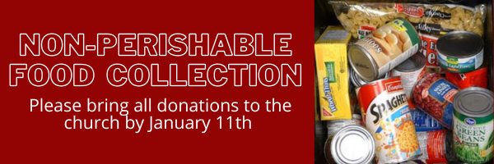

Morning Service
Welcome
Advent Reading
Song – What Child is This
Scripture
Song – Alas and Did My Savior Bleed #208
Communion
Song – O Come All You Unfaithful
Message – Pastor Jim Clemens
Song – I Set my Hope on Jesus



Praise & Prayer Highlights
PRAY for Brian Timmins and his family as they mourn the loss of his grandfather. PRAY that God will give them great comfort in Christ.
PRAY for Pastor Jim & Brenda. PRAY Pastor Jim as he battles a rather stubborn respiratory illness. He is on new medications and is feeling some improvement the last couple of days. Please PRAY for renewed health and an increase of patience as he trusts the Lord's timing in his recovery.
PRAY for Joan Mabley's ongoing health & recovery at home. PRAY for her and the family as they look for care to meet Joan's needs.
PRAY for Barbara Fry and the Werner family as they mourn the loss of Ron. PRAY for Barbara, Roy, Elizabeth and the family as they make preparations for a service. PRAY that God will give them great comfort in Christ and that the truth of the Gospel will shine through this loss.
PRAY for Bert & Ada Faber and their ongoing health concerns.
PRAISE for Carolyn & Ebi Meraji and the birth of their second son Eli. Continue to pray for them as they recover and celebrate this gift.
PRAISE for the safe arrival of Shepherd Bryant. PRAY for Morgan and Josh and their family as they recover and celebrate this new life.
PRAY for Dennis Tomcheski and his ongoing health concerns.
PRAY for Winnie Miller and her ongoing health concerns.
PRAISE for the engagement of Stephanie Harrott and Daniel Wobito (new attendees of PPBC). Please PRAY for them as they prepare for marriage next year.
PRAISE for the engagement of Joshua Bolsonello & Madeline Werner. Please remember them in prayer as they prepare for marriage next fall.
Giving
Just as a reminder, there are several ways you can give:
In Person using the offering box located on the back wall of the sanctuary. Donation envelopes are available at the Welcome Centre. Please contact the church office if you would like a box of donation envelopes (office@portperrybaptist.ca)
Through your online banking, you may send electronic transfers to ppbcdonations@gmail.com.
You can also give through Canada Helps. Donation receipts will be provided by Canada Helps, and transaction fees apply.
***********************************************************************
Weekly Newsletter
The PPBC Newsletter is emailed to the church family every Friday. If you would like to be added to the weekly email list, please contact the office by phone: 905-985-8681 or by email: office@portperrybaptist.ca.
*****************************************************************
Church Information:
Location:
2210 Hwy 7A
Port Perry, ON
L9L 1B4
Office Hours:
Monday: 8:30am – 4:00pm
Tuesday: 8:30am – 4:00pm
Wednesday: Closed
Thursday: 8:30am – 4:00pm
Friday: 8:30 am - 3:00 pm
Contact:
Phone: 905.985.8681
Email: office@portperrybaptist.ca
Website: www.portperrybaptist.ca
Staff:
Sr. Pastor – Rev. Jim Clemens
Administrative Assistant – Madeline Werner
Family Ministries Director – Josh Anderson

PPBC Newsletter
Sunday, December 7, 2025


Sunday Starting Point
Sunday, December 7, 2025 - 9:30 am
“Beginning the day with the Word and prayer”
Adults:
Adults will meet in the sanctuary for a time of study and prayer. Psalm 146.
Youth:
Jr High (Grades 7-8) will meet in room 18 with Kate Anderson to study Advent.
Children:
Children ages 3 - grade 6 will meet in room 26.
(Please note nursery is unavailable during Starting Point)
Sunday Morning Worship
Sunday, December 7, 2025 - 10:30 am
We are meeting in the sanctuary and will continue to live-stream for those who are unable to attend.
Message: The King Speaks to His Churches
Scripture: Revelation 1-3
Pastor Jim Clemens

