Holy Trinity Evangelical Lutheran Church

December 7, 2025 10:30

Pastor Tina Crog

*Prelude

*Welcome and Announcements Worship Assistant

*Gathering Hymn “People Look East” ELW #248
Public Domain
1.People, look east. The time is near of the of the crowning of the year. Make your house fair as you are able, trim the hearth and set the table. People, look east, and sing today Love, the Guest, is on the way.

2.Furrows, be glad. Though earth is bare, one more seed is planted there. Give up your strength the seed to nourish, that in course the flow’r may flourish. People, look east, and sing today Love, the Rose, is on the way.

3.Stars, keep the watch. When night is dim, one more light the bowl shall brim, shining beyond the frosty weather, bright as sun and moon together. People, look east, and sing today Love, the Star, is on the way.

4.Angels announce with shouts of mirth him who brings new life to earth. Set every peak and valley humming with the word, the Lord is coming. People, look east, and sing today Love, the Lord, is on the way.

* Confession and Forgiveness Pastor Tina
Blessed be the holy Trinity, ☩ one God, whose home is heaven and earth, whose salvation is sure. Amen.

God is here, and God sees through every defense that fools the world. Since we cannot hide from God, there is nothing left to do but to be honest with each other and humble before God. So, in humility, we confess our sins.

God with us, we have acted helpless, even when you called us to action. We have resisted your truth, even when our lies were exhausting. We have behaved as though we were alone, even when you were beside us. We can never undo the sins of this world, but we trust in your perfect plan for salvation. Forgive our sins. Set us free to chart a new path. Help us learn from the echoes of our past. In the name of Emmanuel, Jesus Christ, we pray. Amen.

Hear the good news: God the Faithful One loves you, ☩ in Christ Jesus your sins are forgiven, and by the power of the Holy Spirit you are set free. Amen.

* Kyrie (to the Tune of “Come Thou Long Expected Jesus,” ELW 254)
Public Domain
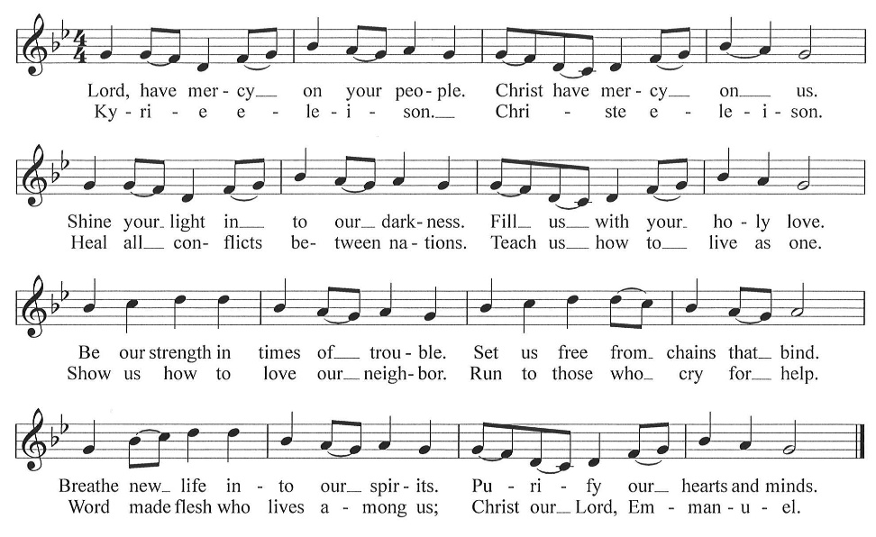

* Greeting Pastor Tina
* Prayer of the Day worship assistant
God of the wilderness, your word breaks open the silence and makes all things new. Call us again to repentance and renewal, that your Spirit’s wild life may take root in us and prepare the way for Christ’s coming; through Jesus Christ, the One who is life abundant. Amen.

*The passing of the Peace worship assistant
The peace of Christ be with you, always.
And also with you.

Share the peace of Christ by staying in your seat and waving.

*Lighting of the Advent Wreath Cindy Byard and Barb Urban
When deep blue darkness steps aside for softly spreading flame, we take comfort from the warmth of living light. This candle on our Advent wreath represents the joy of life, which spreads as we share it. The unpredictable flicker of life brings comfort even when the future remains a mystery.

Two candles are lit.

In time every person will know the warmth of God’s love. But that time is not yet here, so we pray: Emmanuel, God with us, you are Light from Light, the Word made flesh. Help us feel the warmth of your nearness. In the name of Jesus we pray. Amen.

*Song “Light One Candle to Watch for Messiah” ELW 240, vs. 1 & 2
One License A-700000

1.Light one candle to watch for Messiah: let the light banish darkness. He shall bring salvation to Israel, God fulfills the promise.

2.Light two candles to watch for Messiah: let the light banish darkness. He shall feed the flock like a shepherd, gently lead them homeward.

*Children’s Message Pastor Tina
*First Lesson: Isaiah 11:1-10 Reader
Isaiah describes the coming of a future, ideal ruler who will renew David’s royal line (the stump of Jesse). Gifted by the spirit of God, this ruler will reign with perfect justice. Enmity and danger will be restored to harmony and peaceful coexistence.

¹ A shoot shall come out from the stump of Jesse,
and a branch shall grow out of his roots.
² The spirit of the Lord shall rest on him,
the spirit of wisdom and understanding,
the spirit of counsel and might,
the spirit of knowledge and the fear of the Lord.
³ His delight shall be in the fear of the Lord.
He shall not judge by what his eyes see
or decide by what his ears hear,
⁴ but with righteousness he shall judge for the poor
and decide with equity for the oppressed of the earth;
he shall strike the earth with the rod of his mouth,
and with the breath of his lips he shall kill the wicked.
⁵ Righteousness shall be the belt around his waist
and faithfulness the belt around his loins.
⁶ The wolf shall live with the lamb;
the leopard shall lie down with the kid;
the calf and the lion will feed together,
and a little child shall lead them.
⁷ The cow and the bear shall graze;
their young shall lie down together;
and the lion shall eat straw like the ox.
⁸ The nursing child shall play over the hole of the asp,
and the weaned child shall put its hand on the adder’s den.
⁹ They will not hurt or destroy
on all my holy mountain,
for the earth will be full of the knowledge of the Lord
as the waters cover the sea.
¹⁰ On that day the root of Jesse shall stand as a signal to the peoples; the nations shall inquire of him, and his dwelling shall be glorious.

The Word of the Lord. Thanks be to God.

*Second Lesson: Romans 15:4-13 Reader
God’s promise to include Gentiles within the circle of God’s blessed people has been fulfilled in Jesus Christ. Christians live out their unity by welcoming and encouraging each other just as Christ has welcomed them into God’s family.

⁷ Welcome one another, therefore, just as Christ has welcomed you, for the glory of God. ⁸ For I tell you that Christ has become a servant of the circumcised on behalf of the truth of God in order that he might confirm the promises given to the ancestors ⁹ and that the gentiles might glorify God for his mercy. As it is written,
“Therefore I will confess you among the gentiles
and sing praises to your name”;
¹⁰ and again he says,
“Rejoice, O gentiles, with his people”;
¹¹ and again,
“Praise the Lord, all you gentiles,
and let all the peoples praise him”;
¹² and again Isaiah says,
“The root of Jesse shall come,
the one who rises to rule the gentiles;
in him the gentiles shall hope.”
¹³ May the God of hope fill you with all joy and peace in believing, so that you may abound in hope by the power of the Holy Spirit.
The Word of the Lord. Thanks be to God.

*Gospel Acclamation “Emmanuel, Emmanuel”
CCLI #11222261
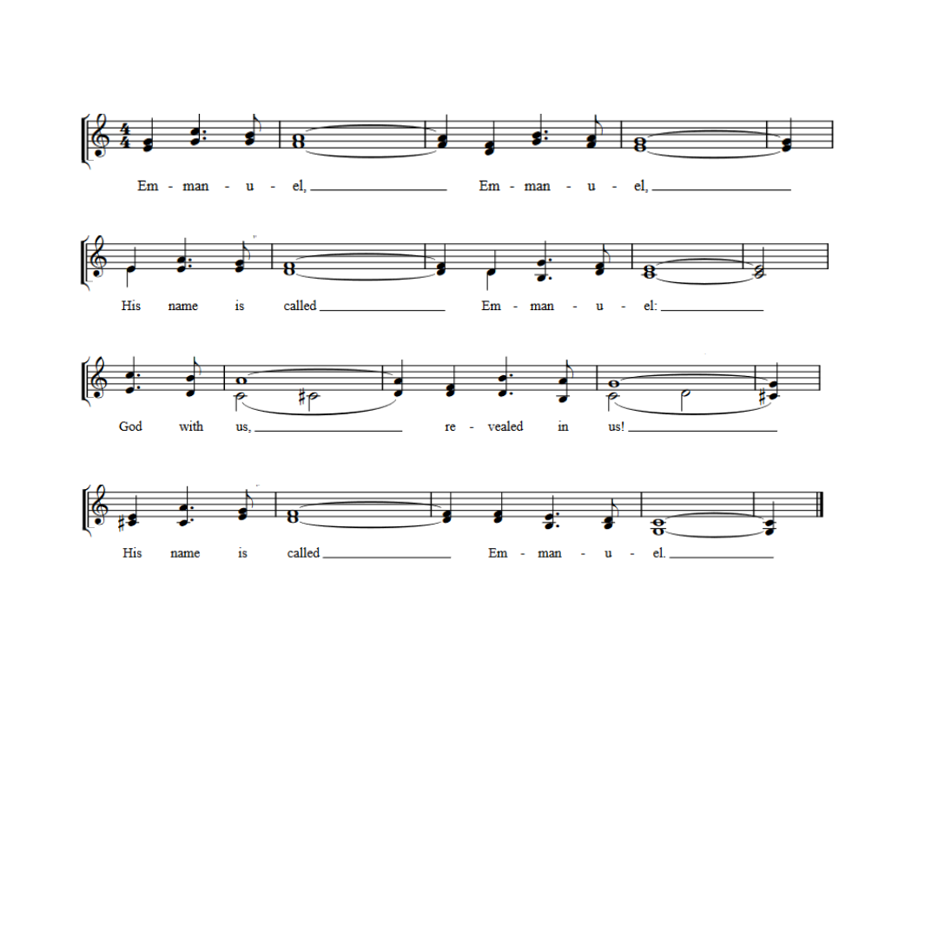

*Gospel: Matthew 3:1-12 Pastor Tina
Just before Jesus begins his public ministry, John the Baptist appears, calling people to mend their ways and speaking of a powerful one who is to come.

The Holy Gospel according to Matthew, the 3rd chapter. Glory to you, O Lord.

¹ In those days John the Baptist appeared in the wilderness of Judea, proclaiming, ² “Repent, for the kingdom of heaven has come near.” ³ This is the one of whom the prophet Isaiah spoke when he said,
“The voice of one crying out in the wilderness:
‘Prepare the way of the Lord;
make his paths straight.”
⁴ Now John wore clothing of camel’s hair with a leather belt around his waist, and his food was locusts and wild honey. ⁵ Then Jerusalem and all Judea and all the region around the Jordan were going out to him, ⁶ and they were baptized by him in the River Jordan, confessing their sins.
⁷ But when he saw many of the Pharisees and Sadducees coming for his baptism, he said to them, “You brood of vipers! Who warned you to flee from the coming wrath? ⁸ Therefore, bear fruit worthy of repentance, ⁹ and do not presume to say to yourselves, ‘We have Abraham as our ancestor,’ for I tell you, God is able from these stones to raise up children to Abraham. ¹⁰ Even now the ax is lying at the root of the trees; therefore every tree that does not bear good fruit will be cut down and thrown into the fire.
¹¹ “I baptize you with water for repentance, but the one who is coming after me is more powerful than I, and I am not worthy to carry his sandals. He will baptize you with the Holy Spirit and fire. ¹² His winnowing fork is in his hand, and he will clear his threshing floor and will gather his wheat into the granary, but the chaff he will burn with unquenchable fire.”

The Gospel of the Lord. Praise to you, O Christ.

*Sermon pastor tina

*Hymn of the Day "Hark, the Glad Sound!" ELW 239
No copyright found

1.Hark, the glad sound! The Savior comes, the Savior promised long;
let every heart prepare a throne and every voice a song.

2.He comes the pris’ners to release, in Satan’s bondage held. The gates of brass before him burst, the iron fetters yield.

3.He comes the broken heart to bind, the bleeding soul to cure, and with the treasures of his grace to enrich the humble poor.

4.Our glad hosannas, Prince of Peace, your welcome shall proclaim, and heav’ns eternal arches ring with your beloved name.

*Prayers of the People
please be seated
any prayer requests or joys to share
As we prepare for Emmanuel, God-with-us, let us pray for all people and places that long for God’s presence.
With wisdom and understanding, inspire the faithful around the world. Unite hearts and minds in work to address poverty, access to housing, and equity among peoples. God of grace, hear our prayer.
With counsel and might, move us to care for creation. As we dream of the day when all creatures will flourish alongside one another, guide us in ways humanity and all creation will mutually thrive. God of grace, hear our prayer.
With righteousness and faithfulness, encourage nations to live in harmony with one another. We pray for international student and teacher exchanges, for our partner churches, and for the shared mission of Lutheran World Relief and Lutheran Disaster Response. God of grace, hear our prayer.
With steadfastness and encouragement, strengthen those who have lost hope in the face of grief, depression, or disease (especially). Renew the spirits of those recovering from surgery and medical procedures. God of grace, hear our prayer.
With welcome and hospitality, embolden us in our shared ministry to overcome all that divides. In acts of repentance, reconciliation, and reparation, may we serve in the way of Christ. God of grace, hear our prayer.
With joy and peace, we remember our ancestors in the faith (especially…). Fill us with the hope of the Holy Spirit now and into the ages of ages. God of grace, hear our prayer.
Savior of the nations, come, and receive these prayers and the pleas of our hearts, in the name of Jesus Christ. Amen.

*Offering worship assistant
the monthly mission in december is for the collaboration. Let us give to god what he has first given us.

*Offering Music by jared

*Offertory Hymn “Our Gifts We Now Bring” vs. 1
to the tune AWAY IN THE MANGER, ELW 277
Public Domain
to be sung while the offering is being returned to the Altar
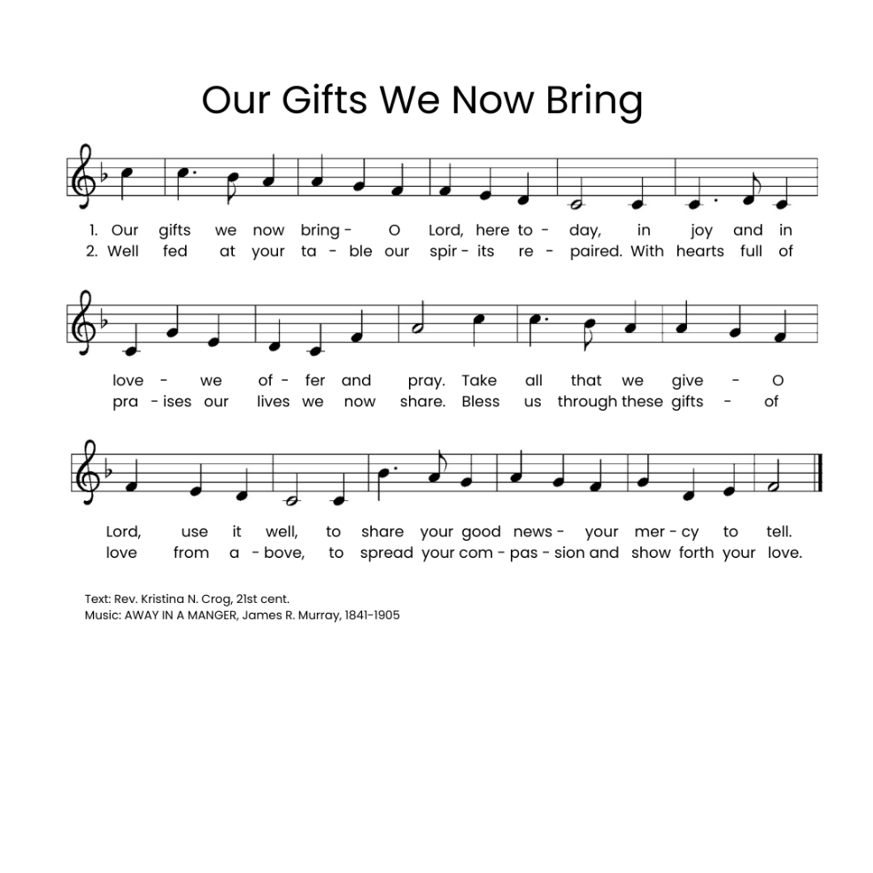

*Offering Prayer. worship assistant
God with us, we cherished what we thought belonged only to us: our money, our time, our families, and our freedom. Yet in a moment, we recognize that every truly good thing was a treasure we had taken from your open hand. We thought such treasures were ours to earn and to own. You grow what we give away. So we give you these gifts as a sign of your love and faithfulness. Amen.

*Communion Liturgy Sung to the tune: O Come, O Come, Emmanuel [ELW 257] One License A-700000

The Lord be with you as we gather here.
Lift up your hearts unto the Lord your God.
For it is right to give God our praise.
Let us prepare our hearts for coming days:
Rejoice, Rejoice! Emmanuel
Shall come to you, O Israel.

You created all things and called them good,
made us like you, but we cast off your love.
You set us free and claimed us as yours,
through sage and prophet spoke to us your word.
Rejoice, Rejoice! Emmanuel
Shall come to you, O Israel.

Holy are you and blessed is your Son,
Jesus, the Light, your presence here with us.
You sent him in the fullness of time,
he came to preach good news to all.
Rejoice, Rejoice! Emmanuel
Shall come to you, O Israel.

And on the night that Jesus was betrayed,
Christ took the bread, and unto you gave thanks.
He broke the bread and shared it with friends.
“Take, eat, my body given for you.”
Rejoice, Rejoice! Emmanuel
Shall come to you, O Israel.

After the meal he lifted up the cup,
“My blood, my life, I pour it out for you.
This covenant I make anew.
Set free from sin! Remember me!"
Rejoice, Rejoice! Emmanuel
Shall come to you, O Israel.

Spirit of God descend upon us now,
And make these gifts become for us
the body and the blood of Christ
a holy, living sacrifice.
Rejoice, Rejoice! Emmanuel
Shall come to you, O Israel.

*Lord’s Prayer Pastor Tina
Our father, who art in heaven, hallowed be thy name, thy kingdom
come, thy will be done, on earth as it is in heaven. Give us this day our daily bread; and forgive us our trespasses, as we forgive those who trespass against us; and lead us not into temptation, but deliver us from evil. For thine is the kingdom, and the power, and the glory,
forever and ever. amen.

Lamb of God Sung to the tune: O Come, O Come, Emmanuel [ELW 257]
One License A-700000
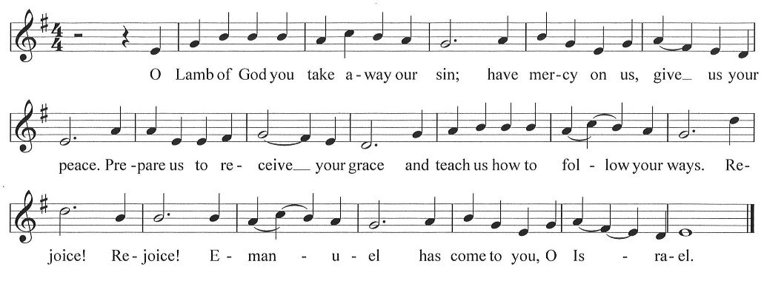

*Post Communion Blessing Pastor Tina

*Post Communion Canticle “Our Gifts We Now Bring” vs. 2
Go back to page 9

*Prayer After Communion Pastor Tina and the congregation
Jesus, the world looks different from your table. Here, there are no strangers, and grace is never a surprise. Life always thrives in the desert, and a promise never shades with doubt. Soon as we rise from this table, our memories of this goodness fade. Bring us back every day to your promises: astonish us again. Amen.

*Blessing Pastor Tina
*Closing Song "Let Justice Flow Like Streams" ELW 717
CCLI #11222261 and One License A-700000

1.Let justice flow like streams of sparkling water, pure, enabling growth, refreshing life, abundant, cleansing, sure.

2.Let righteousness roll on as others’ cares we heed, an everflowing
stream of faith translated into deed.

3.So may God’s plumb line, straight, define our measure true, and justice, right, and peace pervade this world our whole life through.

*Dismissal
Keep watch! Christ is coming soon!
Thanks be to God!

*Postlude

Prayer of the Day, Advent Wreath Lighting, and Offering Prayer by Barn Geese Worship, 2025
“Kyrie” (based on the tune Come, Thou Long-Expected Jesus) by David Eck, Copyright ©2011
"Emmanuel" by Bob McGee, © 1976 C. A. Music (div. of C. A. Records, Inc.)/ASCAP
“A Sung Communion Liturgy for the Season of Advent” (based on tune: VENI EMMANUEL) by Rev. Beth Quick, 2013, http://bethquick.blogspot.com/2013/11/a-sung-communion-liturgy-for-season-of.html
“Lamb of God” “based on the tune VENI EMMANUEL) by David Eck, Copyright ©2011
"Our Gifts We Now Bring" (based on the tune AWAY IN THE MANGER by James R. Murray) by Rev. Kristina N. Crog, 2024

