

The Bells of St. Helen’s FALL/WINTER 2025
KEEPING YOU IN TOUCH WITH YOUR CHURCH FAMILY…
Website: https://www.sthelensurrey.ca
Facebook: St. Helen’s Anglican Church, Surrey “like” us on Facebook!
The Rev. Dr. Robin Ruder Celiz is available by Email: sainthelensrector@gmail.com. or through the Church office: 604-581-4800. He typically will take Friday as his day off. A reminder that if you have anything that needs to be published in the Church bulletin, the deadline for submissions by email: churchoffice@shawbiz.ca please make sure to have it into the office before Thursday of that week.


THIS IS A SPECIAL EDITION to REMIND YOU…
CHRISTMAS MARKET
SATURDAY, DECEMBER 6

You, your family and your friends just have to be there! Invite, bring and enjoy the largest fund-raiser on our Parish calendar. Let’s look at the run-down from set-up to take-down and where you can be part of the day…

STARTING AT 3:00 P.M. ON FRIDAY, DECEMBER 5

Set-up of the Hall, requires a take down of the usual set-up and the placing of the “booth” tables with the appropriate number of chairs. Then the “booth” leads will begin to load their tables with all the items for sale and at the same time price the items, people will be running between tables, moving things around - PERHAPS YOU COULD HELP WITH THIS.

Boxes will need to be carried from the parking lot to the Hall - IT WOULD BE GREAT IF YOU COULD HELP WITH THIS!

General on-going clean-up needs to happen, removing the trash that accumulates and needs to be taken to the dumpster - ANOTHER WAY TO BE OF HELP

And sometimes table leads in the midst of setting up their table(s) need something - like tape, all sorts of things, maybe even a coffee - THERE ARE SO MANY WAYS TO HELP! IT’S FUN BEING A “GOPHER”, AND YOU GET TO STOP AND CHAT WITH EVERYONE!!

SO EVEN IF YOU CANNOT STAY TO HELP - THIS IS WHEN YOU MUST BRING IN ALL THE ITEMS YOU ARE DONATING FOR THE MARKET SALE - BETWEEN 3:00 p.m. and 7:00 p.m. IT IS EXPECTED THAT ALL ITEMS WILL BE ON THE TABLES AND PRICED BEFORE THE DOORS OPEN AT 11:00 a.m. ON SATURDAY, DECEMBER 6

THEN, SEE YOU AT THE “CHRISTMAS MARKET” - DON’T FORGET TO GET YOUR RAFFLE TICKETS - THESE CONTINUE TO BE ON SALE UNTIL JUST BEFORE THE DRAW.


REMEMBER TO PURCHASE YOUR LUNCH TICKETS, PREFERABLE SOON FOR A WARM AND DELICIOUS SOUP LUNCH (Choice of Hamburger or Roasted Squash Soup) includes a homemade dessert, tea or coffee. ALL FOR ONLY $10 - early purchase of tickets helps the kitchen know how many to prepare for, so purchase this Sunday, November 30!

THEN IT’S THE TAKE DOWN:
FIRST, THERE WILL BE THE USUAL SUNDAY SALES OF SOME OF THE UNSOLD ITEMS, PRICES REMAIN THE SAME ON THE PRESERVES ETC.

THE MARKET RUNS UNTIL 2:00 P.M. THEN IT’S TIME TO WRAP UP until next year!
- SOME ITEMS WILL BE BOXED UP FOR TRANSPORT TO A THRIFT SHOP - HERE’S WHERE YOU CAN HELP - ARE YOU ABLE TO DROP A BOX OR TWO OR MORE OFF AT ANY LOCAL THRIFT SHOP - PREFERABLY A CHARITABLE ONE
- THE HALL NEEDS TO BE PUT BACK TO “NORMAL” - YOU CAN HELP TAKE DOWN ONE SET OF TABLES AND PUT THE ROUND ONES BACK IN, WITH EIGHT CHAIRS AT EACH TABLE.
- AND THEN THERE IS ALWAYS MORE GARBAGE AND RECYCLING TO DEAL WITH - INDEED, ANOTHER THING TO DO.

Yes, it’s a huge undertaking and it has been happening at St. Helen’s in some format or another for more than 100 years - unbelievable- but you can be part of it this year - you are needed and appreciated - so, see you at the ‘MARKET’! Then we take time to rejoice with our Parish…

Our Advent Season
Second Sunday in Advent - December 7 10:00 a.m. White Gift Sunday
The history of the White Gift - comes from a small Church back East in the early 1900’s as a Sunday School lesson, helping the children to realize that the amounts and gifts given to the Church to help the poor and needy should not be made into competition among parishioners. Of course the lesson contained all the appropriate scripture readings on helping and giving and the premise reminds us that all gifts from the heart are special and we don’t need to know what others have given, we simply give and do what we can to help others. So on the day of giving, that teacher had everyone bring their gifts wrapped in white paper, and they were not opened except by the needy people they were given to. I have simplified this story here for space - but our White Gift ask is to request that please, if you are able, put any amount of money in a white envelope and seal it, and write WHITE GIFT on the front- it will not be opened by anyone at St. Helen’s - the envelopes will be collected and donated this year to Union Gospel Mission, New Westminster. They need our help in that they now feed 700 people every day of the year and on Christmas Day will run shifts until all who come to their door are given a meal. If you choose to write a cheque it should be made out to Union Gospel Mission and receipts will be sent directly from UGM. You never know how much of an impact even the smallest contribution can have. Your one small gesture can affect hundreds!
Third Sunday in Advent - December 14 10:00 a.m.
AND Multicultural Nine Lessons and Carols at 7:00 p.m.
HERE’S ANOTHER PLACE TO HELP: Will you “gown up” for this service and be part of the choir procession - take a place in the choir loft and simply sing to help lead the parish in the wonderful Carols.
No rehearsals, just please consider being part of this choir, if only for one lovely evening of Lessons and Carols.
Please let Lynn Turner know that you will be part of this very special way to help make this evening worship service even more meaningful - be part of the gowned up Choir procession and sing! Please!
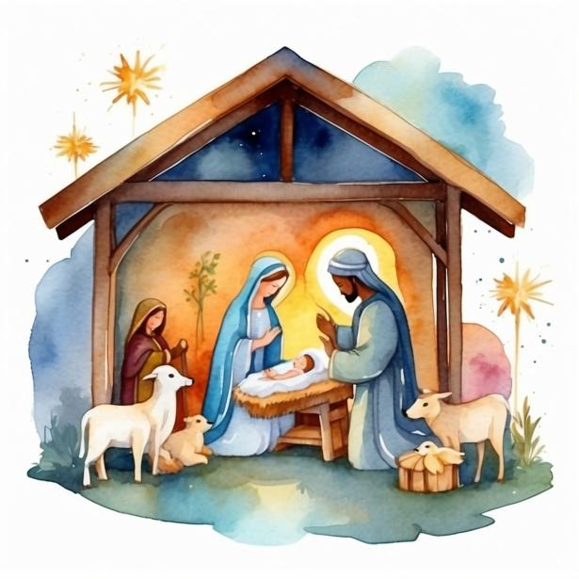
Fourth Sunday in Advent - December 21 10:00 a.m.

CHRISTMAS EVE SERVICES
7:00 p.m. Family Eucharist Candlelight Service
11:00 p.m. Candlelight Midnight Mass

CHRISTMAS DAY the Rector’s Christmas Message online

