

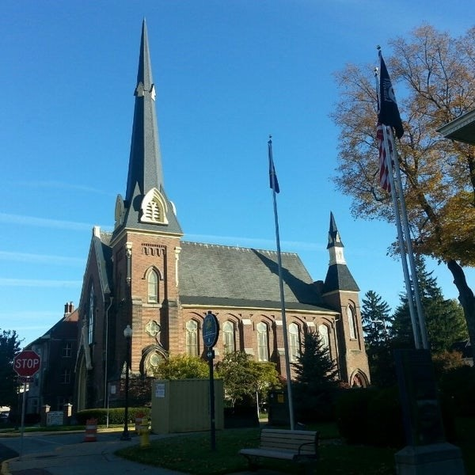
November 26, 2025

A Global Methodist Church
214 S. 5th Street
Goshen, IN 46528
Phone: 574-533-9518
Web Site: goshenfirstgmc.org

Office Hours: Monday-Friday,
8:00 a.m.-12:00 noon
Worship: 9:00 a.m.
Sunday School: 10:30 a.m.
Pastor Jeff & Lisa
Associate Pastor Rich Hull
OUR CHURCH VISION – “Growing in Faith, Gathering in Community, and Giving in Love”.


The Primetimers will meet on Thursday December 4, at the Life Center to hear the Crimsonaires from Goshen High School. Lunch will be at 11:45 a.m., with the program afterward. There will be a $12.00 charge for the holiday ham dinner. You must register to attend. A table will be manned during coffee hour the next two Sundays or you may call the office. Volunteers are needed to make desserts. The entire congregation and friends are welcome to attend. Start your Holiday Season with the Crimsonaires!

CHRISTMAS SERMON SERIES: “I’ll Be Home for Christmas”

The Advent Sermon series will be based upon the teaching of Jesus and the purpose for His coming, not just to the city of Bethlehem but the city of your heart. Join us on Sunday, November 30, the first Sunday after Thanksgiving, as we begin to light the Advent Wreath and unpack the homecoming of Christmas. There’s a message for everyone to bring into their heart for the holiday season. Hope we’ll pack the pews for Advent and the 2026 new year.


CHRISTMAS TREE ORNAMENTS
The Christmas ministry ornaments are on the tree and need to be returned to the church by December 14. Gifts will be delivered December 16-20. They are given to needy children in the Goshen area. You may make financial gifts for others to shop. If you are available to help with shopping or delivering or have questions, contact Loraine Troyer, 574-361-3123.


CHRISTMAS CARD EXCHANGE
The Christmas mailbox and cards are just outside the sanctuary. That allows those who use the elevator to easily send cards and to check for cards being received. Please remember to check for your cards. We will be there to assist you. The last day to mail cards will be December 21. Cards coming in on December 21 will be distributed on Christmas Eve and December 28. Please mail cards to those who would not be available to pick up cards during those dates.

“The Edge” will not meet on November 30 because of Thanksgiving.

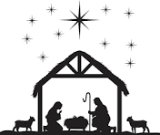
SPECIAL S.S. CLASS
Would you like to learn more about Christ's birth and the prophetic and historical records that show the biblical accounts to be true? Please join Ben and Marie Whirledge in the conference room following Sunday morning worship beginning November 30 as they lead a 4 week study, "The Case for Christmas". This is a video series by Lee Strobel as he presents the evidence that shows the true miracle of Christ's birth. Lee was a former atheist and a legal journalist for the Chicago Tribune who came to believe in God after many years of searching. All are welcome to attend!

RMD’s
Now is the time of year when many people of a certain age (over 73) receive a call from the financial services company that manages their retirement account. The reason for the call is to inform or remind them that tax law requires an annual withdrawal from their retirement account, which is called a Required Minimum Distribution or “RMD”. Typically, these distributions are taxed.

The good news is that there may be a better way to manage the tax implications. If properly handled, an RMD can be donated to an entity such as Goshen First Church or Goshen First Church Foundation or many other “qualified charities”, which allows for tax-free treatment of the RMD.

It is advisable to speak to your tax advisor and financial services representative to be certain the transaction works for your situation and that it is properly structured. Reach out to a Foundation Board member if you are unsure how to get started. -Steve Pettit

OUR STAFF
Pastor Jeff Bealmear – pastorjeff@goshenfirstgmc.org
Associate Pastor Rich Hull – rich@goshenfirstgmc.org
Pastor Emeritus Ben Whirledge – benwhirledge@goshenfirstgmc.org
Harriet Martin, Office Administrator – harrietmartin@goshenfirstgmc.org
Scott Carter, Director of Music Ministry – carters@westview.k12.in.us
Rachel Tenorio, Children/Youth Director – rachel@goshenfirstgmc.org
Linda Ponce, Treasurer – lcponce1@gmail.com
DeDe Russell, Caring Ministries Coordinator – russelldede@yahoo.com
Kimberly Lichty-Nyce, Social Media Editor – klichty-nyce@comcast.net
Joel Lane, Pianist – joell12068@gmail.com
John Jinright, Organist – jjinrig@troy.edu
Rodney Troyer, Custodian – troyerstc@gmail.com
Jazlyn Troyer, Sound Tech
Chris & Gretchen Martin, Video Techs – leia2121@hotmail.com

VOLUNTEERS – Thank you for your service! Sunday morning, November 30
Greeters: Steve & Lori Warner VIP: Arlene Randolph
Elevator Hosts: John Allyn, Kathy Robarge
Ushers: Chuck Rink,Jeff Showalter,George Buckingham, Kent Evans, Mary Ann Eash
Scripture Reader: Dar Dechant
Junior Church: Elementary – Pat Huber, Lori Warner
Junior Church: Jr. High – Loraine Troyer
Coffee Hour: Max Leatherman, Betty Jo Morris, Sally Stutsman, Al Eppert, Sara
Showalter
Bus Driver: Steve Warner

