Sermon Notes, Mark 2

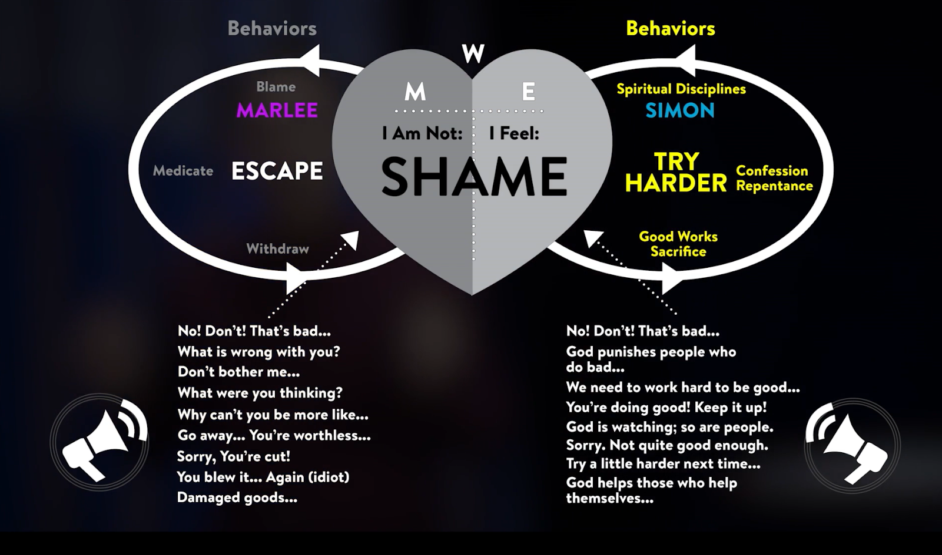

Scripture, Mark 2:1-12

Jesus Forgives and Heals a Paralyzed Man
2 A few days later, when Jesus again entered Capernaum, the people heard that he had come home. 2 They gathered in such large numbers that there was no room left, not even outside the door, and he preached the word to them. 3 Some men came, bringing to him a paralyzed man, carried by four of them. 4 Since they could not get him to Jesus because of the crowd, they made an opening in the roof above Jesus by digging through it and then lowered the mat the man was lying on. 5 When Jesus saw their faith, he said to the paralyzed man, “Son, your sins are forgiven.”
6 Now some teachers of the law were sitting there, thinking to themselves, 7 “Why does this fellow talk like that? He’s blaspheming! Who can forgive sins but God alone?”
8 Immediately Jesus knew in his spirit that this was what they were thinking in their hearts, and he said to them, “Why are you thinking these things? 9 Which is easier: to say to this paralyzed man, ‘Your sins are forgiven,’ or to say, ‘Get up, take your mat and walk’? 10 But I want you to know that the Son of Man has authority on earth to forgive sins.” So he said to the man, 11 “I tell you, get up, take your mat and go home.” 12 He got up, took his mat and walked out in full view of them all. This amazed everyone and they praised God, saying, “We have never seen anything like this!”

Who is Jesus, Part I
Theme and Goal: Jesus reveals his divine I through his divine
A .

Who is Jesus, Part II
Theme and Goal: Jesus reveals his divine identity by D authority and decreeing I .

Who is trying to E their shame, and who is trying H to get rid of their shame?

- Jesus reveals his D identity by displaying A .

Mark 2:3 Some men came, bringing to him a paralyzed man, carried by four of them.

In Jewish thought, there were 3 reasons for sickness:
- Personal S .
- F sin
- Brokenness in the W due to sin

John 9:1-3

Jesus Heals a Man Born Blind
9 As he went along, he saw a man blind from birth. 2 His disciples asked him, “Rabbi, who sinned, this man or his parents, that he was born blind?”
3 “Neither this man nor his parents sinned,” said Jesus, “but this happened so that the works of God might be displayed in him.

Jesus first F the sins of the paralyzed man for the man himself and for the A .

Mark 2:6-7
6 Now some teachers of the law were sitting there, thinking to themselves, 7 “Why does this fellow talk like that? He’s blaspheming! Who can forgive sins but God alone?”

Mark 2:11-12
11 “I tell you, get up, take your mat and go home.” 12 He got up, took his mat and walked out in full view of them all. This amazed everyone and they praised God, saying, “We have never seen anything like this!”

Jesus is D , for he has authority over all the E of sin.

2. Jesus reveals his divine identity by D I .

Mark 2:6-7
6 Now some teachers of the law were sitting there, thinking to themselves, 7 “Why does this fellow talk like that? He’s blaspheming! Who can forgive sins but God alone?”

Jesus takes an image from the P to declare his authority over the S .

Mark 2:8-11
8 Immediately Jesus knew in his spirit that this was what they were thinking in their hearts, and he said to them, “Why are you thinking these things? 9 Which is easier: to say to this paralyzed man, ‘Your sins are forgiven,’ or to say, ‘Get up, take your mat and walk’? 10 But I want you to know that the Son of Man has authority on earth to forgive sins.” So he said to the man, 11 “I tell you, get up, take your mat and go home.”

The term “Son of M ” was a phrase not usually associated with the
P authority of the Messiah. Jesus was using this term to let the people know that God’s messiah would be very D from what they expected.

Tim Keller: If Jesus forgives someone their sins, he is claiming that ALL their sins are against him — that every sin violates HIS rules and crown rights and thus he is saying he is God the Creator.

The Spirit of Jesus was already on the M in the lives of the man and his friends by planting in their hearts F which led them to A .

Mark 2:4-5
4 Since they could not get him to Jesus because of the crowd, they made an opening in the roof above Jesus by digging through it and then lowered the mat the man was lying on. 5 When Jesus saw their faith, he said to the paralyzed man, “Son, your sins are forgiven.”

James 2: 14-17

Faith and Deeds
14 What good is it, my brothers and sisters, if someone claims to have faith but has no deeds? Can such faith save them? 15 Suppose a brother or a sister is without clothes and daily food. 16 If one of you says to them, “Go in peace; keep warm and well fed,” but does nothing about their physical needs, what good is it? 17 In the same way, faith by itself, if it is not accompanied by action, is dead.

Jesus is D for he has the authority to F sins and decree immunity from the J of God.

Jesus reveals his divine identity by D authority and decreeing
I .

