This Week at PPBC

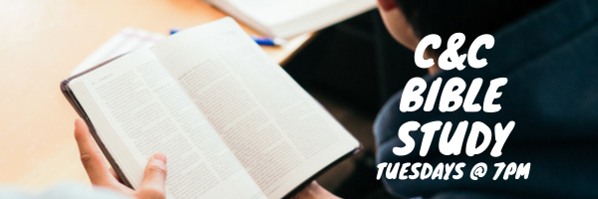

Wednesdays @ 6:30pm



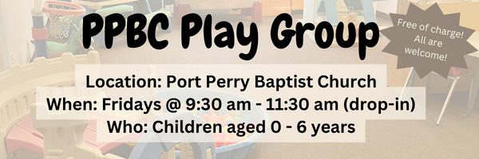Friday, December 5, 2025

Friday, December 5, 2025

December 13th, 2025

A Prayer Request from the Lambs: are praising God for the arrival of the R66 helicopter that had been held up for the last couple of years due to many political and logistical challenges, in Palu, Indonesia. This helicopter will serve existing church planting teams more effectively, and will open up entirely new works where they are waiting for the Gospel. Praise the Lord with us and please pray for the many logistics still ahead, that the Lord would make the way smooth in country


Please Sign up in the foyer and bring a tray of your favourite dessert to share!

Sunday Ministry Schedules
Below are ministry schedules for Nursery, Jr. Church, Greeters, Ushers, and Sound & Video:
Nursery
Nov 30: Jen Werner, Alyssa Summers
Dec 7: Kathryn denOuden, Brantley Colwell
Infant Nursery
Nov 30: Stephanie Anderson, Amber Saunders
Dec 7: Laura Saunders, Elise Anderson
Jr. Church; ages 3 to grade 1
Nov 30: Deb Brown, Mikayla Ferguson
Dec 7: TBA
Jr. Church; Grades 2 to 6
Nov 30: Kate Anderson, Tiffany Green
Dec 7: TBA
Greeters
Nov 30: Paul & Helen Jones
Dec 7: Roy & Elizabeth Werner
Ushers
Nov 30: Paul Sammut, Leno Araujo
Dec 7: Gregg Anderson, Graeme Foster
Sound & Video
Nov 30: Sound: Wyatt Werner | Video: Josh Myers
Dec 7: Sound: TBA | Video: TBA


Morning Service
Welcome
Advent Reading
Song – O Come O Come Emmanuel
Song – Glorious Day
Scripture
Prayer
Song – Here is Love Vast as the Ocean
Message – Pastor Jim Clemens
Song – O Great God



Praise & Prayer Highlights
PRAY for Brian Timmins and his family as they mourn the loss of his grandfather. PRAY that God will give them great comfort in Christ.
PRAY for Pastor Jim & Brenda. PRAY Pastor Jim as he battles a rather stubborn respiratory illness. He is on new medications and is feeling some improvement the last couple of days. Please PRAY for renewed health and an increase of patience as he trusts the Lord's timing in his recovery.
PRAY for Joan Mabley's ongoing health & recovery at home. PRAY for her and the family as they look for care to meet Joan's needs.
PRAY for Barbara Fry and the Werner family as they mourn the loss of Ron. PRAY for Barbara, Roy, Elizabeth and the family as they make preparations for a service. PRAY that God will give them great comfort in Christ and that the truth of the Gospel will shine through this loss.
PRAY for Bert & Ada Faber and their ongoing health concerns.
PRAISE for Carolyn & Ebi Meraji and the birth of their second son Eli. Continue to pray for them as they recover and celebrate this gift.
PRAISE for the safe arrival of Shepherd Bryant. PRAY for Morgan and Josh and their family as they recover and celebrate this new life.
PRAY for Dennis Tomcheski and his ongoing health concerns.
PRAY for Winnie Miller and her ongoing health concerns.
PRAISE for the engagement of Stephanie Harrott and Daniel Wobito (new attendees of PPBC). Please PRAY for them as they prepare for marriage next year.
PRAISE for the engagement of Joshua Bolsonello & Madeline Werner. Please remember them in prayer as they prepare for marriage next fall.
Giving
Just as a reminder, there are several ways you can give:
In Person using the offering box located on the back wall of the sanctuary. Donation envelopes are available at the Welcome Centre. Please contact the church office if you would like a box of donation envelopes (office@portperrybaptist.ca)
Through your online banking, you may send electronic transfers to ppbcdonations@gmail.com.
You can also give through Canada Helps. Donation receipts will be provided by Canada Helps, and transaction fees apply.
***********************************************************************
Weekly Newsletter
The PPBC Newsletter is emailed to the church family every Friday. If you would like to be added to the weekly email list, please contact the office by phone: 905-985-8681 or by email: office@portperrybaptist.ca.
*****************************************************************
Church Information:
Location:
2210 Hwy 7A
Port Perry, ON
L9L 1B4
Office Hours:
Monday: 8:30am – 4:00pm
Tuesday: 8:30am – 4:00pm
Wednesday: Closed
Thursday: 8:30am – 4:00pm
Friday: 8:30 am - 3:00 pm
Contact:
Phone: 905.985.8681
Email: office@portperrybaptist.ca
Website: www.portperrybaptist.ca
Staff:
Sr. Pastor – Rev. Jim Clemens
Administrative Assistant – Madeline Werner
Family Ministries Director – Josh Anderson

PPBC Newsletter
Sunday, November 30, 2025


Sunday Starting Point
Sunday, November 30, 2025 - 9:30 am
“Beginning the day with the Word and prayer”
Adults:
Adults will meet in the sanctuary for a time of study and prayer. Psalm 145.
Youth:
Jr High (Grades 7-8) will meet in room 18 with Kate Anderson to study Advent.
Children:
Children ages 3 - grade 6 will meet in room 26.
(Please note nursery is unavailable during Starting Point)
Sunday Morning Worship
Sunday, November 30, 2025 - 10:30 am
We are meeting in the sanctuary and will continue to live-stream for those who are unable to attend.
Message: The Gospel Applied
Scripture: Ephesians 4-6
Pastor Jim Clemens

