Joint Worship Service

November 30, 2025 at 11:00

Pastor Tina Crog

*Prelude

*Welcome and Announcements Worship Assistant

*Gathering Hymn "Hark! A Thrilling Voice is Sounding!" ELW 246
Public Domain
- Hark! A thrilling voice is sounding! “Christ is near,” we hear it say
“Cast away the works of darkness, all you children of the day!”

- Wakened by the solemn warning, from earth’s bondage let us rise; Christ, our sun, all sloth dispelling, shines upon the morning skies.

- See the Lamb, so long expected, come with pardon down from heav’n. Let us haste, with tears of sorrow, one and all, to be forgiv’n.

- So, when next he comes in glory and the world is wrapped in fear,
he will shield us with his mercy and with words of love draw near.

- Honor, glory, might, and blessing to the Father and the Son with the Everlasting Spirit while unending ages run!

* Confession and Forgiveness Pastor Tina
Blessed be the holy Trinity, ☩ one God, whose home is heaven and earth, whose salvation is sure. Amen.

God is here, and God sees through every defense that fools the world. Since we cannot hide from God, there is nothing left to do but to be honest with each other and humble before God. So, in humility, we confess our sins.

God with us, we have acted helpless, even when you called us to action. We have resisted your truth, even when our lies were exhausting. We have behaved as though we were alone, even when you were beside us. We can never undo the sins of this world, but we trust in your perfect plan for salvation. Forgive our sins. Set us free to chart a new path. Help us learn from the echoes of our past. In the name of Emmanuel, Jesus Christ, we pray. Amen.

Hear the good news: God the Faithful One loves you, ☩ in Christ Jesus your sins are forgiven, and by the power of the Holy Spirit you are set free. Amen.

* Kyrie (to the Tune of “Come Thou Long Expected Jesus,” ELW 254)
Public Domain
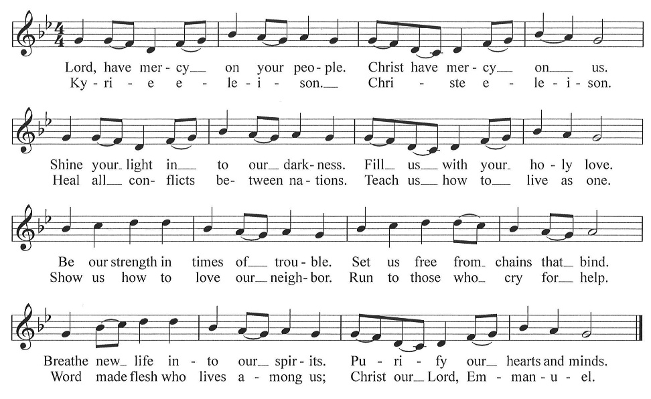
* Greeting Pastor Tina

* Prayer of the Day Worship Assistant
Stir up your power, O Lord, and come. Amid the shaking of the heavens and the trembling of our hearts, teach us to watch and wait with hope. Grant us courage to live in the tension between what has been promised and what is still to come, trusting that your redemption is near; through Jesus Christ, our Savior and Lord. Amen. Amen.

*The Peace Worship Assistant
The peace of Christ be with you, always. And also with you.

Let us share the peace of Christ with one another, by staying in your pew and waving.

*Lighting of the Advent Wreath The Crog Family
If one small flame flourishes in deep blue darkness, then another blossoms beside it; we observe a world transformed from our expectations. This candle on our Advent wreath represents the astonishment we experience when the unforeseen gives way to unexpected alliances, unheard opportunity, or undeserved grace.

The first candle is lit.

In time God’s purposes will feel so familiar, so obvious, we will wonder how we could ever have felt surprised. But that time is not yet here, so we pray: Emmanuel, God with us, may the seeds that you have planted in our hearts help bring about your transformation in the world. Amen.

*Song “Light One Candle to Watch for Messiah” ELW 240, vs. 1
One License A-700000

- Light one candle to watch for Messiah; let the light banish darkness.
He shall bring salvation to Israel, God fulfills the promise.

*Children’s Message

*First Lesson: Isaiah 2:1-5 Reader
¹ The word that Isaiah son of Amoz saw concerning Judah and Jerusalem.
² In days to come
the mountain of the Lord’s house
shall be established as the highest of the mountains
and shall be raised above the hills;
all the nations shall stream to it.
³ Many peoples shall come and say,
“Come, let us go up to the mountain of the Lord,
to the house of the God of Jacob,
that he may teach us his ways
and that we may walk in his paths.”
For out of Zion shall go forth instruction
and the word of the Lord from Jerusalem.
⁴ He shall judge between the nations
and shall arbitrate for many peoples;
they shall beat their swords into plowshares
and their spears into pruning hooks;
nation shall not lift up sword against nation;
neither shall they learn war any more.
⁵ O house of Jacob,
come, let us walk
in the light of the Lord!

The Word of the Lord. Thanks be to God.

*Second Lesson: Romans 13:11-14 Reader
¹ Besides this, you know what time it is, how it is already the moment for you to wake from sleep. For salvation is nearer to us now than when we became believers; ¹² the night is far gone; the day is near. Let us then throw off the works of darkness and put on the armor of light; ¹³ let us walk decently as in the day, not in reveling and drunkenness, not in illicit sex and licentiousness, not in quarreling and jealousy. ¹⁴ Instead, put on the Lord Jesus Christ, and make no provision for the flesh, to gratify its desires

The Word of the Lord. Thanks be to God.

*Gospel Acclamation “Emmanuel, Emmanuel” Worship & Praise 36
CCLI #11222261

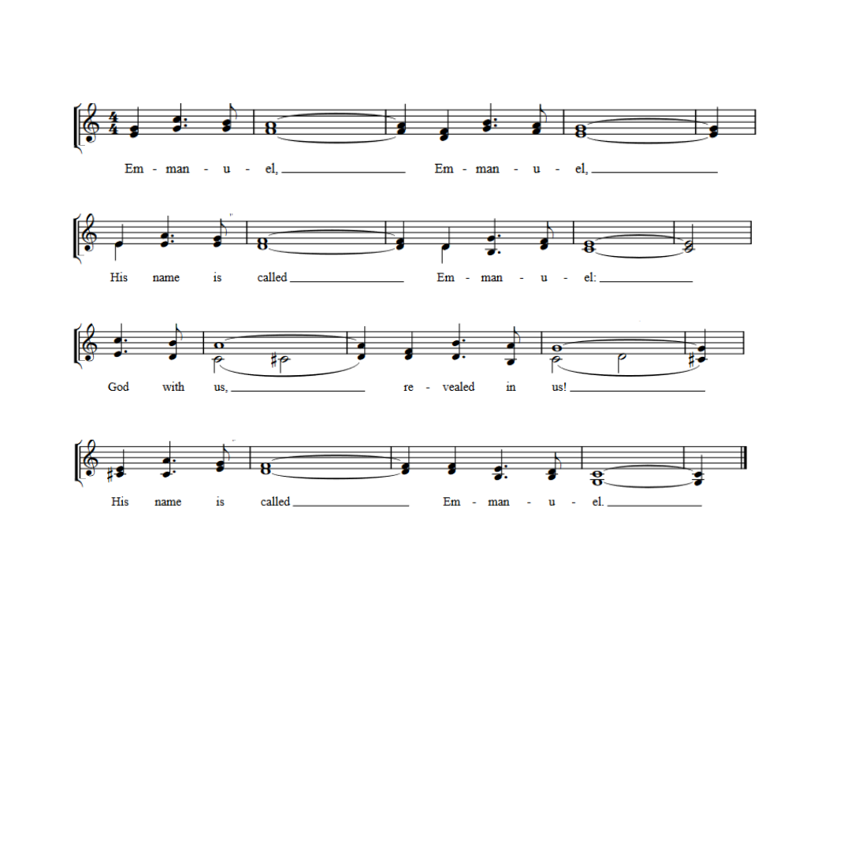

* Gospel: Luke 1: 5-13 Pastor Tina
The Holy Gospel according to Luke, the First chapter. Glory to you, O Lord.

5 in the days of King Herod of Judea, there was a priest named Zechariah, who belonged to the priestly order of Abijah. His wife was descended from the daughters of Aaron, and her name was Elizabeth.
6 Both of them were righteous before God, living blamelessly according to all the commandments and regulations of the Lord.
7 But they had no children, because Elizabeth was barren, and both were getting on in years. 8 Once when he was serving as priest before God during his section’s turn of duty, 9 he was chosen by lot, according to the custom of the priesthood, to enter the sanctuary of the Lord to offer incense. 10 Now at the time of the incense offering, the whole assembly of the people were praying outside. 11 Then there appeared to him an angel of the Lord, standing at he right side of the altar of incense. 12 When Zechariah saw him, he was terrified, and fear overwhelmed him. 13 But the angel said to him, “Do not be afraid, Zechariah, for your prayer has been heard. You wife Elizabeth will bear you a son, and you will name him John.”

The Gospel of the Lord. Praise to you, O Christ.

*Sermon Pastor Tina

*Hymn of the Day "The King Shall Come" ELW 260
One License A-700000
1.The King shall come when morning dawns and light triumphant breaks, when beauty gilds the eastern hills and life to joy awakes.

2. Not as of old a little child, to bear and fight and die, but crowned with glory like the sun that lights the morning sky.

3. Oh, brighter than that glorious morn shall dawn upon our race and left the lonesome place of death, despite the rage of foes.

4. Oh, brighter than that glorious morn shall dawn upon our race the day when Christ in splendor comes, and we shall see his face.

5. The King shall come when morning dawns and light and beauty brings, Hail, Christ the Lord! Your people pray: come quickly, King of kings.

*Pass the Prayer Squares
* Prayers of the People Pastor Tina
Please be Seated
Any Prayer Requests or Joys to Share

In our waiting and watching, we come to you in prayer, O God, trusting your promise to renew the church, the nations, and the whole creation.
God of the people, we come seeking wisdom and instruction. Uphold and strengthen lay leaders, teachers, deacons, pastors, and bishops. Teach us your ways and lead us in your paths. God of grace, hear our prayer.
God of the earth, we seek your goodness in the grandeur of creation. Empower us to care for forests and oceans, as we see you in the world around us. God of grace, hear our prayer.
God of the nations, grant wisdom to leaders, judges, and mediators. Cast out words of hate and transform them into words for building up community. Remake implements of war to sow peace. God of grace, hear our prayer.
God of healing, bring comfort and strength. We pray for our kindred and companions who are ill or despairing, especially for those affected by HIV and AIDS on this World AIDS Sunday. Surround all with care and consolation. God of grace, hear our prayer.
God of new possibilities, when addiction wounds, jealousy tears down, and relationships fray, show us how to journey with one another. Nurture therapists, counselors, and sponsors in their care for others. God of grace, hear our prayer.
God of community, while our heads know that we are all members of one global church, our hearts don’t always feel that way. Today as we gather together with our friends from St. Jacob and Holy Trinity, we take one faithful step forward to living as your unified church. May our time of togetherness help us to deepen our relationships with other Christians in our area. Stir our hearts to participate in worship this Advent, with the downtown community walk next weekend, and our midweek Advent services. God of grace, hear our prayer.
God of all time, build up our lives that we would reflect your grace. At the last, bring us with all the saints (especially) to your holy city where peace and goodness make a home. God of grace, hear our prayer.
Draw near to us, O God, as we commend all for whom we pray, trusting in your mercy through Jesus Christ, Emmanuel. Amen.

*Offering Worship Assistant
The Monthly Mission for November is “Mountain Vision.” Let us give to God what He has first given us,

*Offering Music by Jared

*Offertory Hymn “Our Gifts We Now Bring” vs. 1
to the tune AWAY IN THE MANGER, ELW 277
Public Domain
To be sung while the offering is being returned to the Altar
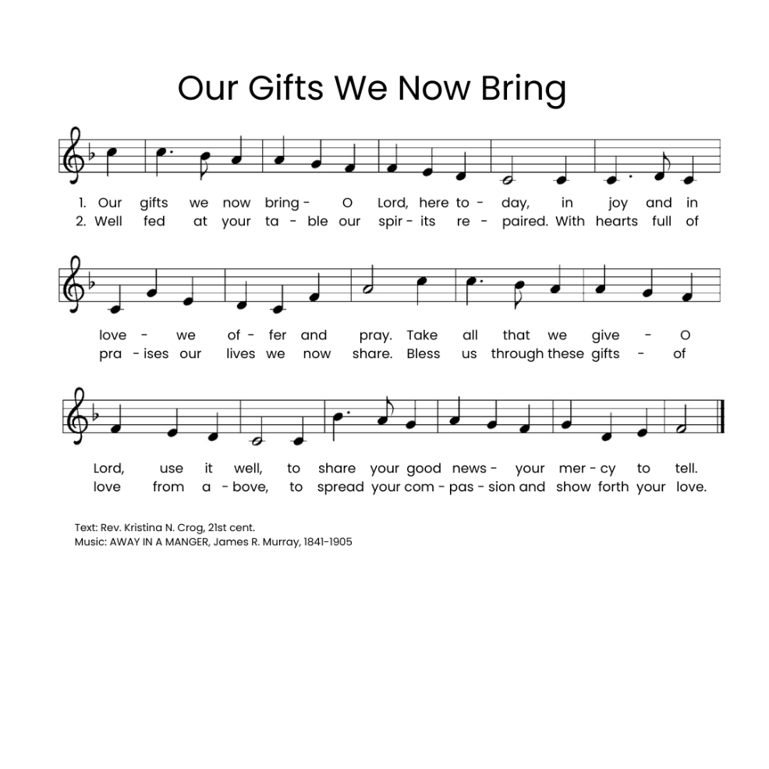

*Offering Prayer Worship Assistant and Congregation
God with us, we cherished what we thought belonged only to us: our money, our time, our families, and our freedom. Yet in a moment, we recognize that every truly good thing was a treasure we had taken from your open hand. We thought such treasures were ours to earn and to own. You grow what we give away. We give you these gifts as a sign of your love and faithfulness. Amen.

* Communion Liturgy
Sung to the tune: O Come, O Come, Emmanuel [ELW 257]
One License A-700000

The Lord be with you as we gather here.
Lift up your hearts unto the Lord your God.
For it is right to give God our praise.
Let us prepare our hearts for coming days:
Rejoice, Rejoice! Emmanuel
Shall come to you, O Israel.

You created all things and called them good,
made us like you, but we cast off your love.
You set us free and claimed us as yours,
through sage and prophet spoke to us your word.
Rejoice, Rejoice! Emmanuel
Shall come to you, O Israel.

Holy are you and blessed is your Son,
Jesus, the Light, your presence here with us.
You sent him in the fullness of time,
he came to preach good news to all.
Rejoice, Rejoice! Emmanuel
Shall come to you, O Israel.

And on the night that Jesus was betrayed,
Christ took the bread, and unto you gave thanks.
He broke the bread and shared it with friends.
“Take, eat, my body given for you.”
Rejoice, Rejoice! Emmanuel
Shall come to you, O Israel.

After the meal he lifted up the cup,
“My blood, my life, I pour it out for you.
This covenant I make anew.
Set free from sin! Remember me!"
Rejoice, Rejoice! Emmanuel
Shall come to you, O Israel.

Spirit of God descend upon us now,
And make these gifts become for us
the body and the blood of Christ
a holy, living sacrifice.
Rejoice, Rejoice! Emmanuel
Shall come to you, O Israel.

*Lord’s Prayer Page 154
Our Father, who art in Heaven, hallowed be thy name, thy kingdom come, thy will be done, on earth as it is in heaven. Give us this day our daily bread; and forgive us our trespasses, as we forgive those who trespass against us; and lead us not into temptation, but deliver us from evil. For thine is the kingdom, and the power, and the glory, forever and ever. Amen.

Lamb of God Sung to the tune: O Come, O Come, Emmanuel [ELW 257]
One License A-700000
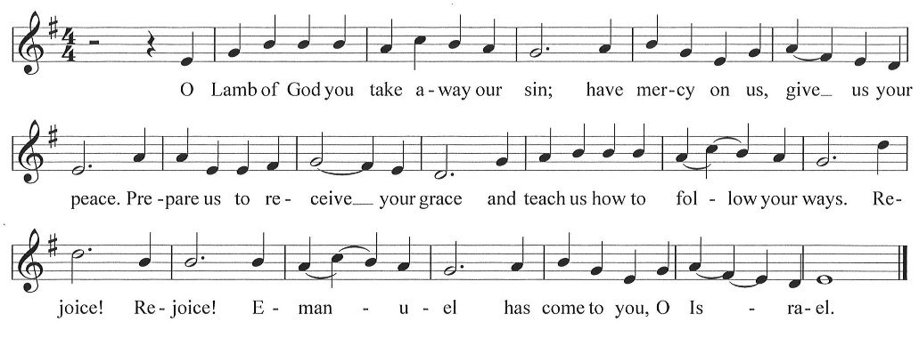

*Post Communion Blessing

*Post Communion Canticle “Our Gifts We Now Bring” vs. 2
Go Back to page 8 for the second verse

*Prayer After Communion Pastor Tina and Congregation
Jesus, the world looks different from your table. Here, there are no strangers, and grace is never a surprise. Life always thrives in the desert, and a promise never shades with doubt. Soon as we rise from this table, our memories of this goodness fade. Bring us back every day to your promises: astonish us again. Amen.

*Luncheon Blessing and Benediction Pastor Tina

*Closing Song "Rejoice, Rejoice Believers" ELW 244
Public Domain
- Rejoice, rejoice, believers, and let your lights appear; the evening is advancing, and darker night is near. The bridegroom is arising and soon is drawing nigh. Up, pray and watch and wrestle; as midnight comes the cry.
- The watchers on the mountain proclaim the bridegroom near; go forth as he approaches with al-le-lu-ias clear. The marriage feast is waiting; the gates wide open stand. Arise, O heirs of glory; the bridegroom is at hand.
- The saints, who here in patience their cross and the suff’rings bore, shall live and reign forever when sorrow is no more. Around the throne of glory the Lamb they shall behold; in triumph cast before him their diadems of gold.
- Our hope and expectation, O Jesus, now appear; arise, O sun so
longed for, o’er this benighted sphere. With hearts and hands uplifted, we plead, O Lord, to see the day of earth’s redemption that sets your people free!

*Dismissal worship assistant
Keep watch! Christ is coming soon!
Thanks be to God!

*Postlude

Prayer of the Day, Advent Wreath Lighting, and Offering Prayer by Barn Geese Worship, 2025
“Kyrie” (based on the tune Come, Thou Long-Expected Jesus) by David Eck, Copyright ©2011
"Emmanuel" by Bob McGee, © 1976 C. A. Music (div. of C. A. Records, Inc.)/ASCAP
“A Sung Communion Liturgy for the Season of Advent” (based on tune: VENI EMMANUEL) by Rev. Beth Quick, 2013, http://bethquick.blogspot.com/2013/11/a-sung-communion-liturgy-for-season-of.html
“Lamb of God” “based on the tune VENI EMMANUEL) by David Eck, Copyright ©2011
"Our Gifts We Now Bring" (based on the tune AWAY IN THE MANGER by James R. Murray) by Rev. Kristina N. Crog, 2024

