Welcome to Hazelgreen Baptist Church. We are glad you’ve chosen to worship with us today. If you are visiting for the first time, please fill out the welcome card provided by our ushers.
We are an Independent Baptist Church that teach and preaches the Word of God.

Pastor John Reed
Assistant Pastor Kevin Ross
Email: hazelgreenbaptistchurch@gmail.com
Phone: 708-389-5941 (Leave a message)
HBC website: https://www.hazelgreenbaptist.com 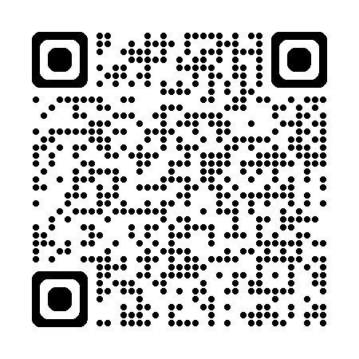
5022 W. 115TH ST.
ALSIP, Illinois
60803 United States

Weekly Services & Meetings

sunday school: 10:00 am – 10:45 am
sunday service: 11:00 am
wednesday night bible study: 6:30 pm – 7:30 pm
Verse of the Week
Psalm 73:25-26 ²⁵ Whom have I in heaven but thee? And there is none upon earth that I desire beside thee.
²⁶ My flesh and my heart faileth: but God is the strength of my heart, and my portion forever.

Order of Service 11/23/25
Welcome & Announcements
Congregation #1: Satisfied Page 518
Special Music: Lisa Ivins
Doxology – pg. 815
Offertory: Phoebe Ross
Congregation #2: We are so blessed Page 795
Sermon: Pastor John R. Reed
Closing: Jesus, We Just Want to Thank You page 79

Announcements/Dates to Remember

11/25/25: Thanksgiving Celebration 6-8 pm
11/30/25: Breakfast Table 9:30 am – bring a dish to share
12/13/25: 1-5pm - Volunteer at Operation Christmas child processing center to pack shoe boxes. (8 slots available)
12/14/25: Cocoa & Carols by Candlelight – A joyful night for all ages – bring a snack or holiday cookie to share – coffee and cocoa provided
Pastor’s Corner
1 Corinthians 15:10 - ¹⁰ But by the grace of God I am what I am: and his grace which was bestowed upon me was not in vain; but I laboured more abundantly than they all: yet not I, but the grace of God which was with me.
Please see the insert from Rami Halaseh, President of Mission Quest. God is really working to reach men of Islam. Rami is a true scholar to defend the Christian faith.
Pastor John R. Reed

