Hope Visioning
Week 1 Nov. 30-Dec. 6

Value: Hope
“Everything that is done in this world is done by hope.” Martin Luther, Table Talk on the Scriptures
Value: Faithfulness
“Great is thy faithfulness, O God, my Father,
There is no shadow of turning with thee,
Thou changest not, thy compassions they fail not,
As thou hast been, thou forever shalt be.”
1st verse, “Great Is Thy Faithfulness,” author Thomas O. Chisholm

Figures of Hope in response to God’s Faithfulness: Simeon and Anna greet the baby Jesus in the temple when he is presented there according to Mosaic law

Anna the Prophetess, Rembrandt van Rijn, 1639. Public domain.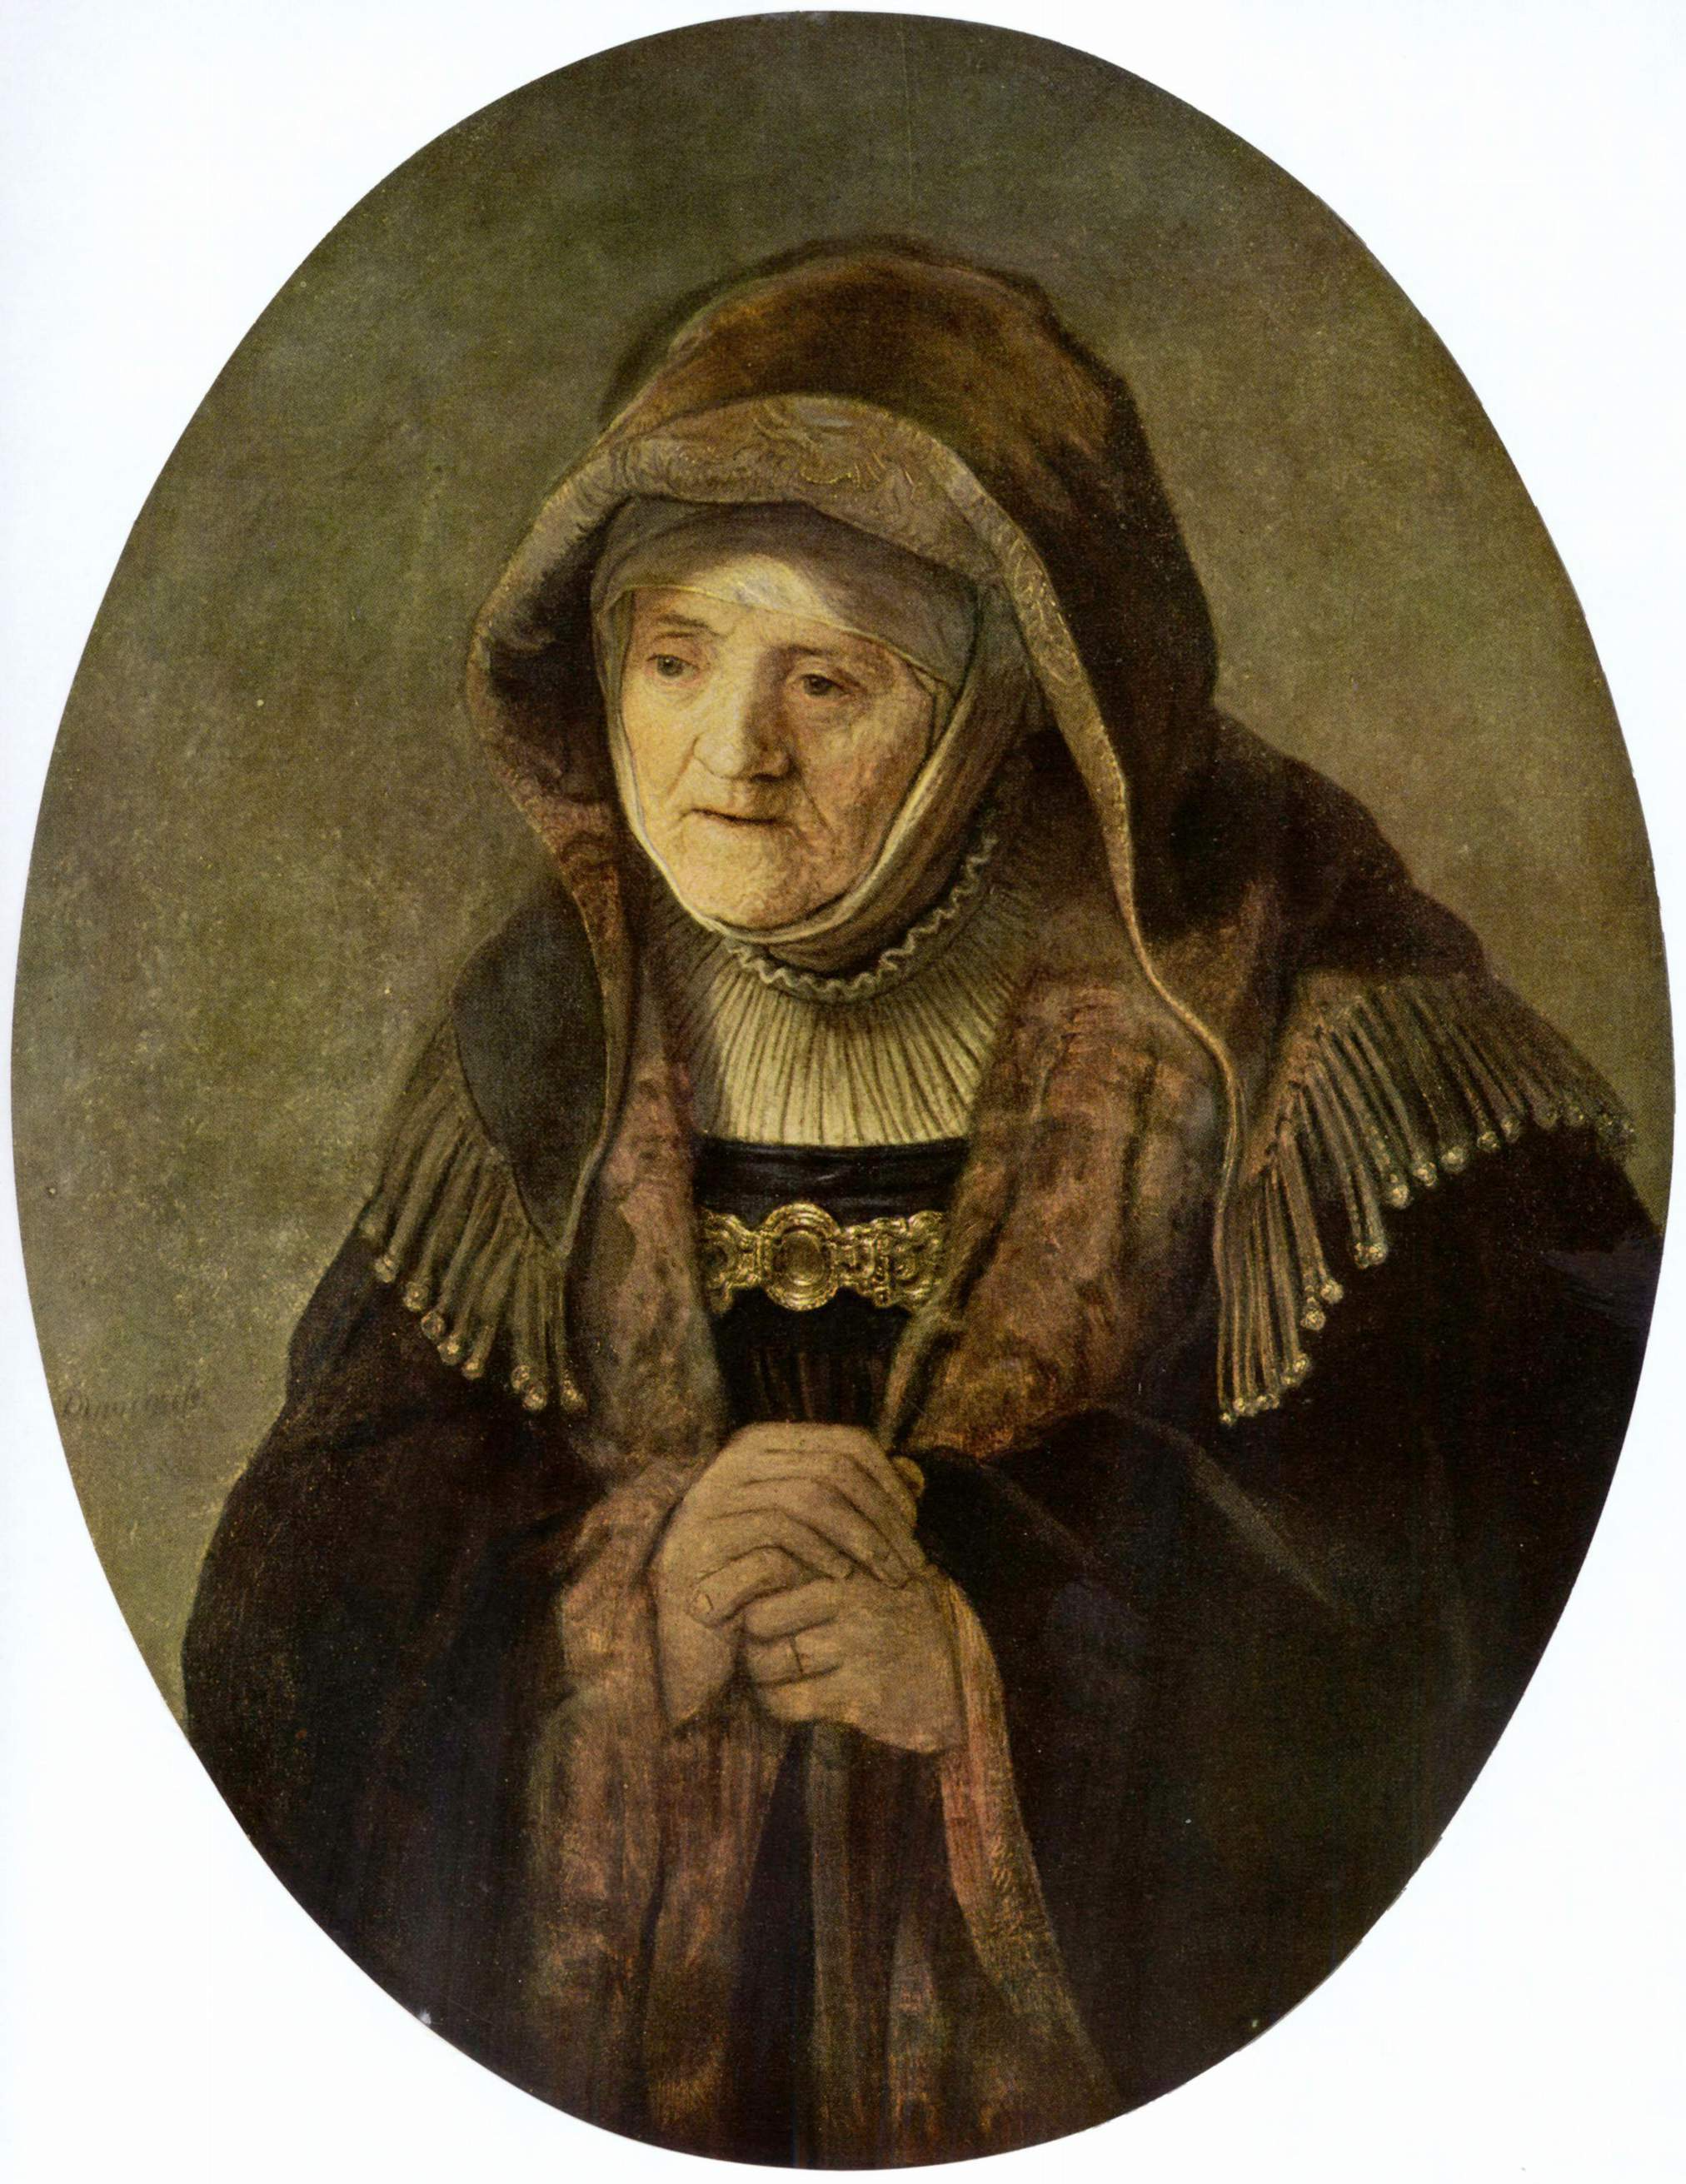
Luke 2:25-38:
25 Now there was a man in Jerusalem whose name was Simeon; this man was righteous and devout, looking forward to the consolation of Israel, and the Holy Spirit rested on him. 26 It had been revealed to him by the Holy Spirit that he would not see death before he had seen the Lord’s Messiah. 27 Guided by the Spirit, Simeon came into the temple; and when the parents brought in the child Jesus, to do for him what was customary under the law, 28 Simeon took him in his arms and praised God, saying:
29 “Master, now you are dismissing your servant in peace,
according to your word;
30 for my eyes have seen your salvation,
31 which you have prepared in the presence of all peoples,
32 a light for revelation to the Gentiles
and for the glory to your people Israel.”
33 And the child’s father and mother were amazed at what was being said about him. 34 Then Simeon blessed them and said to his mother Mary, “This child is destined for the falling and rising of many in Israel, and to be a sign that will be opposed 35 so that the inner thoughts of many will be revealed—and a sword will pierce your own soul too.”
36 There was also a prophet, Anna the daughter of Phanuel, of the tribe of Asher. She was of a great age, having lived with her husband seven years after her marriage, 37 then as a widow to the age of eighty-four. She never left the temple but worshiped there with fasting and prayer night and day. 38 At that moment she came, and began to praise God and to speak about the child to all who were looking for the redemption of Israel.
New Revised Standard Version
Instructions for discussion:
- Read this passage through out loud or silently twice. The first time pay attention to the plot, and the second time take note of what surprises you or stands out for you in the text.
Questions for consideration and/or discussion:
- What gives Simeon and Anna the strength to hope and remain faithful for so many decades? How do they live out their hope? How does their hope lead to action?
- How does God manifest faithfulness in the text? To whom does God show faithfulness?
- What in the figures of Simeon and Anna stands out for you? Do you relate to any particular qualities of their characters? What can we learn from their lives of hope?
- How do we nurture hope as a value and virtue in our church community? In our own faith lives?
- Hope is the theme of the first Sunday of Advent, with the following Sundays being peace, joy, and love. Does hope serve as a foundation for the other three?

© Rachel Schmidt, 2025

