Financial Information – FYI
Tisdale Church 2025 Budget: $206, 742.00
Needed Monthly to Meet Budget: $17,228.50
Total Giving in October - $18, 350.99

Lifeline Screening will be held at Cornerstone Bible Church on December 10. Check the flyer on the bulletin board for more information, including how to register.


At 4:00 next Saturday afternoon, we will gather at the church for
The Hanging of the Greens. The church will be decorated for Advent and Christmas. Following the decorating there will be soup and chili in Apostles Hall as we share in a time of fellowship.


MORE THINGS COMING UP – MARK YOUR CALENDAR!!
*Advent Study – Tuesdays, December 2, 9, 16, 23 at 6:30 p.m.
*Over 75 event December 9
*Movie Night – December 12 (The Best Christmas Pageant Ever)
And much more…..
Don’t forget Christmas Eve – 5:00 and 11:00 p.m.

ANNOUNCEMENTS
November 23, 2025
TODAY
9:30 a.m. – Morning Worship
10:30 a.m. – Fellowship Time
11:00 a.m. – Sunday School Classes
Noon – Congregational Care Committee
Family Gathering in the Gym

MONDAY, November 24
Gym Kitchen Reserved

TUESDAY, November 25
6:00 p.m. – NOW Committee

WEDNESDAY, November 26
NO CHOIR PRACTICE

THURSDAY, November 27
THANKSGIVING DAY
6:00 p.m. – Prayer Hour in the Sanctuary

SATURDAY, November 29
2:00-4:00 p.m. – Gym Reserved
4:00 p.m. – Hanging of the Greens

LOOKING AHEAD
December 2 – Women’s Coffee Fellowship
December 2 – Tisdale Advent Study Begins
December 6 - Birthday Party in the Gym
December 7 – Parish Advent Service at Prairie View

Mission for the Month of November

Helping Hands

BIRTHDAYS

Josh Hoefler – November 29

Leigh Ann Tasker – November 29

ANNIVERSARIES

Steve and Judy Kunkel – November 27

Harlan and Anita Mitchell – November 29

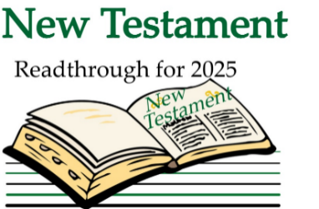

This week’s Scripture reading:
November 24 – 1 Peter 1
November 25 - 1 Peter 2
November 26 - 1 Peter 3
November 27 - 1 Peter 4
November 28 – 1 Peter 5
November 29 - 2 Peter 1
November 30 – 2 Peter 2



Proverbs 22:4 (NASB 1995)
The reward of humility and the fear of the Lord are riches,
honor and life.

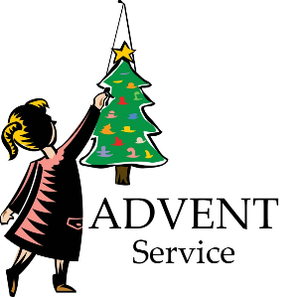
A special treat awaits you for the Sunflower Parish Advent
service on December 7 at 6:00 p.m. at the Prairie View Church.
A historical event from 1912 about a ship captain and his family
whose life and work showed faith, love and courage, was written
in drama form by Cherri Baer.
Eleven characters, most of them from the parish, will
present this heartwarming play followed by a brief
worship service.
Come and enhance the meaning of Christ’s birth.

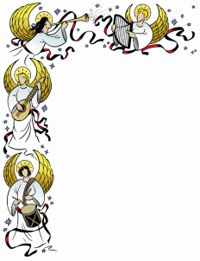

SOS CHRISTMAS ANGEL PROJECT
Important Dates
Today - - - - – Angels available for adoption.

December 7 – Wrapped presents to Tisdale Church by noon.
Presents delivered to Burden Baptist Church
Annex from 1:00-3:00 p.m
.
December 13 –Parents will pick up gifts at Burden Baptist
Church Annex from 9:00 a.m. to noon.

Donations for food baskets may be sent to:
Sunflower Outreach Services
Joseph’s Storehouse
P. O. Box 93
Burden, KS 67019
Or….they may be left here at the church and we will get them to Joseph’s Storehouse. Be sure to mark them “SOS Christmas Project”

