Preamble for Today’s Lesson
Isaiah 43:18-19
Do not [earnestly] remember the former things; neither consider the things of old.
Behold, I am doing a new thing! Now it springs forth; do you not perceive and know it and will you not give heed to it? I will even make a way in the wilderness and rivers in the desert.

Today’s Topic: “An Invitation to Cross Over”

I have a very strong sense that the Lord is calling us over to “His Side” and out of the world system . . . in fact, the picture that I see in my mind’s eye is Jesus, playing the old-fashioned kids game called “red rover”.

He is joined with many who are already with Him, everyone in a line, all holding hands. And, as the games goes, He invites us all, one at a time, to all come on over . . . Red Rover, Red Rover, Send Jimmy right over.

Only this is where the game with Jesus differs a bit . . . once you get called over, you immediately join Jesus’s team. Instead of trying to break through, before you get to the line Jesus is in, you are welcomed by everyone in line, and everyone gets added once they leave from where they came from.

It’s Jesus’ game, and everyone who is added to His side makes Him happier and happier. The game continues on until there is a great multitude of people, all standing in a line, all holding hands and smiling . . . now knowing they are definitely in the right spot.

Why is this taking place . . . because Jesus knows what is coming to planet earth (Matthew 24:6), and so should we . . . but many people are indifferent to the current signs around them . . . here are some real financial signs happening around us that will begin to paint a picture:
- “Gold is humanity’s oldest form of money – so when it goes up in price, that means the currencies against we are measuring it are going down in value.” – John Rubino, USAWatchDog.Com, October 9, 2025.

AI Overview – the value of gold has surged approximately 50-60% so far this year, on track for its strongest annual performance since 1979.

- “The housing market is rolling over because people can’t afford them. What was keeping a floor in the housing market were rents by illegal aliens. That’s all going the wrong way. Trump is deporting people, and we closed down the boarder. Our housing report that we put out a month ago . . . all the indicators are rolling over, and we are going to have a housing recession.” – Edward Dowd, USAWatchDog.com, September 15, 2025.

“Dowd says his forecast of the world going into a very deep recession will come true soon.” – Edward Dowd, USAWatchDog.com, September 15, 2025.
- “I think I have identified the four horsemen of the next stock market apocalypse – each one manageable in isolation, but collectively large enough to reshape a financial system priced for perfection.”

“Subprime auto, commercial real estate, private credit, and crypto all scratch me where I itch when thinking about precarious pockets of today’s stock market.”

“The playbook hasn’t changed much since 2008: delay the markdowns, hope the cycle bails you out, and treat the denial as a risk-management strategy. But the stresses building in auto lending, consumer credit, commercial real estate, crypto, and private credit suggest we are once again in the quiet center of the storm – the part where the outcomes are predictable, but the recognition hasn’t yet hit the tape.” - QTR’s Fringe Finance, November 3, 2025.
- Understanding GDP – Gross Domestic Product

(Consumer Spending) + (Government Spending) + (Investment Spending) + (Exports-Imports) = Gross Domestic Product

2024 Numbers
- Consumer Spending – 68%
- Domestic Investment – 18%
- Government Spending – 17%
- Net Exports of Goods and Services – (3%)

GDP only tells you how much you spend on the shopping spree, and ignores the credit card bill that follows.
- Ray Dalio’s book, How Countries Go Broke . . . Stages 1-9.
- Stage 5 is underway as the Fed tries to see how low it can push rates without raising inflation, while Congress and the President seek ways to salvage politically popular spending programs and tax policies.
- Stage 7 may be starting as some of the riskiest private borrowers (First Brands, Tricolor) start hitting the wall.
- As reported by John Mauldin via MauldineEconomics.com, October 19, 2025.

- “The world faces a slow-motion destruction of currency purchasing power. Inflation remains a persistent threat, eroding wages and deposit savings. Resources divert from innovation to debt service and government bureaucracy, stalling productivity and growth. Thus, the middle class suffers higher taxes and persistent inflation, losing disposable incomes and social mobility.”

“This situation is not a result of government incompetence, rather, it is a deliberate strategy to create a dependent subclass that relies on government assistance due to the repression and elimination of financial freedom.” – Welcome to the Age of Perennial Crisis by Daniel Lacalle, September 29,2025

The cover page of the magazine publication, The Economist

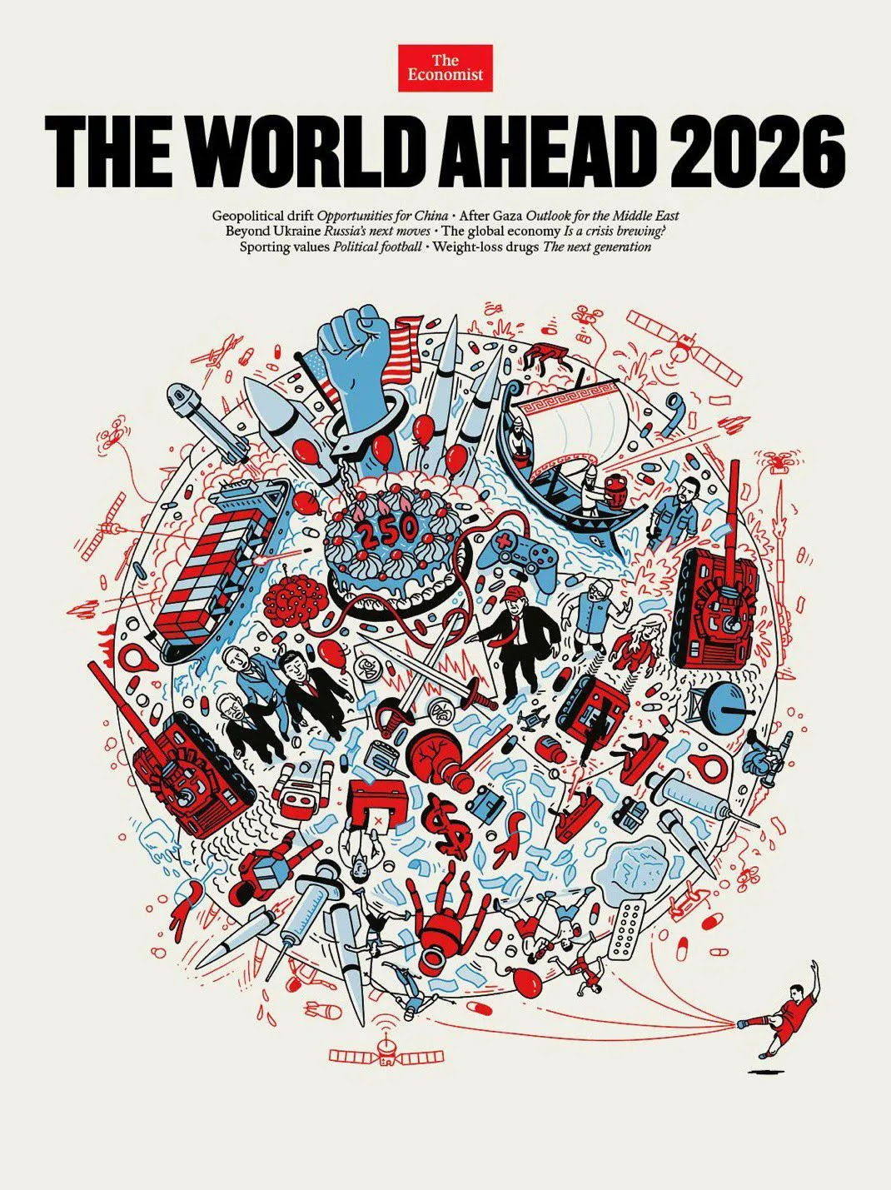

Proverbs 14:15-16 (Amp)
The simpleton believes every word he hears, but the prudent man looks and considers well where he is going.
A wise man suspects danger and cautiously avoids evil, but the fool bears himself insolently and is [presumptuously] confident.

The writing is on the wall for all to see, and steer around, based on the Lord’s invitation to “come on over” to His side (Red Rover). However, many will close their eyes and ears to this economic unfolding, only to then be boxed into a financial malaise in the days to come.

So, crossing over, what does this look like in everyday life?
- Repent for trusting in anything other than the Lord God Almighty. This includes using the Lord as your back-up plan in case the Babylonian Financial Systems breaks apart or crumbles.
- We must understand the financial institutions and vehicles that man created are fragile and are subject to collapse.
- Ask the Lord where He wants His money invested, sowed, or generously given away.
- Invite the Holy Spirit to teach you about Kingdom Finance Principals, and employ them.
- Now would be a good time to speak out loud Psalm 91 daily, over our life and our family’s life.
- Live each day, filled with thanksgiving and gratitude, for the provision the Lord gives you each day.
- Ask the Lord what His Divine Plan was and is for you, what you were destined to do, for His Glory and Kingdom Expansion.

Proverbs 19:23 (Amp)

The reverent, worshipful fear of the Lord leads to life, and he who has it rests satisfied; he cannot be visited with [actual] evil.

Job 5:19-27 (Amp)
¹⁹ He will rescue you in six troubles; in seven nothing that is evil [for you] will touch you.
²⁰ In famine He will redeem you from death, and in war from the power of the sword.
²¹ You shall be hidden from the scourge of the tongue, neither shall you be afraid of destruction when it comes.
²² At destruction and famine you shall laugh, neither shall you be afraid of the living creatures of the earth.
²³ For you shall be in league with the stones of the field, and the beasts of the field shall be at peace with you.
²⁴ And you shall know that your tent shall be in peace, and you shall visit your fold and your dwelling and miss nothing [from them].
²⁵ You shall know also that your children shall be many, and your offspring as the grass of the earth.
²⁶ You shall come to your grave in ripe old age, and as a shock of grain goes up [to the threshing floor] in its season.
²⁷ This is what we have searched out; it is true. Hear and heed it and know for yourself [for your good].

