This Week at PPBC

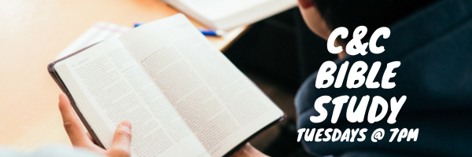

Wednesdays @ 6:30pm



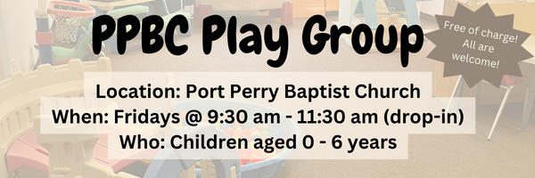Friday, November 28, 2025

Friday, November 28, 2025
Youth in grades 7 – 12

December 13th, 2025
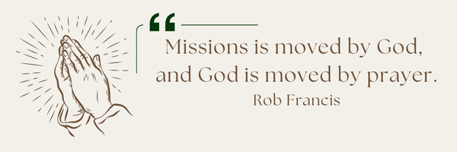
A Prayer Request for Outreach to our Canadian Indigenous: The PPBC Mission Committee continue to seek God’s guidance and provision of an open door to become involved in an outreach to our Canadian Indigenous. Please pray with us for God’s leading towards an opportunity to serve.


Please Sign up in the foyer and bring a tray of your favourite dessert to share!

Sunday Ministry Schedules
Below are ministry schedules for Nursery, Jr. Church, Greeters, Ushers, and Sound & Video:
Nursery
Nov 23: Brenda Clemens, Audrianna Angrove
Nov 30: Jen Werner, Alyssa Summers
Infant Nursery
Nov 23: Stephanie Anderson, Rosalie McLaren
Nov 30: Laura Saunders, Amber Saunders
Jr. Church; ages 3 to grade 1
Nov 23: Ellianne McLaren, Hailey Ferguson
Nov 30: Deb Brown, Mikayla Ferguson
Jr. Church; Grades 2 to 6
Nov 23: Miriam Bolsonello, Kim St-Onge
Nov 30: Kate Anderson, Tiffany Green
Greeters
Nov 23: Leno & Donna Araujo
Nov 30: Paul & Helen Jones
Ushers
Nov 23: Roy Wilson, Mark McLaren
Nov 30: Paul Sammut, Leno Araujo
Sound & Video
Nov 23: Sound: Jordan Anderson | Video: Josh Bolsonello
Nov 30: Sound: Wyatt Werner | Video: Josh Myers

Morning Service
Welcome
Song – Across the Lands
Scripture
Song – Jesus Paid it All
Song – As the Deer
Prayer
Song – Be Thou my Vision
Message – Pastor Jim Clemens
Song – Let it be Said of Us



Praise & Prayer Highlights
PRAY for Brian Timmins and his family as they mourn the loss of his grandfather. PRAY that God will give them great comfort in Christ.
PRAY for Pastor Jim & Brenda. PRAY Pastor Jim as he battles a rather stubborn respiratory illness. He is on new medications and is feeling some improvement the last couple of days. Please PRAY for renewed health and an increase of patience as he trusts the Lord's timing in his recovery.
PRAY for Joan Mabley's ongoing health & recovery at home. PRAY for her and the family as they look for care to meet Joan's needs.
PRAY for Barbara Fry and the Werner family as they mourn the loss of Ron. PRAY for Barbara, Roy, Elizabeth and the family as they make preparations for a service. PRAY that God will give them great comfort in Christ and that the truth of the Gospel will shine through this loss.
PRAY for Bert & Ada Faber and their ongoing health concerns.
PRAISE for Carolyn & Ebi Meraji and the birth of their second son Levi. Continue to pray for them as they recover and celebrate this gift.
PRAISE for the safe arrival of Shepherd Bryant. PRAY for Morgan and Josh and their family as they recover and celebrate this new life.
PRAY for Dennis Tomcheski and his ongoing health concerns.
PRAY for Winnie Miller and her ongoing health concerns.
PRAISE for the engagement of Stephanie Harrott and Daniel Wobito (new attendees of PPBC). Please PRAY for them as they prepare for marriage next year.
PRAISE for the engagement of Joshua Bolsonello & Madeline Werner. Please remember them in prayer as they prepare for marriage next fall.
Giving
Just as a reminder, there are several ways you can give:
In Person using the offering box located on the back wall of the sanctuary. Donation envelopes are available at the Welcome Centre. Please contact the church office if you would like a box of donation envelopes (office@portperrybaptist.ca)
Through your online banking, you may send electronic transfers to ppbcdonations@gmail.com.
You can also give through Canada Helps. Donation receipts will be provided by Canada Helps, and transaction fees apply.
***********************************************************************
Weekly Newsletter
The PPBC Newsletter is emailed to the church family every Friday. If you would like to be added to the weekly email list, please contact the office by phone: 905-985-8681 or by email: office@portperrybaptist.ca.
*****************************************************************
Church Information:
Location:
2210 Hwy 7A
Port Perry, ON
L9L 1B4
Office Hours:
Monday: 8:30am – 4:00pm
Tuesday: 8:30am – 4:00pm
Wednesday: Closed
Thursday: 8:30am – 4:00pm
Friday: 8:30 am - 3:00 pm
Contact:
Phone: 905.985.8681
Email: office@portperrybaptist.ca
Website: www.portperrybaptist.ca
Staff:
Sr. Pastor – Rev. Jim Clemens
Administrative Assistant – Madeline Werner
Family Ministries Director – Josh Anderson

PPBC Newsletter
Sunday, November 23, 2025


Sunday Starting Point
Sunday, November 23, 2025 - 9:30 am
“Beginning the day with the Word and prayer”
Adults:
Adults will meet in the sanctuary for a time of study and prayer. Psalm 142.
Youth:
Jr High (Grades 7-8) will meet in room 18 with Kate Anderson to study Advent.
Children:
Children ages 3 - grade 6 will meet in room 26.
(Please note nursery is unavailable during Starting Point)
Sunday Morning Worship
Sunday, November 23, 2025 - 10:30 am
We are meeting in the sanctuary and will continue to live-stream for those who are unable to attend.
Message: The Gospel Continues to Spread
Scripture: Acts 13-15, 28
Pastor Jim Clemens

