Opportunities for Service

Loaves & Fishes

Nanaimo Free Food Market
1-2:30 p.m. every Tuesday
We are a distribution depot
for our local Nanaimo Food Bank
and see this as a part
of our outreach ministry

Be a Part
of one of our Leadership Teams:

- Faith Formation & Spiritual
Development
- Ministry & Personnel
- Brechin 4 Action
- Pastoral Care
- Pacific Mountain Region
Representatives
- Property
- Stewardship & Finance
- Worship
- Trustees
- Library
- Power Point Presenters
- Fellowship

MISSION STATEMENT

Serving community and caring

for all God's Creation.

Core Values Statement

As people loved by God and as followers

of Jesus, we seek to be compassionate,

relevant, inclusive and Spirit-Centred.

(Revised May 2025)

*************

“As a designated Affirming Ministry we boldly declare that we fully welcome and include the full participation of all people in the life and work of the Ministry as we journey together, regardless of sexual orientation, gender identity, ethnicity, age, marital status, mental or physical ability, beliefs, cultural backgrounds, or economic circumstance. We are dedicated to being good stewards of God’s world, working and living towards justice and wholeness for all God’s people.”

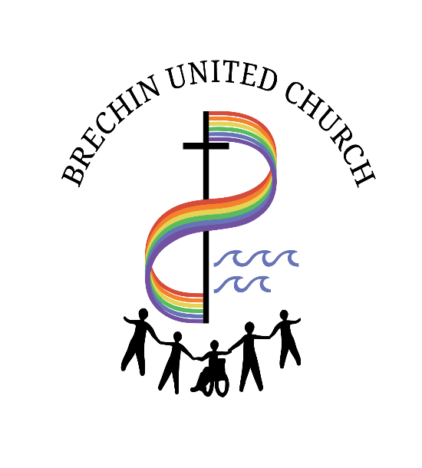

Worship Services
Sundays 10:00 a.m.
incl. Communion
(1st Sunday each month)
Church School 10:00 a.m.
Join Livestream at the time
of worship
Go to WWW.youtube.com/@Brechin
UnitedChurchNanaimoBCCa
And look for the Live Tab
Posted on Youtube later

Office
2020 Estevan Road
Nanaimo BC V9S 0C9
Office phone: (250) 754-9212
Office Hours:
Tues. to Fri. 9:30AM-Noon
and 1PM-3PM
Website: www.brechinunited.org

Church Staff

Minister: Rev. Katherine Brittain

Music Director/Pianist: Tim Weger

Office Administrator: Cindy Gillespie

MINISTRIES

Loaves and Fishes
Nanaimo Free Food Market
2020 Estevan Road
Tuesdays 1:00 - 2:30 pm

Reaching 'Out'
2SLGBTQIA+ Group
Meet at 7:00 pm on the first
Wednesday of the month
Offering a supportive space to
connect, meet new people,
build community, socialize,
have fun and join in discussions
on topics of interest

ROAR
(Reaching Out Assisting Refugees)
Brechin United Church is involved
in sponsoring LGBTI+ refugees.
www.roarrefugees.com
for more information

Sing for Joy
A Choir Active in Worship Services
Practice Thursday 6:00 -7:30 pm
Rehearsal at 9:00 am Sunday
Before Worship Service

OPPORTUNITIES FOR
LEARNING AND FELLOWSHIP

Brechin Friendship Social

2nd Tuesday each month
7:00 - 9:00pm
Everyone is welcome to come for
an evening of games, cards and a
time of socializing.
See Bulletin Board for dates.

Yoga Community at Brechin

Monday Mornings
Seniors Yoga 9:30 - 10:50
Yoga experience is helpful

Chair Yoga 11:10 - 12:10
Suitable for beginners
Instructor: Anne Harris-Freed
(donation of $10.00 per session
as able)

Community Drum Circle
Last Friday of the Month
7:00 pm
Drums provided and
no drumming skills required
Instructor: Richard Freed
(donation of $10.00 per session
as able)

( revised July 2025 )

Ukulele Jam
Meets 2nd and 4th Wednesday
at 12:00 noon
An opportunity to have fun and learn
to play the Ukelele

Brechin Men’s Group
Meets the 4th Monday at 2 pm
A chance for men to meet to discuss current events and share fellowship.

Brechin Ladies WHO Brunch
Meet monthly at Smitty's
(Rock City)
For more information contact
Susanne Body at sbody@shaw.ca

Land Acknowledgement
This land on which we gather
is the traditional land
of the Snuneymuxw people.
They have lived and thrived here
for thousands of years.
We give thanks for the land
and its people and we pray that,
in our worship and our daily lives,
we may honour the traditions and respect that is held for this land.

