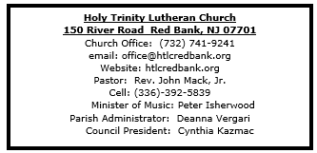

November 16, 2025

23rd Sunday after Pentecost

Introduction
The end is near. There is no doubt about it. The warnings are dire. The tone of today’s texts is ominous. But the baptized know how to live in the meantime. The baptized are strengthened for the living of these days in word and sacrament. The baptized rally around the invitation of the apostle: “Do not be weary in doing what is right.”

Welcome & Announcements (Please silence your cell phone!)

Prelude (We prayerfully prepare our hearts and minds to worship!)

+ GATHERING +

Confession and Forgiveness
All may make the sign of the cross, the sign that is marked at baptism, as the presiding minister begins.
P: Blessed be the holy Trinity, ☩ one God,
who forgives all our sin,
whose mercy endures forever.
C: Amen.
P: Let us confess our sin in the presence of God
and of one another.
Silence is kept for reflection.
Faithful God,
C: you have shown us the ways of your heart,
yet we stray from your paths.
We are stuck in sinful systems of oppression
and do not embrace the freedom
of your faithful promises.
We ignore our neighbors.
We exploit the earth.
We reject your abundance,
trusting our impulses instead of your steadfast love.
Repair our relationships,
restore what we have broken,
renew our hearts,
and bring us to new life.
Amen.
P: Hear the good news:
God the Faithful One loves you,
☩ in Christ Jesus your sins are forgiven,
and by the power of the Holy Spirit you are set free.
C: Amen.

*Gathering Hymn ELW 796 How Firm a Foundation

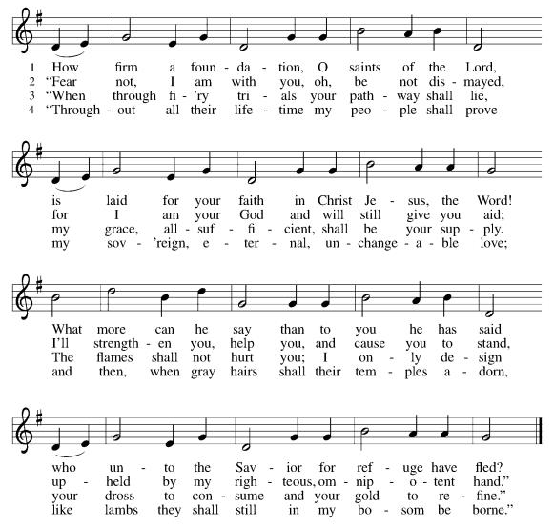

*Pastoral Greeting

P: The Grace and Peace of our Lord Jesus Christ, the love of God, and the communion of the Holy Spirit be with you all! C: And also with you!

Hymn of Praise
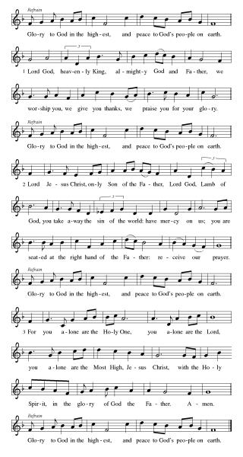

*Prayer of the Day
P: O God, the protector of all who trust in you, without you nothing is strong, nothing is holy. Embrace us with your mercy, that with you as our ruler and guide, we may live through what is temporary without losing what is eternal, through Jesus Christ, our Savior and Lord.
C: Amen!
+WORD+

First Reading: Malachi 4:1-2a
Malachi, whose name means “my messenger,” warns that “the day is coming.” On that day, the evil will be destroyed like stubble in a fire, but the “sun of righteousness” will shine on those who honor God.

¹ See, the day is coming, burning like an oven, when all the arrogant and all evildoers will be stubble; the day that comes shall burn them up, says the Lord of hosts, so that it will leave them neither root nor branch. ^{2a} But for you who revere my name the sun of righteousness shall rise, with healing in its wings.

Psalm: Psalm 98
In righteousness will the Lord judge the world. (Ps. 98:9)

¹ Sing a new song to the Lord, who has done | marvelous things,
whose right hand and holy arm have | won the victory.
² O Lord, you have made | known your victory,
you have revealed your righteousness in the sight | of the nations.
³ You remember your steadfast love and faithfulness to the | house of Israel;
all the ends of the earth have seen the victory | of our God.
⁴ Shout with joy to the Lord, | all you lands;
lift up your voice, re- | joice, and sing.
⁵ Sing to the Lord | with the harp,
with the harp and the | voice of song.
⁶ With trumpets and the sound | of the horn
shout with joy before the | king, the Lord.
⁷ Let the sea roar, and | all that fills it,
the world and those who | dwell therein.
⁸ Let the rivers | clap their hands,
and let the hills ring out with joy before the Lord, who comes to | judge the earth.
⁹ The Lord will judge the | world with righteousness
and the peo- | ples with equity.

Second Reading: 2 Thessalonians 3:6-13
Some members of the Thessalonian community, because of their belief in the nearness of Christ’s return, had ceased to work, living off the generosity of other members of the community. The writer of this letter warns them bluntly that if they want to eat, they need to work.

⁶ Now we command you, brothers and sisters, in the name of our Lord Jesus Christ, to keep away from every brother or sister living irresponsibly and not according to the tradition that they received from us. ⁷ For you yourselves know how you ought to imitate us; we were not irresponsible when we were with you, ⁸ and we did not eat anyone’s bread without paying for it, but with toil and labor we worked night and day so that we might not burden any of you. ⁹ This was not because we do not have that right but in order to give you an example to imitate. ¹⁰ For even when we were with you, we gave you this command: anyone unwilling to work should not eat. ¹¹ For we hear that some of you are living irresponsibly, mere busybodies, not doing any work. ¹² Now such persons we command and exhort in the Lord Jesus Christ to do their work quietly and to earn their own living. ¹³ Brothers and sisters, do not be weary in doing what is right.

*Gospel Acclamation
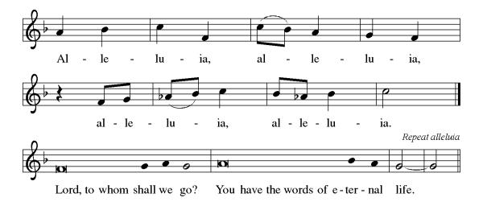
P: The Holy Gospel According to the St. Luke the 21st Chapter
C: Glory to You, O Lord!

Gospel Luke 21:5-19
As history moves toward God’s fulfillment there will be frightening signs and events. Before the end, believers will draw strength from their relationship to God and will be given the words they need to testify and to endure without fear.

⁵ When some were speaking about the temple, how it was adorned with beautiful stones and gifts dedicated to God, [Jesus] said, ⁶ “As for these things that you see, the days will come when not one stone will be left upon another; all will be thrown down.”
⁷ They asked him, “Teacher, when will this be, and what will be the sign that this is about to take place?” ⁸ And he said, “Beware that you are not led astray, for many will come in my name and say, ‘I am he!’ and, ‘The time is near!’ Do not go after them.
⁹ “When you hear of wars and insurrections, do not be terrified, for these things must take place first, but the end will not follow immediately.” ¹⁰ Then he said to them, “Nation will rise against nation and kingdom against kingdom; ¹¹ there will be great earthquakes and in various places famines and plagues, and there will be dreadful portents and great signs from heaven.
¹² “But before all this occurs, they will arrest you and persecute you; they will hand you over to synagogues and prisons, and you will be brought before kings and governors because of my name. ¹³ This will give you an opportunity to testify. ¹⁴ So make up your minds not to prepare your defense in advance, ¹⁵ for I will give you words and a wisdom that none of your opponents will be able to withstand or contradict. ¹⁶ You will be betrayed even by parents and siblings, by relatives and friends, and they will put some of you to death. ¹⁷ You will be hated by all because of my name. ¹⁸ But not a hair of your head will perish. ¹⁹ By your endurance you will gain your souls.”

P: The Gospel of the Lord
C: Praise to you, O Christ!

Sermon

*Hymn of the Day ELW 596 My Hope Is Built on Nothing Less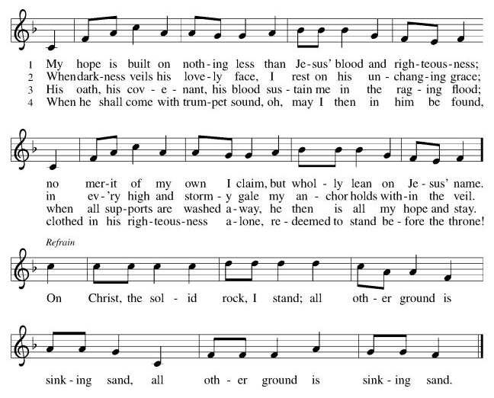
Apostles’ Creed
I believe in God, the Father almighty,
creator of heaven and earth.
I believe in Jesus Christ, God's only Son, our Lord,
who was conceived by the power of the Holy Spirit,
born of the Virgin Mary,
suffered under Pontius Pilate,
was crucified, died, and was buried;
he descended to the dead.
On the third day he rose again;
he ascended into heaven,
he is seated at the right hand of the Father,
and he will come to judge the living and the dead.
I believe in the Holy Spirit,
the holy catholic Church,
the communion of saints,
the forgiveness of sins,
the resurrection of the body,
and the life everlasting. Amen

*Prayers of Intercession
Gathered with one voice, we offer our prayers for the church, the world, and all who are in need.
A brief silence.
God of roots and branches, defend the leaders of your church as they proclaim the gospel using discernment, wisdom, and brave testimony. Keep all the baptized on righteous paths in response to Christ’s call. Hear us, O God.
C:Your mercy is great.
God of roaring seas, in a world of earthquake, famine, and plague, use your mighty power to nurture the land and all that lives upon it. Restore peoples and places experiencing natural disasters (especially). Strengthen organizations who provide aid to any in crisis. Hear us, O God.
C:Your mercy is great.
God of victory, among quests for power, guide those in government, courts, law enforcement agencies, and the military. Turn them from war and violence to actions of care that build up the common good. Hear us, O God.
C:Your mercy is great.
God of healing, where injustice and exploitation result in populations that are marginalized or underserved, accompany those abandoned by friends, hurt by family, and harmed by violence or oppression. Care for all who are ill, anxious, or in pain of any kind (especially). Hear us, O God.
C:Your mercy is great.
God of new songs, in a congregation of faithful believers, energize us for compassionate service and delight us through worship and inspired prayer. Encourage your people in building equitable community where all are valued. Hear us, O God.
C:Your mercy is great.
Here other intercessions may be offered.
God of every generation, we remember the saints with steadfast love and faithfulness (especially). Confident in Christ’s victory over death, may we be inspired by the example of the faithful. Hear us, O God.
C:Your mercy is great.
We offer these and all our prayers to you, O God, trusting in your grace and unyielding love; through Jesus Christ, our Lord.
C: Amen.
Greeting of Peace
P: The peace of Christ be with you and those you love!
C: And also with you! (The peace is shared with all!)

Offering (Thank you for your support for our ministry!)

*Doxology ELW 691 v. 1 (Please stand and join in singing as we share our gifts!)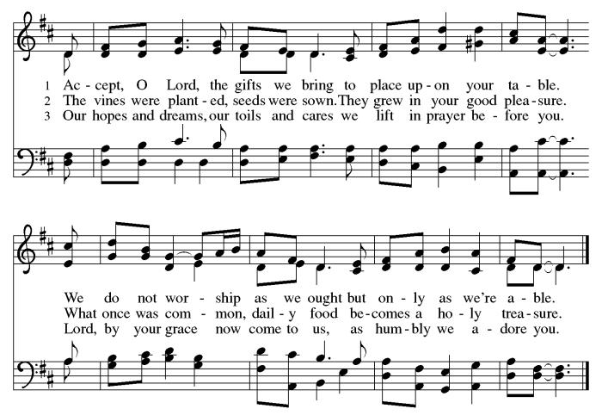
*Offering Prayer
A: God of healing and hope,
C: you bless those who are hungry,
promising to fill them with good things.
Fulfill that promise through us and these your gifts.
Nourish us with the abundance of your feast
and unite us into the blessed body of Jesus Christ our Savior,
now and forever.
Amen.

+MEAL+
(All are welcome at the table of our Lord!)
*Great Thanksgiving
P: The Lord be with you.
C: And also with you.

P: Lift up your hearts.
C: We lift them to the Lord.

P: Let us give thanks to the Lord our God.
C: It is right to give our thanks and praise.

P: It is indeed right, our duty and our joy, that we should at all times and in all places give thanks and praise to you, almighty and merciful God, through our Savior Jesus Christ; who on this day overcame death and the grave, and by his glorious resurrection opened to us the way of everlasting life. And so, with all the choirs of angels, with the church on earth and the hosts of heaven, we praise your name and join their unending hymn:

*Sanctus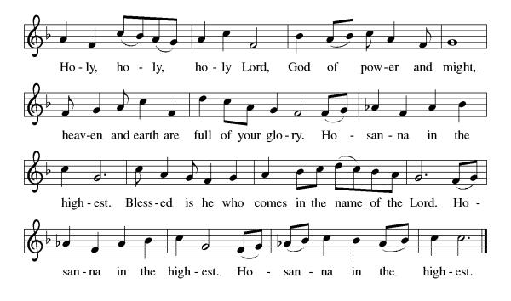

*Eucharistic Prayer
P: Blessed are you, O God,
creator of heaven and earth.
You rescued your covenant people,
led them on all their journeys,
and taught them by the prophets.
You so loved the world
that you gave your only Son,
so that everyone who believes in him
may not perish but may have eternal life.

In the night in which he was betrayed,
our Lord Jesus took bread,
and gave thanks; broke it,
and gave it to his disciples,
saying: Take and eat;
this is my body, given for you.
Do this for the remembrance of me.

Again, after supper,
he took the cup, gave thanks,
and gave it for all to drink,
saying: This cup
is the new covenant in my blood,
shed for you and for all people
for the forgiveness of sin.
Do this for the remembrance of me.

As often as we eat this bread
and drink this cup,
we proclaim the Lord’s death
until he comes.

C: Christ has died. Christ is risen. Christ will come again.

Pour out your Holy Spirit
in this meal,
and make us one
in this community of faith
and with your people
throughout the world.
Glory and praise to you, O God,
Author of life,
Word made flesh,
Power of the Most High,
now and forever.
C: Amen.

*THE LORD’S PRAYER
Our Father, who art in heaven,
hallowed be thy name,
thy kingdom come,
thy will be done,
on earth as it is in heaven.
Give us this day our daily bread;
and forgive us our trespasses,
as we forgive those
who trespass against us;
and lead us not into temptation,
but deliver us from evil.
For thine is the kingdom,
and the power, and the glory, forever and ever. Amen.

*Lamb of God
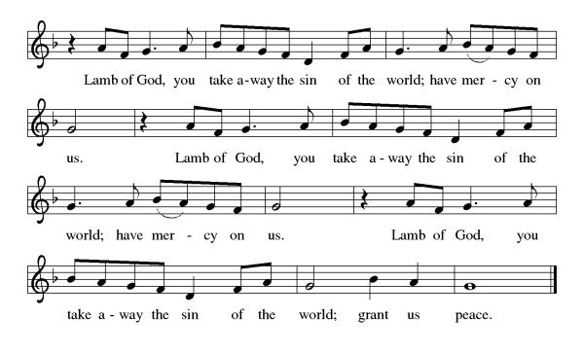

Spiritual Communion Prayer
P: Let us pray for the communion of all present here, those viewing our service virtually, those in our hearts and in our world.
C: Lord Jesus, I believe you are truly present in the Sacrament of Holy Communion. When I cannot receive Communion, I pray that you come into my heart. I know that nothing in Heaven or on earth can separate me from your love. Amen.

Invitation to Communion
P: There is a place for you at the table of God. Come, receive the food that does not perish, a taste of life eternal.
C: Thanks be to God.

(All are invited to the communion rail following the guidance of the ushers. Communion will be shared through the host and individual cups. If you would like communion but are unable to join us at the rail, please alert the usher!)

Communion Hymns (Please join in singing!)
ELW 492 Eat This Bread, Drink This Cup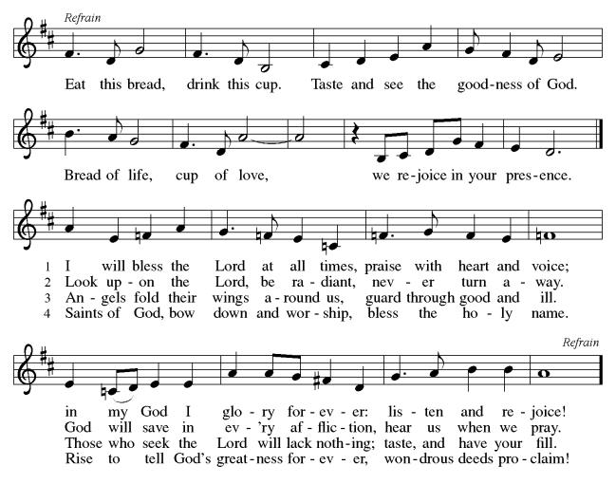
ELW 785 When Peace, Like A River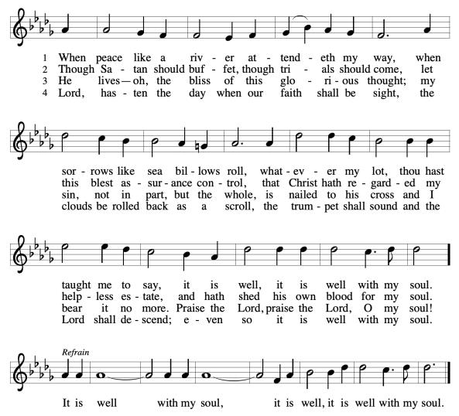

P: The body and blood of our Lord Jesus Christ strengthen you and keep you in his grace. C: Amen!

*Prayer after Communion
A: God of field and flower, wheat and grape,
you have nourished us with the bread of heaven
that gives life to the world.
Strengthened by the body and blood of your Son,
send us out to gather your good gifts for all who
hunger and thirst,
and embolden us to love and serve in Christ’s name. C: Amen!
+Sending+

*Blessing
P: The love of God the Sovereign strengthen you,
God the Son save you,
and God the Holy Spirit anoint you for the work ahead.
The holy Trinity bless you ☩
and grant you a faithful and courageous heart
now and forever.
C: Amen!

*Sending Hymn ELW 632 O God, Our Help In Ages Past
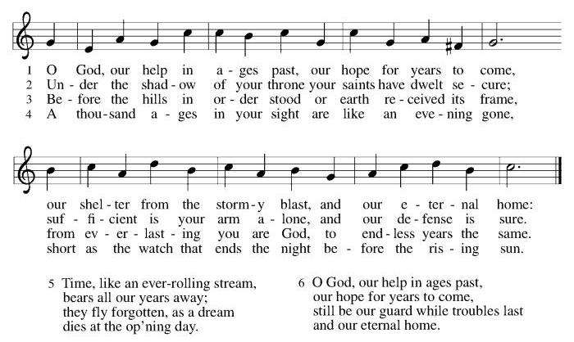
*Dismissal
A: Go in peace. Share the harvest.
C: Thanks Be to God.

Postlude

Copyright © 2020 Augsburg Fortress. All rights reserved. Reprinted by permission under Augsburg Fortress Liturgies Annual License #SB106907. New Revised Standard Version Bible, Copyright © 1989, Division of Christian Education of the National Council of the Churches of Christ in the United States of America. Used by permission. All rights reserved. Revised Common Lectionary, Copyright © 1992 Consultation on Common Texts, admin Augsburg Fortress. Used by permission.
Treasurer’s Report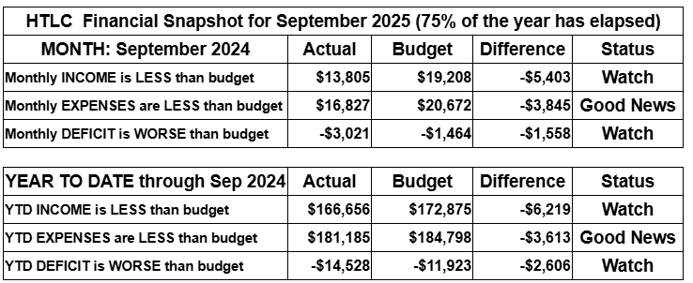
September brought renewed activity—and renewed financial pressure—as giving fell below budget while expenses stayed mostly on track. We’re watching cash flow carefully and invite everyone to help by giving a little extra, responding generously to the Stewardship Appeal, or setting up a recurring gift to support our shared ministry.

Thank you for supporting our ministry! Chris Foard, Treasurer

Worship Volunteer Schedule
Date | Asst. Min | Usher | Sacristan | Lector | Counter
November 16 | Elaine Bradford | Kathy Caputo | Sherry Lee | Bill Spreen | Foss/Coleman
November 23 | Keith Bennett | Gary Joblon | Nancy Poole | Molly Foard | Carleo/Csernica
November 30 | Chris Foard | Dan Grillon | Joanne Giordano | Rosemary Lane | McKenna/Kazmac
December 7 | Linda Coleman | Keith Bennett | Carol Rosen | Emily Kaster
December 14 | Elaine Bradford | Kathy Caputo | Nancy Poole | Jeff Ridberg

Altar Flowers
November 2ND Kathy Caputo, in memory of Bob Wolfrum
November 9th Kari Oswald in memorial of Aiden Oswald
November 16th Roger Foss In memroy of Lillian Foss
November 26th In Memory of Robert Coppotelli, Lisa Lynch
November 30th In memory of Bob Kolb and parents by Mavis Kolb

Coffee Hour Bruce and Rosemary Lane
Please consider siging up of a coffee hour. Recruit some friends to help. Thank you!
ANNOUNCEMENTS Thank you! To all who consistently support our church and ministries through your time, talent, and treasure. Please help us grow by inviting your friends and family to worship and events. You are what makes Holy Trinity a wonderful church family!

Stay in touch! Please visit our church website, www.htlcredbank.org for updates and information. You can also find us on Facebook and view services online. The office is open from 9am to 2pm, Monday to Thursday.

100 Anniversary Committee- If you are interested in being a part of the committee to help plan the 100th anniversary celebration of HTLC in 2028, please sign up in the red book. All are welcome! Also, the committee will be looking for photos and documents of HTLC throughout the years. If you have anything to share, please bring them to the church and marked envelopes or email electronic copies to the church office.

Photo Directory - Day one of photos was a success! After worship, we will be taking photos for an updated Holy Trinity photo directory. Casey H. and her boyfriend Bart (professional photographer!) will have a station set up during coffee hour, so please stop by for an updated head shot! Photos will be taken on the following dates: 11/23, 12/7, 12/14, 12/21. Please see Casey H. or Elaine B. with any questions.

Name Tag Sundays: On the first Sunday of each month, names tags and markers will be at each entrance of the sanctuary. Please fill out a tag and wear one for worship and for coffee hour to welcome visitors and help newcomers put names to faces.

Choir The Holy Trinity Choir welcomes our singers back for a preparation rehearsal on Sunday, September 7th at 9am in the church hall. All are welcome to join us in song as often as you are able. Choir meets each Sunday at 9am to practice and prepare our music. Join us and help us grow by spreading the word about the HTLC Choir!

Quilting- The Quilters need gently used any bed sheets of any size! Please leave any donations in the quilters closet in Fellowship Hall. Thank you!

Weekly Quilting on Wednesdays at 9:30. Bring your lunch and enjoy some fellowship at noon. All are welcome. There will be no quilting on Wednesday September 24 due to the garage sale set up.

WELCA Update:The garage sale was another success. The net profit after the bank deposit was $3,408.24. It should be noted that other money is still coming in. There was a meeting on 10/12 with congregation members, and it was decided that the giving amount would be rounded up to $3,500. The donations would be made to:
Lutheran Disaster Response - $1,000. It will be noted that this donation should cover both national & international needs.
180 Turning Lives Around - $500
HABCore - $1,000
Monmouth Day Care - $1,000
*It should be noted that a regional donation will be made later in the year to Crossroads for the Tee sign.

Evening Quilting Evening Quilting –
Please share this information . This is an important ministry that helps so many. It’s very easy and you don’t need to know how to sew. We have a great time socializing too! We will meet:
Oct. 15, Nov 19, Dec 17 At 6:00 PM. Note: If we have to cancel I will send an email. Please let me know only if you can come. Contacts: Pat Pienkos 732-513-9615 Debbie Yetka 908-461-4084 Looking forward to seeing you all!

Bagels and Bible- Bagels and Bible will be meeting on the second and fourth Saturdays of the month at 8:30. The group will meet in the Parish House.

Social Ministry
*Year-round collections will continue for food items for Lunch Break. There is a sign-up sheet in the red book for those who can help drop these items to Lunch Break.
*We will also collect adult men's socks to periodically drop at the Red Bank Warminq Center.
*For those interested in the Heartwarminq Center — the new women's shelter is adjacent to the First Baptist Church of Red Bank at 90 Maple Ave. You can follow up on this mission through their website - https://www.thefeastnj.org- On this site, they also include wish list items that can be purchased through amazon. We will be exploring purchasing some of these through a Thrivent card. If you want to purchase on your own, you can leave items at church, and the Social Ministry will deliver them.

Pastoral Care and Prayer... We are here to care for and pray! Please contact the office to add or adjust prayer requests. If you or someone you know needs pastoral care, please contact the office and Pastor Mack!

THANK YOU for supporting and sustaining our church and ministries! All are welcome here! Please invite your family and friends to worship with us! Find us online at www.htlcredbank.org

