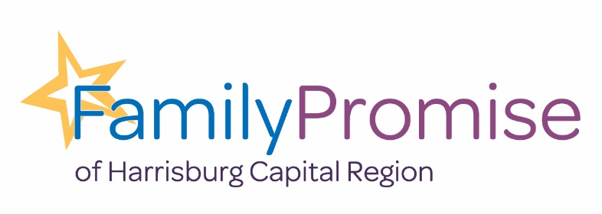
56 Erford Rd.
Camp Hill, PA 17011
(717) 737-1100
www.familypromisehcr.org

Family Promise of Harrisburg Capital Region (FPHCR)
Meal Provider

Our Organization:
Family Promise of Harrisburg Capital Region (FPHCR) is a 501(c)3 nonprofit agency that serves families experiencing various degrees of homelessness. We are one of over 200 Family Promise affiliates in 41 states. Over 110,000 volunteers serve in Family Promise affiliates nationwide.

Thank you for using your gift of cooking to provide a meal to our families! By doing so, you allow them to save their funds and work towards housing of their own.

Contact:
Community Outreach Associate. Susan Ryder, susan@familypromisehcr.org

Responsibilities:
Provide meals to families (guests) in the Family Promise HCR shelter program.

Description:
Provide a meal for up to 13 people, based on the family profiles given to you. The profile includes likes, dislikes, and allergies.

The meal is either taken to a congregation or provided at the Day Center.

Meals are served “family style” and prepared ahead of time delivered hot or ready to reheat.

Meals are dropped off at the Day Center 56 Erfrod Rd., Camp Hill, by 5:30 p.m. on the day you signed up.

Family profiles will be sent to you so that meal makers know allergies, preferences and ages of all the family members.

