Name of Assembly: United Apostolic Church
Type of service: Bible Study
Date: November 18th, 2025
Series Topic: “Questions from Corinth”
Lesson 4B: “What about Marriage and Sexual Relations?”
Scripture Text: 1 Corinthians 7

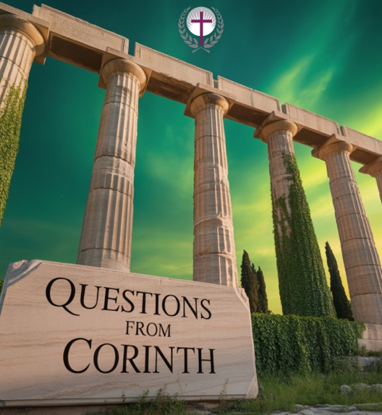

The Gift of Singleness and Celibacy

“⁷ For I would that all men were even as I myself. But every man hath his proper gift of God, one after this manner, and another after that. ⁸ I say therefore to the unmarried and widows, it is good for them if they abide even as I. ⁹ But if they cannot contain, let them marry: for it is better to marry than to burn” – 1 Corinthians 7:7-9.

- In this lesson, singleness means being unmarried even though there is a desire to marry. Celibacy is the voluntary lifelong choice to abstain from marriage and related activities. The celibate person does not have any desire to marry.

- Paul explicitly mentions that these two states of being are gifts from God.

- His perspective on singleness provides deep insight into its worth. He doesn’t criticize marriage but instead emphasizes singleness as a valid and, for some, a preferred state for Christian service. His personal experience as an unmarried apostle likely shaped his view that singleness can foster a unique focus on God’s kingdom, free from the competing demands of family life. He saw it not as a deficiency but as a specific gifting, empowering individuals to dedicate themselves fully to the Lord’s work.

- The Bible presents several examples of individuals who served God effectively while remaining single, demonstrating the validity and fruitfulness of this calling:

- Apostle Paul: As he himself stated, Paul leveraged his singleness to travel extensively, plant churches, and endure immense hardship for the sake of the Gospel.

- John the Baptist: Known for his austere lifestyle and prophetic ministry, John’s single status allowed him to wholeheartedly prepare the way for the Lord (Luke 1:15-17).

- These examples show that singleness is not a second-class spiritual status but can be a powerful asset for advancing the business of God’s Kingdom.

Some Benefits of Singleness in Ministry:

- Flexibility for mission work and demanding schedules.
- Freedom from some family obligations, which allows for greater availability.
- Potential for deeper focus on spiritual disciplines and study.
- Reduced financial complexities in certain ministry contexts.

Some Challenges of Singleness in Ministry:

- Loneliness and isolation, especially in demanding roles.
- Lack of a built-in emotional and practical support system that will always be there.
- Societal and church pressure to conform to marital norms.
- Misconceptions or scrutiny regarding motives or character.

- Many people wrongly assume that singleness is a temporary state that needs to be fixed through marriage, that single individuals are less mature or spiritual, or that they are inherently lonely or unfulfilled. Theologically, both marriage and singleness serve God’s Kingdom purposes. Marriage beautifully reflects the covenant relationship between Christ and the Church (Ephesians 5:31-32), symbolizing union and procreation. Singleness, on the other hand, often points to the reality of the coming Kingdom, where there will be no marriage: “For in the resurrection they neither marry, nor are given in marriage, but are as the angels of God in heaven” -Matthew 22:30.

- For those blessed with the gift of celibacy, as described by the Apostle Paul, consider these practical applications.

- Embrace the Gift: Recognize singleness as a divine calling, not a waiting period or a curse. Cultivate gratitude for the unique opportunities it presents (1 Corinthians 7:32-35).

- Invest in Community: Actively seek out and build deep, meaningful relationships within the church, family, and friendships to combat loneliness and find support.

- Serve Wholeheartedly: Utilize the flexibility and availability that singleness often affords for dedicated service, ministry, and spiritual growth.

- Seek Mentorship: Find both married and single mentors who can offer wisdom and guidance for navigating life and ministry.

- Offer Mentorship: Find both married and single mentees to guide in navigating life and ministry.

- Manage Expectations: Challenge cultural and church narratives that elevate marriage above singleness, understanding that God equally values both.

- “⁹ But if they cannot contain, let them marry: for it is better to marry than to burn” – 1 Corinthians 7:9. This verse highlights marriage’s role as God’s primary provision for human sexual expression. This is not merely a pragmatic suggestion but a recognition of God’s wisdom in creating an institution that directs natural desires toward a holy and protective channel.

- Without this God-ordained outlet, individuals are more susceptible to the “flames” of temptation, which can lead to sexual sin.

- For those who sincerely desire marriage (you don’t have the “gift of celibacy”), this season can be challenging. It’s important to acknowledge that this longing is natural and God-given. While you hold onto hope for future blessings, you are also called to cultivate a vibrant faith and purposeful life in your current circumstances. Remember, both singleness and marriage are sacred paths through which God accomplishes His will and builds His Kingdom.
- As you wait on the Lord, consider the following practical applications:
- Trust God’s Timing & Sovereignty: Pray diligently for your future spouse and for wisdom in your current season. Cultivate a deep, unwavering relationship with Christ, recognizing His perfect plan unfolds in His perfect timing.

- Invest in Personal & Spiritual Growth: Focus on becoming the person God wants you to be. Prioritize spiritual, emotional, and intellectual development, not just for a potential spouse, but first and foremost for Him.

- Engage in Godly Community: Actively build strong relationships with friends, family, and mentors. Serve wholeheartedly in your church. God often works through the connections we nurture.

- Live with Purpose & Passion: Maximize your current season for God’s glory. Pursue your passions, gifts, and callings without delay. Your singleness offers unique opportunities for focused service and adventure.

- For unmarried brothers seeking marriage, the journey to find a godly wife is rooted in faith, purpose, and preparation. Proverbs 18:22 states, “Whoso findeth a wife findeth a good thing, and obtaineth favour of the Lord.” This verse highlights the divine blessing of having a spouse, fostering a hopeful and prayerful mindset.

  - Seek God’s Will First: Prioritize your relationship with God above all else. Align your desires with His perfect plan and trust in His timing for your future spouse.

- Cultivate Godly Character: Focus on personal growth and becoming the man God calls you to be. Develop virtues such as patience, kindness, and faithfulness to make you a loving partner.

- Be An Active Participant in the life of the Church: Actively participate in church, as this will assist in your preparation to assume you’re calling as a husband. Additionally, this environment naturally connects you with like-minded Christians and fosters healthy relationships.

- Pray and Be Patient: Continually pray for your future wife and for wisdom in the search. Exercise patience, understanding that God orchestrates divine connections in His perfect way.

- Discerning and Pursuing Your Spouse-to-be: When God provides clear direction regarding a potential spouse, and after counsel from Pastoral leadership, courageously and respectfully pursue that relationship. Trust in God’s guidance and provision, overcoming any perceived inadequacy or fear.

- For those previously married and are now widows or widowers, remember Anna, an elderly prophetess and widow, who exemplified profound spiritual service in her singleness. “³⁶ And there was one Anna, a prophetess, the daughter of Phanuel, of the tribe of Aser: she was of a great age, and had lived with an husband seven years from her virginity; ³⁷ And she was a widow of about fourscore and four years, which departed not from the temple, but served God with fastings and prayers night and day” — Luke 2:36-37.

Her unwavering devotion to God led her to worship night and day in the temple, fasting and praying. This focused commitment allowed her to be a crucial witness to the arrival of the Messiah, demonstrating that dedication to the Lord’s work is empowered by a concentrated heart, regardless of marital status.

Anna’s unwavering dedication offers a powerful model for widows and widowers today. If you are a widow or widower, here are some practical ways to embrace a life of purpose and service within the church community:

  - Deepened Spiritual Disciplines: Emulate Anna’s commitment to prayer, fasting, and Scripture study. Cultivate an intimate walk with God, finding solace, strength, and renewed purpose in daily devotion.

  - Active Church Engagement: Remain an integral part of your church family. Seek out ministries or volunteer roles where your unique gifts, wisdom, and life experience can profoundly bless others.

Lord willing, next week, we will complete this lesson by focusing on “maintaining the marital bond,” being “unequally yoked with other believers,” and a “word on divorce and remarriage.”

Notes
………………………………………………………………………………………………………………………………………………………………………………………………………………………………..………………………………………………………………………………………………………………………………………………………………………………………………………………………………..
………………………………………………………………………………………………………………………………………………………………………………………………………………………………..……………………………………………………………………………………………………………………………………………………..

