A Service of Celebration and Thanksgiving
for the life of
Rev. David Rivers
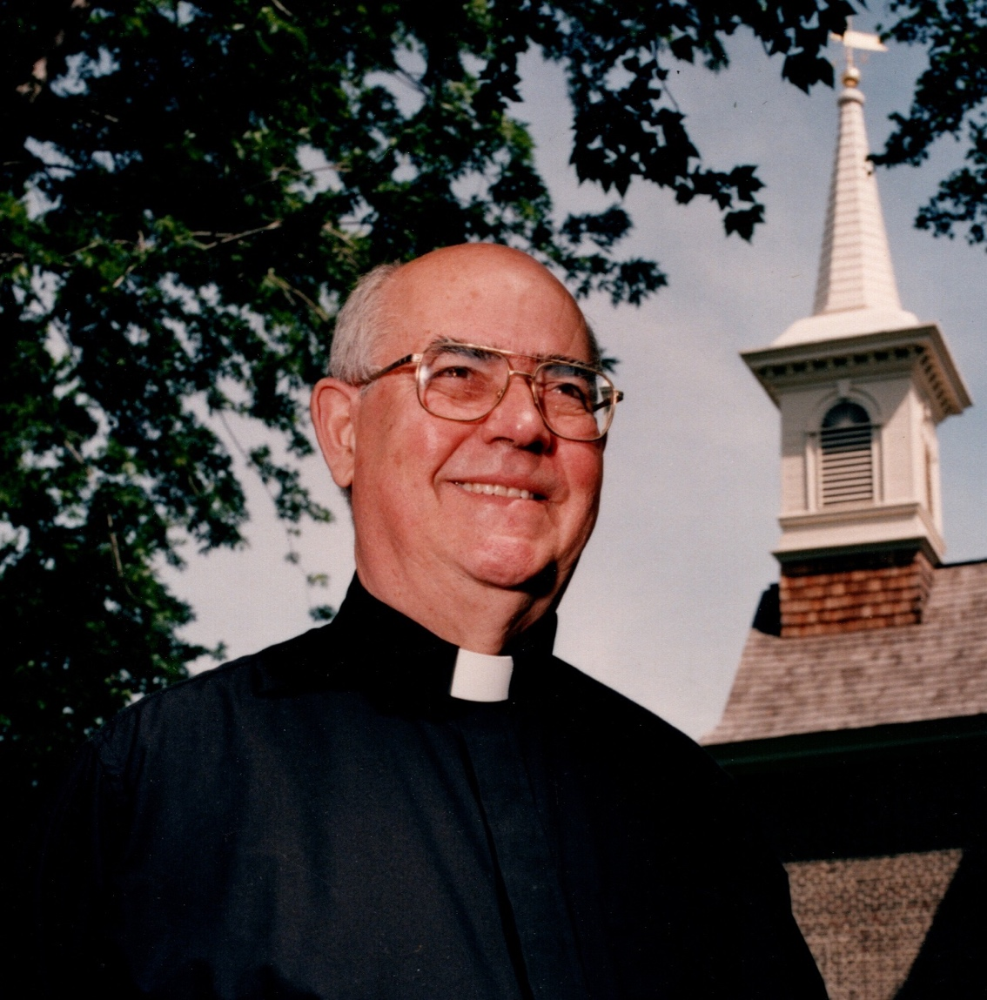
May 22, 1937– September 20, 2025

Gloria Dei (Old Swedes’) Church
Christian Street and Columbus Boulevard
Philadelphia, PA 19147
215-389-1513 www.old-swedes.org
November 15, 2025



Obituary

Reverend David B Rivers passed into eternal life on Saturday, September 20, 2025, in Wyncote Pennsylvania, following a long illness.

Born May 22, 1937, in New Haven, Connecticut, he was the son of Reverend Burke Rivers and Phyllis McCausland Rivers, who predeceased him. A brother, Richard Rivers, also preceded him in death.

David Rivers spent his childhood largely in Johnson City, New York and Wilkes-Barre, Pennsylvania, where his father was the priest serving All Saints Church, Johnson City and St Stephen's Church, Wilkes-Barre. He loved vacations on the Maine coast with his family. He graduated from Wyoming Seminary, Kingston and Haverford College. After teaching English at The Pennington School in New Jersey, he earned a Master of Divinity degree at Episcopal Divinity School in Cambridge, Massachusetts.

In 1961, Rev. Rivers was wedded to Elizabeth Zeller; Dave and Liz recently celebrated 64 years of marriage. He viewed his ministry as their ministry. Their first parish was St. Elizabeth's Schnecksville, where he was ordained in 1965 by Bishop Frederick Warnecke. Interested in adventure, they explored mission opportunities. After several months learning Spanish in Cuernavaca, Mexico, Rev. Rivers became the Priest in Charge at San Esteban, San Pedro de Marcoris in the Dominican Republic. After 3 years as a missionary, they returned to the United States and Rev. Rivers was called to Gloria Dei (Old Swedes) Church in Philadelphia, PA. Rev. Rivers was the Rector at Old Swedes Church from 1972 through 2004. While serving this historic church (the oldest church in Pennsylvania), he oversaw renovations and commemorated the 300th anniversary of its construction. For several years, he was Dean of the Episcopal Southwark deanery. He was a member of the Swedish Colonial Society. Rev. Rivers then served in interim and part-time roles at Philadelphia area churches, including Holy Trinity Church, Lansdale and St. Dunstan's Church, Blue Bell.

Rev. Rivers was a gifted preacher of the word of God, following in his father's footsteps. He was a leader by example, and genuinely interested in people from all walks of life who he welcomed to church. His sense of humor, fondness for jokes and love of a good party extended throughout his lifetime. He could be an irreverent reverend.

A fishing, hunting and camping enthusiast, Rev. Rivers enjoyed time outdoors particularly at the New Jersey shore, in northeast Pennsylvania and at Algonquin Park, Ontario. He was a devoted Eagles, Phillies and Penn State fan. He was a skilled photographer, particularly for black and white photos, and maintained a dark room for many years. Rev. Rivers appreciated classical and folk music, and sang bass in church choirs as a boy and adult. He supported music as part of services as well as separate musical programs, considering music to be an integral part of church life.

Rev. Rivers is survived by his wife, Elizabeth Zeller Rivers; children Christine (Stephen Albert) Rivers; Julia (Mark Chatman-Royce) Rivers; Diana (Lawrence) Bloom; and John (Frances) Rivers. He is also survived by his grandchildren Meagan, Nicholas, Kyra, Lukas, Alexander, Robert, Noel, Larson and Beatrice; great grandchildren Julian and Sienna; and numerous nieces and nephews. Rev Rivers is survived by his sister-in-law Virginia Rivers.

Service Participants

Celebrant Rev. Chris Micklewright
Altar Assistants Jeanette Woehr
Nina & Jim Dubois
Cathy Ufheil
Organist Wesley Parrott
Soloist Thomas Balfour-Austin
Remembrance John Rivers
Readers Diana Bloom
Jim Ufheil
Julie Rivers
Intercessor Rev. Chris Exley
Oblation Bearers Rivers’ Grandchildren:
Noel, Larson, Beatrice,
Julian, Sienna

* * *

Prelude Fanfare for the Common Man Aaron Copeland
Welcome and Message from the Bishop Rev. Chris Micklewright & Rev. Glenn Ma
Opening Hymn # 680 O God, Our Help in Ages Past Hymnal 1982
(In tribute to Dick Rivers, David’s beloved brother)

Celebrant For none of us has life in himself, and none becomes his own master when he dies.
For if we have life, we are alive in the Lord, and if we die, we die in the Lord.
So, then, whether we live or die, we are the Lord's possession.
Celebrant The Lord be with you.
All And also with you.
Celebrant Let us pray.
O God of grace and glory, we remember before you this day our brother, David. We thank you for giving him to us, his family and friends, to know and to love as a companion on our earthly pilgrimage. In your boundless compassion, console all who mourn. Give us faith to see in death the gate of eternal life, so that in quiet confidence we may continue our course on earth, until, by your call, we are reunited with those who have gone before; through Jesus Christ our Lord. Amen.
All Amen.
(All are seated for the readings)

First Reading Isaiah 61:1-3 Diana Bloom

The spirit of the Lord God is upon me, because the Lord has anointed me; he has sent me to bring good news to the oppressed, to bind up the brokenhearted, to proclaim liberty to the captives, and release to the prisoners; to proclaim the year of the Lord’s favor, and the day of vengeance of our God; to comfort all who mourn; to provide for those who mourn in Zion—to give them a garland instead of ashes, the oil of gladness instead of mourning, the mantle of praise instead of a faint spirit. They will be called oaks of righteousness, the planting of the Lord, to display his glory.

Reader Hear what the Spirit is saying to God’s people.
All Thanks be to God.

Psalm 42:1-7 Jim Ufheil
As the deer longs for the water-brooks, *
so longs my soul for you, O God.
My soul is athirst for God, athirst for the living God; *
when shall I come to appear before the presence of God?
My tears have been my food day and night, *
while all day long they say to me, “Where now is your God?”
I pour out my soul when I think on these things: *
how I went with the multitude and led them into the house of God,
With the voice of praise and thanksgiving, *
among those who keep holy-day.
Why are you so full of heaviness, O my soul? *
and why are you so disquieted within me?
Put your trust in God; *
for I will yet give thanks to him, who is the help of my countenance, and my God.

Hymn # 711 Seek Ye First Hymnal 1982
(All are invited to join in singing this hymn in rounds)

Second Reading 2 Corinthians 4:16-5:9 Julie Rivers

We do not lose heart. Even though our outer nature is wasting away, our inner nature is being renewed day by day. For this slight momentary affliction is preparing us for an eternal weight of glory beyond all measure, because we look not at what can be seen but at what cannot be seen; for what can be seen is temporary, but what cannot be seen is eternal. For we know that if the earthly tent we live in is destroyed, we have a building from God, a house not made with hands, eternal in the heavens. For in this tent we groan, longing to be clothed with our heavenly dwelling— if indeed, when we have taken it off we will not be found naked. For while we are still in this tent, we groan under our burden, because we wish not to be unclothed but to be further clothed, so that what is mortal may be swallowed up by life. He who has prepared us for this very thing is God, who has given us the Spirit as a guarantee. So we are always confident; even though we know that while we are at home in the body we are away from the Lord— for we walk by faith, not by sight. Yes, we do have confidence, and we would rather be away from the body and at home with the Lord. So whether we are at home or away, we make it our aim to please him.

Reader Hear what the Spirit is saying to God’s people.
All Thanks be to God

Eulogy The Rectors Rivers: An Unfinished Requiem
A Eulogy for the Rev. David B. Rivers by Dr. John M. Rivers

Hymn # 673 The First One Ever Hymnal 1982

Gospel Reading Rev. Chris Micklewright

Celebrant The Holy Gospel of our Lord Jesus Christ according to John (14:1-6)
All Glory to you, Lord Christ.

“Do not let your hearts be troubled. Believe in God, believe also in me. In my Father’s house there are many dwelling places. If it were not so, would I have told you that I go to prepare a place for you? And if I go and prepare a place for you, I will come again and will take you to myself, so that where I am, there you may be also. And you know the way to the place where I am going.” Thomas said to him, “Lord, we do not know where you are going. How can we know the way?” Jesus said to him, “I am the way, and the truth, and the life.”
Celebrant The Gospel of the Lord.
All Praise to you, Lord Christ.

Homily Rev. Chris Micklewright

Hymn # 599 Lift Every Voice and Sing Hymnal 1982

Prayers of the People Rev. Chris Exley

Celebrant For our brother David, let us pray to our Lord Jesus Christ who said, “I am Resurrection and I am Life.”
Intercessor Lord, you consoled Martha and Mary in their distress; draw near to us who mourn for David, and dry the tears of those who weep.
All Hear us, Lord.
Intercessor You wept at the grave of Lazarus, your friend; comfort us in our sorrow.
All Hear us, Lord.
Intercessor You raised the dead to life; give to our brother eternal life.
All Hear us, Lord.
Intercessor You promised paradise to the thief who repented; bring our brother to the joys of heaven.
All Hear us, Lord.
Intercessor Comfort us in our sorrows at the death of our brother; let our faith be our consolation, and eternal life our hope.
All Hear us, Lord.

Celebrant Father of all, we pray to you for David, and for all those whom we love but see no longer. Grant to them eternal rest. Let light perpetual shine upon them. May his soul and the souls of all the departed, through the mercy of God, rest in peace.
All Amen.

The service continues with communion, in which we receive a taste of the heavenly banquet that David now enjoys. The communion elements will be brought forward by the oblation bearers as the altar is prepared.
The congregation is invited to sit and listen to the Offertory Music.

Oblation Bearers Noel, Larson, Beatrice, Julian, and Sienna

Offertory Music Mount Moab Music Included Below
(Soloist will lead the verses, with congregation joining on the chorus)

Chorus
The Holy Communion

Eucharistic Prayer 2 – Enriching Our Worship
Celebrant The Lord be with you.
People And also with you.
Celebrant Lift up your hearts.
People We lift them to the Lord.
Celebrant Let us give thanks to the Lord our God.
People It is right to give our thanks and praise
Celebrant We praise you and we bless you, holy and gracious God, source of life abundant. From before time you made ready the creation. Your Spirit moved over the deep and brought all things into being: sun, moon, and stars; earth, winds, and waters; and every living thing. You made us in your image, and taught us to walk in your ways. But we rebelled against you, and wandered far away; and yet, as a mother cares for her children, you would not forget us. Time and again you called us to live in the fullness of your love. And so this day we join with Saints and Angels in the chorus of praise that rings through eternity, lifting our voices to magnify you as we sing:

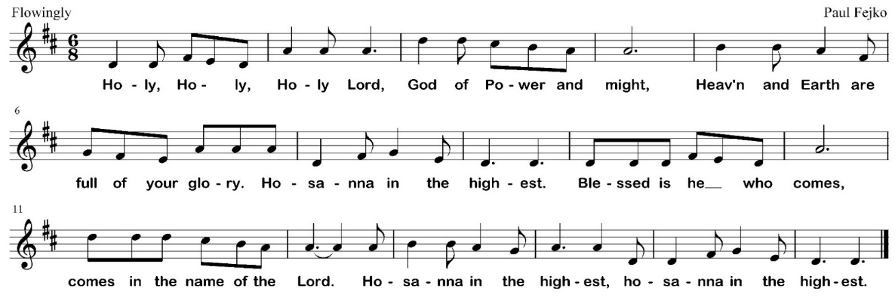

Celebrant Glory and honor and praise to you, holy and living God. To deliver us from the power of sin and death and to reveal the riches of your grace, you looked with favor upon Mary, your willing servant, that she might conceive and bear a son, Jesus the holy child of God. Living among us, Jesus loved us. He broke bread with outcasts and sinners, healed the sick, and proclaimed good news to the poor. He yearned to draw all the world to himself yet we were heedless of his call to walk in love. Then, the time came for him to complete upon the cross the sacrifice of his life, and to be glorified by you.
On the night before he died for us, Jesus was at table with his friends. He took bread, gave thanks to you, broke it, and gave it to them, and said: “Take, eat: This is my Body, which is given for you. Do this for the remembrance of me.”
As supper was ending, Jesus took the cup of wine. Again, he gave thanks to you, gave it to them, and said: “Drink this, all of you: This is my Blood of the new Covenant, which is poured out for you and for all for the forgiveness of sins. Whenever you drink it, do this for the remembrance of me.”
Now gathered at your table, O God of all creation, and remembering Christ, crucified and risen, who was and is and is to come, we offer to you our gifts of bread and wine, and ourselves, a living sacrifice. Pour out your Spirit upon these gifts that they may be the Body and Blood of Christ.

Celebrant Breathe your Spirit over the whole earth and make us your new creation, the Body of Christ given for the world you have made. In the fullness of time bring us, with David and all your saints, from every tribe and language and people and nation, to feast at the banquet prepared from the foundation of the world.
Through Christ and with Christ and in Christ, in the unity of the Holy Spirit, to you be honor, glory, and praise, for ever and ever. AMEN.

Celebrant I invite you now to join me in praying the Lord’s Prayer – but please note that we’re using a different translation that comes from the New Zealand Book of Common Prayer:

Eternal Spirit, Earth-maker, Pain-bearer, Life-giver,
Source of all that is and that shall be,
Father of us all, Loving God, who is in heaven:
The hallowing of your name echo through the universe!
The way of your justice be followed by the peoples of the world!
Your heavenly will be done by all created beings!
Your commonwealth of peace and freedom sustain our hope and come on earth.
With the bread we need for today, feed us.
In the hurts we cause one another, forgive us.
In times of temptation and test, strengthen us.
From trials too great to endure, spare us.
For you reign in the glory of the power that is love, now and for ever. Amen.

Fraction & Invitation

Celebrant Alleluia! Christ our Passover is sacrificed for us.
All Therefore let us keep the feast. Alleluia!
Celebrant This is the table not of the church but of our Lord Jesus. It is made ready for those who love
him and those who want to love him more. So come, you who have much faith and you
who have little, you who have been here often and you who have not been here long,
you who have tried to follow and you who have failed. Come, because it is Jesus
who invites you. It is his will that those who want him should meet him here.

All those interested in receiving communion should make their way forward to the rail. In the Episcopal Church, baptism is normally recognized as a prerequisite for receiving the sacrament of communion. However, we also recognize that God meets us wherever we are on our journey of faith. Moreover, Jesus regularly welcomed and ate with people from outside of his normal community. Therefore, all are welcome at this table.
Kneel or stand at the rail, as you are comfortable. Gluten free wafers are available – just hold up one finger. The priest will distribute wafers, which you receive in your outstretched hands. If you wish to receive the wine, you may sip from the cup or dip your wafer; it is also okay to receive the wafer only – we believe that Jesus is fully present in each of the elements of communion. If, for any reason, you prefer not to receive, you are still warmly invited to come forward and cross your arms to receive a blessing instead.

Communion Music
# 335 I Am The Bread of Life Hymnal 1982
# 324 Let All Mortal Flesh Keep Silence Hymnal 1982

Post Communion Prayer

All Almighty God, we thank you that in your great love you have fed us with the spiritual food and drink of the Body and Blood of your Son Jesus Christ, and have given us a foretaste of your heavenly banquet. Grant that this Sacrament may be to us a comfort in affliction, and a pledge of our inheritance in that kingdom where there is no death, neither sorrow nor crying, but the fullness of joy with all your saints; through Jesus Christ our Savior. Amen.

Closing Hymn # 473 Lift High the Cross Hymnal 1982

Rev. Rivers will be interred in the church yard at Gloria Dei immediately following this service. Due to space constraints, this service of committal will be limited to immediate family and invited guests. All other guests and loved ones are invited to proceed to the reception, and to return at their convenience to pay further respects.

The reception will be held at Penn’s Landing Caterer’s, which is based at the local Sheet Metal Worker’s Union Hall. The address is 1301 S. Christopher Columbus Blvd, and the map below provides directions on walking there from the church.



The Committal

Celebrant Everyone the Father gives to me will come to me; I will never turn away anyone who believes in me.
He who raised Jesus Christ from the dead will also give new life to our mortal bodies through his indwelling Spirit.
My heart, therefore, is glad, and my spirit rejoices; my body also shall rest in hope.
You will show me the path of life; in your presence there is fullness of joy, and in your right hand are pleasures for evermore.
(The urn is committed to the earth)

Celebrant In sure and certain hope of the resurrection to eternal life through our Lord Jesus Christ, we commend to Almighty God our brother David, and we commit his body to the ground; earth to earth, ashes to ashes, dust to dust. The Lord bless him and keep him, the Lord make his face to shine upon him and be gracious to him, the Lord lift up his countenance upon him and give him peace. Amen.

Celebrant Let us pray.
All Our Father, who art in heaven, hallowed be thy name, thy kingdom come, thy will be done, on earth as it is in heaven. Give us this day our daily bread. And forgive us our trespasses, as we forgive those who trespass against us. And lead us not into temptation, but deliver us from evil. For thine is the kingdom, and the power, and the glory, for ever and ever. Amen.

Celebrant Rest eternal grant to him, O Lord;
All And let light perpetual shine upon him.

Celebrant In darkness and in light, in trouble and in joy, help us, heavenly Father, to trust your love, to serve your purpose, and to praise your name, through Jesus Christ our Lord.
All Amen.

A Prayer for Reflection

God our Creator, our centre, our friend,
we thank you for our good life,
for those who are dear to us,
for our dead, and for all who have helped and influenced us.

We thank you for the measure of freedom we have,
and to the extent to which we control our lives;
and most of all we thank you for the faith that is in us,
for our awareness of you and our hope in you.

Keep us, we pray, thankful and hopeful
and useful until our lives shall end.

AMEN.

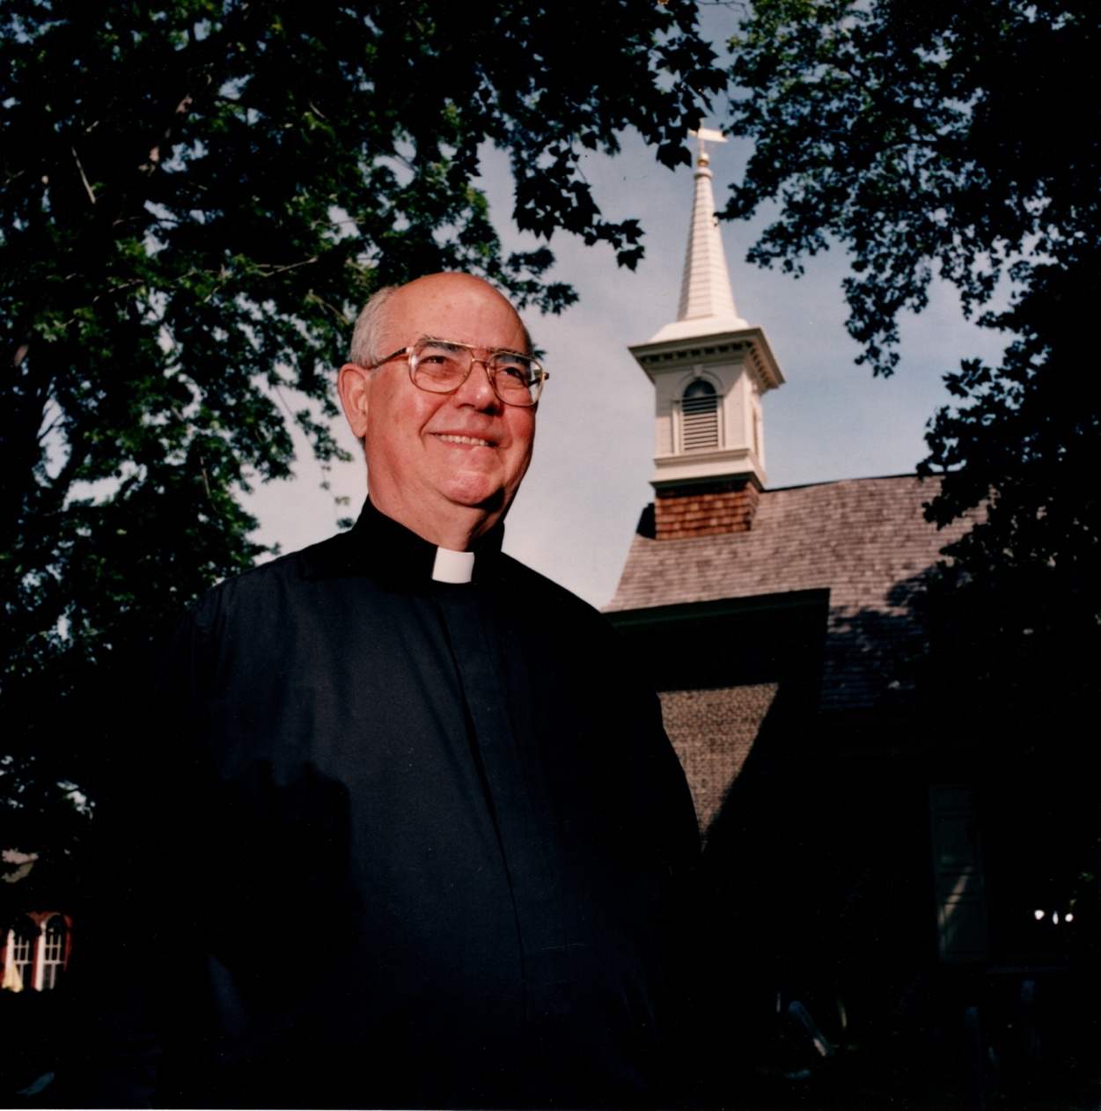



Gloria Dei (Old Swedes’ Church
Rev. Chris Micklewright, Rector
916 S. Swanson Street, Philadelphia, PA 19147
215-389-1513 - www.old-swedes.org

