Announcements

Monday, November 17
UCW Executive meeting Board room 1:00p.m.
UCW Unit meeting banquet hall 2:00p.m.
Beaver Valley Concert Band Banquet hall 5:30p.m.
Choral Works practice Sanctuary 7:00p.m.

Tuesday, November 18
Community dinner prep Kitchen 9:15a.m.
Bell practice Banquet hall 7:00p.m.

Wednesday, November 19
Community dinner Kitchen / Banquet hall 5:00p.m.
Choir rehearsal Banquet hall 7:00p.m.

Thursday, November 20
Sunset Manor Service Sunset Manor 10:00a.m.
Board meeting Board room 7:00p.m.
Thursday night group Banquet hall 8:00p.m.

TODAY! After coffee: Congregational conversation about becoming an Affirming ministry.
Please join us for a review of what the process would be for becoming Affirming, and for a conversation with other Trinity members. Bring your questions, feelings and thoughts-positive, neutral, or negative-about Trinity’s becoming Affirming. Join an accepting, respectful and friendly discussion. We’ll gather at small tables, snack on some crackers, cheese and hummus, and exchange thoughts. Affirming Group members will be at the tables to hear your feelings and questions. If you can’t come or stay today, please join us on November 30. Please consider joining both sessions-at the end of the first one you can tell us what you’d like to talk about, or hear about, the next time.
Affirming congregations are publicly, explicitly and intentionally open to people of all gender identities and sexual orientations. Affirming congregations explore various ways to make anyone, regardless of their identity and background (racial, cultural, economic, mental and physical) feel safe in joining them for worship, community and service to others. We are all invited guests of God.

Coming Events
Men’s social Men’s social will be Monday November 24th at 10:00am.

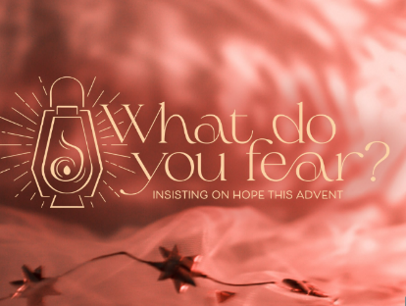
Want to go deeper into our Advent theme of hope in the midst of a fearful world? Join us for our adult study group on Monday mornings from 10 to 11ish in the Meeting Room on November 24 and December 1, 8 and 15. Everyone is welcome. Pick up a copy of the Advent devotional that we will use as a starting point at either sanctuary entrance or contact the church office.

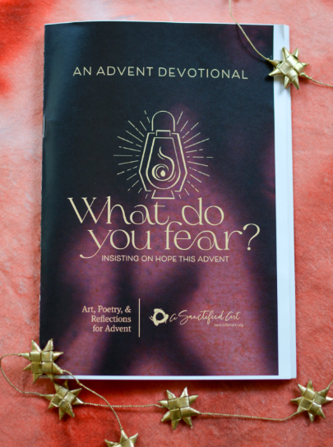
Get your Advent devotional today. Copies are available at the both sanctuary entrances. It includes lovely artwork and daily reflections to guide us through our preparations for Christmas. It starts November 30 which is the First Sunday of Advent and is produced by Sanctified Arts (sanctified art.org).

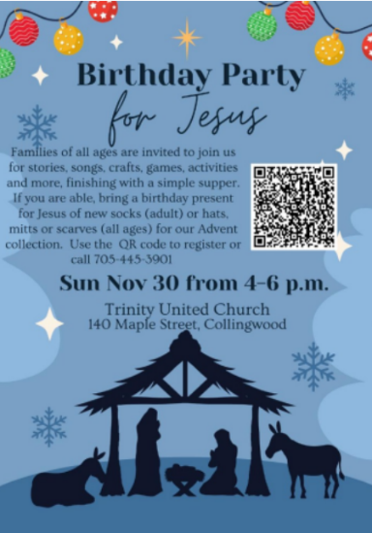
Birthday Party Invite
Birthday Party for Jesus - Sign up now for the Birthday Party for Jesus on Sunday, November 30 from 4 to 6 p.m. at Trinity United Church (140 Maple St, Collingwood). This is a free family event for all ages. If you are able please bring a donation of new socks (adult) or mittens, scarves or hats (all ages) for our Advent collection for those in need. There will be informal worship, activities, music, and a simple supper of mac and cheese, hot dogs and birthday cupcakes. By letting us know you are coming, we can make sure we have the right amount of food and supplies. You can sign up using the QR code below or on posters at the church or by contacting the church office at 705- 445-3901.

It is the time of year to assess your donations, and the way you make your donations, to Trinity.
- If you would like to increase your PAR amount, please let me know.
- If you would like envelopes with a number on it, please advise.
- Conversely, if you only give to the church once a month or so, rather than weekly envelopes perhaps you would like envelopes with no number - just add your name - that can also be arranged.
- Those who regularly give by e-transfer - no changes necessary. Carry on!
- IF YOU HAVE CHANGED YOUR EMAIL ADDRESS AND USUALLY RECEIVE YOUR INCOME TAX RECEIPT VIA EMAIL, PLEASE ADVISE. And if you no longer are able to print your emailed receipt, also advise.
Thanks for your assistance as I work on preparing for 2026.
Ruth
705 445 1499
ruth.crittenden2978@gmail.com
Community Events:
Shipyard Kitchen Party “Christmas”
An evening of holiday music and laughter with Shipyard Kitchen Party and special guests in support of the Trinity Church Food Program!
Saturday, December 6
Doors open 7:00p.m.
Concert Starts 7:30p.m.
Trinity United Church
Tickets available: Eventbright.com or the church office

Choral Works “Christmas in Song”
Featuring
Bach’s “Christmas Oratorio” and Handel’s “Messiah”
With Solsoists Bethany Horst, Jennifer Enna Modolo, Stephen Hegedus.
November 28 7:00p.m. November 29 2:00p.m.
First Presbyterian Church, Collingwood
Tickets - $General $50 / Youth $25
Available through www.choralworks.ca or 705-888-4454

Sound Investment “Christmas Time”
A joyful evening of music and song celebrating Christmas through the ages.
Saturday November 29 at 7:30p.m.
New Life Church
28 Tracey Lane Collingwood
Music Director: Danil Biba
Accompanist: Keiko Yoden-Kuepfer
Guest artist: Susan Connolly
Tickets: $25
Children 12 and under, free
Available from choir member Dickey Scholten 705-539-0479
theatre Collingwood and at the door.

A presentation of “CHRISTMAS GEMS”
Trinity United Church Choir
Together with Community singers and Instrumentalists
Sunday December 21 @ 10:30a.m.

