WELCOME TO METROPOLITAN UNITED CHURCH


Photo by Drew Beamer on Unsplash

TOW FELLOWSHIP SUNDAY
November 16, 2025
We are an Affirming Congregation, offering welcome and companionship
to all, inclusive of age, ethnicity, gender identity, differing abilities, and sexual orientation.

For thousands of years, this land has been the traditional home of the Huron-Wendat, the Seneca, and the Mississaugas of the Credit, covered by Treaty 13. It is still home to Indigenous people from across Turtle Island. We are grateful to work, live and worship on this land.
ORDER OF SERVICE

♪ indicates “please stand as you are able.” Our services are livestreamed, so please be aware that you may appear on camera. If you have children with you, there is Sunday School and a quiet play area at the back of the sanctuary.

CARILLON PRELUDE

HAND BELLS PRELUDE Shall We Gather at the River arr. William H. Mathis
I’ve Got Peace Like a River arr. Linda R. Lamb
Remembrance (Donna’s Song) Margaret R. Tucker

~ We are gathered in Christ ~

WORDS OF WELCOME

♪PROCESSIONAL HYMN 262 A Mighty Fortress is Our God EIN FESTE BURG

♪INVITATION TO WORSHIP
One: Make a joyful noise to the Lord, all the earth;
All: We will lift up joyous songs and sing your praises.
One: Let the sea roar, and all that fills it; the world and those who live in it rejoice.
All: Let the hills sing together for joy at the presence of the Lord,
One: For God will come to judge the world with righteousness,
and the peoples with equity.
All: Let us join with all creation to praise the Lord! Let us worship God.
One: The Lord be with you.
All: And also with you.
One: Let us pray. (please be seated)

PRAYER OF APPROACH AND CONFESSION

SILENCE FOR PRIVATE PRAYER

KYRIE (Sung by All) More Voices 67 John Bell
Lord, have mercy. Christ, have mercy. Lord, have mercy.

ASSURANCE OF PARDON

♪ACT OF PRAISE (All, sung 2x) Voices United 37 Gloria Jacques Berthier
Gloria, gloria, in excelsis Deo. Gloria, gloria, alleluia, alleluia.

~ We encounter the Word ~

READINGS Malachi 4:1-2a
A day of healing for the righteous

2 Thessalonians 3:6-13
Do what is right

ANTHEM Tune My Heart Michael Colvin
Tune my heart and lend me voice, / You who know my discord well.
Draw me close that I may hear / how holy music trains the ear.
Loose my tongue to tell your love, / You whose breath proclaimed The Word.
In solemn tribute gladly raised / I’ll sing your everlasting praise!

Margo Swiss, from Second Gaze (The St. Thomas Poetry Series, Toronto, 2020)
Permission to use granted by Margo Swiss

GOSPEL Luke 21:5-19
“By your endurance you will gain your souls.”
One: This is the witness of the good news of Jesus Christ.

All: Thanks be to God.

A TIME WITH YOUNG PEOPLE (Children are invited forward to go to Sunday School)

♪HYMN 842 Unto the Hills (Psalm 121) SANDON

SERMON “Watching, Witnessing, and Waiting” Ruth Kause

ANTHEM Lead Me, Lord Will Todd, b. 1970
Lead me, Lord, in your righteousness. Make your way clear before my face.
Only my Lord brings me safety, so lead me, Lord. -text adapted from Psalm 5
Gisele Kulak, soprano

~ We respond with love ~

PEACE GREETING
One: The peace of Christ be with you always.

All: And also with you.

One: Let us greet one another with the peace of Christ.

♪AFFIRMATION OF FAITH
We are not alone, we live in God’s world.

We believe in God:

who has created and is creating, who has come in Jesus, the Word made flesh,

to reconcile and make new, who works in us and others by the Spirit.

We trust in God.

We are called to be the Church:

to celebrate God’s presence, to live with respect in Creation,

to love and serve others, to seek justice and resist evil,

to proclaim Jesus, crucified and risen, our judge and our hope.

In life, in death, in life beyond death, God is with us.

We are not alone. Thanks be to God. (please be seated)

ANNOUNCEMENTS

STEWARDSHIP MOMENT Susan Mabey

OFFERING (To make a donation, you can use the envelopes in the pews or scan the QR code to the right with your phone.)

OFFERTORY Chatter With the Angels arr. Mark S. Arnold
The Metropolitan Hand Bells

♪DOXOLOGY 541 OLD 100TH
Praise God from whom all blessings flow;
Praise God, all creatures high and low.
Give thanks to God in love made known:
Creator, Word and Spirit, One. Amen.

♪DEDICATION OF OFFERING

♪GREAT THANKSGIVING

One: Lift up your hearts.

All: We lift them up to the Lord.

One: Let us give thanks to the Lord God.

All: It is right to give God thanks and praise.

One: Let us pray. (please be seated)

PRAYERS OF THE PEOPLE

LORD’S PRAYER

Our Father, who art in heaven, hallowed be thy name,

Thy kingdom come, thy will be done, on earth, as it is in heaven.

Give us this day our daily bread,

And forgive us our trespasses, as we forgive those who trespass against us.

And lead us not into temptation, but deliver us from evil:

For thine is the kingdom, the power, and the glory forever and ever. Amen.

~ We are sent to offer hope, healing and beauty in Jesus' name ~

♪RECESSIONAL HYMN 660 How Firm a Foundation ST DENIO

♪COMMISSIONING AND BENEDICTION

♪BLESSING (sung by all) Don Besig
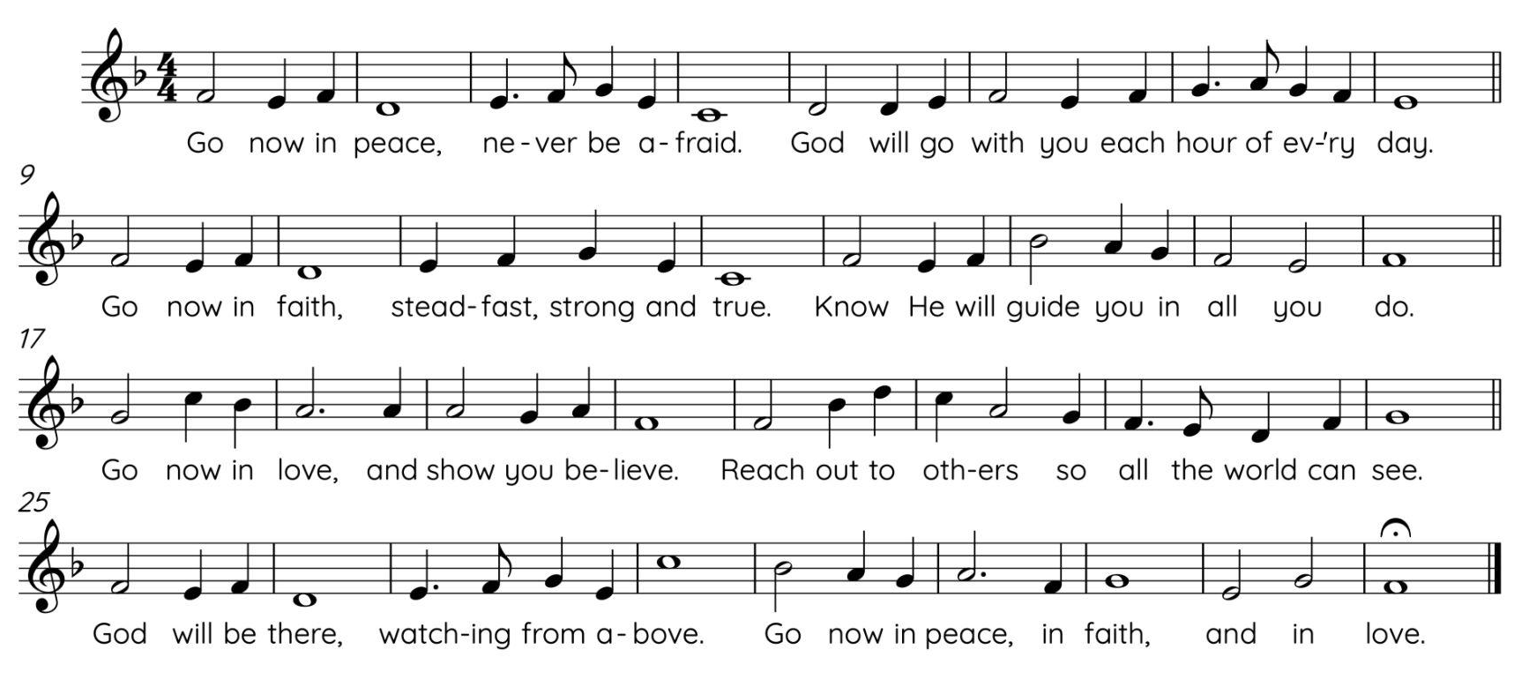
ORGAN POSTLUDE Improvisation on ST DENIO Jonathan Oldengarm, b. 1975



Leading in worship are Ruth Kause, The Rev. Jason Meyers, and Ael Spence. Reading the lessons is Eleanor Walker. The ministry of music is offered by Wayne C. Vance Carillonist Dr. Elisa Tersigni, Minister of Music Dr. Jonathan Oldengarm, Wayne C. Vance Organ Scholars Ethan Duan and Edward Xu, the Metropolitan Hand Bells and the Metropolitan Choir. Members of our Care Staff are Siva Selva and Gerold Mayer. Our sound and livestream technicians are Paya Dehghani and Nishaanth Siva. Metropolitan’s livestreaming equipment was made possible thanks to the generosity of Wayne C. Vance. Music reprinted with permission under One Licence #707-069. All rights reserved.

MUSIC NOTES

This morning we are honoured to welcome composer and celebrated Canadian tenor Michael Colvin, who two years ago sang the Evangelist role in our Good Friday performance of Handel’s Brockes Passion. His anthem Tune my heart sets a poem by Margo Swiss, a parishioner at St. Thomas Anglican Church in Toronto; the poem was the chosen text for St Thomas’ Sesquicentennial Choral Composition Competition held in 2020.
English choral composer Will Todd’s Lead me, Lord has a serene, minimalistic quality that underlines the Psalm text’s simple prayer for Divine guidance and protection. The postlude is improvised in the style of the late 19th and early 20th-century French Symphonic toccatas, brilliant showpieces that were inspired by the mighty instruments of Aristide Cavaillé-Coll and others, and the teaching of César Franck, Charles-Marie Widor, Louis Vierne and others. A defining feature of these great organs is their rich, fiery tone, and their ability to add blocks of colour in a codified sequence, resulting in a seamless, truly symphonic crescendo. While our own landmark Met instrument is conceived in the Anglo-American rather than the French tradition, it still speaks with a passably good Gallic accent upon request!

UPCOMING PROGRAMS AND EVENTS
*Zoom links in Met Connect and/or at metunited.ca

MONDAY, NOVEMBER 17
8:00 p.m. Centring Prayer*

TUESDAY, NOVEMBER 18
12:30 p.m. Celtic Communion*
6:00 p.m. Board Meeting
7:00 p.m. Metropolitan Silver Band

WEDNESDAY, NOVEMBER 19
12:00 p.m. Wednesday Bible Study*
7:00 p.m. Met Care

THURSDAY, NOVEMBER 20
8:45 a.m. Thursday Morning Bible Study*
10:45 a.m. Rimbala*
12:00 p.m. Noon at Met*
1:00 p.m. Knitting Group*
4:00 p.m. Wild Church
4:30 p.m. Chop Chop
6:30 p.m. Handbell Choir
7:30 p.m. Metropolitan Choir

FRIDAY, NOVEMBER 21
10:30 a.m. Community Meal Program

NEXT SUNDAY: NOVEMBER 23 - Reign of Christ | Stewardship Sunday
10:00 a.m. Choristers
10:00 a.m. Library Open (re-opens 12:15 p.m.)
10:30 a.m. Nursery
11:00 a.m. Worship - The Rev. Jason Meyers preaching
Colossians 1:11-20; Luke 23:33-43
11:15 a.m. Sunday School
12:30 p.m Chapel Chat on Benjamin Britten’s Rejoice in the Lamb

COMMUNITY NEWS
WITH GRATITUDE
The Official Board of Metropolitan United Church acknowledges with deepest thanks the generosity of an anonymous donor who provided an Owl panoramic camera. This additional piece of equipment will greatly facilitate and expand our ability to meet effectively online. Metropolitan is grateful for this thoughtful and helpful gift.

NOON AT MET
This Thursday, Nov 20, we welcome the U of T’s Oratorio Class, directed by Prof. Darryl Edwards. A group of outstanding young singers will treat us to classics by Mendelssohn, Sullivan and Honegger, as well as new works from around the world. Buy a tasty and economical lunch from Trinity Café on the way in, find a pew, and immerse yourself in 45 minutes of beautiful music. Can’t attend in person? Join us online at metunited.ca/live.

STEWARDSHIP: TREASURE
This week, we’re focusing on sharing our financial gifts to support Metropolitan’s ministry. Your generosity helps sustain our worship, outreach, and online community, continuing Met’s legacy of faith and service in downtown Toronto. Thank you for your ongoing support! You’ll find ways to give in your Stewardship package or online.

MONEY
Money is a person’s personal energy reduced to portable form. Money can go where we cannot go; speak languages that we cannot speak; lift burdens that we cannot touch; save lives with which we cannot relate directly. (Harry Emerson Fosdick). Thank you for remembering the church in your estate plans. Your future gift can make a world of difference. For information, please contact Doug Flanders at (416) 769-2746; dougflanders@sympatico.ca A legacy — It’s ours to leave.

NEXT SUNDAY
November 23 is Reign of Christ and our Stewardship Sunday. The service will include Benjamin Britten’s remarkable anthem “Rejoice in the Lamb.”

ADVENT STARTS ON NOV 30
Advent is a season of intentional waiting that prepares our hearts to encounter the deepest truth: that God is with us. Also on Nov 30, Sunday Lunch returns after the service at a new location! Stay tuned…

MARK YOUR CALENDARS FOR CHRISTMAS
- Dec 7 at 12:30pm: Christmas Lunch; and at 2:00pm: ‘Deck the Halls’ with the Metropolitan Silver Band
- Dec 14 at 11:00am: Christmas Pageant; and at 1:00pm a screening of a Christmas movie
- Dec 14 at 7:30pm: Candlelight Carol Service
- Dec 17 at 5:00pm: Blue Christmas
- Dec 24 at 4:00pm - Christmas Eve - All-ages service with tree lighting and hot apple cider
- Dec 24 at 11:00pm - Christmas Eve - “Christmas by Candlelight with Holy Communion”
- Dec 25 at 11:00am - Christmas Day

CONTINUED GIVING
Scan the QR code to be directed to our online giving page. You can also send an e-transfer to donations@metunited.ca, or mail in envelopes and/or cheques to the church. If you would like to arrange a pre-authorized remittance for regular giving (PAR) from your bank account or credit card, please contact Elena Pejcinovska at elenap@metunited.ca or 416-363-0331 ext. 229.


DIRECTORY

Chair of the Official Board: Peter Johnston (boardchair@metunited.ca)
Minister of Worship & Faith Formation: The Rev. Jason Meyers, ext 224.(jasonm@metunited.ca)
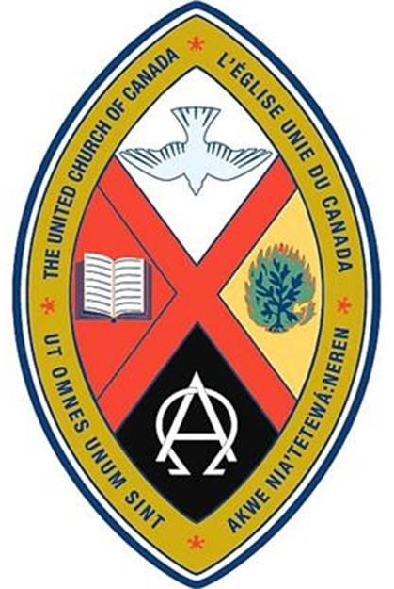
Minister of Pastoral Care: The Rev. Mark Aitchison, ext. 254 (marka@metunited.ca)
Minister of Music: Dr. Jonathan Oldengarm, ext. 226 (jonathano@metunited.ca)
Minister Emeritus: The Rev. Dr. G. Malcolm Sinclair
Minister of Music Emerita: Dr. Patricia Wright
Voluntary Associate Minister: The Rev. Alana Martin (officiant@metunited.ca)
Voluntary Associate Minister: The Rev. Warren McDougall (officiant2@metunited.ca)
Children & Youth Coordinator: Ael Spence (ael@metunited.ca)
Nursery Attendant: Johnavac Abraham
Library: Marion Lick and Maureen Maguire (library@metunited.ca)
Seniors Support Worker: Allen Mathewkutty (allenm@metunited.ca)


Ministry of Music
Minister of Music: Dr. Jonathan Oldengarm, ext. 226 (jonathano@metunited.ca)
Wayne C. Vance Organ Scholars: Ethan Duan & Edward Xu
Metropolitan Choir Lead Singers: Noelle Slaney, Gisele Kulak, Valeria Kondrashov, Michelle Simmons, Alexander Cappellazzo, Alain Paquette, Ian Speck, Matheus Coelho, Parker Clements
Director, Great Heart Youth Ensemble: Dr. Benjamin Stein
Conductor, Metropolitan Choristers: Alessia Signorella
Wayne C. Vance Carillonist: Dr. Elisa Tersigni
Director, Metropolitan Silver Band: Fran Harvey

Administrative Ministry
Executive Director: Dr. David Harrison, ext. 222 (davidh@metunited.ca)
Office & Communications Administrator: Elisabeth Beattie, ext. 210 (elisabethb@metunited.ca)
Financial Manager: Elena Pejcinovska, ext. 229 (elenap@metunited.ca)
Property Manager: Frank Cormier, ext. 231 (frankc@metunited.ca)
Custodians: Puvi Kanagalingam, Siva Selva, Gerold Mayer, Mohammad Wahedi, Austin Tran, Krissy Borsa,
ext. 320

56 Queen Street East, Toronto, ON M5C 2Z3

Tel. 416.363.0331 | Email: office@metunited.ca





@MetropolitanUnitedChurch /MetUnited /MetropolitanUnitedTO/

