Holy Trinity Evangelical Lutheran Church

November 16, 2025 10:30 am

Pastor Tina Crog

*Prelude

*welcome and Announcements Worship assistant

*Gathering Hymn "If You but Trust in God to Guide You" ELW 769
One License a-700000

- If you but trust in God to guide you with gentle hand through all your ways, you’ll find that god is there beside you when crosses come, in trying days. Trust then in God’s unchanging love; build on the rock that will not move.
- What gain is there in anxious weeping, in helpless anger and distress? if you are in your savior’s keeping, in sorrow will he love you less? for christ who took for you a cross will bring you safe through every loss.
- The Lord our restless hearts is holding, in peace and quietness content. We rest in God’s good will unfolding, what wisdom from on high has sent. God, who has chosen us by grace, knows very well the fears we face.
- Sing, pray, and keep God’s ways unswerving, offer your service faithfully. trust heaven’s word; though undeserving, you’ll find God’s promise true to be. This is our confidence indeed: god never fails in time of need.

* Confession and Forgiveness Pastor Tina
Blessed be the holy Trinity, ☩ one God, whose home is heaven and earth, whose salvation is sure. Amen.

God is here, and God sees through every defense that fools the world. Since we cannot hide from God, there is nothing left to do but to be honest with each other and humble before God. So, in humility, we confess our sins.
God with us, we have acted helpless, even when you called us to action. We have resisted your truth, even when our lies were exhausting. We have behaved as though we were alone, even when you were beside us. We can never undo the sins of this world, but we trust in your perfect plan for salvation. Forgive our sins. Set us free to chart a new path. Help us learn from the echoes of our past. In the name of Emmanuel, Jesus Christ, we pray. Amen.

Hear the good news: God the Faithful One loves you, ☩ in Christ Jesus your sins are forgiven, and by the power of the Holy Spirit you are set free. Amen.

* Kyrie (to the Tune of “Come Thou Long Expected Jesus,” ELW 254)
Public Domain
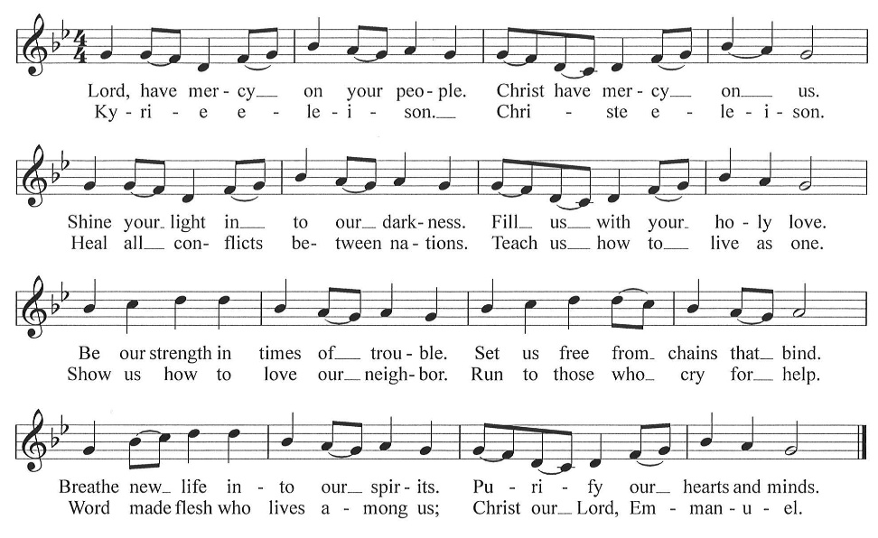

*Greeting Pastor Tina

*Prayer of the Day Worship Assistant
Eternal God, you are the beginning and the end, and your purposes unfold in ways beyond our sight. Keep us steadfast in faith amid uncertainty, that when the foundations around us crumble, we may stand firm in your promise and recognize your work made ready in our midst; through Jesus Christ, our Lord. Amen.

*The Peace Worship Assistant
The peace of Christ be with you always. And also with you.

Please share the Peace of Christ with One Another.

*Children’s Message Pastor Tina

*First Lesson: Malachi 4:1-2a Reader
¹ See, the day is coming, burning like an oven, when all the arrogant and all evildoers will be stubble; the day that comes shall burn them up, says the Lord of hosts, so that it will leave them neither root nor branch. ^{2a} But for you who revere my name the sun of righteousness shall rise, with healing in its wings.
The Word of the Lord. Thanks be to God.

*Psalm 98 Reader
¹ O sing to the Lord a new song,
for he has done marvelous things.
His right hand and his holy arm
have gotten him victory.
² The Lord has made known his victory;
he has revealed his vindication in the sight of the nations.
³ He has remembered his steadfast love and faithfulness
to the house of Israel.
All the ends of the earth have seen
the victory of our God.
⁴ Make a joyful noise to the Lord, all the earth;
break forth into joyous song and sing praises.
⁵ Sing praises to the Lord with the lyre,
with the lyre and the sound of melody.
⁶ With trumpets and the sound of the horn
make a joyful noise before the King, the Lord.
⁷ Let the sea roar and all that fills it,
the world and those who live in it.
⁸ Let the floods clap their hands;
let the hills sing together for joy
⁹ at the presence of the Lord, for he is coming
to judge the earth.
He will judge the world with righteousness
and the peoples with equity.

*Second Lesson:1 Thessalonians 3:9-13 Reader
⁶ Now we command you, brothers and sisters, in the name of our Lord Jesus Christ, to keep away from every brother or sister living irresponsibly and not according to the tradition that they received from us. ⁷ For you yourselves know how you ought to imitate us; we were not irresponsible when we were with you, ⁸ and we did not eat anyone’s bread without paying for it, but with toil and labor we worked night and day so that we might not burden any of you. ⁹ This was not because we do not have that right but in order to give you an example to imitate. ¹⁰ For even when we were with you, we gave you this command: anyone unwilling to work should not eat. ¹¹ For we hear that some of you are living irresponsibly, mere busybodies, not doing any work. ¹² Now such persons we command and exhort in the Lord Jesus Christ to do their work quietly and to earn their own living. ¹³ Brothers and sisters, do not be weary in doing what is right.
The Word of the Lord. Thanks be to God.

*Gospel Acclamation “Emmanuel, Emmanuel” Worship & Praise 36
CCLI #11222261

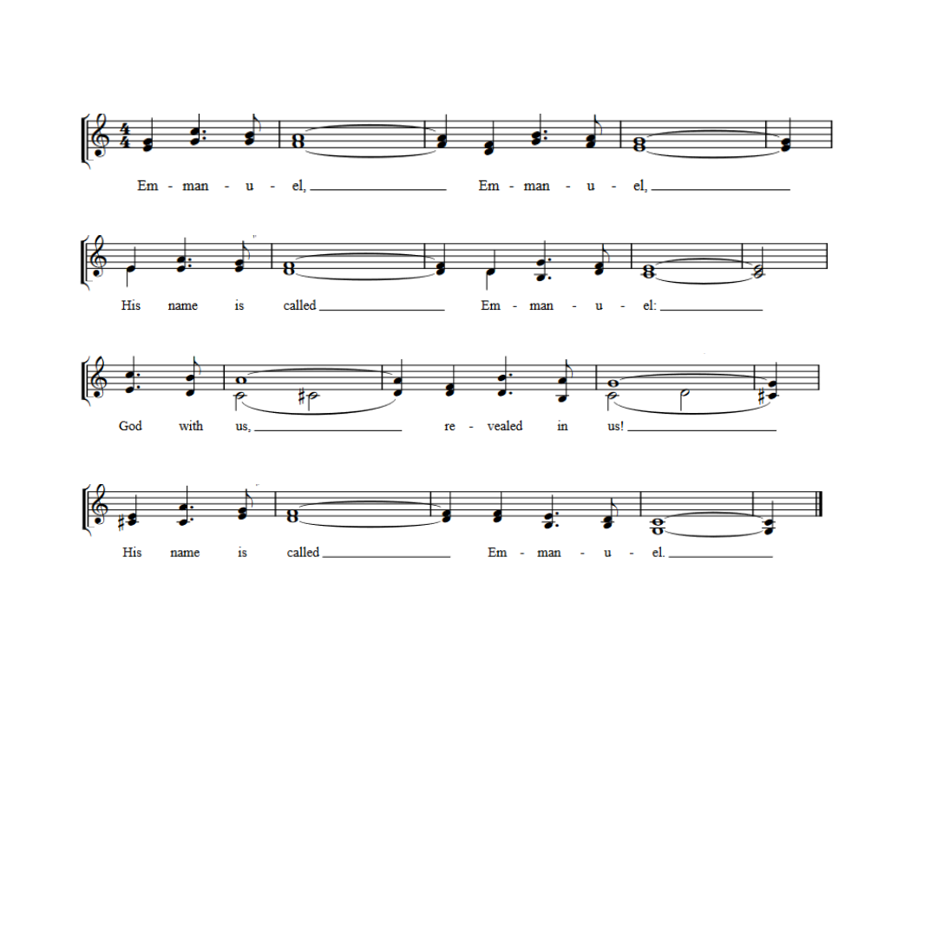

*Gospel: Luke 21:5-19 Pastor Tina
The Holy Gospel according to Luke, the 21st chapter. Glory to you, O Lord.

⁵ When some were speaking about the temple, how it was adorned with beautiful stones and gifts dedicated to God, [Jesus] said, ⁶ “As for these things that you see, the days will come when not one stone will be left upon another; all will be thrown down.”
⁷ They asked him, “Teacher, when will this be, and what will be the sign that this is about to take place?” ⁸ And he said, “Beware that you are not led astray, for many will come in my name and say, ‘I am he!’ and, ‘The time is near!’ Do not go after them.
⁹ “When you hear of wars and insurrections, do not be terrified, for these things must take place first, but the end will not follow immediately.” ¹⁰ Then he said to them, “Nation will rise against nation and kingdom against kingdom; ¹¹ there will be great earthquakes and in various places famines and plagues, and there will be dreadful portents and great signs from heaven.
¹² “But before all this occurs, they will arrest you and persecute you; they will hand you over to synagogues and prisons, and you will be brought before kings and governors because of my name. ¹³ This will give you an opportunity to testify. ¹⁴ So make up your minds not to prepare your defense in advance, ¹⁵ for I will give you words and a wisdom that none of your opponents will be able to withstand or contradict. ¹⁶ You will be betrayed even by parents and siblings, by relatives and friends, and they will put some of you to death. ¹⁷ You will be hated by all because of my name. ¹⁸ But not a hair of your head will perish. ¹⁹ By your endurance you will gain your souls.”

The Gospel of the Lord. Praise to you, O Christ.

*Sermon Pastor Tina

*Hymn of the Day "Through the Night of Doubt and Sorrow" ELW 327
Public Domain
- Through the night of doubt and sorrow, onward goes the pilgrim band, singing songs of expectation, marching to the promised land. Clear before us through the darkness gleams and burns the guiding light; pilgrim clasps the hand of pilgrim stepping fearless through the night.

2.One the light of God’s own presence on the ransomed people shed, chasing far the gloom and terror, bright’ning all the path we tread. One the object of our journey, one the faith which never tires, one the earnest looking forward, one the hope our God inspires.

3.One the strain that lips of thousands lift as from the heart of one; one the conflict, one the peril, one the march in God begun. One the gladness of rejoicing on the far eternal shore, where the one almighty Father reigns in love for-ev-er-more.
4.Onward, therefore, sisters, brothers; onward, with the cross our aid. Bear its shame, and fight its battle till we rest beneath its shade. Soon shall come the great awak’ning; soon the rending of the tomb! Then the scatt’ring of all shadows, and the end of toiled gloom.

* Prayers of the People Pastor Tina
Be seated
Any Prayer requests or Joys
As we prepare for Emmanuel, God-with-us, let us pray for all people and places that long for God’s presence.
God of righteousness, your people live in hopeful expectation of your coming. Fill your church with renewed passion for our shared mission, and deepen our relationships with other Christians and other faith traditions in our local community and across the world. Lord, in your mercy, receive our prayer.
God of the cosmos, all creation shows that your presence is near. Help us sense your goodness and love in the sun and moon, in sprouting leaves and bare branches, in the roaring sea and quiet breeze. Lord, in your mercy, receive our prayer.
God of the nations, your reign extends over all principalities and powers. Give leaders and all in authority hearts for justice and peace. Encourage efforts to enact policies that benefit the common good. Lord, in your mercy, receive our prayer.
God of change, you accompany us through life’s transitions. Be near to all who are changing jobs, moving, welcoming children, or facing the loss of loved ones. Sustain those who are ill or suffering (especially). In times of change, remind us of your steadfast love. Lord, in your mercy, receive our prayer.
God of community, your Spirit holds us together. Sustain our care for one another, especially the work of the SALT Box Ministry. Inspire us to seek new ways to live together and to embrace the diversity of thought and identity in our communities. Lord, in your mercy, receive our prayer.
God of memory, we give you thanks for faithful ones who have died (especially). Tend to our grief and sorrow with renewed trust in your promise of abundant and eternal life. Lord, in your mercy, receive our prayer.
Savior of the nations, come, and receive these prayers and the pleas of our hearts, in the name of Jesus Christ. Amen.

Offering Worship Assistant
The monthly mission is for “Mountain Vision.” Let us give to God what He has first given us.

Offering Music by Jared

*Offertory Hymn “Our Gifts We Now Bring” vs. 1
to the tune AWAY IN THE MANGER, ELW 277
Public Domain

To be sung while the offering is being returned to the Altar
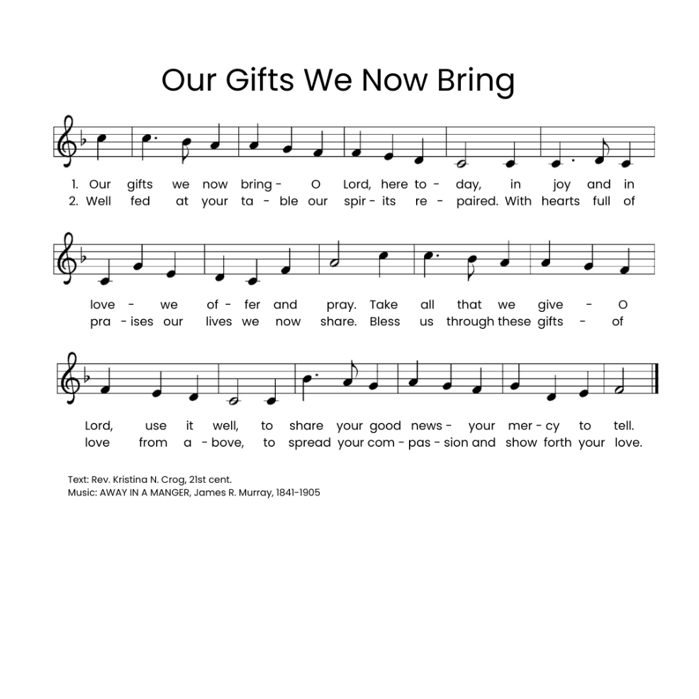

*Offering Prayer. Worship Assistant and congregation
God with us, we cherished what we thought belonged only to us: our money, our time, our families, and our freedom. Yet in a moment, we recognize that every truly good thing was a treasure we had taken from your open hand. We thought such treasures were ours to earn and to own. You grow what we give away. So, we give you these gifts as a sign of your love and faithfulness. Amen.

* Communion Liturgy Sung to the tune: O Come, O Come, Emmanuel [ELW 257] One License A-700000
The Lord be with you as we gather here.
Lift up your hearts unto the Lord your God.
For it is right to give God our praise.
Let us prepare our hearts for coming days:
Rejoice, Rejoice! Emmanuel
Shall come to you, O Israel.

You created all things and called them good,
made us like you, but we cast off your love.
You set us free and claimed us as yours,
through sage and prophet spoke to us your word.
Rejoice, Rejoice! Emmanuel
Shall come to you, O Israel.

Holy are you and blessed is your Son,
Jesus, the Light, your presence here with us.
You sent him in the fullness of time,
he came to preach good news to all.
Rejoice, Rejoice! Emmanuel
Shall come to you, O Israel.

Rejoice, Rejoice! Emmanuel
Shall come to you, O Israel.
After the meal he lifted up the cup,
“My blood, my life, I pour it out for you.
This covenant I make anew.
Set free from sin! Remember me!"
Rejoice, Rejoice! Emmanuel
Shall come to you, O Israel.

Spirit of God descend upon us now,
And make these gifts become for us
the body and the blood of Christ
a holy, living sacrifice.
Rejoice, Rejoice! Emmanuel
Shall come to you, O Israel.

*Lord’s Prayer Pastor Tina
Our Father, who art in heaven, hallowed be thy name, thy kingdom come, they will be done, on earth as it is in heaven. give us this day our daily bread; and forgive us our trespasses, as we forgive those who trespass against us; and lead us not into temptation, but deliver us from evil. for thine is the kingdom, and the power, and the glory, forever and ever. amen.

*Lamb of God Sung to the tune: O Come, O Come, Emmanuel [ELW 257]
One License – A-700000
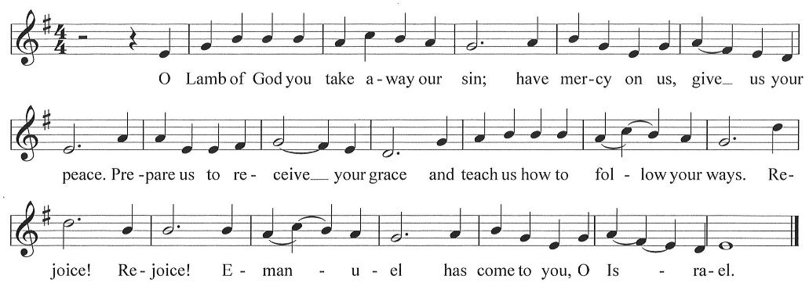

*Post Communion Blessing Pastor Tina

*Post Communion Canticle “Our Gifts We Now Bring” vs. 2 go back to page 9 for verse 2

*Prayer After Communion Pastor Tina and Congregation
Jesus, the world looks different from your table. Here, there are no strangers, and grace is never a surprise. Life always thrives in the desert, and a promise never shades with doubt. Soon as we rise from this table, our memories of this goodness fade. Bring us back every day to your promises: astonish us again. Amen.

*Blessing Pastor Tina

*Closing Song "O God, Our Help in Ages Past" ELW 632
Public Domain
- O God, our help in ages past, our hope for years to come,
our shelter from the stormy blast, and our eternal home.
- Under the shadow of your throne your saints have dwelt secure;
sufficient is your arm alone, and our defense is sure.
- Before the hills in order stood or earth received its frame,
from everlasting you are God, to endless years the same.
- A thousand ages I your sight are like an evening gone, short as the watch that ends the night before the rising sun.

*Dismissal
Keep watch! Christ is coming soon!
Thanks be to God!

*Postlude

Prayer of the Day, and Offering Prayer by Barn Geese Worship, 2025

“Kyrie” (based on the tune Come, Thou Long-Expected Jesus) by David Eck, Copyright ©2011

"Emmanuel" by Bob McGee, © 1976 C. A. Music (div. of C. A. Records, Inc.)/ASCAP

“A Sung Communion Liturgy for the Season of Advent” (based on tune: VENI EMMANUEL) by Rev. Beth Quick, 2013, http://bethquick.blogspot.com/2013/11/a-sung-communion-liturgy-for-season-of.html

“Lamb of God” “based on the tune VENI EMMANUEL) by David Eck, Copyright ©2011

"Our Gifts We Now Bring" (based on the tune AWAY IN THE MANGER by James R. Murray) by Rev. Kristina N. Crog, 2024

