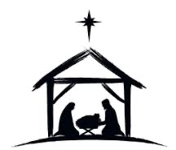
Monday, Nov. 17, 2025
Year End monthly Women’s Phillips Mission Group meeting.
- Celebrate the miracle of Christ's birth,
- Hear updates from our Canadian Baptist Ministries Partners in Mission,
- and take time to pray and to encourage each other.

All women are welcome to attend any or all Phillips Group meetings.


Please join us from 11:00am - 12:30pm in the Fireside Room on Monday, Nov. 17, 2025.
- A complimentary lunch will be served.
- Please bring a $5.00 donation for our mission fund.

Please sign up in the gym after Sunday services on Nov. 9th and Nov 16th, 2025.

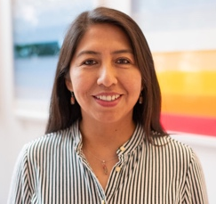  Canadian Baptist Ministries  Partner in Mission  Patty Nacho Vargas  Regional Team Leader in Latin America | Canadian Baptist Ministries  Global Field Staff  “J” serves in a restricted area in East Asia

Save the Date: The next Phillips Group meeting will be on Monday, Jan. 19, 2026.

