
ST. MARK’S ANGLICAN CHURCH, BARRIEFIELD
2026 ANNUAL PLEDGE CAMPAIGN

2 Corinthians 9:6:
“The point is this: whoever sows sparingly will also reap sparingly,
and whoever sows bountifully will also reap bountifully.”

To assist in the planning cycle for St. Mark’s 2026 operating budget, it would be of great value to the Wardens if you could provide an indication of your intended financial support to St. Mark’s general operating expenses during 2026. This can be achieved by completing and returning the confidential pledge form attached. Completed forms can be placed on the offertory plate or returned to the church office in the envelope provided. St. Mark’s estimated operating expenses for 2026 are approximately $250,000.
A response by November 30, 2025, would be greatly appreciated.

Today, most of St. Mark’s parishioners donate through Monthly Pre-Authorized Giving (PAG). If you still donate through Envelopes, would you consider changing to PAG in 2026? Online giving through the church website is now also available.

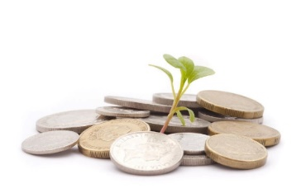
Note: Tax receipts will be issued where the source of the Giving can be identified. Depending on the size of your taxable income, a charitable tax receipt can return as much as 45% of your initial donation.

ST. MARK’S CHURCH, BARRIEFIELD – 2026 PLEDGE FORM

NAME(S): __________________________________________________________
ADDRESS: __________________________________________________________
With joy and gratitude, and to assist the Wardens in St. Mark’s financial planning for 2026, it is my/our intention, God willing, to support our Church and its work through total General Givings of:
$__________ during the year 2026.
[This amount may change should my/our financial situation change.]

My Method of Giving will be:

□ Monthly Pre-Authorized Giving (PAG) - If signing up for Pre-Authorized Giving for the first time, please attached a cheque marked “VOID”.

□ Online Giving through the Church Website
□ Offering Envelopes
□ Other (Please define: ____________________________________________)

Attention Existing PAG donors: It’s easy to increase your monthly Givings!
Just indicate your increased amount on this form and we’ll take care of the rest!
Increase from $__________ to $__________ effective _____________ (date).

Signature_________________________________________________________

(Please return this form in the envelope provided by November 30th, by placing on the offertory plate or returning to the church office, even if you will not be making any changes to your current level of giving.)

