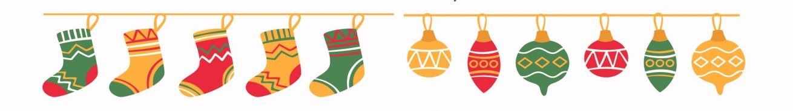
A big thank you to all the early birds, who have already placed their orders over the past weekend! YOU ARE AMAZING!
For those who haven’t got a chance, there is still plenty of time! Orders are open until Friday Nov 14 (but don’t wait too long!)
This is our chance to give back to our wonderful school community that gives so much to our children every day.
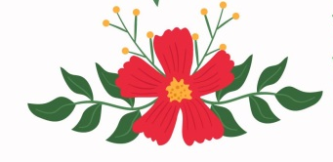
Here’s part of our prizes: $100 Amazon gift card, $100 Costco gift card, and $100 gift card from Inffun Event.
We truly appreciate the incredible support from our sponsors.
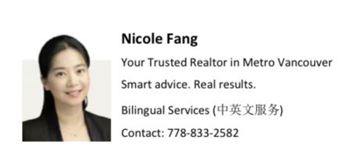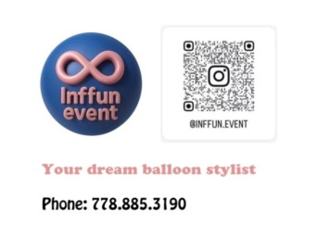
Join the excitement!

Please refer to our launch package that was sent home last week for details to order.
Remember: If there are other family/friends supporting your child, please remember to email us at christmas.sales.sfds@gmail.com with (1) each supporter's name, (2) child’s name and (3) grade. That way, all your sales count toward your prizes!

