This Week at PPBC

Tuesday, November 11, 2025


Wednesdays @ 6:30pm



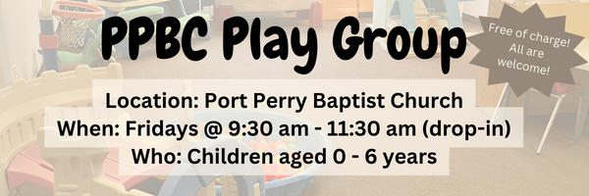Friday, November 14, 2025

Friday, November 14, 2025
Youth in grades 7 – 12

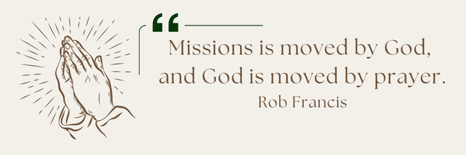
A Prayer Request from AOJ: Canadian Leadership
Please pray for Roy, Brock and our Canadian leadership team as they continue to guide, encourage, and support the mission across Haiti, Guatemala, and Kenya. Their work involves vision, coordination, and constant encouragement for our local leaders. Pray especially for Brock as he prepares to travel to Guatemala in November — that the Lord would protect him, strengthen him, and use this visit to bless and encourage the staff and children.

Notes

Sunday Ministry Schedules
Below are ministry schedules for Nursery, Jr. Church, Greeters, Ushers, and Sound & Video:
Nursery
Nov 9: Kathryn denOuden, Alyssa Summers
Nov 16: Jan Gerrow, Hannah Colwell
Infant Nursery
Nov 9: Lisa Dallas, Elise Anderson
Nov 16: Laura Saunders, Karis Henkleman
Jr. Church; ages 3 to grade 1
Nov 9: Justine McKenzie, Mikayla Ferguson
Nov 16: Christine McLaren, Grace Brown
Jr. Church; Grades 2 to 6
Nov 9: Gregg & Karen Anderson, Graeme Anderson
Nov 16: Mary Deli, Jen Owens
Greeters
Nov 9: Graeme & Barb Foster
Nov 16: Steve & Wendy Angrove
Ushers
Nov 9: Matt Saunders, Joe Colwell
Nov 16: Graeme Foster, Nick Woytowich
Sound & Video
Nov 9: Sound: Charlie Deane | Video: William Conley
Nov 16: Sound: Wyatt Werner | Video: Josh Myers

Morning Service
Welcome
Song – May the Peoples Praise You
Scripture
Song – Before the Throne of God Above
Song – Amazing Grace (My Chains are Gone)
Song – Lord I Need You
Prayer
Message – Pastor Jim Clemens
Song – Oh How Good it is


Please sign up at the Welcome centre.
For the group gift, please speak to Madeline Werner.

Praise & Prayer Highlights
PRAY for Brian Timmins and his family as they mourn the loss of his grandfather. PRAY that God will give them great comfort in Christ.
PRAY for Dave and Mary Deli. Dave was in an ATV accident and is now at home to recover. PRAY for Dave's physical and spiritual health and healing and for Mary as she looks to love and care for her husband.
PRAY for Joan Mabley's ongoing health & recovery at home. PRAY for her and the family as they look for care to meet Joan's needs.
PRAY for Barbara Fry and the Werner family as they mourn the loss of Ron. PRAY for Barbara, Roy, Elizabeth and the family as they make preparations for a service. PRAY that God will give them great comfort in Christ and that the truth of the Gospel will shine through this loss.
PRAY for our nursery ministry. PRAY for wisdom and discernment as we look to accommodate for our growing numbers in the nursery. PRAY that God would sustain our volunteers and grow us in our faithfulness to Christ.
PRAY for Bert & Ada Faber and their ongoing health concerns.
PRAY for Betty & Ray Collins and her ongoing health concerns.
PRAY for Dennis Tomcheski and his ongoing health concerns.
PRAY for Winnie Miller and her ongoing health concerns.

Giving
Just as a reminder, there are several ways you can give:
In Person using the offering box located on the back wall of the sanctuary. Donation envelopes are available at the Welcome Centre. Please contact the church office if you would like a box of donation envelopes (office@portperrybaptist.ca)
Through your online banking, you may send electronic transfers to ppbcdonations@gmail.com.
You can also give through Canada Helps. Donation receipts will be provided by Canada Helps, and transaction fees apply.
***********************************************************************
Weekly Newsletter
The PPBC Newsletter is emailed to the church family every Friday. If you would like to be added to the weekly email list, please contact the office by phone: 905-985-8681 or by email: office@portperrybaptist.ca.
*****************************************************************
Church Information:
Location:
2210 Hwy 7A
Port Perry, ON
L9L 1B4
Office Hours:
Monday: 8:30am – 4:00pm
Tuesday: 8:30am – 4:00pm
Wednesday: Closed
Thursday: 8:30am – 4:00pm
Friday: 8:30 am - 3:00 pm
Contact:
Phone: 905.985.8681
Email: office@portperrybaptist.ca
Website: www.portperrybaptist.ca
Staff:
Sr. Pastor – Rev. Jim Clemens
Administrative Assistant – Madeline Werner
Family Ministries Director – Josh Anderson

PPBC Newsletter
Sunday, November 9, 2025


Sunday Starting Point
Sunday, November 9, 2025 - 9:30 am
“Beginning the day with the Word and prayer”
Adults:
Adults will meet in the sanctuary for a time of study and prayer. Psalm 142.
Youth:
Jr High (Grades 7-8) will meet in room 18 with Kate Anderson to study the book of Ephesians.
Children:
Children ages 3 - grade 6 will meet in room 26.
(Please note nursery is unavailable during Starting Point)
Sunday Morning Worship
Sunday, November 9, 2025 - 10:30 am
We are meeting in the sanctuary and will continue to live-stream for those who are unable to attend.
Message: The Gospel Begins to Spread to the Gentiles
Scripture: Acts 9-12
Pastor Jim Clemens

