SUNDAY NOVEMBER 09, 2025

, 2023

, 2023

, 2022

, 2022

, 2021

PRAYER NEEDS: Prayer needs will remain on the list for 30 days unless requested another 30 days. Request indicated by an asterisk (*) will remain indefinitely.

"Pray for Laborers"
DATES TO REMEMBER
NOVEMBER 09 ANNUAL BUSINESS MEETING 7 P.M.
NOVEMBER 11 VETERAN’S DAY
NOVEMBER 16 PACKING OF THE SHOEBOXES OPERATION CHRISTMAS CHILD 2:00 P.M.
NOVEMBER 21 FOOD PANTRY/CLOTHES CLOSET 10 A.M. – NOON
NOVEMBER 27 THANKSGIVING DAY
NOVEMBER 30 FIFTH SUNDAY FELLOWSHIP SEE SIGN UP SHEET IN COFFEE ROOM
DECEMBER 06 MEN’S PRAYER BREAKFAST 8:30 A.M.
DECEMBER 19 FOOD PANTRY/CLOTHES CLOSET 10 A.M. – NOON
DECEMBER 21 CHOIR CANTATA 10:45 A.M.
DECEMBER 25 CHRISTMAS DAY
DECEMBER 28 BUSINESS MEETING 7 P.M.
GOLDEN AGERS EVENTS EVERY THIRD SATURDAY OF THE MONTH

*MARK BEAR | *DAVID COOK | *ALEX KENNEY | *FRANK & ANNA MULLINS
*CAROL & CALVIN BENGE | *JERRY DUNCAN | *JASON LAMBERT | *ROY PRICE
*JOE & JUDY BLAKLEY | *EDITH HAWKINS | *SANDY LAMBERT | *JENNY ROSE
*JANE BOOHER | *GENOLA HAWKINS | *B.J. LANE FAMILY | *DOROTHY SMITH
*LEONARD BOWMAN | *MARS HAWKINS | *CONNIE LITTLE | * RITA STEPHENS
*PAT CALLAHAN | *NATHAN HONEYCUTT | *ALMA SUE LITTLE | *BRENDA SWIGER
*KELLY CARROLL | *CAROLYN JONES | *CAROL MILES | *WANDA WINEGAR
*TONY CODY

NOVEMBER BIRTHDAYS
KENNETH COX – 02 SHARON MCCURRY – 10 JANICE DUNCAN – 22
LINVILLE BISHOP – 05 EMMA NELMS – 14 ALYSSA HENRY – 23
RACHEL YOUNG – 06 LAURA MINNICH – 18 FELICIA TENNANT – 24
JASON TENNANT – 09 RICK SHELTON – 20 MICKEY SAWYER – 28
JUDY BLAKLEY – 09 JUDY CROSS – 21 DEBBIE CLARK - 30
NOVEMBER ANNIVERSARIES
JARROD & ALYSSA HENRY - 09 MARS & GENOLA HAWKINS - 22

GREETERS 11/16/2025
GARY & HEAVEN ARNOLD LAURA MINNICH
If you have a prayer request or an announcement for the bulletin, you can call the church office or email to tbckpt@templebaptistkpt.com

Friendsgiving
November 30, 6:00pm
A time of fellowship, friends, and fun, with games and prizes to win.
Signup sheet in the coffee room for finger foods.

COUNTRY OF THE WEEK
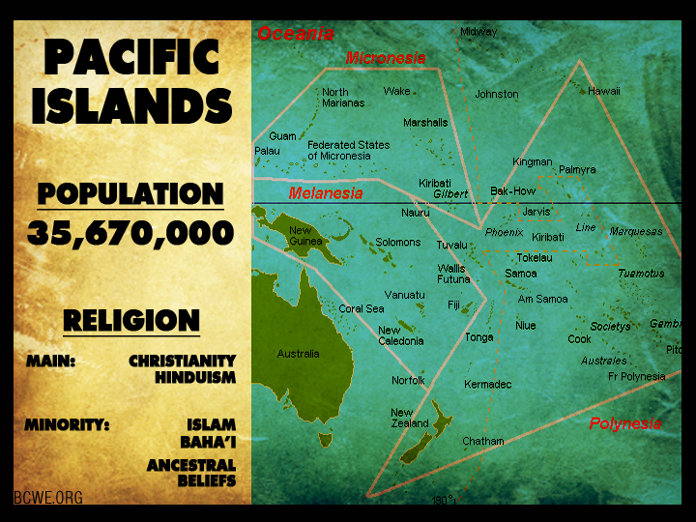

If you have a prayer request or an announcement for the bulletin, you can call the church office or email to tbckpt@templebaptistkpt.com

MISSIONARY OF THE WEEK
Howard Rothenberg
Missionary to Miami
Email: amolam@ibjm.org

SUNDAY SCRIPTURE
Psalm 100:4-5
Enter into his gates with thanksgiving, and into his courts with praise: be thankful unto him, and bless his name. For the LORD is good; his mercy is everlasting; and his truth endureth
to all generations.


OPERATION CHRISTMAS CHILD COLLECTION DATES
August - items will be school supplies and craft items such as crayons, small notebooks, pencils, markers, scissors, stickers.
September- small toy items and hygiene items
October- clothing items ages (4-12)
November- 16th packing of the shoeboxes 2:00 p.m. donations for shipping ($10 to ship each box)
EACH MONTH DONATED ITEMS CAN BE PLACED
IN THE BOX IN THE COFFEE ROOM



