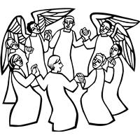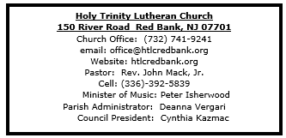

November 2, 2025

All Saints Sunday

Introduction
In holy baptism God makes saints out of sinners. In holy communion God forgives the sins of all the saints. In worship today we give thanks for all the saints “who from their labors rest.” In the same breath we petition our God for the strength to hear and to heed the admonitions of Jesus in today’s gospel. Sealed by the Spirit and sustained by the Savior’s body and blood, we live with joy as God gives us breath, to the praise of God’s glory.

Welcome & Announcements (Please silence your cell phone!)

Prelude (We prayerfully prepare our hearts and minds to worship!)

+ GATHERING +

Confession and Forgiveness
All may make the sign of the cross, the sign that is marked at baptism, as the presiding minister begins.
P: Blessed be the holy Trinity, ☩ one God,
who forgives all our sin,
whose mercy endures forever.
C: Amen.
P: Let us confess our sin in the presence of God
and of one another.
Silence is kept for reflection.
Faithful God,
C: you have shown us the ways of your heart,
yet we stray from your paths.
We are stuck in sinful systems of oppression
and do not embrace the freedom
of your faithful promises.
We ignore our neighbors.
We exploit the earth.
We reject your abundance,
trusting our impulses instead of your steadfast love.
Repair our relationships,
restore what we have broken,
renew our hearts,
and bring us to new life.
Amen.
P: Hear the good news:
God the Faithful One loves you,
☩ in Christ Jesus your sins are forgiven,
and by the power of the Holy Spirit you are set free.
C: Amen.

*Gathering Hymn ELW 418 Rejoice in God’s Saints

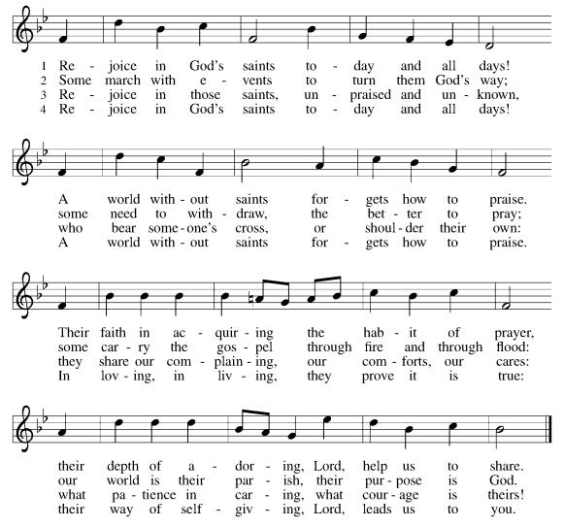

*Pastoral Greeting

P: The Grace and Peace of our Lord Jesus Christ, the love of God, and the communion of the Holy Spirit be with you all! C: And also with you!

Hymn of Praise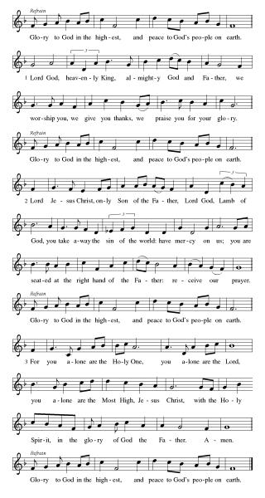

*Prayer of the Day
P: Almighty God, you have knit your people together in one communion in the mystical body of your Son, Jesus Christ our Lord. Grant us grace to follow your blessed saints in lives of faith and commitment, and to know the inexpressible joys you have prepared for those who love you, through Jesus Christ, our Savior and Lord, who lives and reigns with you and the Holy Spirit, one God, now and forever.
C: Amen!
+WORD+

First Reading: Daniel 7:1-3, 15-18
The book of Daniel was written in the second century BCE, when the Syrian king Antiochus Epiphanes was severely persecuting the Jews. Daniel’s vision of the four beasts proclaims that human kings will come and go, but the kingdom will ultimately belong to God and to God’s people.

¹ In the first year of King Belshazzar of Babylon, Daniel had a dream and visions of his head as he lay in bed. Then he wrote down the dream: ² I, Daniel, saw in my vision by night the four winds of heaven stirring up the great sea, ³ and four great beasts came up out of the sea, different from one another.
¹⁵ As for me, Daniel, my spirit was troubled within me, and the visions of my head terrified me. ¹⁶ I approached one of the attendants to ask him the truth concerning all this. So he said that he would disclose to me the interpretation of the matter: ¹⁷ “As for these four great beasts, four kings shall arise out of the earth. ¹⁸ But the holy ones of the Most High shall receive the kingdom and possess the kingdom forever—forever and ever.”

Psalm: Psalm 149
Sing the Lord’s praise in the assembly of the faithful. (Ps. 149:1)

¹ Hallelujah! Sing to the Lord | a new song,
God’s praise in the assembly | of the faithful.
² Let Israel rejoice | in their maker;
let the children of Zion be joyful | in their ruler.
³ Let them praise their maker’s | name with dancing;
let them sing praise with tambou- | rine and harp.
⁴ For the Lord takes pleasure | in the people
and adorns the | poor with victory.
⁵ Let the faithful re- | joice in triumph;
let them sing for joy | on their beds.
⁶ Let the praises of God be | in their throat
and a two-edged sword | in their hand,
⁷ to wreak vengeance | on the nations
and punishment | on the peoples,
⁸ to bind their | kings in chains
and their nobles with | links of iron,
⁹ to inflict on them the judg- | ment decreed;
this is glory for all God’s faithful ones. | Hallelujah!

Second Reading: Ephesians 1:11-23
After giving thanks for the faith of the Ephesians, the writer of this letter prays that they might understand the wisdom, hope, and power of God that is embodied in Jesus Christ.

¹¹ In Christ we have also obtained an inheritance, having been destined according to the purpose of him who accomplishes all things according to his counsel and will, ¹² so that we, who were the first to set our hope on Christ, might live for the praise of his glory. ¹³ In him you also, when you had heard the word of truth, the gospel of your salvation, and had believed in him, were marked with the seal of the promised Holy Spirit; ¹⁴ this is the pledge of our inheritance toward redemption as God’s own people, to the praise of his glory.
¹⁵ I have heard of your faith in the Lord Jesus and your love toward all the saints, and for this reason ¹⁶ I do not cease to give thanks for you as I remember you in my prayers, ¹⁷ that the God of our Lord Jesus Christ, the Father of glory, may give you a spirit of wisdom and revelation as you come to know him, ¹⁸ so that, with the eyes of your heart enlightened, you may perceive what is the hope to which he has called you, what are the riches of his glorious inheritance among the saints, ¹⁹ and what is the immeasurable greatness of his power for us who believe, according to the working of his great power. ²⁰ God put this power to work in Christ when he raised him from the dead and seated him at his right hand in the heavenly places, ²¹ far above all rule and authority and power and dominion and above every name that is named, not only in this age but also in the age to come. ²² And he has put all things under his feet and has made him the head over all things for the church, ²³ which is his body, the fullness of him who fills all in all.

*Gospel Acclamation
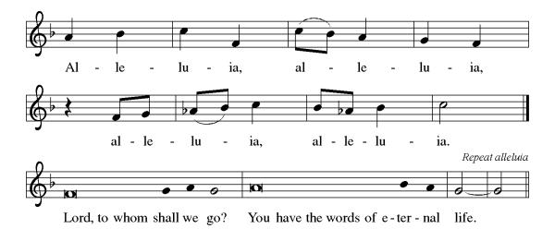
P: The Holy Gospel According to the St. Luke the 6th Chapter
C: Glory to You, O Lord!

Gospel Luke 6:20-31
In echoes of the prophet Isaiah and Mary’s song of praise, Jesus reveals surprising things about who enjoys blessing and who endures woe. He invites his disciples to shower radical love, blessing, forgiveness, generosity, and trust even on enemies and outsiders.

²⁰ Then [Jesus] looked up at his disciples and said:
“Blessed are you who are poor,
for yours is the kingdom of God.
²¹ “Blessed are you who are hungry now,
for you will be filled.
“Blessed are you who weep now,
for you will laugh.
²² “Blessed are you when people hate you and when they exclude you, revile you, and defame you on account of the Son of Man. ²³ Rejoice on that day and leap for joy, for surely your reward is great in heaven, for that is how their ancestors treated the prophets.
²⁴ “But woe to you who are rich,
for you have received your consolation.
²⁵ “Woe to you who are full now,
for you will be hungry.
“Woe to you who are laughing now,
for you will mourn and weep.
²⁶ “Woe to you when all speak well of you, for that is how their ancestors treated the false prophets.
²⁷ “But I say to you who are listening: Love your enemies; do good to those who hate you; ²⁸ bless those who curse you; pray for those who mistreat you. ²⁹ If anyone strikes you on the cheek, offer the other also, and from anyone who takes away your coat do not withhold even your shirt. ³⁰ Give to everyone who asks of you, and if anyone takes away what is yours, do not ask for it back again. ³¹ Do to others as you would have them do to you.”

P: The Gospel of the Lord
C: Praise to you, O Christ!

Sermon

*Hymn of the Day ELW 422 For All The Saints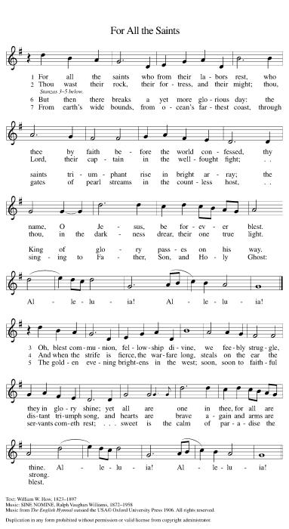

Apostles’ Creed
I believe in God, the Father almighty,
creator of heaven and earth.
I believe in Jesus Christ, God's only Son, our Lord,
who was conceived by the power of the Holy Spirit,
born of the Virgin Mary,
suffered under Pontius Pilate,
was crucified, died, and was buried;
he descended to the dead.
On the third day he rose again;
he ascended into heaven,
he is seated at the right hand of the Father,
and he will come to judge the living and the dead.
I believe in the Holy Spirit,
the holy catholic Church,
the communion of saints,
the forgiveness of sins,
the resurrection of the body,
and the life everlasting. Amen

*Prayers of Intercession
Gathered with one voice, we offer our prayers for the church, the world, and all who are in need.
A brief silence.
God of all that is, delight in the praises of your people and revive the spirit of your church. Move through us with boldness so that we proclaim the gospel of Christ throughout the world. Renew and revive pastors, deacons, and lay leaders. Hear us, O God.
C:Your mercy is great.
God of the beginning, give us the courage to advocate for environmental policy that will ensure a viable future for generations to come. Restore desolate places to health and flourishing. Hear us, O God.
C:Your mercy is great.
God of all our days, guide the leaders of governments, nations, municipalities, and all those seeking office. Accompany election officials and volunteers. Dismantle injustice and oppression wherever it is found. Hear us, O God.
C:Your mercy is great.
God of comfort in troubled times, we pray for those in need of protection and care (especially). Trusting that you are constant in mercy, protect those who seek safety and solace. Hear us, O God.
C:Your mercy is great.
God of what is yet to come, encourage and inspire those who give their time, talent, and treasure in service to your church. By their commitment, further the work of ministry in this place and uplift your gospel. Hear us, O God.
C:Your mercy is great.
Here other intercessions may be offered.
God of time and space, we give thanks for the faithful departed (those who have died during the past year may be named). Sustain us in hope of our eternal unity in Christ. Hear us, O God.
C:Your mercy is great.
We offer these and all our prayers to you, O God, trusting in your grace and unyielding love; through Jesus Christ, our Lord.
C: Amen.

Greeting of Peace
P: The peace of Christ be with you and those you love!
C: And also with you! (The peace is shared with all!)

Offering (Thank you for your support for our ministry!)

*Doxology ELW 691 v. 1 (Please stand and join in singing as we share our gifts!)
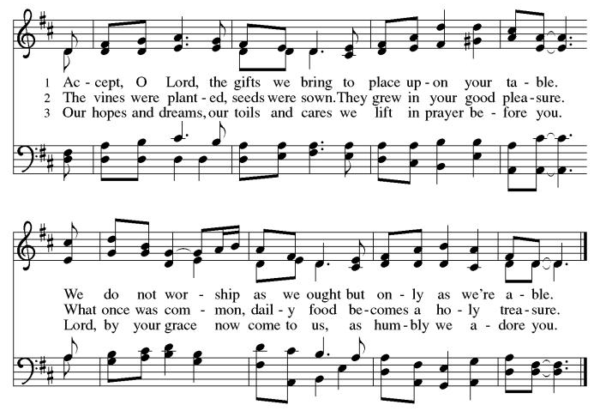
*Offering Prayer
A: God of healing and hope,
C: you bless those who are hungry,
promising to fill them with good things.
Fulfill that promise through us and these your gifts.
Nourish us with the abundance of your feast
and unite us into the blessed body of Jesus Christ our Savior,
now and forever.
Amen.
+MEAL+
(All are welcome at the table of our Lord!)
*Great Thanksgiving
P: The Lord be with you.
C: And also with you.

P: Lift up your hearts.
C: We lift them to the Lord.

P: Let us give thanks to the Lord our God.
C: It is right to give our thanks and praise.

P: It is indeed right, our duty and our joy, that we should at all times and in all places give thanks and praise to you, almighty and merciful God, through our Savior Jesus Christ. By the witness of your saints you show us the hope of our calling and strengthen us to run the race set before us, that we may delight in your mercy and rejoice with them in glory. And so, with [ name/s and] all the saints, with the choirs of angels and all the hosts of heaven, we praise your name and join their unending hymn:
*Sanctus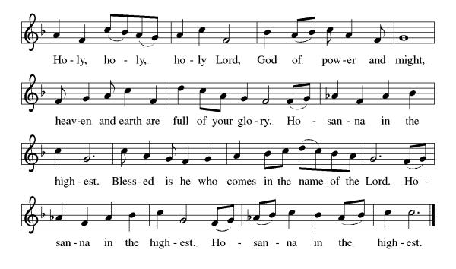
*Eucharistic Prayer
P: Blessed are you, O God,
creator of heaven and earth.
You rescued your covenant people,
led them on all their journeys,
and taught them by the prophets.
You so loved the world
that you gave your only Son,
so that everyone who believes in him
may not perish but may have eternal life.

In the night in which he was betrayed,
our Lord Jesus took bread,
and gave thanks; broke it,
and gave it to his disciples,
saying: Take and eat;
this is my body, given for you.
Do this for the remembrance of me.

Again, after supper,
he took the cup, gave thanks,
and gave it for all to drink,
saying: This cup
is the new covenant in my blood,
shed for you and for all people
for the forgiveness of sin.
Do this for the remembrance of me.

As often as we eat this bread
and drink this cup,
we proclaim the Lord’s death
until he comes.

C: Christ has died. Christ is risen. Christ will come again.

Pour out your Holy Spirit
in this meal,
and make us one
in this community of faith
and with your people
throughout the world.
Glory and praise to you, O God,
Author of life,
Word made flesh,
Power of the Most High,
now and forever.
C: Amen.

*THE LORD’S PRAYER
Our Father, who art in heaven,
hallowed be thy name,
thy kingdom come,
thy will be done,
on earth as it is in heaven.
Give us this day our daily bread;
and forgive us our trespasses,
as we forgive those
who trespass against us;
and lead us not into temptation,
but deliver us from evil.
For thine is the kingdom,
and the power, and the glory, forever and ever. Amen.

*Lamb of God
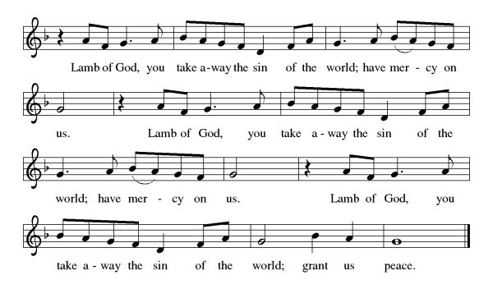

Spiritual Communion Prayer
P: Let us pray for the communion of all present here, those viewing our service virtually, those in our hearts and in our world.
C: Lord Jesus, I believe you are truly present in the Sacrament of Holy Communion. When I cannot receive Communion, I pray that you come into my heart. I know that nothing in Heaven or on earth can separate me from your love. Amen.

Invitation to Communion
P: There is a place for you at the table of God. Come, receive the food that does not perish, a taste of life eternal.
C: Thanks be to God.

(All are invited to the communion rail following the guidance of the ushers. Communion will be shared through the host and individual cups. If you would like communion but are unable to join us at the rail, please alert the usher!)
Communion Hymns (Please join in singing!)
ELW 628 Jerusalem, My Happy Home
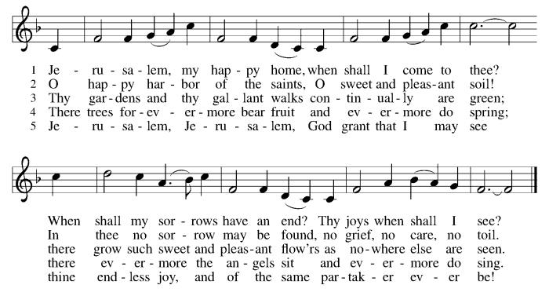
ELW 423 Shall We Gather at the River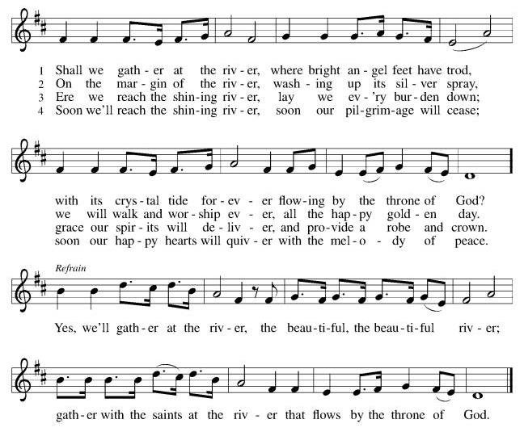
ELW 697 Just a Closer Walk with Thee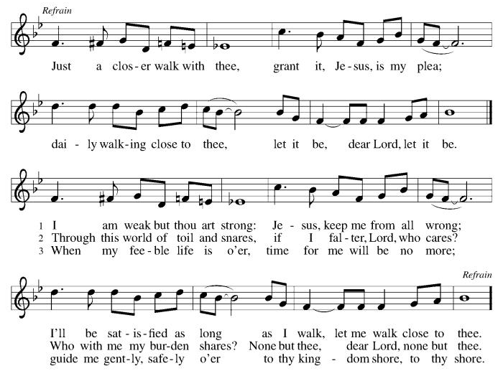

P: The body and blood of our Lord Jesus Christ strengthen you and keep you in his grace. C: Amen!

*Prayer after Communion
A: God of field and flower, wheat and grape,
you have nourished us with the bread of heaven
that gives life to the world.
Strengthened by the body and blood of your Son,
send us out to gather your good gifts for all who
hunger and thirst,
and embolden us to love and serve in Christ’s name.
C: Amen!

+Sending+

*Blessing
P: The love of God the Sovereign strengthen you,
God the Son save you,
and God the Holy Spirit anoint you for the work ahead.
The holy Trinity bless you ☩
and grant you a faithful and courageous heart
now and forever.
C: Amen!

*Sending Hymn ELW 427 For All Your Saints, O Lord
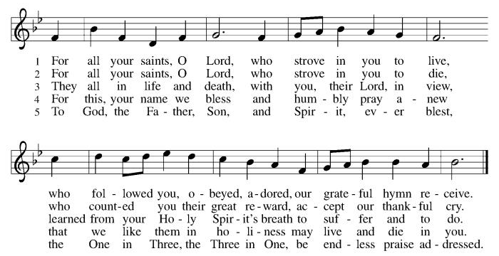

*Dismissal
A: Go in peace. Share the harvest.
C: Thanks Be to God.

Postlude

Copyright © 2020 Augsburg Fortress. All rights reserved. Reprinted by permission under Augsburg Fortress Liturgies Annual License #SB106907. New Revised Standard Version Bible, Copyright © 1989, Division of Christian Education of the National Council of the Churches of Christ in the United States of America. Used by permission. All rights reserved. Revised Common Lectionary, Copyright © 1992 Consultation on Common Texts, admin Augsburg Fortress. Used by permission.

Remembering loved ones on All Saints Sunday

John Vitols | John and Frances Poscheska
Anthony Vaccaro | John and Mary Mckenna
Dominic Torre | Ruth Poshiska
Mike Logue | Brian Przybylowski
Alyson Raywood | Hank Przybylowski
Jane Hendrickson | Neil Britton
Marvin Marquart | Herbert Kreuz
Al DiBenedetto | Doris Beutel
Karen Cronk | Helen Ridberg
George Yetka | Rosa, Rey, Felix and Jaime
Dorbert & Richard Thomas | Ed McNamara
Emily, Eleanor and William Spreen | Harriet McNamara
Randy Gastwirt | Donald Gordon
Jeanne Kerwin | Joseph D’Intron
Bob Kerwin | Paula Boehmer
Sister Loraine Ayres | Gordon Fraser
Dave Volk | Sauman Choy Fraser
Sylvia Coyne | Our parents, Grandma and Uncle Bill
Beverly Burges | Robert and Corinne Lane
Violet Ruberg | Tim Cronin
Robert Cappotelli | Frederick Cox Sr.
Jack Niederer | Rev. James Capers
Rev. Harvard Stephens | Rev. Joanne Bond
Steven Ruzika | Doris Gillott

Treasurer’s Report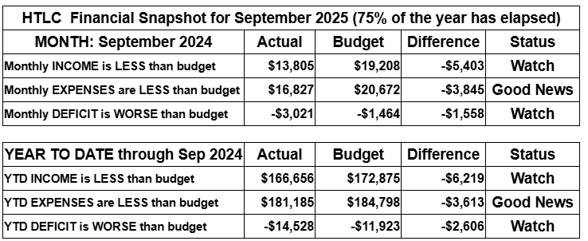
September brought renewed activity—and renewed financial pressure—as giving fell below budget while expenses stayed mostly on track. We’re watching cash flow carefully and invite everyone to help by giving a little extra, responding generously to the Stewardship Appeal, or setting up a recurring gift to support our shared ministry.

Thank you for supporting our ministry! Chris Foard, Treasurer

Worship Volunteer Schedule
Date | Asst. Min | Usher | Sacristan | Lector | Counter
November 2 | Keith Bennett | Dan Grillon | Nancy Poole | Jeff Ridberg | Bohner/Foard
November 9 | Linda Coleman | Keith Bennett | Helga Britton | Cynthia Kazmac | Carleo/Spreen
November 16 | Elaine Bradford | Kathy Caputo | Sherry Lee | Bill Spreen | Foss/Coleman
November 23 | Keith Bennett | Gary Joblon | Nancy Poole | Molly Foard | Carleo/Csernica
November 30 | Chris Foard | Dan Grillon | Joanne Giordano | Rosemary Lane | McKenna/Kazmac

Altar Flowers
November 2ND Kathy Caputo, in memory of Bob Wolfrum
November 9th Kari Oswald in memorial of Aiden Oswald
November 16th Roger Foss In memroy of Lillian Foss
November 26th In Memory of Rober Coppotelli, Lisa Lynch
November 30th In memory of Bob Kolb and parents by Mavis Kolb

Coffee Hour The Endowment Committee
Please consider siging up of a coffee hour. Recruit some friends to help. Thank you!

ANNOUNCEMENTS Thank you! To all who consistently support our church and ministries through your time, talent, and treasure. Please help us grow by inviting your friends and family to worship and events. You are what makes Holy Trinity a wonderful church family!

Stay in touch! Please visit our church website, www.htlcredbank.org for updates and information. You can also find us on Facebook and view services online. The office is open from 9am to 2pm, Monday to Thursday.

100 Anniversary Committee- If you are interested in being a part of the committee to help plan the 100th anniversary celebration of HTLC in 2028, please sign up in the red book. All are welcome! Also, the committee will be looking for photos and documents of HTLC throughout the years. If you have anything to share, please bring them to the church and marked envelopes or email electronic copies to the church office.

Photo Directory- The time has come for an updated Holy Trinity photo directory.
Please join in... it will be easy and informal. For the next five or six Sundays (starting 11/9) after worship we will snap photos that show your best smile. Please step up -- singles, couples and families! Casey H. and her boyfriend Bart (professional photographer!) will have an area set up downstairs to get consistent distancing. If the weather is nice, photo's outside can be an option. Questions can be addressed to Casey or Elaine B.

Name Tag Sundays: On the first Sunday of each month, names tags and markers will be at each entrance of the sanctuary. Please fill out a tag and wear one for worship and for coffee hour to welcome visitors and help newcomers put names to faces.

Choir The Holy Trinity Choir welcomes our singers back for a preparation rehearsal on Sunday, September 7th at 9am in the church hall. All are welcome to join us in song as often as you are able. Choir meets each Sunday at 9am to practice and prepare our music. Join us and help us grow by spreading the word about the HTLC Choir!

Church Mum Sales Proceeds go to the Summer Youth Day Camp. Thank you for your support.
Suggested Donation:1 for $6.00 or 2 for $10.00. Cash and checks made our to Holy Trintiy Lutheran Church with MUMS in the memo line.

Quilting- The Quilters need gently used any bed sheets of any size! Please leave any donations in the quilters closet in Fellowship Hall. Thank you!

Weekly Quilting on Wednesdays at 9:30. Bring your lunch and enjoy some fellowship at noon. All are welcome. There will be no quilting on Wednesday September 24 due to the garage sale set up.

WELCA Update:The garage sale was another success. The net profit after the bank deposit was $3,408.24. It should be noted that other money is still coming in. There was a meeting on 10/12 with congregation members, and it was decided that the giving amount would be rounded up to $3,500. The donations would be made to:

Lutheran Disaster Response - $1,000. It will be noted that this donation should cover both national & international needs.
180 Turning Lives Around - $500
HABCore - $1,000
Monmouth Day Care - $1,000
*It should be noted that a regional donation will be made later in the year to Crossroads for the Tee sign.

Evening Quilting Evening Quilting –
Please share this information . This is an important ministry that helps so many. It’s very easy and you don’t need to know how to sew. We have a great time socializing too! We will meet:
Oct. 15, Nov 19, Dec 17 At 6:00 PM. Note: If we have to cancel I will send an email. Please let me know only if you can come. Contacts: Pat Pienkos 732-513-9615 Debbie Yetka 908-461-4084 Looking forward to seeing you all!

Bagels and Bible- Bagels and Bible will be meeting on the second and fourth Saturdays of the month at 8:30. The group will meet in the Parish House.

ALL SAINTS’ SUNDAY, NOVEMBER 2ND -This is a day that the church remembers all the baptized, especially the faithfully departed. If you have a friend or family member who has passed away and you would like them to be named in the Prayers of Intercession (after the Creed but before the Sharing of the Peace), there is a signup sheet in the Red Binder. You are welcome to bring a framed photo to be placed in fellowship hall. A candle will be lit for each person in front of the church.

Social Ministry
*Year-round collections will continue for food items for Lunch Break. There is a sign-up sheet in the red book for those who can help drop these items to Lunch Break.
*We will also collect adult men's socks to periodically drop at the Red Bank Warminq Center.
*For those interested in the Heartwarminq Center — the new women's shelter is adjacent to the First Baptist Church of Red Bank at 90 Maple Ave. You can follow up on this mission through their website - https://www.thefeastnj.org- On this site, they also include wish list items that can be purchased through amazon. We will be exploring purchasing some of these through a Thrivent card. If you want to purchase on your own, you can leave items at church, and the Social Ministry will deliver them.

Pastoral Care and Prayer... We are here to care for and pray! Please contact the office to add or adjust prayer requests. If you or someone you know needs pastoral care, please contact the office and Pastor Mack!

THANK YOU for supporting and sustaining our church and ministries! All are welcome here! Please invite your family and friends to worship with us! Find us online at www.htlcredbank.org

Special Endowment Appeal for All-Saints Day, 2025
“Be holy, for I am holy” (Lev. 11:44, 1 Peter 1:16)
As it is an Endowment tradition, the Endowment Fund will continue to do its All-Saint’s Day Appeal to help support our congregation’s ministry.
On Sunday 2 November, you will have the opportunity to make a special offering in honor and memory of our brothers and sisters in Christ, well pleasing to God. Your donation will have a bigger impact than you might ordinarily imagine. Endowment continues to support many ministries at Holy Trinity, including the Quilting, VBS and HTLC Choir. We have continued supporting the development of the Memorial Garden.
As you are aware, last year, Endowment funded the replacement of the roof of the temple. The funding for this repair came from our investments. This is what the Endowment investment fund is needed for. Otherwise, the Church would have to find our sources of funding to make these repairs (including loans).
It is Endowment Committee’s responsibility to continue to grow our investments to help provide sources of funding for major capital outlays needed to maintain and operate HTLC in the future. Your donations help us do this.
And at Coffee Hour following services, the Endowment committee will host its annual Oktoberfest.
The Endowment Ministry wishes to thank you in advance for your continuing support. Every donation is greatly appreciated, and every donation will make a difference.
Mark Csernica
Endowment Ministry Chair

