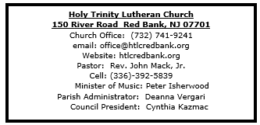

October 26, 2025

20th Reformation Sunday

Introduction
Rooted in the past and growing into the future, the church must always be reformed in order to live out the love of Christ in an ever-changing world. We celebrate the good news of God’s grace, that Jesus Christ sets us free every day to do this life-transforming work. Trusting in the freedom given to us in baptism, we pray for the church, that Christians will unite more fully in worship and mission.

Welcome & Announcements (Please silence your cell phone!)

Prelude (We prayerfully prepare our hearts and minds to worship!)

+ GATHERING +

Confession and Forgiveness
All may make the sign of the cross, the sign that is marked at baptism, as the presiding minister begins.
P: Blessed be the holy Trinity, ☩ one God,
our maker, our helper, and our keeper.
C: Amen.
P: Trusting in God’s mercy, let us confess our sin
in the presence of God and of one another.
Silence is kept for reflection.
Merciful and loving God,
C: we are your stiff-necked people.
We trample on the needy.
We grumble about your grace to others.
We turn away from the poor.
Have mercy on us and forgive our sins.
Rejoice over us as ones who were lost
and have been found. Amen.
P:Even when we are faithless, God remains faithful.
Jesus Christ came into the world to save sinners.
You who were lost have been found.
In the name of ☩ Jesus, your sins are forgiven!
C: Amen.

*Gathering Hymn ELW 654 The Church’s One Foundation

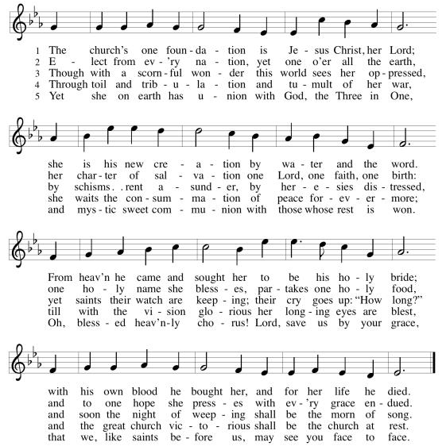
*Pastoral Greeting

P: The Grace and Peace of our Lord Jesus Christ, the love of God, and the communion of the Holy Spirit be with you all! C: And also with you!
Hymn of Praise
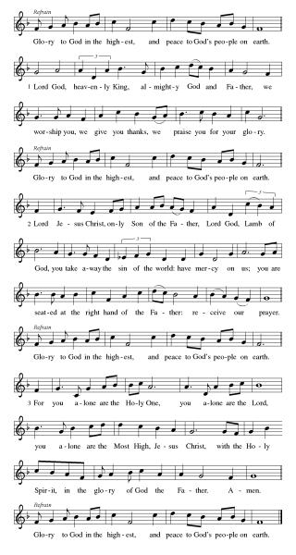

*Prayer of the Day
P: Almighty God, gracious Lord, we thank you that your Holy Spirit renews the church in every age. Pour out your Holy Spirit on your faithful people. Keep them steadfast in your word, protect and comfort them in times of trial, defend them against all enemies of the gospel, and bestow on the church your saving peace, through Jesus Christ, our Savior and Lord, who lives and reigns with you and the Holy Spirit, one God, now and forever.
C: Amen!
+WORD+

First Reading: Jeremiah 31:31-34
The renewed covenant will not be breakable, but like the old covenant it will expect the people to live upright lives. To know the Lord means that one will defend the cause of the poor and needy (Jer. 22:16). The renewed covenant is possible only because the Lord will forgive iniquity and not remember sin. Our hope lies in a God who forgets.

³¹ The days are surely coming, says the Lord, when I will make a new covenant with the house of Israel and the house of Judah. ³² It will not be like the covenant that I made with their ancestors when I took them by the hand to bring them out of the land of Egypt—a covenant that they broke, though I was their husband, says the Lord. ³³ But this is the covenant that I will make with the house of Israel after those days, says the Lord: I will put my law within them, and I will write it on their hearts, and I will be their God, and they shall be my people. ³⁴ No longer shall they teach one another or say to each other, “Know the Lord,” for they shall all know me, from the least of them to the greatest, says the Lord, for I will forgive their iniquity and remember their sin no more.

Psalm: Psalm 46
The Lord of hosts is with us; the God of Jacob is our stronghold. (Ps. 46:7)

¹ God is our ref- | uge and strength,
a very present | help in trouble.
² Therefore we will not fear, though the | earth be moved,
and though the mountains shake in the depths | of the sea;
³ though its waters | rage and foam,
and though the mountains tremble | with its tumult.
⁴ There is a river whose streams make glad the cit- | y of God,
the holy habitation of | the Most High.
⁵ God is in the midst of the city; it shall | not be shaken;
God shall help it at the | break of day.
⁶ The nations rage, and the | kingdoms shake;
God speaks, and the earth | melts away.
⁷ The Lord of | hosts is with us;
the God of Jacob | is our stronghold.
⁸ Come now, regard the works | of the Lord,
what desolations God has brought up- | on the earth;
⁹ behold the one who makes war to cease in | all the world;
who breaks the bow, and shatters the spear, and burns the | shields with fire.
¹⁰ “Be still, then, and know that | I am God;
I will be exalted among the nations; I will be exalted | in the earth.”
¹¹ The Lord of | hosts is with us;
the God of Jacob | is our stronghold.

Second Reading: Romans 3:19-28
Paul’s words stand at the heart of the preaching of Martin Luther and other Reformation leaders. No human beings make themselves right with God through works of the law. We are brought into a right relationship with God through the divine activity centered in Christ’s death. This act is a gift of grace that liberates us from sin and empowers our faith in Jesus Christ.

¹⁹ Now we know that, whatever the law says, it speaks to those who are under the law, so that every mouth may be silenced and the whole world may be held accountable to God. ²⁰ For no human will be justified before him by deeds prescribed by the law, for through the law comes the knowledge of sin.
²¹ But now, apart from the law, the righteousness of God has been disclosed and is attested by the Law and the Prophets, ²² the righteousness of God through the faith of Jesus Christ for all who believe. For there is no distinction, ²³ since all have sinned and fall short of the glory of God; ²⁴ they are now justified by his grace as a gift, through the redemption that is in Christ Jesus, ²⁵ whom God put forward as a sacrifice of atonement by his blood, effective through faith. He did this to demonstrate his righteousness, because in his divine forbearance he had passed over the sins previously committed; ²⁶ it was to demonstrate at the present time his own righteousness, so that he is righteous and he justifies the one who has the faith of Jesus.
²⁷ Then what becomes of boasting? It is excluded. Through what kind of law? That of works? No, rather through the law of faith. ²⁸ For we hold that a person is justified by faith apart from works prescribed by the law.

*Gospel Acclamation
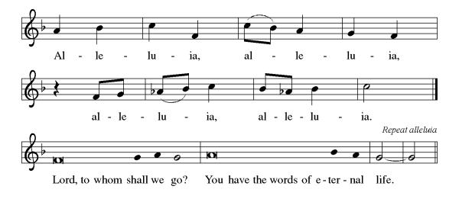
P: The Holy Gospel According to the St. John the 8th Chapter
C: Glory to You, O Lord!

Gospel: John 8:31-36
Jesus speaks of truth and freedom as spiritual realities known through his word. He reveals the truth that sets people free from sin.
³¹ Jesus said to the Jews who had believed in him, “If you continue in my word, you are truly my disciples, ³² and you will know the truth, and the truth will make you free.” ³³ They answered him, “We are descendants of Abraham and have never been slaves to anyone. What do you mean by saying, ‘You will be made free’?”
³⁴ Jesus answered them, “Very truly, I tell you, everyone who commits sin is a slave to sin. ³⁵ The slave does not have a permanent place in the household; the son has a place there forever. ³⁶ So if the Son makes you free, you will be free indeed.”

P: The Gospel of the Lord
C: Praise to you, O Christ!

Sermon

*Hymn of the Day ELW 504 A Mighty Fortress Is Our God
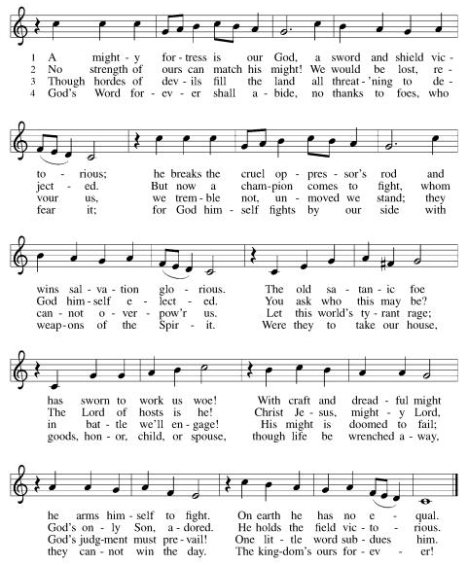

Apostles’ Creed
I believe in God, the Father almighty,
creator of heaven and earth.
I believe in Jesus Christ, God's only Son, our Lord,
who was conceived by the power of the Holy Spirit,
born of the Virgin Mary,
suffered under Pontius Pilate,
was crucified, died, and was buried;
he descended to the dead.
On the third day he rose again;
he ascended into heaven,
he is seated at the right hand of the Father,
and he will come to judge the living and the dead.
I believe in the Holy Spirit,
the holy catholic Church,
the communion of saints,
the forgiveness of sins,
the resurrection of the body,
and the life everlasting. Amen

*Prayers of Intercession
Renewed in God’s everlasting grace, let us pray for the church, the world, and all creation.
A brief silence.
Free your church, O God, with grace, mercy, and love to be transformed by your word. Direct your church to be united in word and deed so that all creation knows the uniting and transforming power of the gospel. God of grace,
C:receive our prayer.
Renew creation, O God, so that all living creatures thrive together. Guide those who work to restore and renew creation. Preserve and care for endangered species throughout the world. God of grace,
C:receive our prayer.
Bring peace among the nations, O God, so violence and terror are not the norm on your earth. Inspire leaders of communities to work for peace and justice. Unite our politicians with a common mission and purpose. God of grace,
C:receive our prayer.
Heal all who suffer, O God, and bring them peace. Draw near to people who are incarcerated. Give hope to people experiencing housing or employment insecurity, oppression, or discrimination. Heal those who are ill (especially). Be our stronghold at all times. God of grace,
C:receive our prayer.
Forgive us our sins, O God, and grant us your grace. Move us to understanding and reconciliation between people of other faiths and other Christian traditions in our community. Mend hurt feelings and heal wounds we have caused one another. God of grace,
C:receive our prayer.
Here other intercessions may be offered.
We give you thanks, O God, for the life and witness of all your saints (especially Philipp Nicolai, Johann Heermann, and Paul Gerhardt). Give us hope in your son’s victory through the cross. God of grace,
C:receive our prayer.
We offer our prayers, O God, trusting in your everlasting grace and mercy, through Jesus Christ our Lord.
C: Amen.

Greeting of Peace
P: The peace of Christ be with you and those you love!
C: And also with you! (The peace is shared with all!)

Offering (Thank you for your support for our ministry!)

*Doxology ELW 691 v. 1 (Please stand and join in singing as we share our gifts!)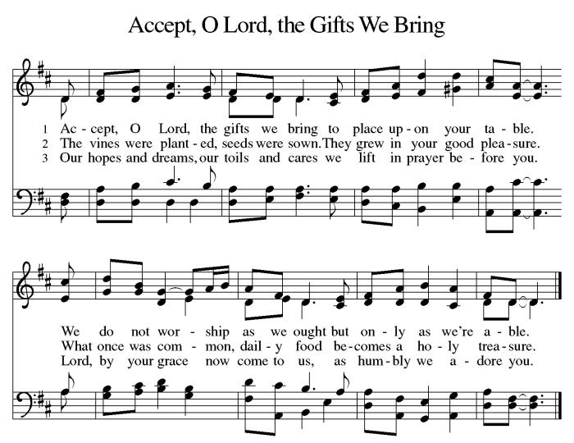
*Offering Prayer
A: Lord of the harvest,
C: we return to you a portion of what you have given to us.
Turn us to set our hope not on the uncertainty of riches,
but on you, who richly provides for us.
Multiply what we have gathered
to bless all who are suffering and in need,
through Jesus Christ our Lord. Amen.

+MEAL+
(All are welcome at the table of our Lord!)
*Great Thanksgiving
P: The Lord be with you.
C: And also with you.

P: Lift up your hearts.
C: We lift them to the Lord.

P: Let us give thanks to the Lord our God.
C: It is right to give our thanks and praise.

P: It is indeed right, our duty and our joy, that we should at all times and in all places give thanks and praise to you, almighty and merciful God, through our Savior Jesus Christ; who on this day overcame death and the grave, and by his glorious resurrection opened to us the way of everlasting life. And so, with all the choirs of angels, with the church on earth and the hosts of heaven, we praise your name and join their unending hymn:

*Sanctus
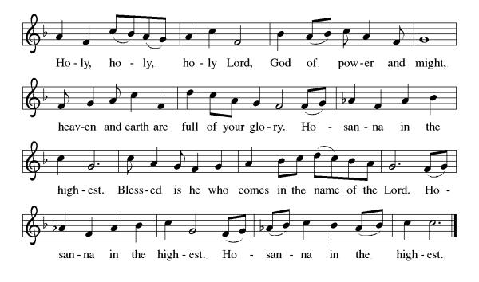

*Eucharistic Prayer
P: Blessed are you, O God,
creator of heaven and earth.
You rescued your covenant people,
led them on all their journeys,
and taught them by the prophets.
You so loved the world
that you gave your only Son,
so that everyone who believes in him
may not perish but may have eternal life.

In the night in which he was betrayed,
our Lord Jesus took bread,
and gave thanks; broke it,
and gave it to his disciples,
saying: Take and eat;
this is my body, given for you.
Do this for the remembrance of me.

Again, after supper,
he took the cup, gave thanks,
and gave it for all to drink,
saying: This cup
is the new covenant in my blood,
shed for you and for all people
for the forgiveness of sin.
Do this for the remembrance of me.

As often as we eat this bread
and drink this cup,
we proclaim the Lord’s death
until he comes.

C: Christ has died. Christ is risen. Christ will come again.

Pour out your Holy Spirit
in this meal,
and make us one
in this community of faith
and with your people
throughout the world.
Glory and praise to you, O God,
Author of life,
Word made flesh,
Power of the Most High,
now and forever.
C: Amen.

*THE LORD’S PRAYER
Our Father, who art in heaven,
hallowed be thy name,
thy kingdom come,
thy will be done,
on earth as it is in heaven.
Give us this day our daily bread;
and forgive us our trespasses,
as we forgive those
who trespass against us;
and lead us not into temptation,
but deliver us from evil.
For thine is the kingdom,
and the power, and the glory, forever and ever. Amen.

*Lamb of God
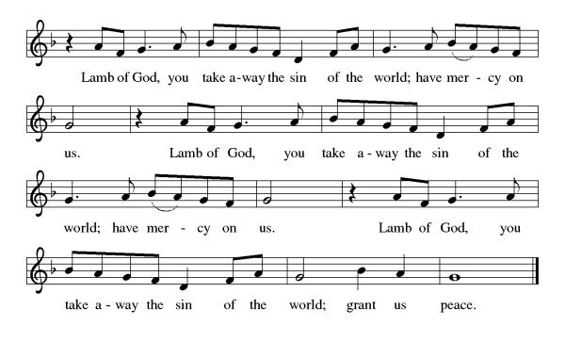

Spiritual Communion Prayer
P: Let us pray for the communion of all present here, those viewing our service virtually, those in our hearts and in our world.
C: Lord Jesus, I believe you are truly present in the Sacrament of Holy Communion. When I cannot receive Communion, I pray that you come into my heart. I know that nothing in Heaven or on earth can separate me from your love. Amen.

Invitation to Communion
P: Jesus welcomes sinners and eats with them. Come to this meal of mercy.
C: Thanks be to God.

(All are invited to the communion rail following the guidance of the ushers. Communion will be shared through the host and individual cups. If you would like communion but are unable to join us at the rail, please alert the usher!)
Communion Hymns (Please join in singing!)
ELW 471 Let Us Break Bread Together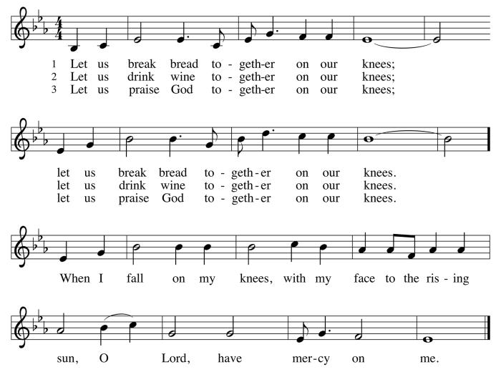
ELW 518 We Eat the Bread of Teaching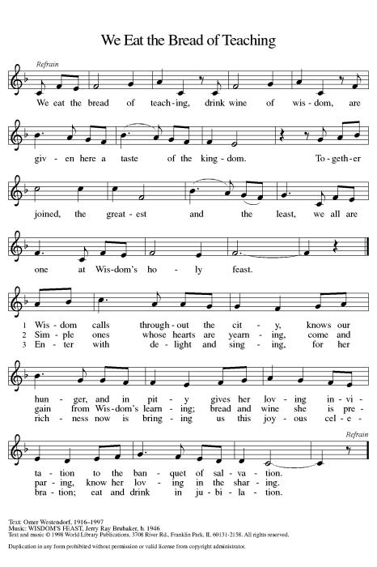

P: The body and blood of our Lord Jesus Christ strengthen you and keep you in his grace. C: Amen!

*Prayer after Communion
A: O God,
through this meal you have strengthened us
and appointed us to be your servants.
Send us to do good and to share our possessions
with all in need.
We ask this in Jesus’ name.
C: Amen!

+Sending+

*Blessing
P: The God of righteousness,
who gives justice to the oppressed,
who gives food to the hungry,
who sets the prisoners free,
☩ bless you now and forever.
C: Amen!

*Sending Hymn ELW 729 The Church of Christ, in Every Age
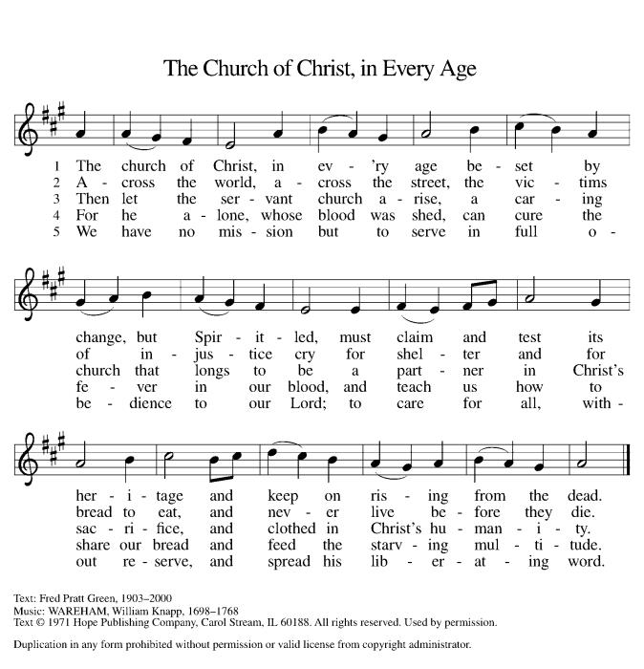
*Dismissal
A: Go in peace. Do not lose heart.
C: Thanks Be to God.
Postlude

Copyright © 2020 Augsburg Fortress. All rights reserved. Reprinted by permission under Augsburg Fortress Liturgies Annual License #SB106907. New Revised Standard Version Bible, Copyright © 1989, Division of Christian Education of the National Council of the Churches of Christ in the United States of America. Used by permission. All rights reserved. Revised Common Lectionary, Copyright © 1992 Consultation on Common Texts, admin Augsburg Fortress. Used by permission.

Treasurer’s Report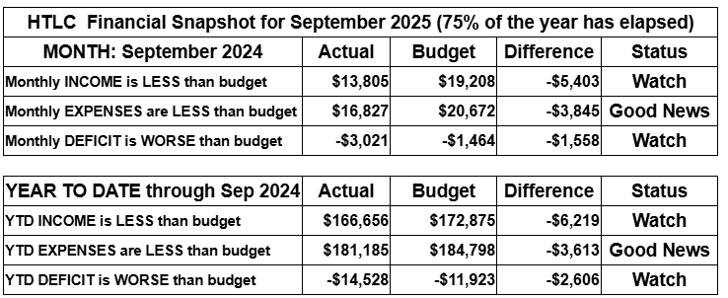
September brought renewed activity—and renewed financial pressure—as giving fell below budget while expenses stayed mostly on track. We’re watching cash flow carefully and invite everyone to help by giving a little extra, responding generously to the Stewardship Appeal, or setting up a recurring gift to support our shared ministry.
Thank you for supporting our ministry! Chris Foard, Treasurer

Worship Volunteer Schedule
Date | Asst. Min | Usher | Sacristan | Lector | Counter
October 5 | Chris Foard | Keith Bennett | Sherry Lee | Molly Foard | Carleo/Csernica
October 12 | Elaine Bradford | Kathy Caputo | Joanne Giordano | Jeff Ridberg | Kazmac/Volk
October 19 | Charlie Rugg | Gary Joblon | pat Pienkos | Emily Kaster | Mckenna/Socha
October 26 | Linda Coleman | Dan Grillon | Carol Rosen | Bill Spreen | Giordano/Bradford
November 2 | Keith Bennett | Dan Grillon | Nancy Poole | Jeff Ridberg | Bohner/Foard

Altar Flowers
October 5th The Doyles, Happy 10th Wedding Anniversary
October 12th Dee Stein, in memory of her parents and her sister.
October 19th William Spreen, in memory of Emily Spreen and in memory of Eleanor Spreen.
October 26th William Spreen in Memory of William Spreen Sr. and in honor of Carol Spreen.

Coffee Hour Potluck
Please consider siging up of a coffee hour. Recruit some friends to help. Thank you!

ANNOUNCEMENTS Thank you! To all who consistently support our church and ministries through your time, talent, and treasure. Please help us grow by inviting your friends and family to worship and events. You are what makes Holy Trinity a wonderful church family!

Stay in touch! Please visit our church website, www.htlcredbank.org for updates and information. You can also find us on Facebook and view services online. The office is open from 9am to 2pm, Monday to Thursday.

100 Anniversary Committee- If you are interested in being a part of the committee to help plan the 100th anniversary celebration of HTLC in 2028, please sign up in the red book. All are welcome! Also, the committee will be looking for photos and documents of HTLC throughout the years. If you have anything to share, please bring them to the church and marked envelopes or email electronic copies to the church office.

Name Tag Sundays: On the first Sunday of each month, names tags and markers will be at each entrance of the sanctuary. Please fill out a tag and wear one for worship and for coffee hour to welcome visitors and help newcomers put names to faces.

Choir The Holy Trinity Choir welcomes our singers back for a preparation rehearsal on Sunday, September 7th at 9am in the church hall. All are welcome to join us in song as often as you are able. Choir meets each Sunday at 9am to practice and prepare our music. Join us and help us grow by spreading the word about the HTLC Choir!

Church Mum Sales Proceeds go to the Summer Youth Day Camp. Thank you for your support.
Suggested Donation:1 for $6.00 or 2 for $10.00. Cash and checks made our to Holy Trintiy Lutheran Church with MUMS in the memo line.

Baby Lotion Collection- Our confirmands will be helping put together gift bags at Holiday Express in Eatontown on Tuesday, December 16. We are collecting full size bottles of baby lotion to donate to this cause. There will be a bin to collect the lotion if you would like to donate.

Quilting- The Quilters need gently used any bed sheets of any size! Please leave any donations in the quilters closet in Fellowship Hall. Thank you!

Weekly Quilting on Wednesdays at 9:30. Bring your lunch and enjoy some fellowship at noon. All are welcome. There will be no quilting on Wednesday September 24 due to the garage sale set up.

WELCA Update:The garage sale was another success. The net profit after the bank deposit was $3,408.24. It should be noted that other money is still coming in. There was a meeting on 10/12 with congregation members, and it was decided that the giving amount would be rounded up to $3,500. The donations would be made to:

Lutheran Disaster Response - $1,000. It will be noted that this donation should cover both national & international needs.
180 Turning Lives Around - $500
HABCore - $1,000
Monmouth Day Care - $1,000
*It should be noted that a regional donation will be made later in the year to Crossroads for the Tee sign.

Evening Quilting Evening Quilting –
Please share this information . This is an important ministry that helps so many. It’s very easy and you don’t need to know how to sew. We have a great time socializing too! We will meet:
Oct. 15, Nov 19, Dec 17 At 6:00 PM. Note: If we have to cancel I will send an email. Please let me know only if you can come. Contacts: Pat Pienkos 732-513-9615 Debbie Yetka 908-461-4084 Looking forward to seeing you all!

Trunk or Treat 10/25 2:00PM-4:00PM- Our fifth annual Trunk or Treat will be Saturday, October 25th from 2 - 4 PM. Would you like your car or truck to be a part of this fun day? Participants will decorate their trunks and hand out candy to the children. Each car should have at least 300 pieces of candy. Please sign up in the red book or via email by October 12th.
Volunteers are needed to help set up and clean up. Remember, older youth helpers can receive community service hours. If you would like to make a monetary donation, we will do the shopping for you. You do not want to miss the most spooktacular event of the season!

The CPC Thanksgiving Dinner is scheduled for Wednesday 11/26/25. With collaboration from CPC staff, we will have one serving time for individuals served and their staff. We typically serve about 60 clients and 10 staff. We need volunteers for set-up, serving, providing pies & turkeys, and clean-up. The meal is served at 12:00 noon and the clients will go to the clothing center.
If you have leftover Halloween candy and don't want it hanging around your house, please feel free to donate it to the church to be included in goody bags for the CPC individuals attending the dinner.
There will be sign-up sheets in the red book for congregation members who can donate items needed and for those who can help at the dinner. Thank you all for supporting this cherished mission.

Bagels and Bible- Bagels and Bible will be meeting on the second and fourth Saturdays of the month at 8:30. The group will meet in the Parish House.

ALL SAINTS’ SUNDAY, NOVEMBER 2ND -This is a day that the church remembers all the baptized, especially the faithfully departed. If you have a friend or family member who has passed away and you would like them to be named in the Prayers of Intercession (after the Creed but before the Sharing of the Peace), there is a signup sheet in the Red Binder. You are welcome to bring a framed photo to be placed in fellowship hall. A candle will be lit for each person in front of the church.

Social Ministry
*Year-round collections will continue for food items for Lunch Break. There is a sign-up sheet in the red book for those who can help drop these items to Lunch Break.
*We will also collect adult men's socks to periodically drop at the Red Bank Warminq Center.
*For those interested in the Heartwarminq Center — the new women's shelter is adjacent to the First Baptist Church of Red Bank at 90 Maple Ave. You can follow up on this mission through their website - https://www.thefeastnj.org- On this site, they also include wish list items that can be purchased through amazon. We will be exploring purchasing some of these through a Thrivent card. If you want to purchase on your own, you can leave items at church, and the Social Ministry will deliver them.

Pastoral Care and Prayer... We are here to care for and pray! Please contact the office to add or adjust prayer requests. If you or someone you know needs pastoral care, please contact the office and Pastor Mack!

THANK YOU for supporting and sustaining our church and ministries! All are welcome here! Please invite your family and friends to worship with us! Find us online at www.htlcredbank.org

Special Endowment Appeal for All-Saints Day, 2025
“Be holy, for I am holy” (Lev. 11:44, 1 Peter 1:16)
As it is an Endowment tradition, the Endowment Fund will continue to do its All-Saint’s Day Appeal to help support our congregation’s ministry.
On Sunday 2 November, you will have the opportunity to make a special offering in honor and memory of our brothers and sisters in Christ, well pleasing to God. Your donation will have a bigger impact than you might ordinarily imagine. Endowment continues to support many ministries at Holy Trinity, including the Quilting, VBS and HTLC Choir. We have continued supporting the development of the Memorial Garden.
As you are aware, last year, Endowment funded the replacement of the roof of the temple. The funding for this repair came from our investments. This is what the Endowment investment fund is needed for. Otherwise, the Church would have to find our sources of funding to make these repairs (including loans).
It is Endowment Committee’s responsibility to continue to grow our investments to help provide sources of funding for major capital outlays needed to maintain and operate HTLC in the future. Your donations help us do this.
And at Coffee Hour following services, the Endowment committee will host its annual Oktoberfest.
The Endowment Ministry wishes to thank you in advance for your continuing support. Every donation is greatly appreciated, and every donation will make a difference.
Mark Csernica
Endowment Ministry Chair

